Software Engineering Project Test Report

1. Overview of the Test Plan

1.1 Purpose
The purpose of this test plan is to ensure that the software project functions correctly, meets the specified requirements, and is free of major defects before deployment.

1.2 Scope
This test plan covers the following features:
- User authentication (login and registration)
- Form validation and error handling
- Supabase backend
- Performance and security checks

1.3 Project Description
This software project serves as a digital business card, with its users being able to save contact details and social media details and have them displayed publicly and accessible via a search bar on your homepage. It is a networking tool improving on traditional physical business cards and can be integrated with an NFC card to emulate a physical business card. This allows it to be dynamic, as details can always be updated later.
It has been built using HTML, CSS, and JavaScript. It integrates with Supabase for a Postgres backend for authentication and data storage.

1.4 Testing Objectives
- Verify that all features work as expected
- Test backend for authentication and data storage
- Identify and fix bugs before deployment
- Performance, usability, and security standards

2. Testing Strategy

2.1 Types of Testing
- Unit Testing: Testing individual components or functions.
- System Testing: Verifying the entire system's behaviour.
- Performance Testing: Checking page load speed and system response time.
- Security Testing: Ensuring protection against vulnerabilities like SQL Injection or Cross-Site Scripting (XSS).

2.2 Testing Environment
- Browsers: Vivaldi, Firefox, Edge
- Devices: Mobile, Desktop
- Tools: Supabase Dashboard (backend), Browser DevTools (for debugging), ZAP (security)

3. Test Cases
Test Case ID | Feature | Test Steps | Expected Result | Actual Result | Pass/Fail
1 | Search | Navigate to home page. Search by username and by display name in the search box. | Exact matches will appear, ordered by username. | Search by username works, but display name doesn't. | FAIL
2 | Search | Navigate to home page. Search by username and by display name in the search box. | Exact matches will appear, ordered by username. | Bug has been resolved, result matches expected | PASS
3 | Authentication | Navigate to register page. Test with invalid data first. Then, fill in with valid details. Log out. Login with registered details. | Invalid data should be flagged. Valid record should save to Supabase and should be valid for future login | Matches Expected | PASS
4 | Profile Editing | Login with valid details and fill in profile details. Test invalid values. | Invalid data will be flagged. Data will be saved to Supabase. | Matches expected | PASS
5 | Mobile Layout | Test on mobile device and navigate through website. | Website should be formatted for a mobile layout with adequate spacing and font size. | Matches Expected | Pass
6 | Different Browsers | Test layout in other browsers: Opera, Edge, Firefox | Will appear near identical to default browser | Matches Expected | PASS
7 | Test Performance | Use Lighthouse in DevTools to test performance | Should be fast | Performance is good on desktop, adequate on mobile | PASS
8 | Test Security | Attempt basic SQL Injection, XSS in input fields. Scan with ZAP. | All attempts should fail or be escaped. Zap should show no major errors. | Matches Expected | PASS
9 | Test redirects and invalid profile page | Attempt to navigate to ../user/randomusername. Randomusername should be a profile that does not exist.  Also attempt to navigate to ../asdjasdhfksda. | Anything in directory of /user/ will look for a username. If there is none, there will be an error message displayed. Any other invalid pages will redirect back to the home page. | Matches Expected | PASS

4. Evidence of Testing

Search Function (Test ID = 1)
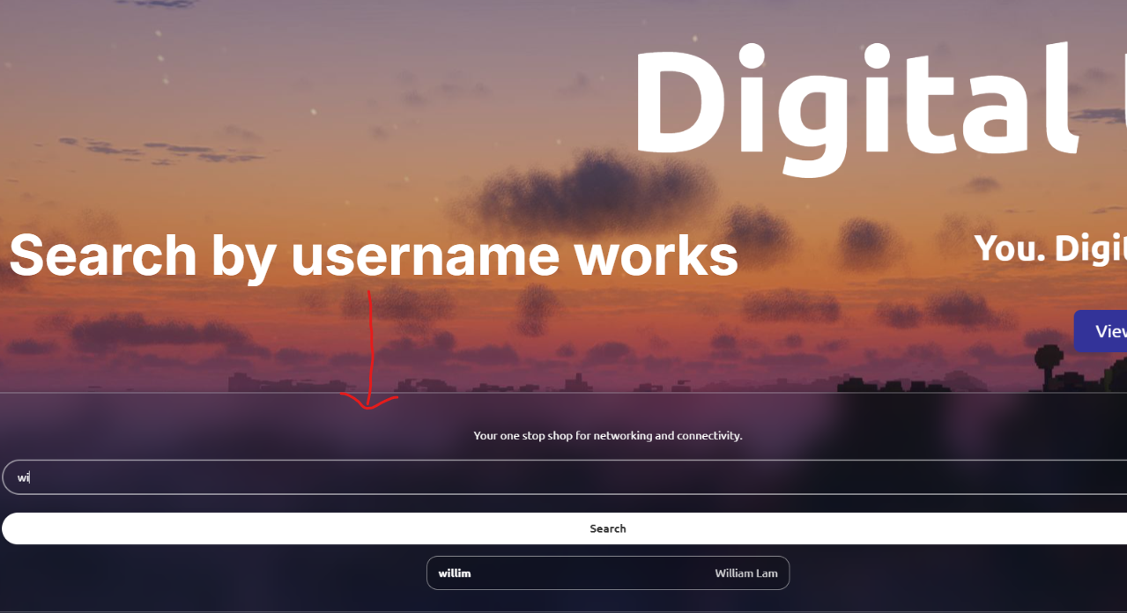

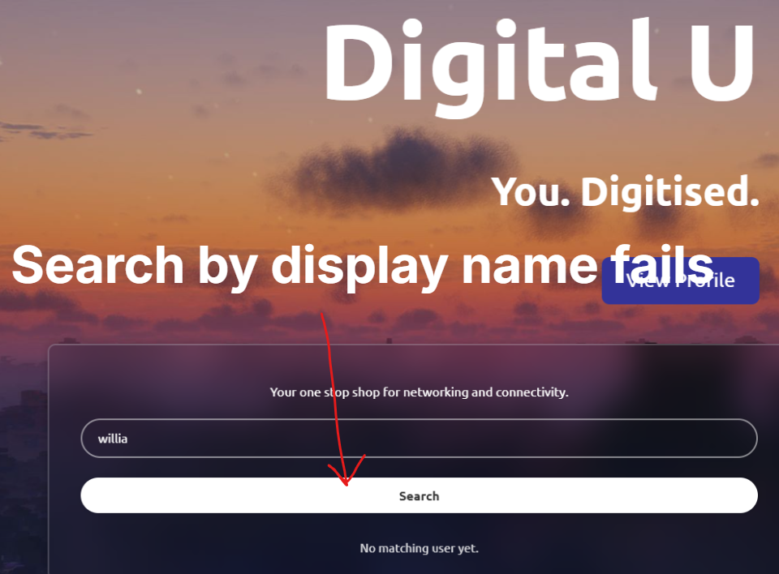

Search Function (Test ID = 2)
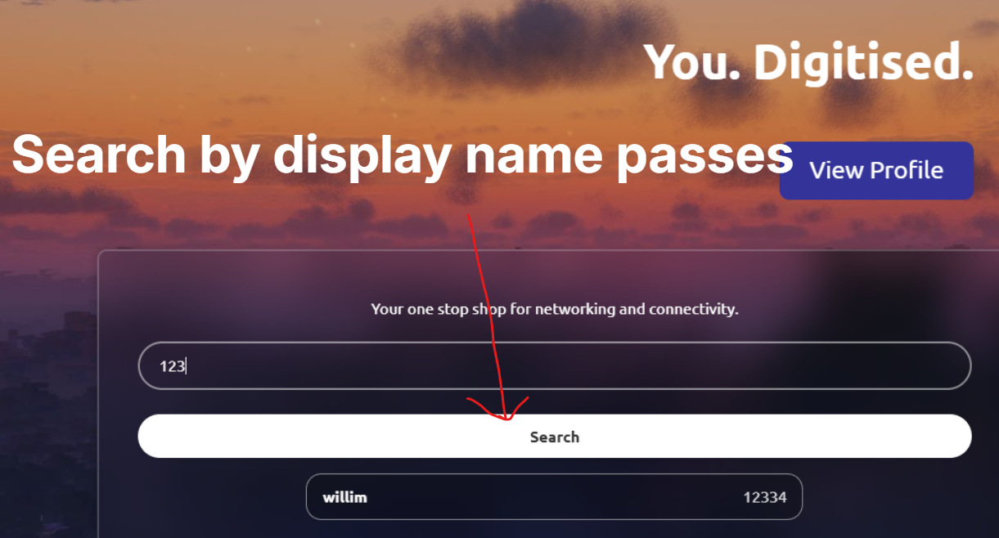

Authentication
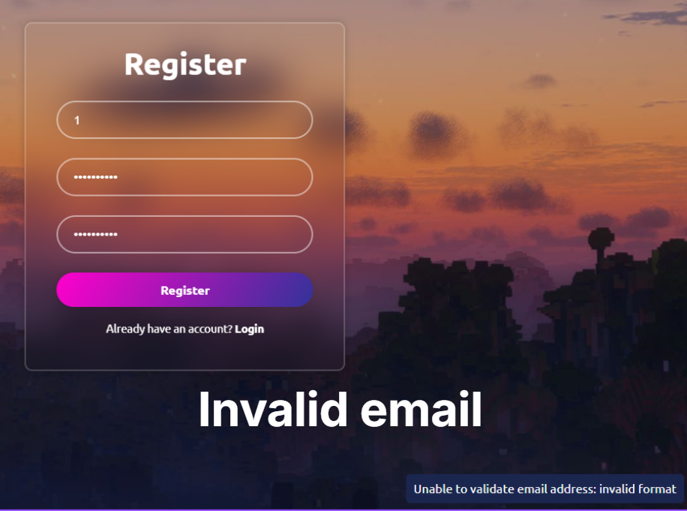
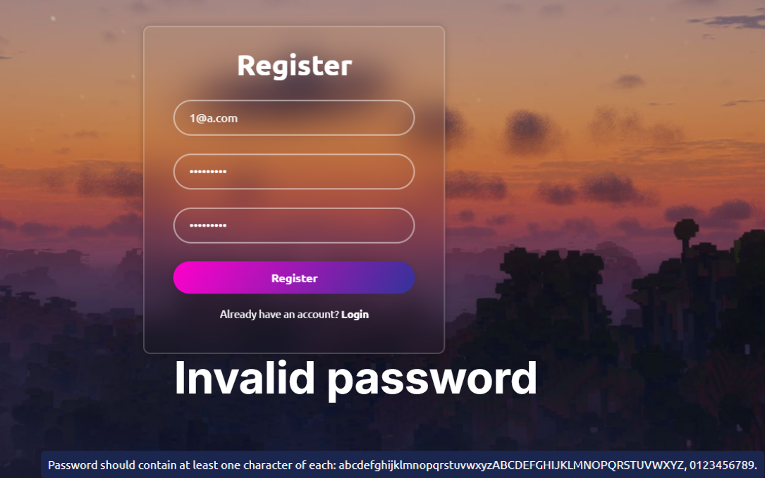
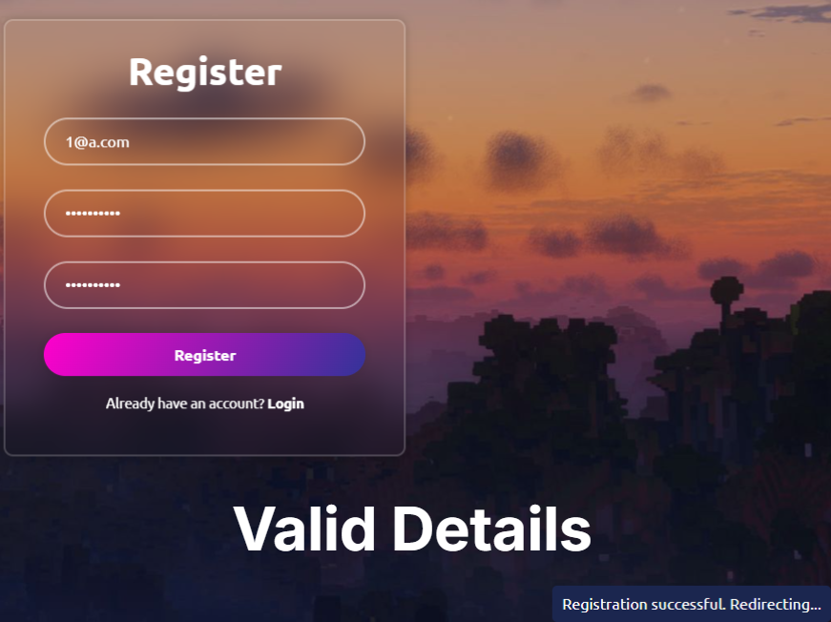
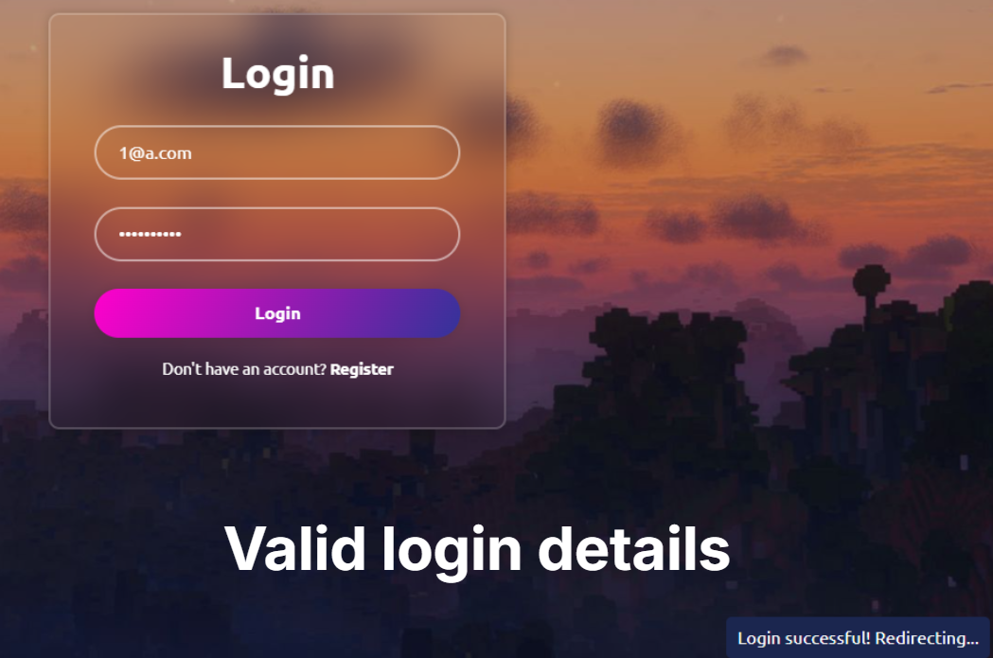

Mobile Layout
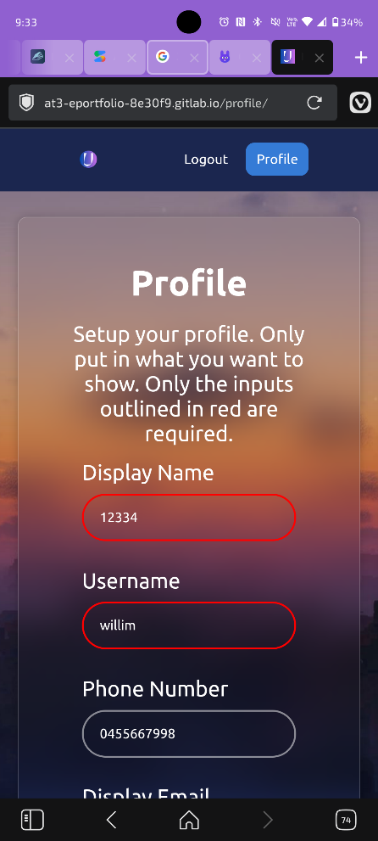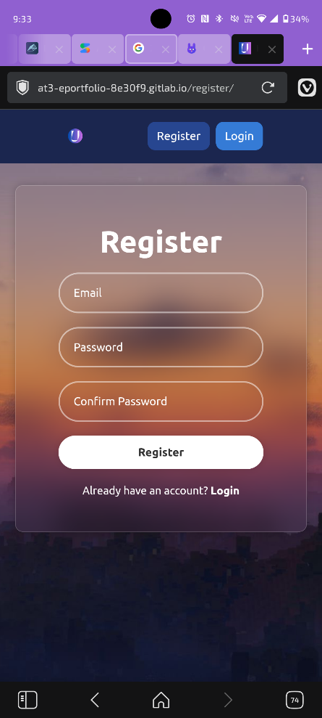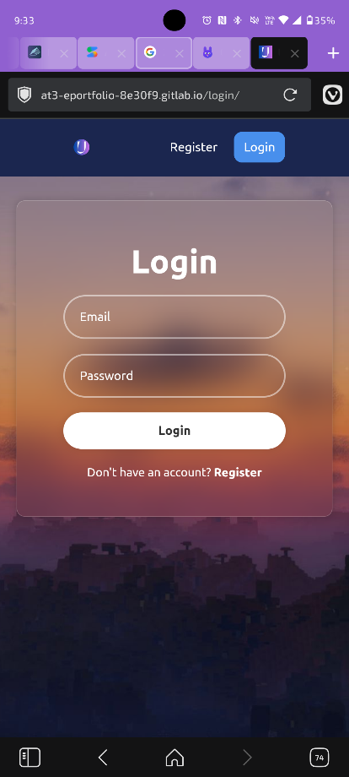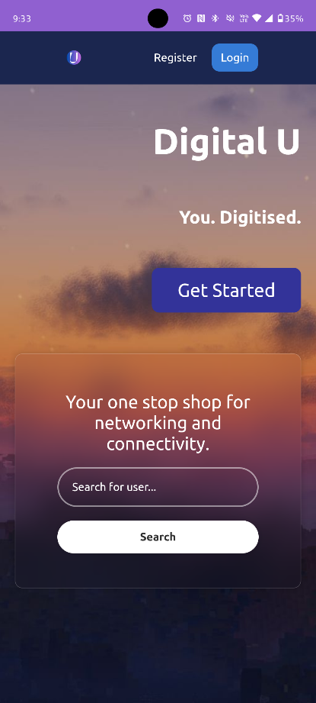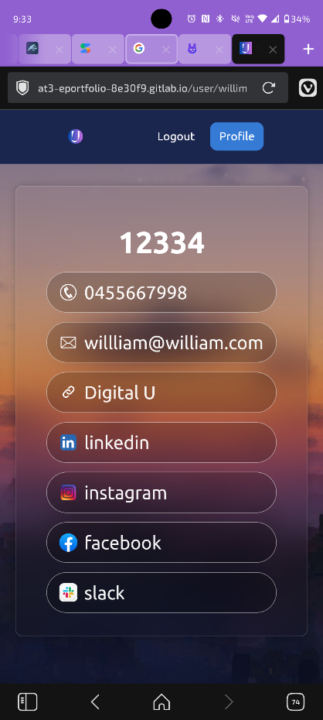

Different Browsers
  - Opera
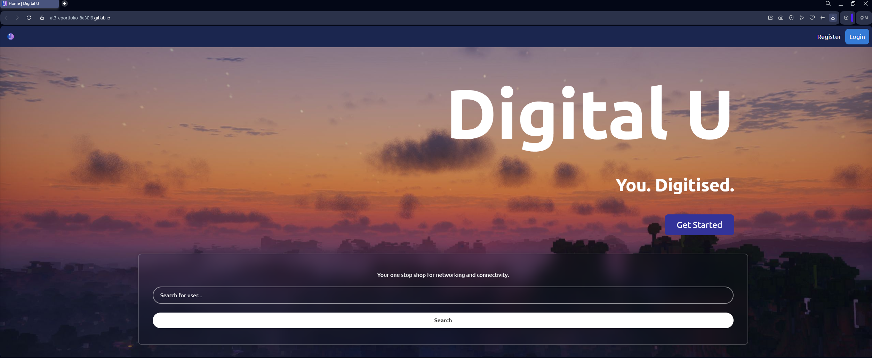
  - Firefox
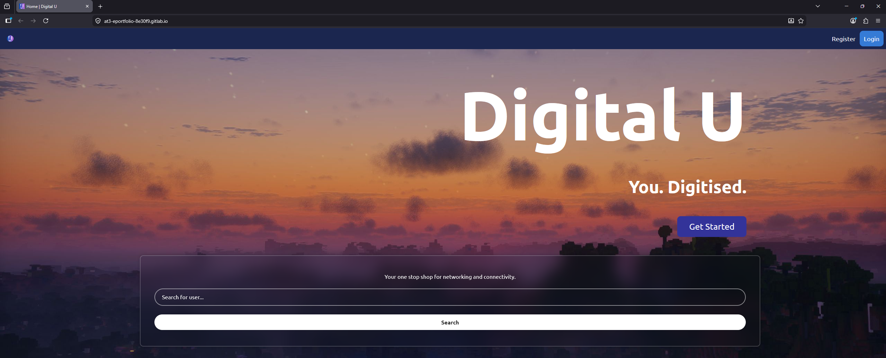
  - Edge
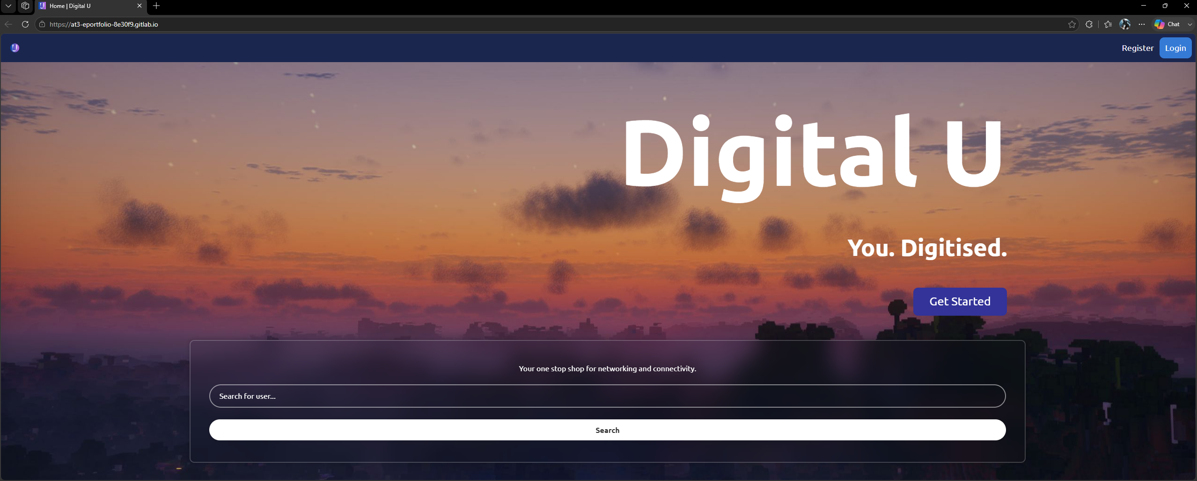

Lighthouse
Desktop Config:
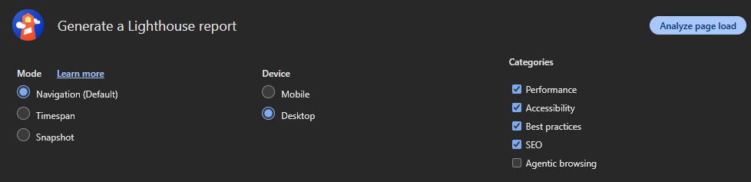

Result:

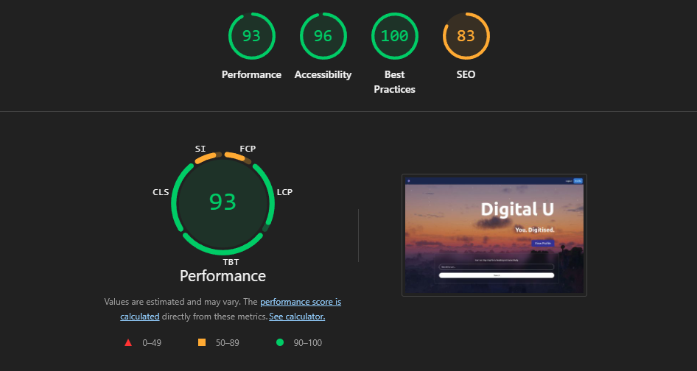
Mobile Config:
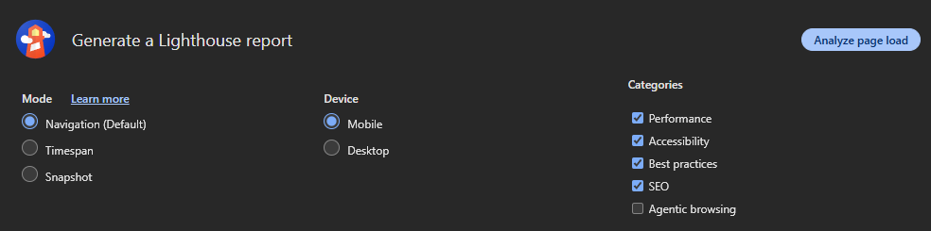
Result:
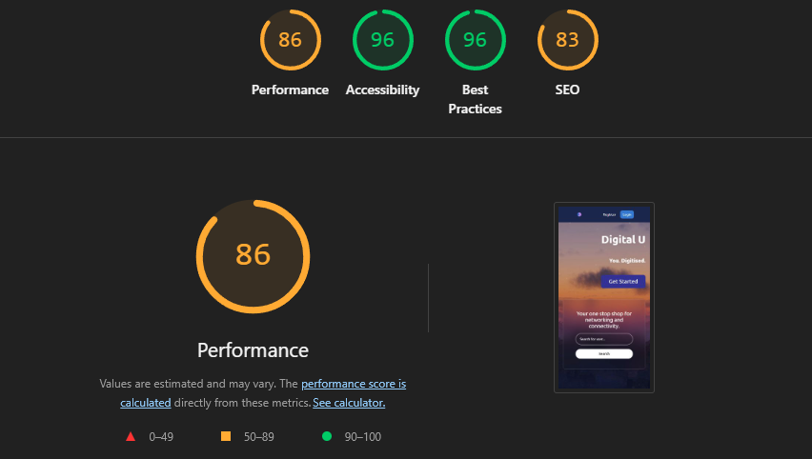

Security Testing
ZAP Results:
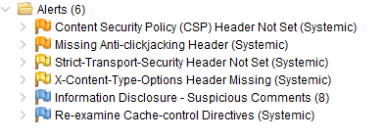

XSS
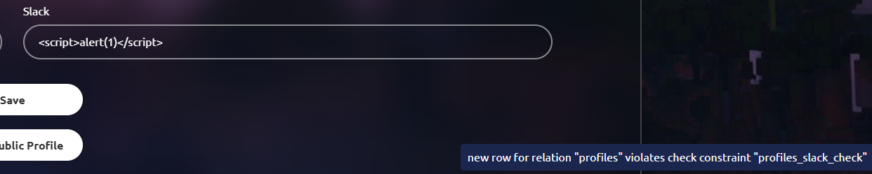

SQL Injection:
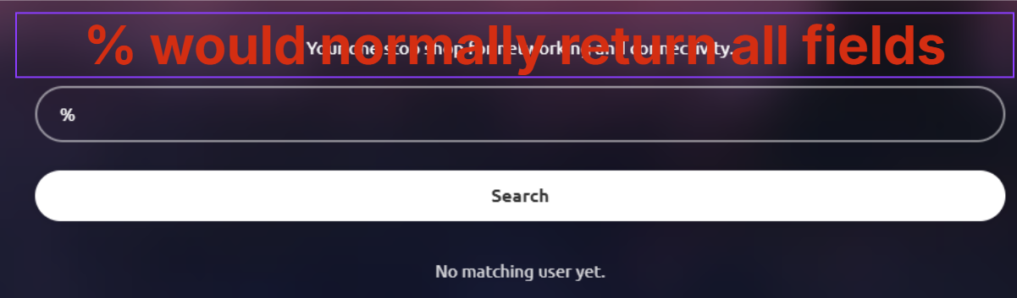

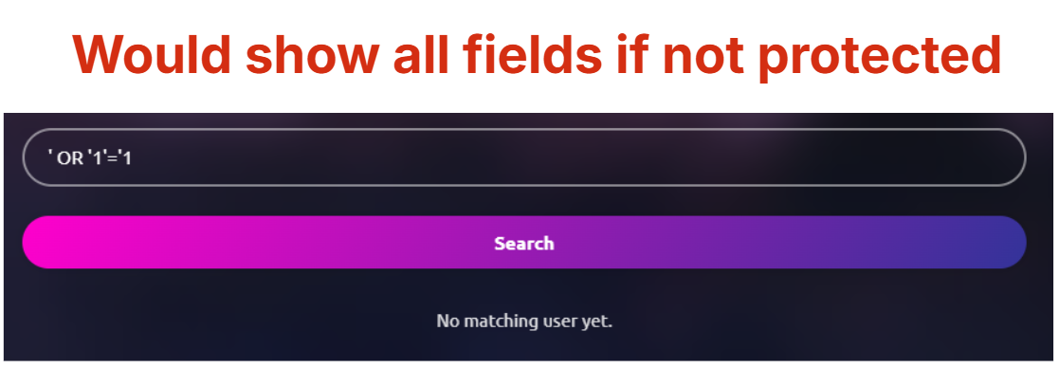
Test Navigation
Redirects:

Unknown Profile:
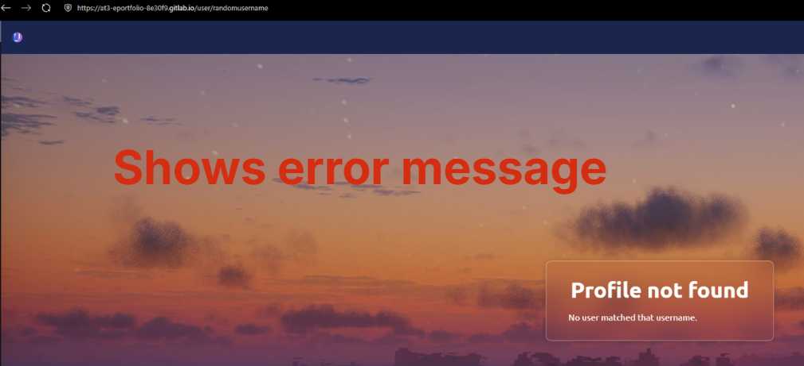

5. Bug Tracking & Fixing
Bug ID | Description | Severity (Low/Med/High) | Status (Open/Closed) | Fix Details
1 | When searching, it only does by username, instead of both display name and username | Medium | Closed | Added logic for searching by display name as well. Tested with a mock profile with username 'willim' and display name '12334'.
2 | The "Forgot Password?" link on the login page points to /forgot/, but there is no /forgot/ entry in the routes table in app.js (was removed long ago). The router's fallback silently sends the user to the home page instead of a password reset page, so the link appears broken to the user. | Medium | Closed | Removed the redundant link.
3 | The "View Public Profile" button on the profile page reads the username straight from the input box rather than from the saved record. If the user edits the username field and clicks the button without saving first, they are navigated to a profile that does not exist and see "Profile not found". | Low | Closed | Users will be navigated to the last saved profile.
4 | Using ‘%’ in the search field would show all the profiles, which presents a potential privacy risk. (‘%’ is a wildcard operator in SQL). | High | Closed | All special characters are now escaped

