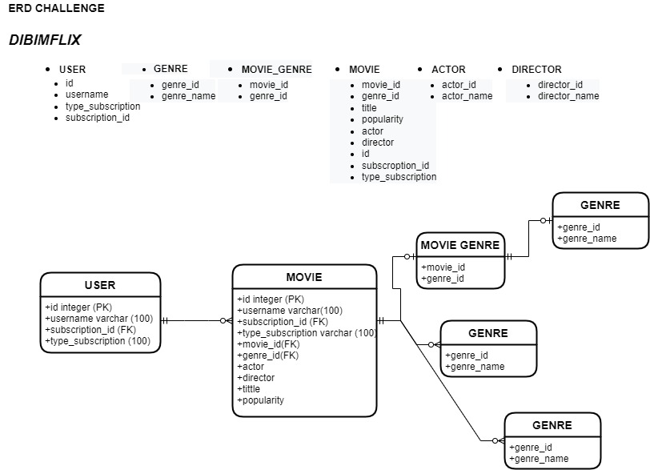

**Nama : Allan Wydianto**

**Kelas : FWD Batch 4**

**Github : https//github.com/w1shm3luck/mini-project**