CBDN Emergency Response App Testing Plan

Author: Diego Tomsig
Date: 03/11/2024

No. | Risk | Test Type | Test Procedure | Link
1 | Application does not work with Spanish characters. | Manual | Verify that a report can be created with Spanish characters and viewed with the search function. | Test 1
2 | Application doesn’t work generally for creating a new report. | Manual | Verify end-to-end that a new report can be created and all fields are stored in the report when accessed. | Test 2
3 | Application doesn’t work generally for amending an existing report | Manual | Verify end-to-end that a new report can be amended and all fields are stored in the report when accessed. | Test 3
4 | Application doesn’t allow for a new victim to be added in an existing report. | Manual | Verify that a new victim can be added in an existing report. | Test 4
5 | Application allows too much data to be entered into a data field which could cause database overload. | Manual | Attempt to overload a field with too much data. | Test 5
6 | Application search feature is not working correctly. | Manual | Verify several search strings match a specific report and verify that date filter works. | Test 6

Current Findings as of 03/11/2024:

- The “amend” report function appears to input data correctly from UI fields. However, it creates a new report. It does not replace the current report’s data. Verify if this is expected behavior or not (left for next group).

- Data fields appear to have no character limits. See Test 5.

Test 1

Procedure:

Verify that a report can be created with Spanish characters and viewed with the search function.

Result:

1. A new report was created with the Spanish character. The report was able to be searched.
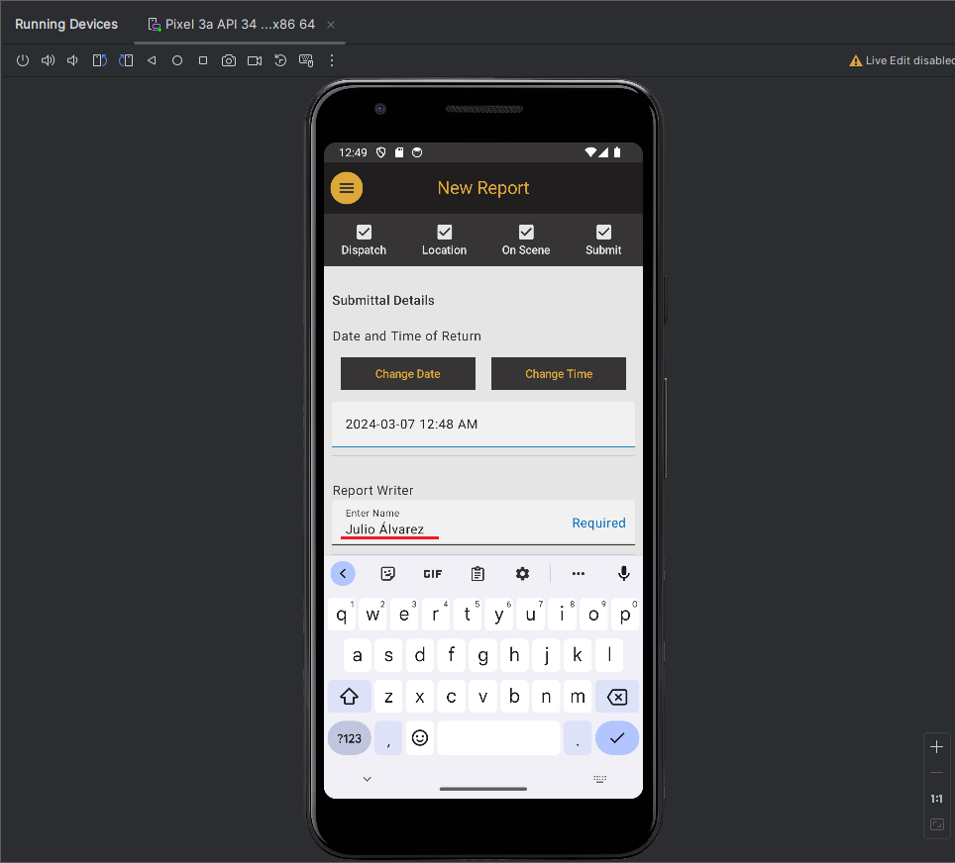Figure 1: Spanish name as report writer, Julio Álvarez, is able to be entered.

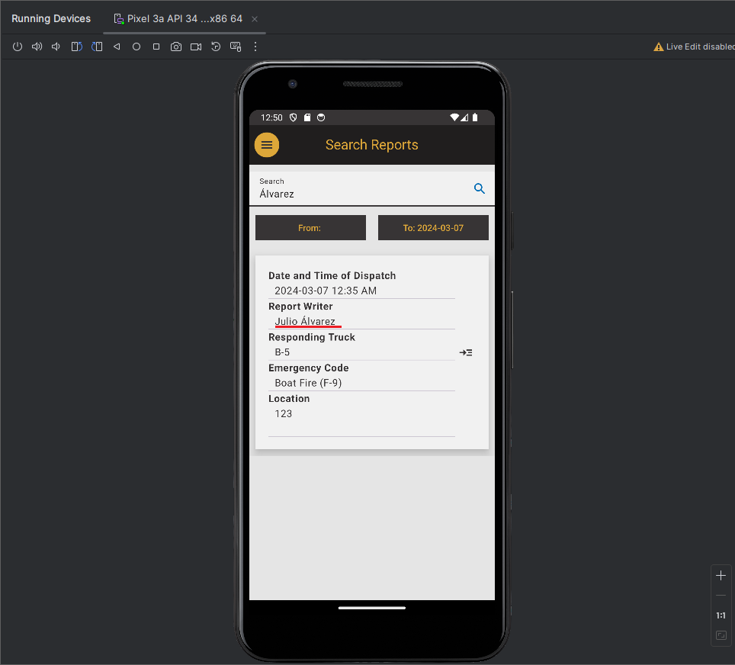Figure 2: When searching for “Álvarez”, the report created in Figure 1 is able to be accessed.

Test 2

Procedure:

Verify end-to-end that a new report can be created and all fields are stored in the report when accessed.

Result:

1. On the Dispatch screen, the following entries were made: Truck Id = “B-3”, Officer Name = “Officer Test, Dispatch Date = “2024-03-01”, Dispatch Time = “07:41 AM”, Emergency Code = “Rescue”, and Emergency Code ID = “Land Rescue (R-2)”.
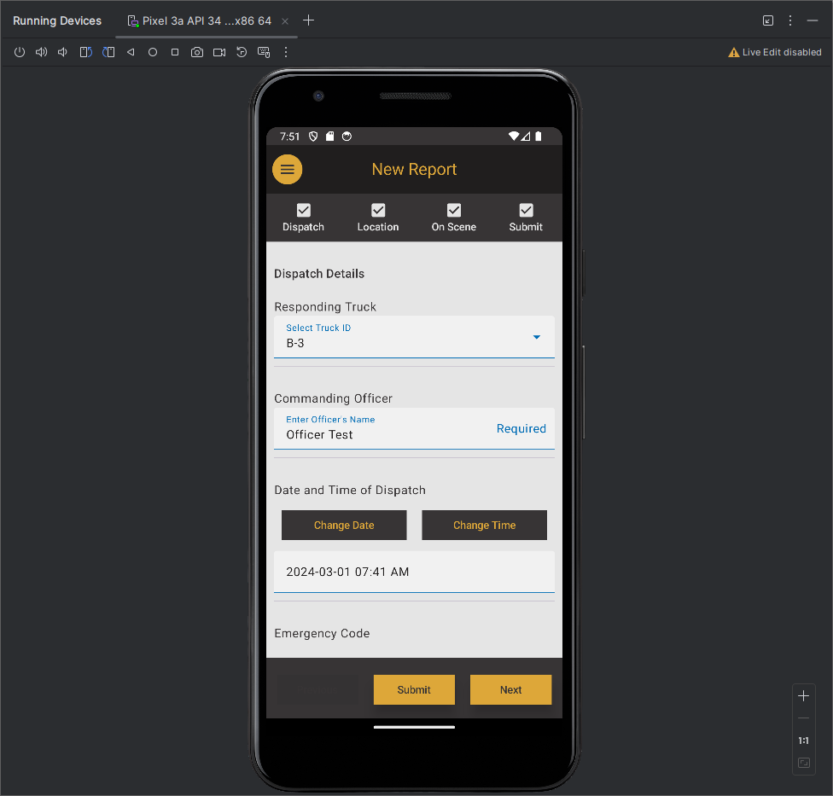Figure 3: Entries made to the dispatch screen for testing.

2. On the Location screen, the following entries were made: Location = “123 Street”.
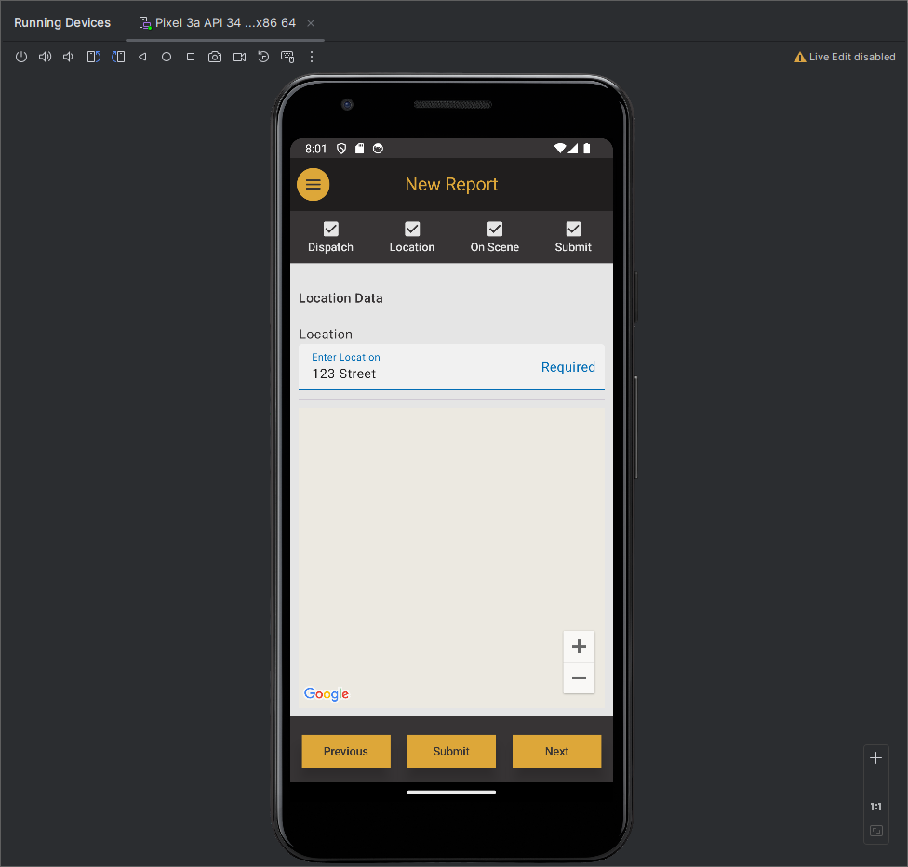 Figure 4: Entries made to the location screen for testing.

3. On the On Scene screen, the following entries were made: Status Code = “Person without physical damage (I-26)”, Name = “Victim”, Age = “26”, and Identification = “23”, Note = “a note”, Time of Arrival was set to “2024-03-01 07:44 AM”, Police Unit = “24”, Ambulance Unit = “26”, Electricity Company = “Robert’s Electric”, and Transit Police = “19”.
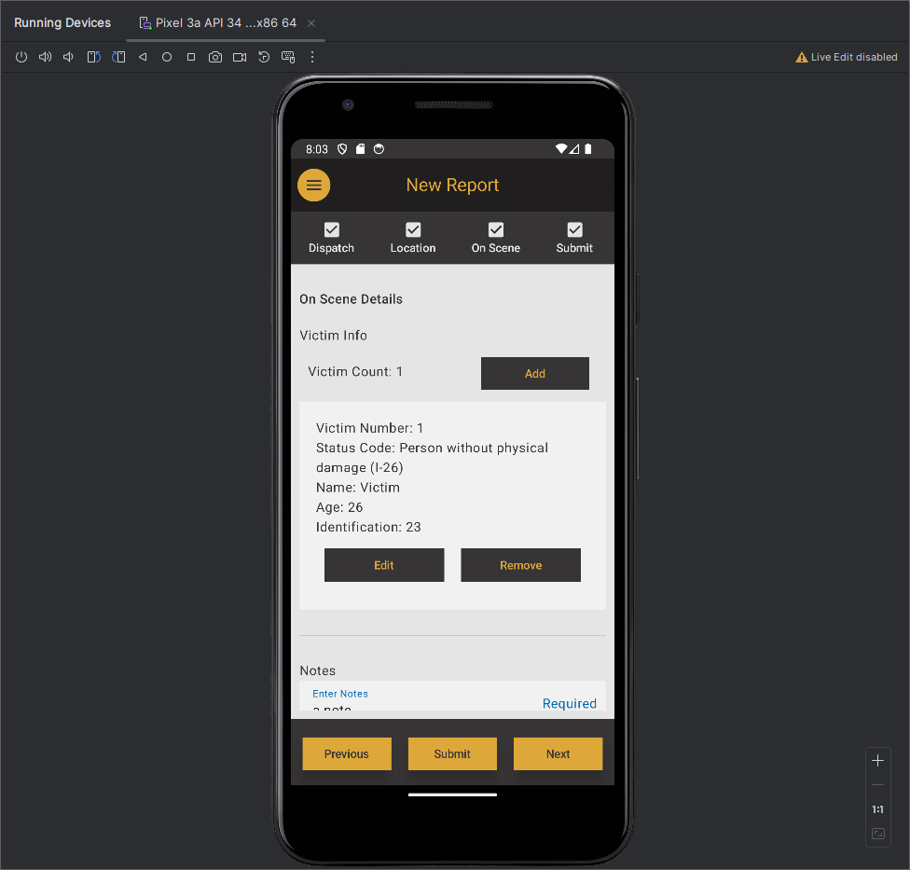Figure 5: Entries made to the on scene screen for testing.

4. On the Submit screen, the Date and Time of Return = “2024-03-01 11:48 AM” and Report Writer = “Julio Jones”. The submit button was pressed.
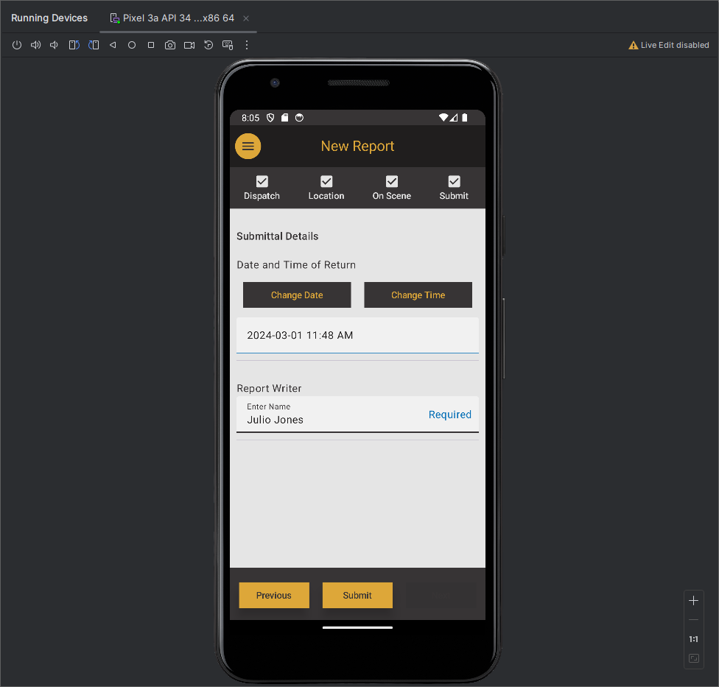Figure 6: Entries made to the submit screen for testing.

5. Observed the final report in the Search Reports window.
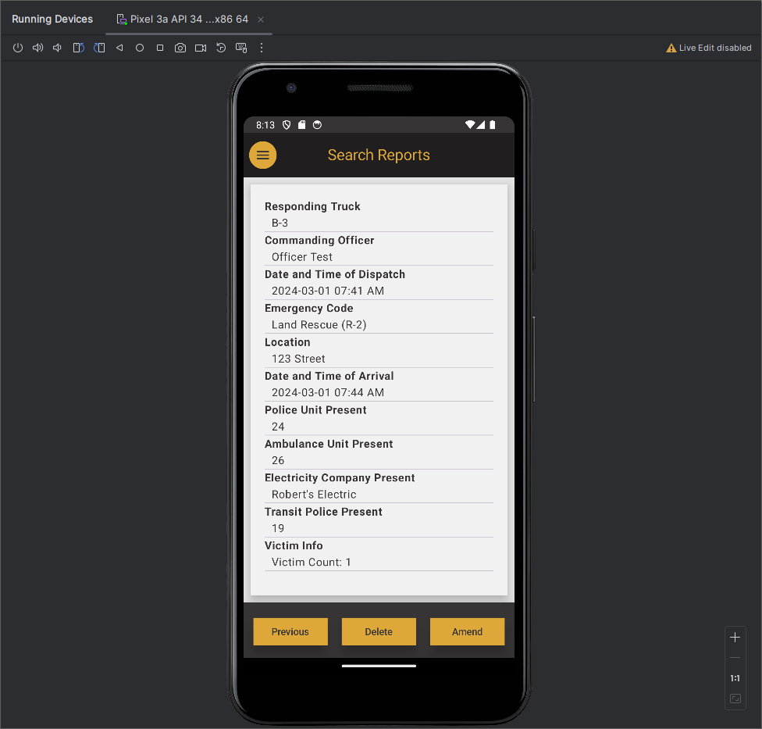Figure 7: Retrieved report after report was submitted.

A comparison was made between what was manually entered and what was viewed on the retrieved report. All of the fields passed.

Field | Entered Data | Retrieved Data | Result
Responding Truck | B-3 | B-3 | Pass
Commanding Officer | Officer Test | Officer Test | Pass
Date and Time of Dispatch | 2024-03-01 07:41 AM | 2024-03-01 07:41 AM | Pass
Emergency Code ID | Land Rescue (R-2) | Land Rescue (R-2) | Pass
Location | 123 Street | 123 Street | Pass
Date and Time of Arrival | 2024-03-01 07:44 AM | 2024-03-01 07:44 AM | Pass
Police Unit Present | 24 | 24 | Pass
Ambulance Unit Present | 26 | 26 | Pass
Electricity Company Present | Robert’s Electric | Robert’s Electric | Pass
Transit Police Present | 19 | 19 | Pass
Victim Count | 1 | 1 | Pass
Status Code | Person without physical damage (I-26) | Person without physical damage (I-26) | Pass
Name | Victim | Victim | Pass
Age | 26 | 26 | Pass
Identification | 23 | 23 | Pass
Notes | a note | a note | Pass
Date and Time of Return | 2024-03-01 11:48 AM | 2024-03-01 11:48 AM | Pass
Report Write | Julio Jones | Julio Jones | Pass

Test 3

1. After creating the report in Test 2, the “Amend feature” was pressed.
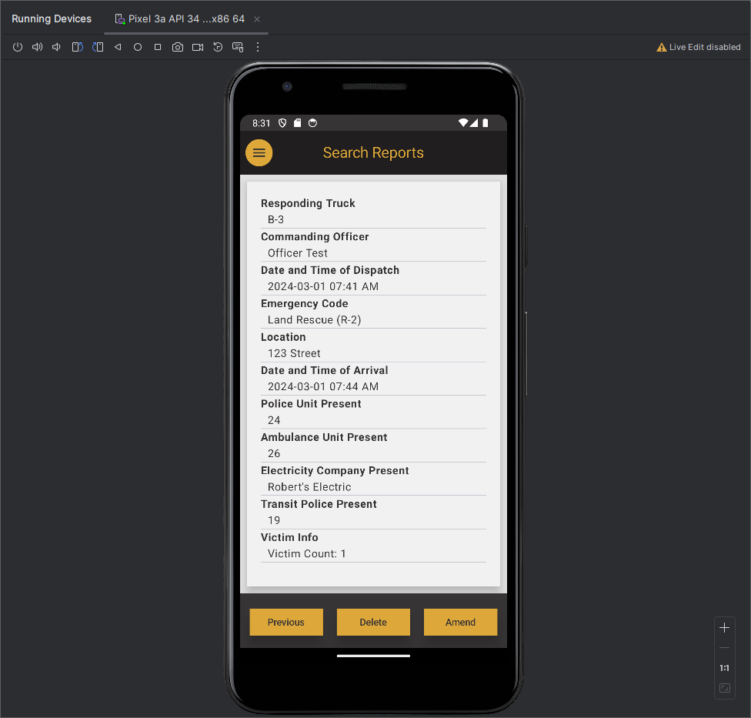Figure 8: Original report from Test 2 prior to being amended.

2. Data inside the report was amended. The report was accessed again.
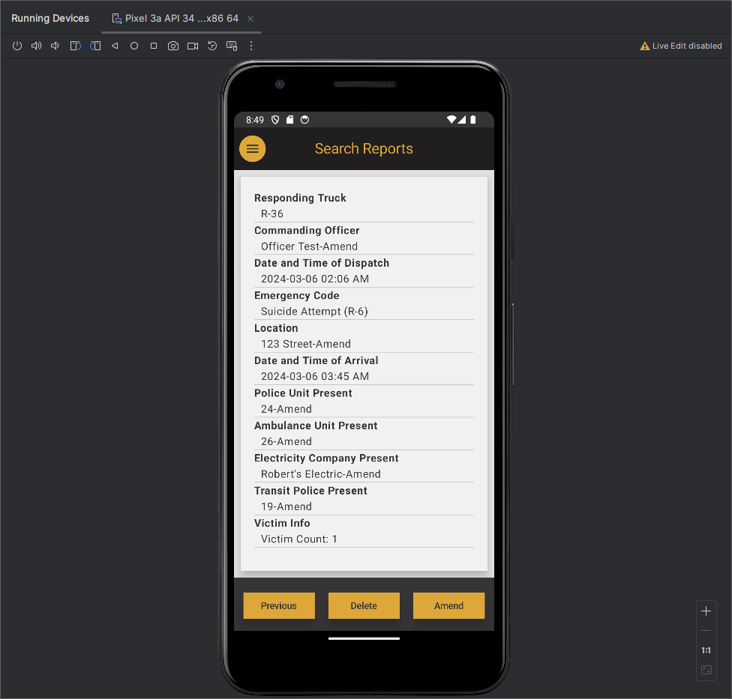Figure 9: The report after amendments were made.

A comparison was made between what was manually amended and what was viewed on the retrieved report. All of the fields passed.

Field | Amended Data | Retrieved Data | Result
Responding Truck | R-36 | R-36 | Pass
Commanding Officer | Officer Test-Amend | Officer Test-Amend | Pass
Date and Time of Dispatch | 2024-03-06 02:06 AM | 2024-03-06 02:06 AM | Pass
Emergency Code ID | Suicide Attempt (R-6) | Suicide Attempt (R-6) | Pass
Location | 123 Street-Amend | 123 Street-Amend | Pass
Date and Time of Arrival | 2024-03-06 03:45 AM | 2024-03-06 03:45AM | Pass
Police Unit Present | 24-Amend | 24-Amend | Pass
Ambulance Unit Present | 26-Amend | 26-Amend | Pass
Electricity Company Present | Robert’s Electric-Amend | Robert’s Electric-Amend | Pass
Transit Police Present | 19-Amend | 19-Amend | Pass
Victim Count | 1 | 1 | Pass
Status Code | Deceased Person (I-29) | Deceased Person (I-29) | Pass
Name | Victim-Amend | Victim-Amend | Pass
Age | 26-Amend | 26-Amend | Pass
Identification | 23-Amend | 23-Amend | Pass
Notes | a note-Amend | a note-Amend | Pass
Date and Time of Return | 2024-03-06 5:00 AM | 2024-03-061 5:00 AM | Pass
Report Write | Julio Jones-Amend | Julio Jones-Amend | Pass

Test 4

Procedure:

Verify that a new victim can be added in an existing report.

Result:

1. An existing report was amended. A new victim was added with Status Code = “Deceased Person (I-29)”, Name = “Sarah Yi”, Age = “35”, and identification = “13B”.
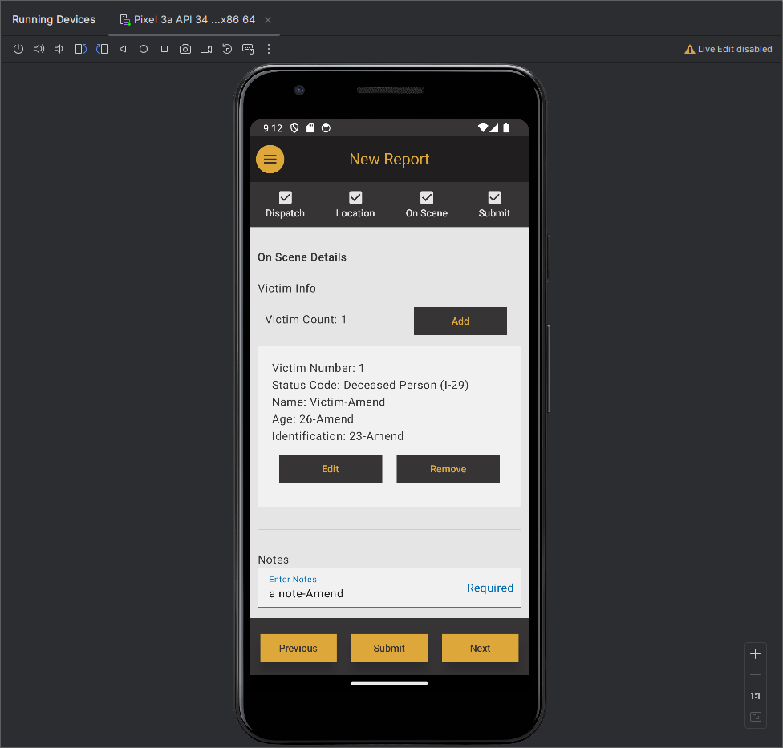Figure 10 – Add victim screen for an existing report.

2. The report contains a new victim with Status Code = “Deceased Person (I-29)”, Name = “Sarah Yi”, Age = “35”, and identification = “13B”.
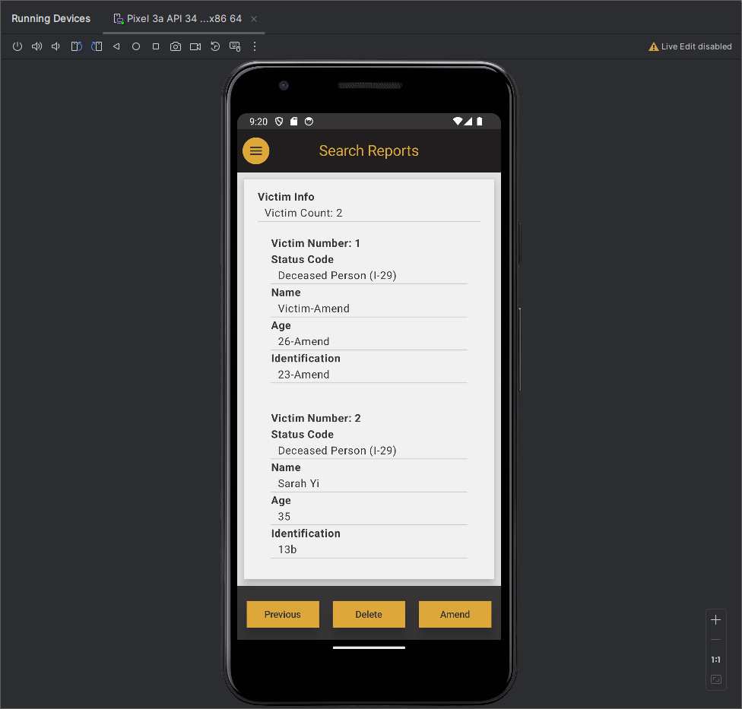Figure 11 – Amended report contains additional victim.

Test 5

Procedure:

Attempt to overload a field with too much data.

Result:

1. An existing report was amended. A string with at least 89,000 characters was placed into the Enter Notes field. The application stores the data. This is thought to be excessive and is a finding.
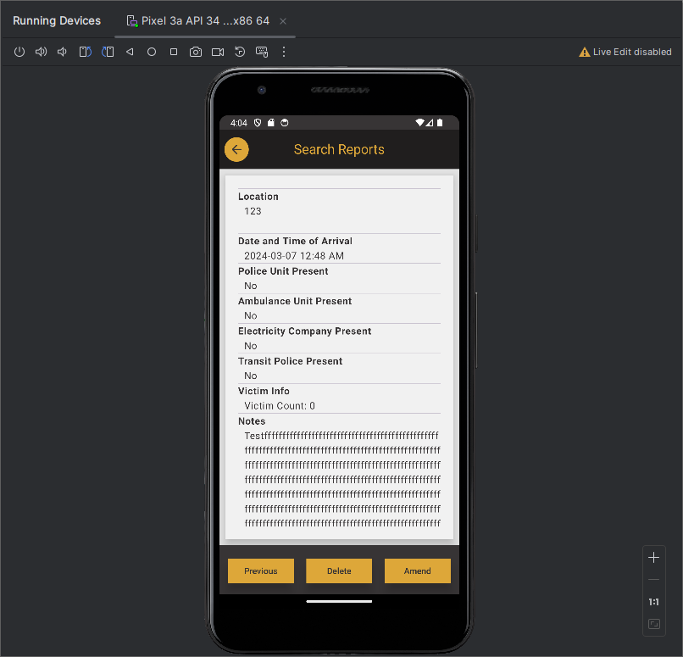Figure 12 – Report after “Enter Notes” was amended to contain a string at least 89,000 characters long

Test 6

Procedure:

Verify several search strings match a specific report and verify that date filter works.

Result:

1. On the Search Reports screen, several combinations were attempted. There was a report written by Joshua that was a target of the search. The search feature attempts to match four different fields including victim name, commanding officer, report writer, and location.
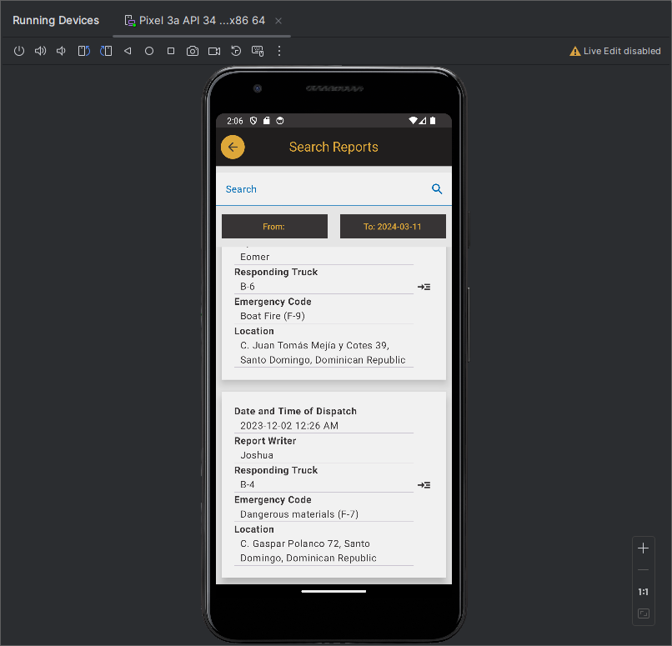Figure 13 – Report id gEPFT50ZqZuKdTdyduYW has a report writer of Joshua. It is the report that is tested in the table below

The following tests were performed on the search feature. The tests targeted the report with Report ID = “gEPFT50ZqZuKdTdyduYW”.

Search String | Date Range Begin | Date Range End | Test Desc | Test Result
joshua | 2024-01-01 | 2024-03-11 | Verify date filters exclude report. | Pass – Report was not pulled up
joshua | 2023-03-01 | 2024-03-11 | Verify case insensitive searches for Report Writer field. | Pass – Report was pulled up
Josh | 2023-03-01 | 2024-03-11 | Verify partial string can be matched for Report Writer field. | Pass – Report was pulled up
Josk | 2023-03-01 | 2024-03-11 | Verify typo does not match report for Report Writer field. | Pass – Report was not pulled up
frodo | 2023-03-01 | 2024-03-11 | Verify case insensitive searches for Victim Name field. | Pass – Report was pulled up
Fro | 2023-03-01 | 2024-03-11 | Verify partial string can be matched for Victim Name field. | Pass – Report was pulled up
Frp | 2023-03-01 | 2024-03-11 | Verify typo does not match report for Victim Name field. | Pass – Report was not pulled up
gandalf | 2023-03-01 | 2024-03-11 | Verify case insensitive searches for Commanding Officer field. | Pass – Report was pulled up
Gan | 2023-03-01 | 2024-03-11 | Verify partial string can be matched for Commanding Officer field. | Pass – Report was pulled up
Gat | 2023-03-01 | 2024-03-11 | Verify typo does not match report for Commanding Officer field. | Pass – Report was not pulled up
c. rafael | 2023-03-01 | 2024-03-11 | Verify case insensitive searches for Location field. | Pass – Report was pulled up
C. Raf | 2023-03-01 | 2024-03-11 | Verify partial string can be matched for Location field. | Pass – Report was pulled up
C. Rat | 2023-03-01 | 2024-03-11 | Verify typo does not match report for Location field. | Pass – Report was not pulled up

