**A04-ITAI 1378**

**Department of Science, Technology, Engineering & Math**

**Patricia Mcmanus**

Andre Ellis

Sha’Rise Griggs

Carlos Granillo

Olowatoyin Abolarin

Mike Huynh

Enrique Quintero

SLIDES OF PRESENTATION (Power point to Word)

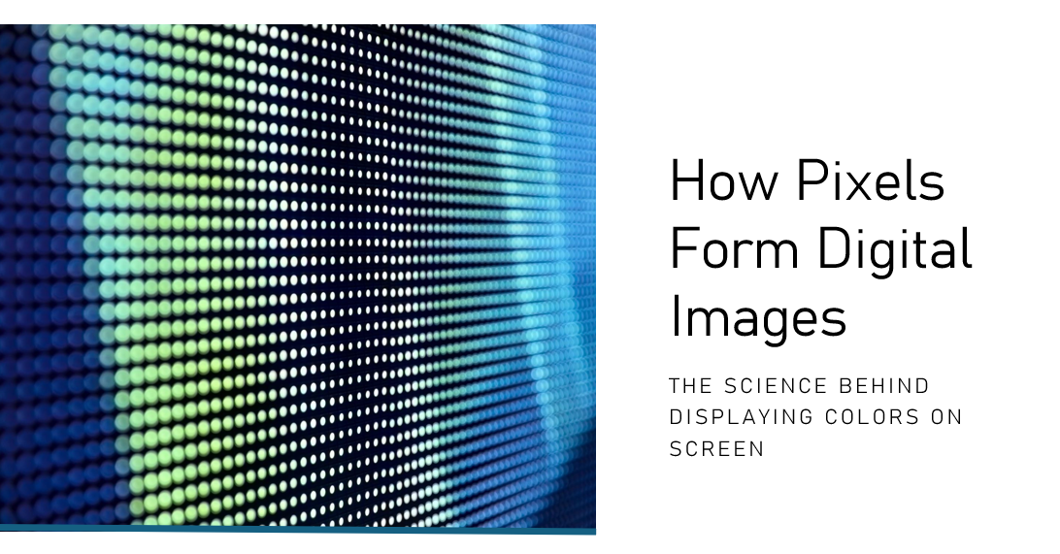

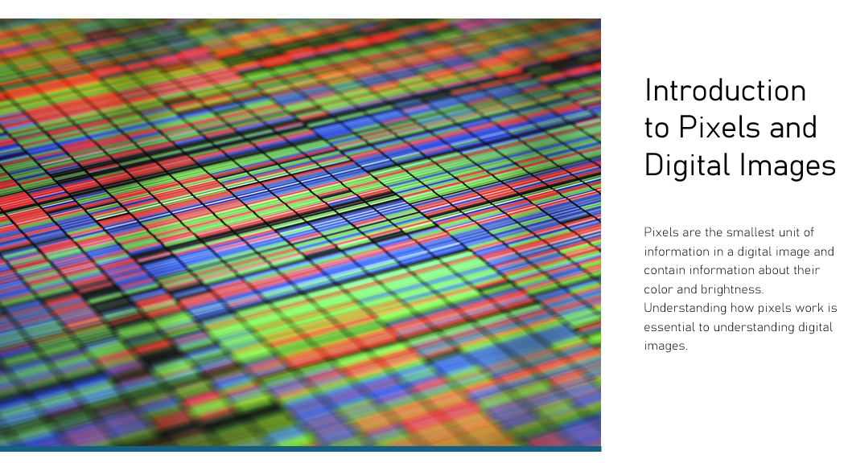

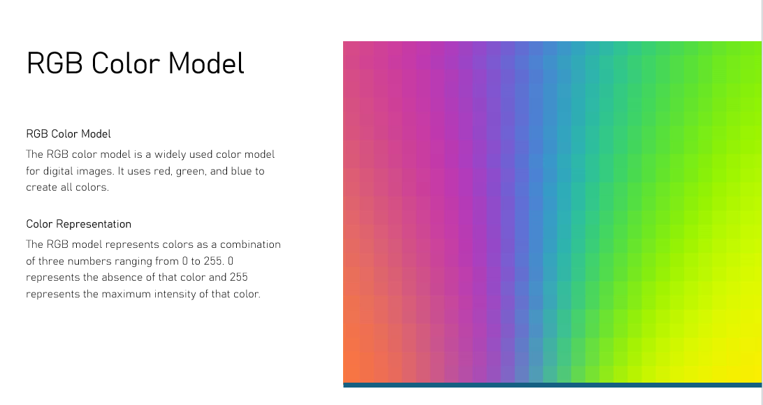

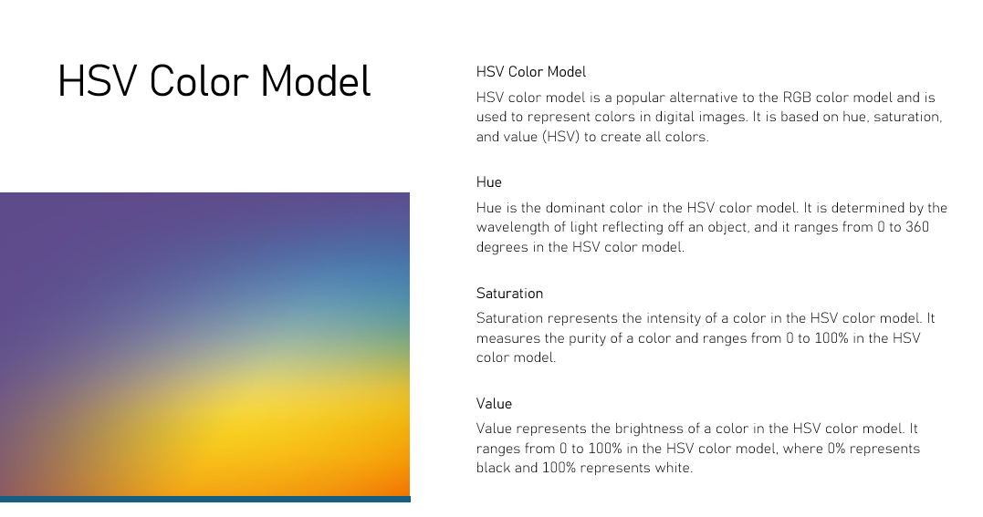

Comparation different types of files

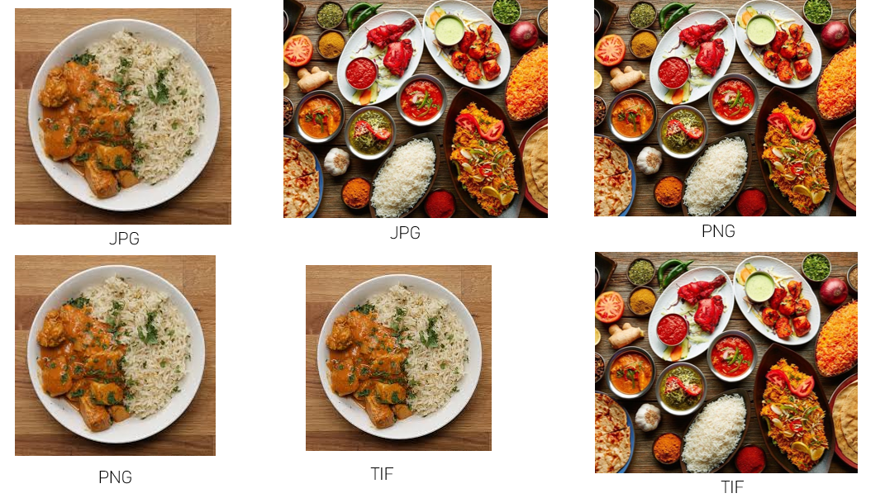

# Code for Course Compute Vision.!!! HCC Class!!!

from time import strftime

import cv2

import numpy as np

# Cargar una imagen en formato RGB

image_path = 'Images\Dishes01Jpg.jpg'  # Cambia esto a la ruta correcta

image_rgb = cv2.imread(image_path)

# Verificar si la imagen se carga correctamente

if image_rgb is None:

    print("Error: No se pudo cargar la imagen. Verifica la ruta.")

    exit()

# Mostrar la imagen original en RGB

cv2.imshow('Imagen Original (RGB)', image_rgb)

cv2.waitKey(0)

# Convertir la imagen de RGB a HSV

image_hsv = cv2.cvtColor(image_rgb, cv2.COLOR_BGR2HSV)

# Mostrar la imagen convertida en HSV

cv2.imshow('Imagen en HSV', image_hsv)

cv2.waitKey(0)

# Manipulación: Cambiar el valor de saturación

h, s, v = cv2.split(image_hsv)  # Separar los canales HSV

s += 50  # Aumentar la saturación (ajustar según sea necesario)

s = np.clip(s, 0, 255)  # Asegurarse de que los valores estén en el rango correcto

image_hsv = cv2.merge((h, s, v))  # Combinar los canales de nuevo

# Convertir de vuelta a RGB

image_rgb_modified = cv2.cvtColor(image_hsv, cv2.COLOR_HSV2BGR)

# Mostrar la imagen modificada

cv2.imshow('Imagen Modificada (RGB)', image_rgb_modified)

cv2.waitKey(0)

# Guardar la imagen modificada

new_time_str = strftime("%H%M")

cv2.imwrite('Images\imagenmod01' + new_time_str + '.jpg', image_rgb_modified)

# Cerrar todas las ventanas

cv2.destroyAllWindows()

Code used to create HSV and RGB images

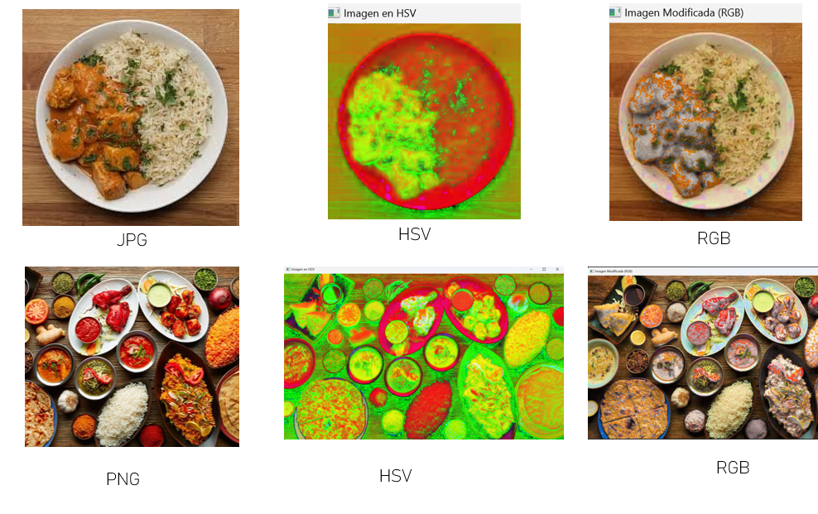

Pixelated World

By Andre Ellis

Throughout this assignment my knowledge was continuously being added onto and checked, I realized that the entirety of it all showed that every detail whether it be huge or minute was critical. The conceptualization and foundation of pixels in my opinion brings you to an almost occult like realm, this being because through the images that we see the computer/software sees it as lines of code essentially and those lines of code is what brings the image to us for viewing. Honestly from my perspective I feel that a majority of people just simply view something and not appreciate and or know the very details that may comprise an image (pixels). Pixels and understanding pixels helps give us an insight into exactly how the digital world we create is crafted and additionally how we apply it to our day to day lives. I didn't fully understand the difference at first between RGB and HSV and essentially I grasped the understanding that the difference between the two are two different color models that are implemented to present colors within the digital realm. RGB mixes blue, green and red in order to help create different colors. HSV represents colors in the term of a hue which means that it comes down to the organic nature and intensity of the color. Overall the emphasis I really got from this assignment was the fundamental concepts of pixels and the very intricate and complex nature that it brings along with it. RGB is what essentially the base is of color mixing while HSV can amplify the product in a very profound and unique way for us all to be able to apply and work with. I know that with time and more practical application from myself my knowledge will only become more deepend do to the clinical experience that I will gain from doing various things within the digital world

**September 19, 2024**

By Sha’Rise Griggs

In this project, I explored the creation of digital images from pixels and examined color models like RGB and HSV. Beginning with the basics, I learned that pixels are the smallest units of an image, combining to form the visuals displayed on screens. Zooming into images revealed how each pixel, with its unique color, contributes to the overall picture, making the concept of pixels more tangible.

While looking deeper into color models, I enhanced my understanding of the RGB model, which blends these three colors to produce a wide spectrum of hues. This model is fundamental in display technologies and understanding it has deepened my appreciation for color rendering on screens. The HSV model also intrigued me, as it offers an intuitive approach to color perception, breaking it down into hue (the type of color), saturation (the intensity of the color), and value (the brightness or darkness of the color). This insight has simplified tasks like color adjustment in image editing.

A significant challenge I encountered was managing file paths in OpenCV. Initially, I struggled to load images due to incorrect file path settings. OpenCV requires precise specifications for image file locations, and my initial misconfigurations led to program errors. Through research and trial and error, I learned the importance of exact file paths and how to adjust the program to access files correctly, depending on their storage location. Overcoming this obstacle was frustrating but ultimately rewarding, as it underscored the critical role of file path management in programming.

From a programming perspective, I engaged with Python libraries such as OpenCV to manipulate and visualize images. The capabilities of these tools were very overwhelming. However, by displaying images and handling more complex operations, including zooming into pixel regions and converting color models, I built confidence and enhanced my understanding.

In summary, this project not only deepened my comprehension of digital image construction and color models but also emphasized the importance of attention to detail in programming, particularly regarding file paths. The challenges I faced and overcame have equipped me with practical skills and a more profound understanding of both the technical and l aspects of digital imaging.

By: Carlos Granillo

While working on this assignment, I was able to gain a better understanding of exactly how pixels transform into digital images. This is because pixels work as building blocks for digital images and they work together to form pictures. I was also able to learn more about how all the different visual images are made up of many different color models like RGB and HSV. In addition, my knowledge and understanding of pixels, digital images, and color models were on a beginners level because I was able to learn a lot that I didn’t know about throughout this assignment.

One of the things that mostly surprised me was when I learned that pixels are what make up all types of digital images and that without them it wouldn’t be possible for an image to even be clear. All images are made up of millions of tiny rectangles that are known as pixels and those pixels work together to make sure that the image doesn’t look blurry or pixelated. It is very important to understand this because if an image is enlarged more pixels will be needed or the image will not be as clear as it was before.

With this assignment, I also learned more about the RGB color model and how it is used to create all the different colors that are needed for images. I was also able to find out that the RGB color model is primarily used for televisions, computers, phones and video games. There are many ways that it can be used and one of the best things is that you can always adjust the absence or intensity of the colors and they may range from 0 (absent) to 255 (most intensity).

The HSV (Hue, Saturation, Value) color model relates more to how we humans see and understand colors. This is because it is solely based on Hue (type of color), Saturation (intensity of color) and Value (Brightness of a color) in an image. In addition, the HSV color model is mostly used when editing images and can completely change the way we see an image by increasing or decreasing the amount of each one depending on what wants to be done.

In conclusion I was able to understand the importance of Pixels, RGB and HSV as well as I could and I can now work on trying to implement them myself when necessary in the future.

By: Khanh Huynh

Throughout this experience, I developed a solid understanding of not just how pixels represent digital images, but how visual images composed of pixels are created by different color models (such as RGB and HSV). My initial view of digital images was on a basic level; however, I now appreciate the depth related to how an image is generated and ultimately represented.

One of my key "aha" moments came when I learned that pixels are the base units of digital images. Each and every image displayed on a screen is composed of thousands or millions of rectangles, and each represents specific colors. Although an image can appear smooth and continuous from a distance, zooming in on the image shows that it is just a combination of individual pixels. This made me realize how important it is for each pixel to generate the image as an entity. After seeing how pixels are used, I understood how these small building blocks represent very complex visuals, such as photographs or digital art. I also learned about two common color models used to represent images rasterized from camera systems, RGB and HSV. The RGB (Red Green Blue) color model I had some experience with, but I have a much better understanding of how the primary colors work as unique colors and combine to create the many colors observed on a screen. Each RGB pixel operates based on values of red, green, and blue; thus, by changing their stated brightness, the combination of colors varies in millions of shades. Clearly this color model is the industry standard used in all display technologies on laptops, monitors and televisions, and I now understand how it uses RGB color combinations to display futuristic colors.

The HSV (Hue, Saturation, Value) color model represents color relationships more aligned with human perception. Rather than blend colors together by primary colors, the HSV color relations use properties such as hue (the type of color), saturation (how intense a hue of color appears), and value (how bright or dark a color appears). This model is frequently found as selection of color used in tools for editing images, due to the model separating colors from intensity of the hue. Studying HSV has greatly expanded my understanding of how different models can represent the same image for different purposes. Along the way, I have also learned how to manipulate and visualize these same concepts through programming with Python libraries like OpenCV and Matplotlib. With these libraries, I have been able to load images into the programming environment, zoom in on pixel areas, and convert images from one color model to another. Working with the libraries was at times challenging, but at the same time, I found them to be incredibly powerful. OpenCV served as the tool for many of the image processes, while Matplotlib provided an easy platform for visualizing my concepts. Manipulating and working with these images provided me with a more practical and deeper understanding of the pure coding concepts and pixels and the color data attached to pixels.

By: Enrique Quintero

In my opition this assigment was import for many reasons. one is reflexion about as person and machines uses the same information. But processing of different ways the information.

This assignment was exciting. Because we need understood details about of image, for example kind of file, formats. other important thing was differences between format RGB and HSV where HSV is more used by machines and process of images.

Once we made the code it was easier to understand the differences. We used cv2 to manipulate the images and compare the result between them.

In conclusion, pixels, contours and other important aspects can be used for the benefit of data manipulation, algorithms obtain the best features to be used in new computer vision models.