Khanh Huynh

ITAI 1378

Prof. Patricia McManus

9/26/2024

L05

1. Reflection on Learning

* Describe your understanding of the SVM algorithm and its application in image classification.

A Support Vector Machines (SVM) is a supervised machine learning algorithm that can be used for classification or regression problems, but it is most commonly used for classification. A SVM tries to find a hyperplane (decision boundary) that best separates the data into two different classes. In binary classification problems, that hyperplane maximizes the margin between the two classes.

For the image classification problem, SVM can be used by first converting the image into numerical form, such as by flattening image pixel values. The SVM then tries to find the hyperplane that best separates the different classes, such as a cat vs a dog. Tackling multi-class classification problems, such as CIFAR-10 (10 classes), SVM uses either a one-vs-all mode or one-vs-one mode to classify the images.

For image classification, SVM will perform well, establishing whether the data is linearly separable. There are also techniques to improve SVM accredit performance by implementing the kernel trick that efficiently handles non-linear data.

* Reflect on the data preparation steps, model training, and evaluation process.

It is essential to understand, the data preparation steps are fundamental to implement an effective model. With the CIFAR-10 dataset, once the dataset has been loaded, it is helpful to visualize a few images to get a sense of how complex and varied the image dataset is. By converting the image to grayscale, we can reduce the dimensionality of the image dataset, which reduces the problem into one color channel instead of three. We also need to flatten these images into vector form so that it is easier for the SVM to process.

Once we split the dataset, the training and test evaluation dataset will ensure that the model is objectively evaluated using unseen data. The SVM training procedure involves providing the SVM classifier with the flattened grayscale images. The SVM classifier uses the training input to learn how to find a decision boundary that governs the image classes.

In the evaluation procedures, the model will go into the testing dataset and predictions will be made. By comparing these predictions against the true label, we can evaluate the simple metric accuracy, which is a useful way to understand if the model is performing well. Visualizing a few predictions gives us a sense of how well the model performs finished saved images in conjunction with the true labels. This can expose the areas the model does well and struggles well to better define improvements to implement to the model.

* Discuss challenges faced, how you addressed them, and insights from the model's performance.

When utilizing an SVM on the CIFAR-10 dataset, there are many challenges related to high-dimensional data, the nature of features in an image, and multi-class classification. While the process of converting to grayscale and flattening an image helps reduce the dimensionality, there is still enough information in an individual image that separating classes effectively will be challenging for the SVM to do.

An additional challenge with SVM is that it will misclassify the data due to sensitivity to non-linearity. Using the kernel trick (i.e., radial basis function kernel, RBF kernel) resolves this problem by providing the model with a non-linear decision boundary where the data can be mapped into a higher dimensional space where the data is linearly separated

1. Responses to Lab Questions:A screenshot of a computer program

   Description automatically generated

(Image Classification with CIFAR-10 Dataset)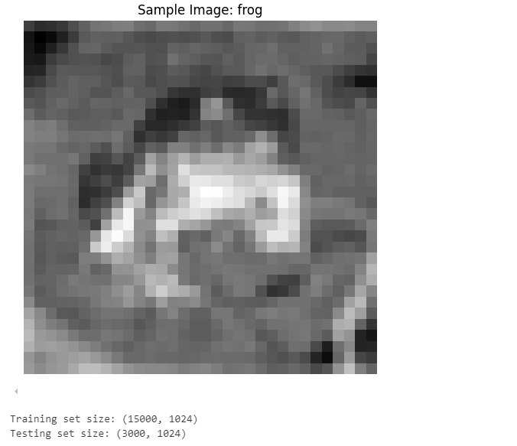

The lab illustrates the utility of model evaluation for assessing model accuracy as a first step but also encourages further exploration and insights with an attempt to visualize prediction output or results. Such efforts may provide evidence of model quality, or bias or a harder time distinguishing between classes, which may elicit the question of how well the model fits the problem, and if there are any alternative models (e.g., deep learning) that would perform better.

1. 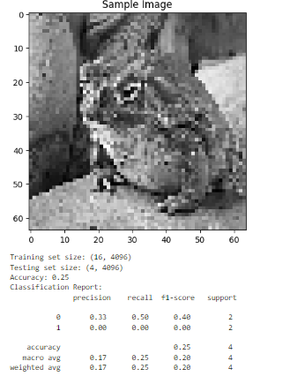A screenshot of a computer code

   Description automatically generatedA computer screen shot of a code

   Description automatically generatedInclusion of Visual

