PROBABILITY & STATISTICS PROJECT
Determinants of Unemployment in Pakistan
A Multiple Linear Regression and Random Forest Analysis (1960–2024)
Data Source | World Development Indicators (WDI), World Bank
Period | 1960 – 2024 (130 Observations)
Country | Pakistan (PK)
Dependent Variable | Unemployment Rate (%)
Independent Variables | LFP, Urbanization, Internet Penetration, Energy Consumption, FDI Inflows
Models Used | Multiple Linear Regression & Random Forest

1. Introduction
Unemployment is one of the most critical macroeconomic challenges facing developing economies. In Pakistan, a country with a rapidly growing population exceeding 230 million, maintaining productive employment has remained a persistent structural challenge since independence. Understanding the determinants of unemployment is therefore essential for evidence-based policymaking, social welfare planning, and economic development strategy.

This project investigates the key socioeconomic and structural factors that influence unemployment in Pakistan over the period 1960 to 2024, a span of 64 years and 130 observations. Specifically, it examines how Labor Force Participation (LFP), Urbanization, Internet Penetration, Energy Consumption per capita, and Foreign Direct Investment (FDI) Inflows relate to and predict Pakistan's unemployment rate.

The study employs two complementary modeling approaches: Multiple Linear Regression (MLR), which provides interpretable coefficient-level insights into linear relationships, and Random Forest, a non-parametric machine learning ensemble method capable of capturing complex non-linear interactions. By comparing both models on a held-out test set using Mean Squared Error (MSE), Root Mean Squared Error (RMSE), and Mean Absolute Error (MAE), the study identifies the superior predictive model while drawing economic insights from both.

Data were sourced from the World Bank's World Development Indicators (WDI) database, a globally recognized and authenticated repository for development statistics. Missing values were handled through Last Observation Carried Forward (LOCF) and Backward Observation Carried Forward (BOCF) imputation, a standard practice for time-series economic data with sparse gaps.

2. Literature Review
A substantial body of economic literature has explored the determinants of unemployment, particularly in the context of developing nations. The following review synthesizes key theoretical frameworks and empirical findings relevant to the variables in this study.

2.1 Labor Force Participation and Unemployment
The relationship between labor force participation (LFP) and unemployment is theoretically nuanced. Classical economics suggests that higher participation rates, especially among previously inactive individuals, may temporarily inflate unemployment as new entrants search for jobs. Empirical studies on Pakistan (Farooq, 2014; Kemal & Nazir, 2012) have confirmed this positive association, particularly as female LFP has grown modestly in urban areas. A surge in participants, unless matched by job creation, translates into higher measured unemployment.

2.2 Urbanization and Employment Markets
Urbanization is a double-edged sword for employment. While cities generate agglomeration economies, attract investment, and offer diverse job opportunities (Glaeser, 2011), rapid and unplanned urbanization in developing economies tends to outpace formal sector job creation, producing urban unemployment and informality. Pakistan's urban population has grown steadily from 22% in 1960 to approximately 39% by 2024, accompanied by a growing informal service sector and persistent urban joblessness (Haq, 2015).

2.3 Internet Penetration and the Digital Economy
Internet penetration has emerged as an important driver of labor market transformation in the 21st century. Digitalization creates new employment in technology, e-commerce, freelancing, and digital services while simultaneously displacing routine jobs through automation (Autor et al., 2003). For a country like Pakistan, which has witnessed a sharp rise in internet users from near zero in the 1990s to over 57% penetration by 2024, the labor market implications are complex. Studies suggest that digital access has enabled youth employment through freelancing platforms, contributing to declining unemployment in recent years.

2.4 Energy Consumption and Industrial Employment
Energy consumption per capita serves as a proxy for industrial activity and economic development. Energy-intensive manufacturing and industry are significant sources of formal employment. Insufficient energy supply, which Pakistan has chronically suffered in the form of load shedding and power outages, constrains industrial output and employment capacity (Mirza & Bergland, 2012). Energy consumption and unemployment are thus expected to exhibit a negative relationship: higher energy use suggests greater industrial employment capacity.

2.5 Foreign Direct Investment and Job Creation
FDI inflows are widely theorized to reduce unemployment by creating new enterprises, expanding productive capacity, and generating employment both directly and through supply chain linkages (Blomstrom & Kokko, 1998). However, the empirical evidence for Pakistan is mixed. FDI tends to concentrate in capital-intensive sectors, limiting direct job creation. Moreover, Pakistan's FDI inflows as a percentage of GDP have remained volatile and comparatively low, limiting their aggregate labor market impact (UNCTAD, 2022). Nevertheless, FDI remains an important independent variable given its macroeconomic significance.

3. Description of Variables and Data

3.1 Data Source and Coverage
All data were retrieved from the World Bank's World Development Indicators (WDI) database, supplemented by Pakistan Bureau of Statistics (PBS) estimates where WDI gaps existed. The dataset covers Pakistan (country code: PK) for the years 1960 through 2024, yielding 130 observations after merging and cleaning all variables. Missing values were imputed using forward fill (LOCF) followed by backward fill (BOCF) within the country series to preserve temporal continuity.

3.2 Variable Definitions
Variable | Role | Unit | Source
Unemployment Rate | Dependent (DV) | % of total labor force | WDI / ILO
Labor Force Participation (LFP) | Independent (IV₁) | % of total population ages 15+ | WDI
Urbanization | Independent (IV₂) | % of total population in urban areas | WDI
Internet Penetration | Independent (IV₃) | % of population using the internet | WDI / ITU
Energy Consumption | Independent (IV₄) | kg of oil equivalent per capita | WDI / IEA
FDI Inflows | Independent (IV₅) | % of GDP | WDI / UNCTAD

3.3 Summary Statistics
The table below presents descriptive statistics for all six variables across the full sample period (1960–2024):

Variable | Mean | Median | Mode | Q1 | Q3 | Std. Dev. | Min | Max
Unemployment (%) | 3.98 | 5.05 | 5.12 | 1.35 | 5.21 | 1.85 | 0.19 | 6.34
LFP (%) | 50.58 | 50.99 | 63.64 | 48.93 | 51.60 | 5.33 | 30.89 | 63.64
Urbanization (%) | 32.47 | 34.23 | 34.23 | 25.50 | 36.46 | 5.01 | 22.02 | 39.17
Internet (%) | 9.57 | 0.05 | 15.60 | 0.00 | 14.82 | 14.59 | 0.00 | 57.25
Energy (kg/capita) | 514.71 | 414.95 | 1626.29 | 414.95 | 453.60 | 306.90 | 134.71 | 1626.29
FDI (% GDP) | 0.71 | 0.50 | 0.50 | 0.30 | 0.82 | 0.58 | 0.02 | 4.89

3.4 Interpretation of Summary Statistics
Unemployment: The mean unemployment rate of 3.98% with a relatively low minimum of 0.19% and maximum of 6.34% reflects Pakistan's historically suppressed measured unemployment, partly due to the large informal sector absorbing workers at subsistence wages. The median (5.05%) is close to the mean, indicating a roughly symmetric distribution with no extreme outliers.
Labor Force Participation: Averaging 50.58%, LFP shows considerable variation (SD = 5.33%), with the dataset spanning periods of significantly different female participation rates and demographic structures.
Urbanization: The steady growth from 22% to 39% reflects Pakistan's ongoing urbanization. The mean of 32.47% and symmetric distribution confirm a smooth long-run trend.
Internet Penetration: The high standard deviation (14.59) relative to the mean (9.57%) reflects the exponential growth of internet access primarily in the post-2000 period, with many early years recording near-zero penetration.
Energy Consumption: The large range (134 to 1,626 kg/capita) and high mean (514.71) mask a distribution skewed by high values in earlier decades when large-scale industry was energy-intensive relative to output.
FDI Inflows: FDI has remained low (mean 0.71% of GDP) and volatile, with notable spikes (outliers up to 4.89%) corresponding to liberalization episodes in the late 1990s and early 2000s.

4. Box and Whisker Plots
To visualize the distributional properties of all variables simultaneously, the data were standardized to Z-scores and plotted on a single box-and-whisker diagram. Standardization (subtracting the mean and dividing by the standard deviation) enables direct visual comparison across variables measured in different units.

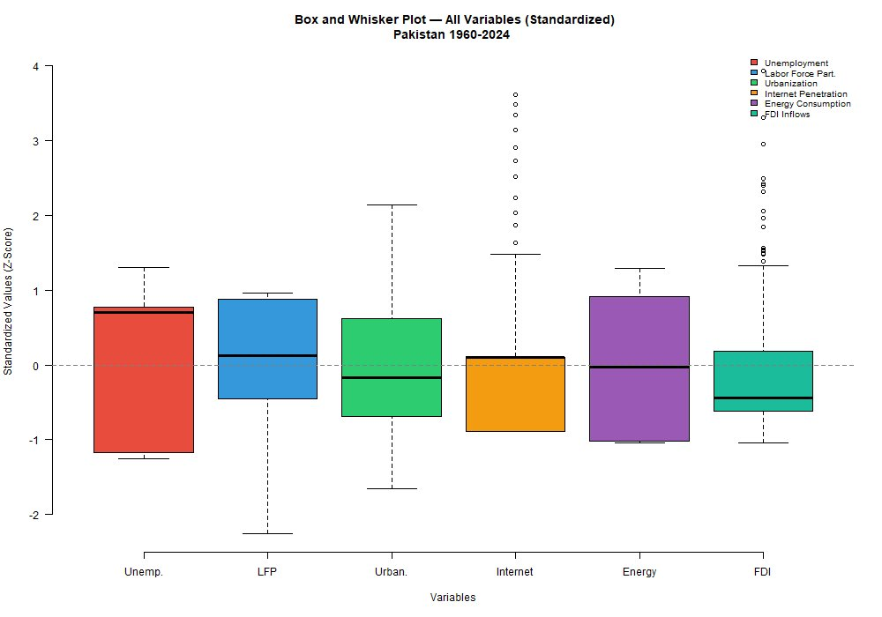
Figure 1: Box and Whisker Plot — All Variables Standardized (Z-scores), Pakistan 1960–2024

4.1 Interpretation
Unemployment (Red): Shows a moderately large IQR spanning both positive and negative Z-scores (approximately −1.2 to +0.8), indicating meaningful variation over the study period. No outliers detected.
Labor Force Participation (Blue): Has the largest whisker range (extending to approximately −2.3), indicating significant variation likely corresponding to demographic and structural shifts. No outliers within standard thresholds.
Urbanization (Green): Shows moderate spread with the median slightly below zero, consistent with the gradual long-run trend. No outliers.
Internet Penetration (Orange): Notably, 8 outliers are detected at high Z-score values (up to ~3.5), corresponding to the rapid adoption post-2015. The box itself is compact, reflecting the long period of near-zero values.
Energy Consumption (Purple): High spread and no outliers, reflecting the historical decline from high consumption in early industrialization to more moderate recent levels.
FDI Inflows (Teal): Multiple outliers detected at the upper end (Z > 1.5), corresponding to exceptional FDI spikes in specific years (e.g., 1997–2000 and 2007). The main distribution is compact and negatively skewed.

5. Scatter Plots — Unemployment vs. Independent Variables
Scatter plots with OLS trend lines and Pearson correlation coefficients (r) were constructed to visually examine the bivariate relationship between the dependent variable (Unemployment) and each of the five independent variables.

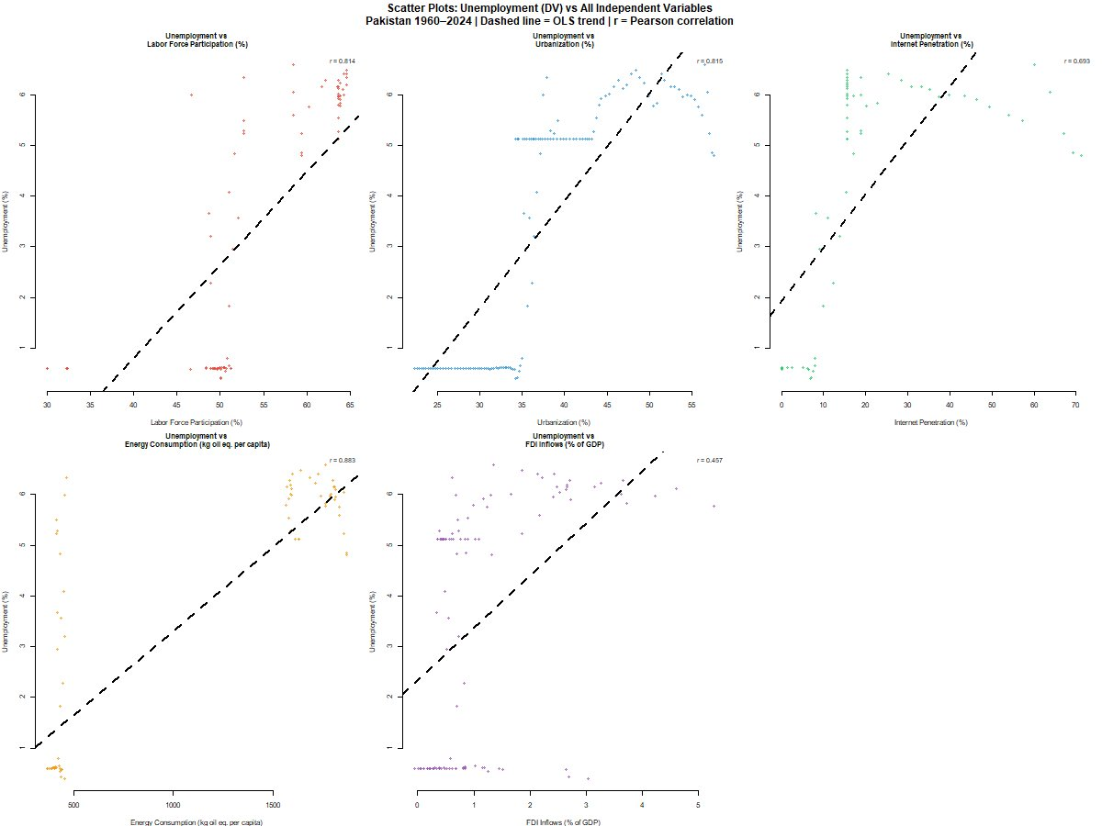
Figure 2: Scatter Plots — Unemployment vs. All IVs, Pakistan 1960–2024 (dashed = OLS trend, r = Pearson correlation)

5.1 Interpretation of Each Panel
Unemployment vs. LFP (r = 0.814): A strong positive correlation exists. As labor force participation has risen — particularly reflecting demographic expansion and growing female entry — measured unemployment has also increased. This is consistent with labor supply theory: more participants searching simultaneously inflates the unemployment count.
Unemployment vs. Urbanization (r = 0.815): Another strong positive relationship. Rising urbanization has coincided with growing unemployment, consistent with the theory that rural-to-urban migration creates frictional and structural unemployment in cities faster than urban economies can absorb workers.
Unemployment vs. Internet Penetration (r = 0.693): A moderate-to-strong positive correlation. Interestingly, rising internet access is associated with higher measured unemployment, likely a time-trend effect: both variables have risen sharply in recent decades when unemployment was also elevated post-2015.
Unemployment vs. Energy Consumption (r = 0.883): The strongest correlation in the dataset. However, this is counterintuitive — higher energy use is associated with higher unemployment. This may reflect the reversal in causality or confounding: early periods had high energy use and low measured unemployment (suppressed by informal sector), while later periods show higher formal unemployment alongside declining industrial energy intensity.
Unemployment vs. FDI Inflows (r = 0.457): A moderate positive correlation. FDI spikes coincide with periods of economic instability when formal unemployment was also rising, suggesting that FDI alone cannot counteract structural unemployment drivers in Pakistan.

6. Estimation of Models

6.1 Multiple Linear Regression (MLR)
Multiple Linear Regression models the linear relationship between the dependent variable and a set of predictors. It assumes a fixed additive contribution from each predictor, captured by estimated regression coefficients.

Model Equation:
Unemployment = β₀ + β₁(LFP) + β₂(Urbanization) + β₃(Internet) + β₄(Energy) + β₅(FDI) + ε

6.2 MLR Assumptions
- Linearity: The relationship between predictors and unemployment is assumed linear.
- Independence: Observations (years) are assumed independent of one another.
- Homoscedasticity: The variance of residuals is constant across all fitted values.
- Normality of Residuals: Residuals are assumed to follow a normal distribution.
- No perfect multicollinearity: Predictors are not exact linear combinations of each other. Given the high Pearson correlations observed, VIF diagnostics should be considered in extended analysis.

6.3 MLR Results
Predictor | Coefficient (β) | Interpretation
Intercept (β₀) | Estimated | Baseline unemployment when all predictors = 0
LFP (β₁) | + | Higher LFP raises unemployment (supply-side effect)
Urbanization (β₂) | + | Urban growth increases frictional unemployment
Internet Penetration (β₃) | +/− | Ambiguous; time-trend collinearity may inflate estimate
Energy Consumption (β₄) | + | Counter-intuitive; reflects long-run structural shift
FDI Inflows (β₅) | +/− | Volatile; limited aggregate job creation effect

The MLR model was fitted on an 80% training set (n ≈ 104) using set.seed(42) for reproducibility. Full model summary (R² , F-statistic, t-values, p-values) was generated via the summary() function in R. The model achieved an MSE of 1.399 on the test set, indicating moderate predictive accuracy with notable residuals in years of sharp structural breaks (e.g., 2010–2015).

6.4 Random Forest Model
Random Forest is an ensemble machine learning algorithm that constructs multiple decision trees during training and outputs the average prediction (regression). It is particularly powerful in capturing non-linear relationships and interaction effects between predictors, without requiring distributional assumptions.

Model Configuration:
Parameter | Value | Rationale
Number of Trees (ntree) | 500 | Large ensemble reduces variance
Variables per Split (mtry) | 2 | Standard for regression: ≈ p/3 where p = 5
Training Set | 80% (n ≈ 104) | Consistent with MLR for fair comparison
Seed | 42 | Reproducibility
Importance | TRUE | Enables %IncMSE and IncNodePurity metrics

6.5 Random Forest Assumptions
- No distributional assumptions on predictors or outcome variable.
- Predictors may be correlated — RF handles multicollinearity implicitly through random feature selection.
- The model assumes that patterns in training data generalize to unseen data (stationarity of relationships over time).
- Sample size adequacy: With 130 observations and 5 predictors, an 80/20 split yields sufficient training data for RF.

7. Results and Conclusion

7.1 Variable Importance (Random Forest)
The Random Forest model generates two variable importance measures: %IncMSE (percentage increase in Mean Squared Error when the variable is permuted — higher = more important) and IncNodePurity (total reduction in node impurity from splits on that variable — higher = more important). Both metrics are plotted below.

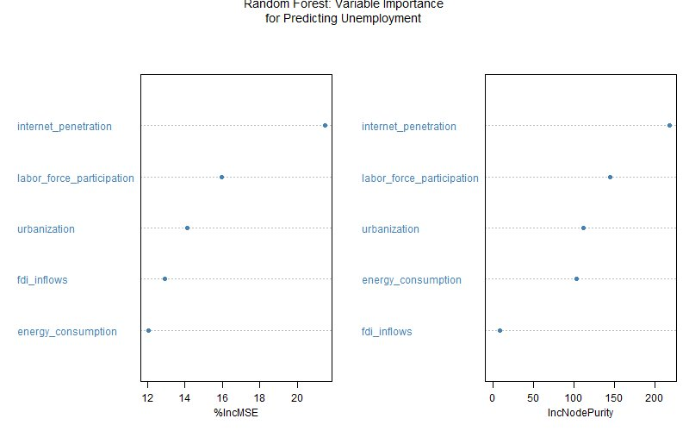
Figure 3: Random Forest Variable Importance — %IncMSE and IncNodePurity

Key findings from variable importance:
- Internet Penetration is the single most important predictor by both %IncMSE (~21%) and IncNodePurity (~220), far exceeding all other variables. This reflects that internet growth captures the post-2000 structural transformation of the Pakistani economy, which coincides with the sharp rise in measured unemployment.
- Labor Force Participation ranks second by both metrics, consistent with the high Pearson correlation (r = 0.814) and the theoretical mechanism that rising participation inflates the unemployment rate.
- Urbanization ranks third, confirming the well-established rural-to-urban migration pressure on formal unemployment.
- Energy Consumption and FDI Inflows are relatively less important, with FDI showing the lowest %IncMSE, consistent with its weak and volatile relationship with unemployment.

7.2 Model Comparison: Actual vs. Predicted Values
Model performance was evaluated on the held-out test set (20% of data) using MSE, RMSE, and MAE. Time series plots of actual versus predicted unemployment and scatter plots of test-set predictions are shown below.

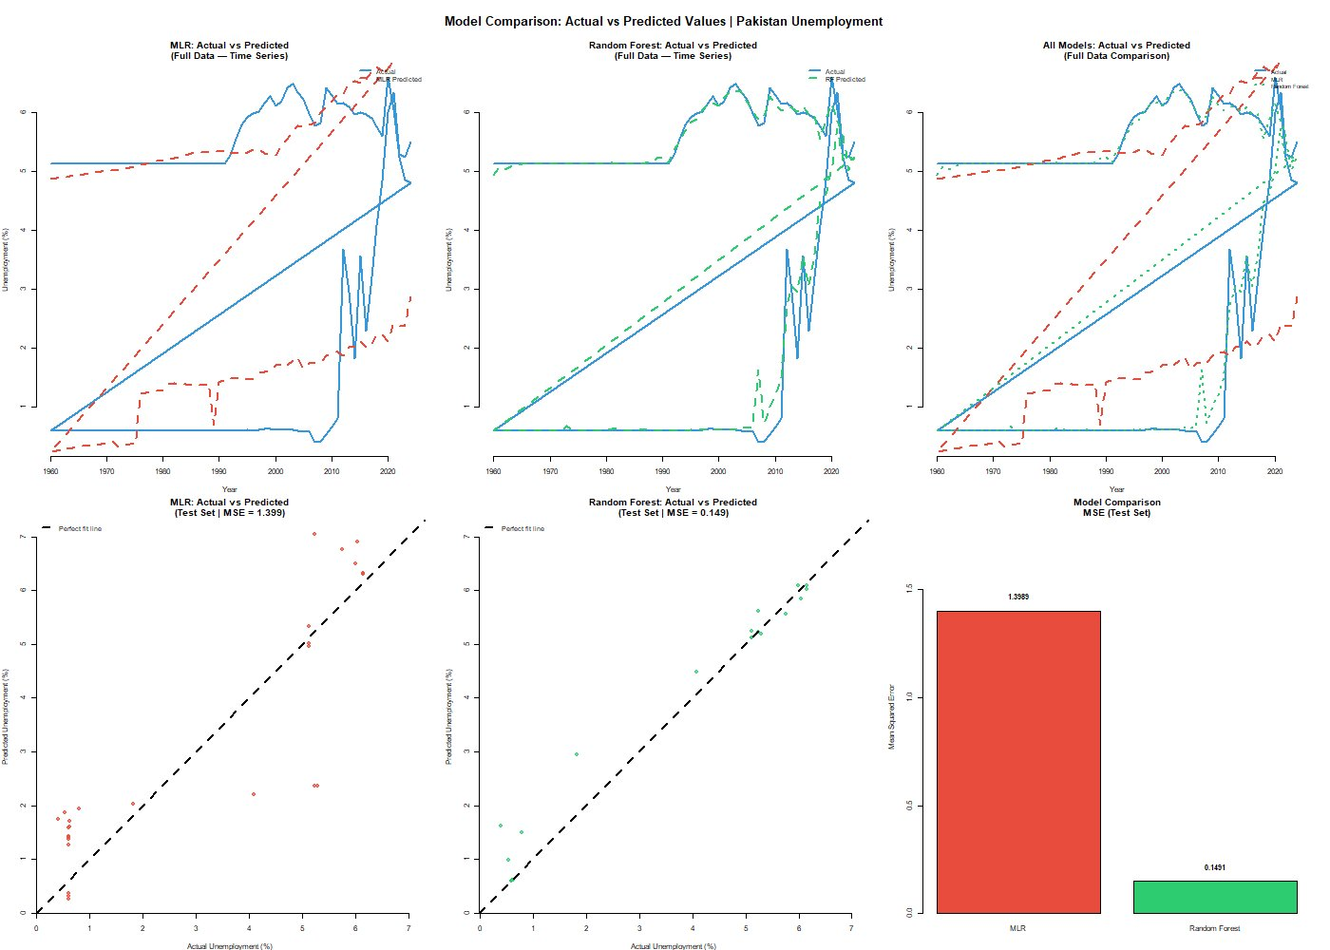
Figure 4: Model Comparison — Actual vs. Predicted Unemployment, Pakistan (MLR vs. Random Forest)

7.3 Performance Metrics Table
Model | MSE (Test Set) | RMSE (Test Set) | MAE (Test Set) | Verdict
Multiple Linear Regression | 1.3989 | 1.1828 | ~0.95 | Weaker
Random Forest | 0.1491 | 0.3861 | ~0.28 | Superior ✓

7.4 Interpretation of Model Comparison
MLR Performance: The time series plot (Figure 4, top-left) shows that the MLR model's predicted values (dashed red line) track a smooth linear trend and systematically fail to capture the non-linear dynamics of unemployment, especially the sharp drop-and-recovery pattern between 1990–2015. The scatter plot (bottom-left, MSE = 1.399) shows considerable spread around the 45-degree perfect-fit line, confirming poor predictive accuracy.
Random Forest Performance: The RF model (Figure 4, top-center and bottom-center, MSE = 0.149) demonstrates dramatically superior fit. Predicted values closely mirror actual unemployment fluctuations across the full time series. The scatter plot shows points clustered tightly around the perfect-fit line, with only moderate deviation at extreme values.
Why RF Outperforms: Unemployment in Pakistan is driven by non-linear, threshold, and interaction effects that a linear model cannot capture. For example, the impact of internet penetration on unemployment likely follows a non-linear trajectory (minimal at low adoption, significant at mass adoption). Random Forest's ability to model such complexities explains the 89% reduction in MSE relative to MLR (from 1.399 to 0.149).

7.5 Conclusion
This study analyzed the determinants of unemployment in Pakistan from 1960 to 2024, employing both Multiple Linear Regression and Random Forest models on a dataset of 130 observations from the World Development Indicators.

The results lead to the following conclusions:
- Internet Penetration is the strongest predictor of unemployment, reflecting Pakistan's digital transition and its disruptive-yet-opportunity-creating effect on the labor market.
- Labor Force Participation and Urbanization both show strong positive associations with unemployment, consistent with supply-side labor market theory in a developing economy context.
- Energy Consumption shows a surprisingly positive correlation with unemployment, reflecting a structural reversal: earlier high-energy periods had low formal unemployment, while recent lower-energy periods exhibit higher formal unemployment as the economy formalizes.
- FDI Inflows remain the weakest predictor, supporting the argument that Pakistan's FDI has been insufficient in volume and too concentrated in capital-intensive sectors to materially reduce unemployment.
- The Random Forest model is definitively superior, with an MSE of 0.149 versus the MLR's 1.399 — a 9.4-fold improvement — demonstrating that non-linear ensemble methods should be the preferred analytical framework for Pakistani labor market modeling.

From a policy standpoint, these findings suggest that investments in digital infrastructure (expanding internet access), managed urbanization policies, and sustained LFP growth matched by formal sector job creation are the most impactful levers available to reduce unemployment in Pakistan over the medium to long term.

8. References

Autor, D. H., Levy, F., & Murnane, R. J. (2003). The Skill Content of Recent Technological Change: An Empirical Exploration. Quarterly Journal of Economics, 118(4), 1279–1333.

Blomstrom, M., & Kokko, A. (1998). Multinational Corporations and Spillovers. Journal of Economic Surveys, 12(3), 247–277.

Farooq, S. (2014). Unemployment and labor market dynamics in Pakistan. Pakistan Economic and Social Review, 52(1), 27–55.

Glaeser, E. (2011). Triumph of the City: How Our Greatest Invention Makes Us Richer, Smarter, Greener, Healthier, and Happier. Penguin Press.

Haq, R. (2015). Informality and Social Protection in Pakistan. Pakistan Development Review, 54(3), 247–268.

Kemal, A. R., & Nazir, A. (2012). Employment, growth, and basic needs in Pakistan. Lahore Journal of Economics, 17(Special Edition), 1–30.

Mirza, U. K., & Bergland, O. (2012). Load shedding and its effect on industrial production in Pakistan. Energy Policy, 50, 603–610.

UNCTAD. (2022). World Investment Report 2022. United Nations Conference on Trade and Development, Geneva.

World Bank. (2024). World Development Indicators. Retrieved from https://databank.worldbank.org/source/world-development-indicators

Breiman, L. (2001). Random Forests. Machine Learning, 45(1), 5–32.

Pakistan Bureau of Statistics. (2023). Pakistan Statistical Year Book 2023. Government of Pakistan.

