环境搭建准备:确保centos能够正常访问外网
#查看ip:ip addr (若新建虚似机,没网络则)
cd /etc/sysconfig/network-scripts下vi ifcfg-ens33 修改ONBOOT=yes
Sudo service network restart
# rzsz安装
yum -y install lrzsz
yum install zip unzip

================apache服务安装(按装完后开启apache即可)==================
1 #一般安装服务/工具可以通过rpm -qa | grep xx命令查看
Yum - y install httpd
#启动Apache服务
Systemctl start httpd
#设置Apache服务开机启动
Systemctl enable httpd
#查看Apache服务状态(running:表示正在运行中)
Systemctl status httpd
#重启或关闭Apache服务
Systemctl restart httpd
Systemctl stop httpd
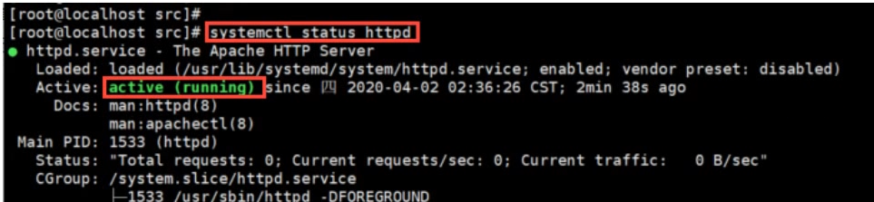
2 #Apache处于running状态验证Apache服务器
#2.1下直查看防火墙是否允许开启80端口
firewall-cmd --zone=public --query-port=80/tcp
#2.2查看防火墙状态,默认是running
systemctl status firewalld
Firewall-cmd --state
#2.3添加开启80端口
firewall-cmd --zone=public --add-port=80/tcp --permanent
命令含意:--zone#用用域,--add-port=80/tcp#添加端口,格式为:端口/通讯协议,--permanent #永久生效,没有此参数重启后失效
2.4 修改后重新加载下防火墙
firewall-cmd --reload
2.4 临时关闭SELinux安全模块,重启服务器失效
setenforce 0
2.5 永久关闭SELinux安全模块
Vi /etc/selinux/conifg #修改文件中的 SELINUX=disabled
2.6 打开浏览器输入cenots的Ip地址能否打开默认apache服务
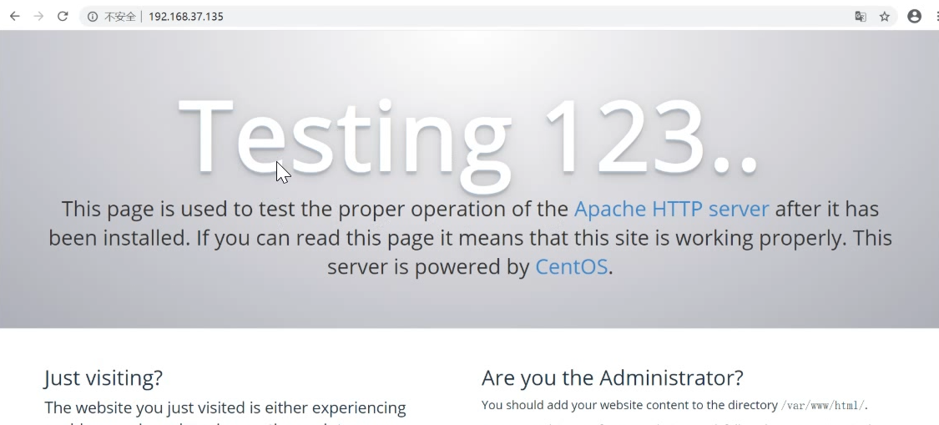

=============================安装PHP语言==================================
#1 配置yum源,例如版本7.X
rpm -Uvh https://dl.fedoraproject.org/pub/epel/epel-release-latest-7.noarch.rpm
rpm -Uvh https://mirror.webtatic.com/yum/el7/webtatic-release.rpm
#2 yum安装所需组件,例如安装php7.1
yum -y install php71w php71w-pdo php71w-mysql php71w-mbstring php71w-ldap php71w-gd php71w-json
#3 创建phpinfo文件,测试php与Apache服务的整合(cd /var/www/html目录下)
echo '<?php phpinfo();?>' > /var/www/html/index.php
#4 修改后重启apache
#5 验证Apache解析PHP是否成功,浏览器输入:centosIP/index.php

===========================安装mariadb==================================
1 yum -y install mariadb mariadb-server (yum安装并启动Mariadb)
2 systemctl status mariadb (查看mariadb状态)
3 systemctl start mariadb (启动mariadb,systemctl stop mariadb为关闭服务)
4 mysql_secure_installation (数据库安全模块,如提示Enter current password for root (enter for none) 回车即可)
4.1 Set root password? [Y/n] (输入y)
4.2 New password: (输入123456)
4.3 Re-enter new password (输入123456)
4.4 Remove anonymous users? [Y/n] (移除匿名用户，输入y)
4.5 Disallow root login remotely? [Y/n] (是否允许root远程登录,输入n)
4.6 Remove test database and access to it? [Y/n] (移除测试数据库,输入y)
4.7 Reload privilege tables now? [Y/n] (重新载入表,输入y)
5 mysql --version (查看数据库版本)
6 mysql -u root -p (通过root账号密码进入数据库)
7 select User,host from mysql.user; (查看用户及访问权限)
8 grant all privileges on *.* to 'root'@'%' identified by '123456' with grant option; (授权root远程访问所有用户权限)
9 flush privileges; (刷新更改,此时即可偿试使用navicat连接,若不通,使用防火墙查看3306端口是否开启)
10 firewall-cmd --zone=public --query-port=3306/tcp (若3306端口是关闭的,永久性打开3306端口)
11 firewall-cmd --zone=public --add-port=3306/tcp --permanent (若果需要打开)
12 firewall-cmd --reload (修改防火墙后需要重新加载一次)
13 setenforce 0 (如果还是连接不上数据库,关闭掉linux安全模块,注:linux两个安全防户,防火墙及自身安全模块)

=====================禅道项目安装=============================================
1 进入apache安装目录,
cd /var/www/html
2 上传解压禅道包如:ZenTaoPMS.11.6.2.zip
unzip ZenTaoPMS.11.6.2.zip
3 vi /etc/httpd/conf/httpd.conf 修改appace配置
3.1DocumentRoot "/var/www/html" 改为 DocumentRoot "/var/www/html/zentaopms/www"
3.2 # Further relax access to the default document root:
<Directory "/var/www/html"> 改为:<Directory "/var/www/html/zentaopms/www">
3.3 AllowOverride None 修改为:AllowOverride ALL
4 修改了appace配置重启下appche
systemctl restart httpd
5 浏览器访问即可以了
http://192.168.133.132/install.php
6 在浏览器内根据安装向导一步步按装即可

