Certified Red Team Professional


XXX XXXX - Report
Made by w3n0ga5h
If you found this template useful for your exam, don't forget to give it a star on GitHub! ⭐⭐⭐

Red Team Operator | [Your Name / Alias]
Submission Date | [Month Day, Year]
Target Environment | [Fictional Lab Environment Name]

Executive Summary 3
Engagements Details and Objectives 3
Recommendations & Defenses 3
Mission Details and Objectives 4
Methodology 4
Tools Used 4
Scope 5
Kill Chain 5
Detailed Technical Analysis of the Compromise 6
1. [Vulnerability Name, e.g., GPO Permission Abuse] 6
Detailed Walk-Through 6
Step 1: 6
Step 2: 6
Mitigations: 7
Specific Action: 7
2. Domain Admin Escalation via Shadow Credentials 7
Detailed Walk-Through 7
Step 1: 7
Step 2: 7
Mitigations: 8
Reference 8

Executive Summary

Engagements Details and Objectives
[Instruction: Summarize the mission's context. Explain the "Assumed Breach" starting point , the primary goals (e.g., full compromise of specific domains) , and the final result including the timeframe for completion.]

This report documents a Red Team simulation conducted on the [FICTIONAL.LOCAL] Active Directory environment. The objective was to map and exploit systemic weaknesses within the forest and its trusts. Adopting an "Assumed Breach" model, initial access was granted via a standard user account ([fictional_user]) on a workstation ([WKSTN-01]). Full domain compromise was achieved within [Timeframe] by exploiting a series of misconfigurations.

Recommendations & Defenses

(Instruction: Provide high-level recommendations that cover the entire AD domain, for example, network segmentation, strengthening Identity and Access Management (IAM), monitoring, and logging. These points can be general but must be relevant to the types of attacks you conducted.)

- Identity Governance and Access Control: Implement a strict "Least Privilege" model and a tiered administration framework to ensure that high-level credentials are never exposed to lower-security environments.
- To be completed …

Mission Details and Objectives

Methodology
The operation followed a standard Red Teaming methodology for Active Directory environments.

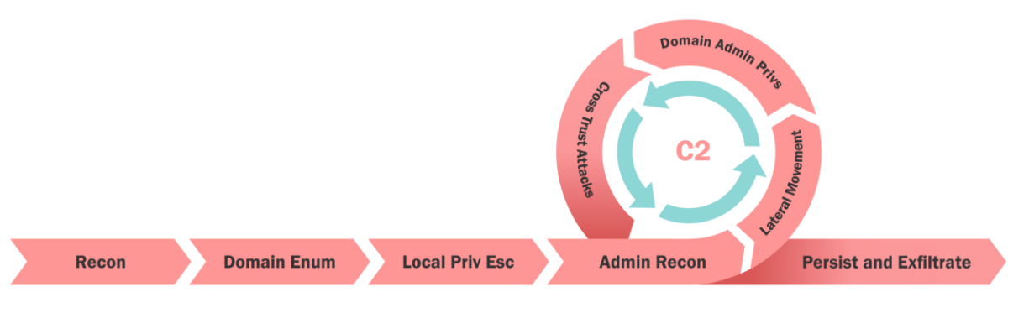

Tools Used
[Instruction: List the tools used during the engagement. Categorize them to show the breadth of your toolkit (e.g., Enumeration, Credential Maneuvers, Certificate Attacks).]

The following industry-standard tools were utilized during the engagement:

- SharpHound
- BloodHound
- PowerView
- Netexec
- Impacket
- …
- …
- …

Scope
[Instruction: Define the boundaries of the test. List the initial access account, target computer, domain names involved, and the primary objective (e.g., capturing a final flag).]

The operation was confined to the following domains and identities:

Initial Access Account | fictionaluser
Initial Access Computer | fictionalcomputer
Domain Name | primary.local  primary.net
Primary Objective | - Achieve full compromise of all the domains.  - XXX  - XXXX

Kill Chain
[Instruction: Narrate the chronological attack path. Use "Phases" to show progress from an entry-level user to a forest-level administrator.]

[ Note to user: This section is a completely fictionalized scenario to avoid leaking exam-specific paths ].

Start:
Initial access as XXX on XXX via XXX.
Phase 1: Initial Discovery Starting from [WKSTN-ALPHA], the team identified an insecure GPO (Group Policy Object) with weak permissions. This GPO was editable by standard users, allowing for the injection of a malicious scheduled task.
Phase 2: Lateral Movement via GPO Abuse The injected task granted local administrator rights on a targeted management server. Upon gaining access, the team utilized fileless techniques to extract service account credentials from the server's memory.
Phase 3: Privilege Escalation via Kerberoasting The extracted credentials allowed for a Kerberoasting attack. Offline cracking of the service account's ticket revealed a cleartext password for a user with delegated rights to modify the msDS-KeyCredentialLink attribute of an administrator account.
Phase 4: Domain Takeover via Shadow Credentials By leveraging the Shadow Credentials technique, the team requested a Kerberos TGT for the Domain Administrator. This granted full control over the primary domain.

Detailed Technical Analysis of the Compromise
The following section provides a comprehensive list of all commands used, in chronological order, to reproduce the specific attack path that led to the total compromise of the infrastructure.

[Vulnerability Name, e.g., GPO Permission Abuse]
[Instruction: Describe the vulnerability in general technical terms. Explain how the misconfiguration creates a risk.]
Description: [General explanation of the vulnerability, e.g., "This vulnerability occurs when a user has write permissions over a critical object."].

[Instruction: Clearly state what the attacker gains. Does it allow for local privilege escalation? Does it lead to domain-wide compromise?.]
Impact: Successful exploitation results in immediate local administrative control over all targeted hosts, facilitating credential theft and further lateral movement.

Detailed Walk-Through
[Instruction: Provide the step-by-step commands (anonymized) and a clear explanation for each.]

Step 1:
[Action Name] Describe the enumeration or identification step
Used Command | Command Explanation
[COMMAND_PLACEHOLDER] | [Explanation of what the command achieves].

[Caption for Screenshot ]]

Step 2:
[Action Name] Describe the enumeration or identification step
Used Command | Command Explanation
[COMMAND_PLACEHOLDER] | [Explanation of what the command achieves].

[Caption for Screenshot ]]

Mitigations:
[Instruction: Provide specific, actionable steps to remediate the issue and prevent it from recurring.]
- Restrict GPO "Write" permissions to the Domain Admins group only.
- …

Specific Action:
- …

Domain Admin Escalation via Shadow Credentials
Description : This attack exploits the msDS-KeyCredentialLink attribute on Active Directory objects. When an attacker has "Write" permissions over a target user, they can populate this attribute with a new public key. This allows the attacker to authenticate as that user via the PKINIT Kerberos extension without needing the user's actual password.

Impact: Successful exploitation allows for the complete takeover of high-privileged accounts, such as Domain Administrators. Once the attacker assumes this identity, they possess unrestricted access to the Domain Controller, sensitive data, and the ability to maintain long-term persistence within the forest.

Detailed Walk-Through

Step 1:
Identify Modification Rights The attacker uses enumeration tools to find users they can modify. In this case, the account [svc_sql_admin] was found to have GenericWrite permissions over the Domain Admin account [adm_forest_boss].

[Caption for Screenshot ]]

Step 2:
Attribute Manipulation and Key Generation The attacker generates a new key pair and updates the target's attribute in Active Directory.
Used Command | Command Explanation
.\Whisker.exe add /target:adm_forest_boss /domain:PRIMARY.LOCAL | Generates a new key pair and populates the msDS-KeyCredentialLink attribute for the target user.
[COMMAND_PLACEHOLDER] | [Explanation of what the command achieves].

[Caption for Screenshot ]]

Mitigations:
- "Write" or "GenericAll" permissions over administrative accounts.
- Monitoring: Monitor for Event ID 5136 (Directory Service Object Modified) specifically targeting the msDS-KeyCredentialLink attribute.
- Restricted Groups: Place all administrative accounts in the Protected Users group to enforce stricter Kerberos policies.

Reference
- https://attack.mitre.org/

[Please note that the attack scenarios, command examples, and technical data presented in this template were generated by an AI and have not been manually verified for technical accuracy or operational relevance." ]

