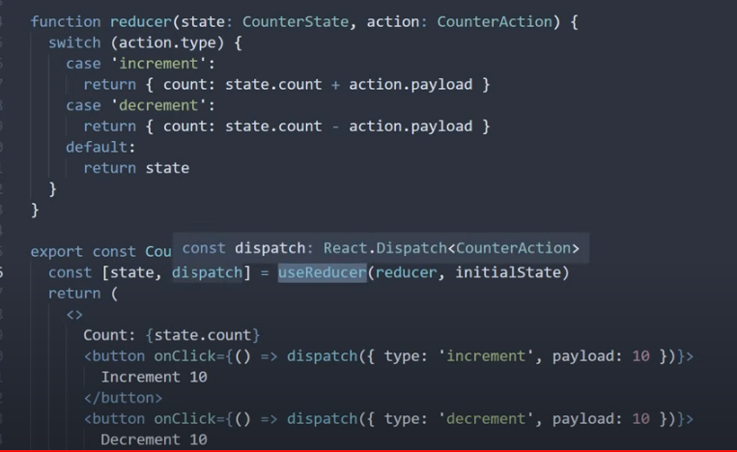

Better approach……

