Design Parameters:

1.

2.

3.a

(MATLAB Equation Solver)

(MATLAB Solver Approximation)

(MATLAB Equation Solver)

(MATLAB Solver Approximation)

3.b.

(Same as 3.a)

4.

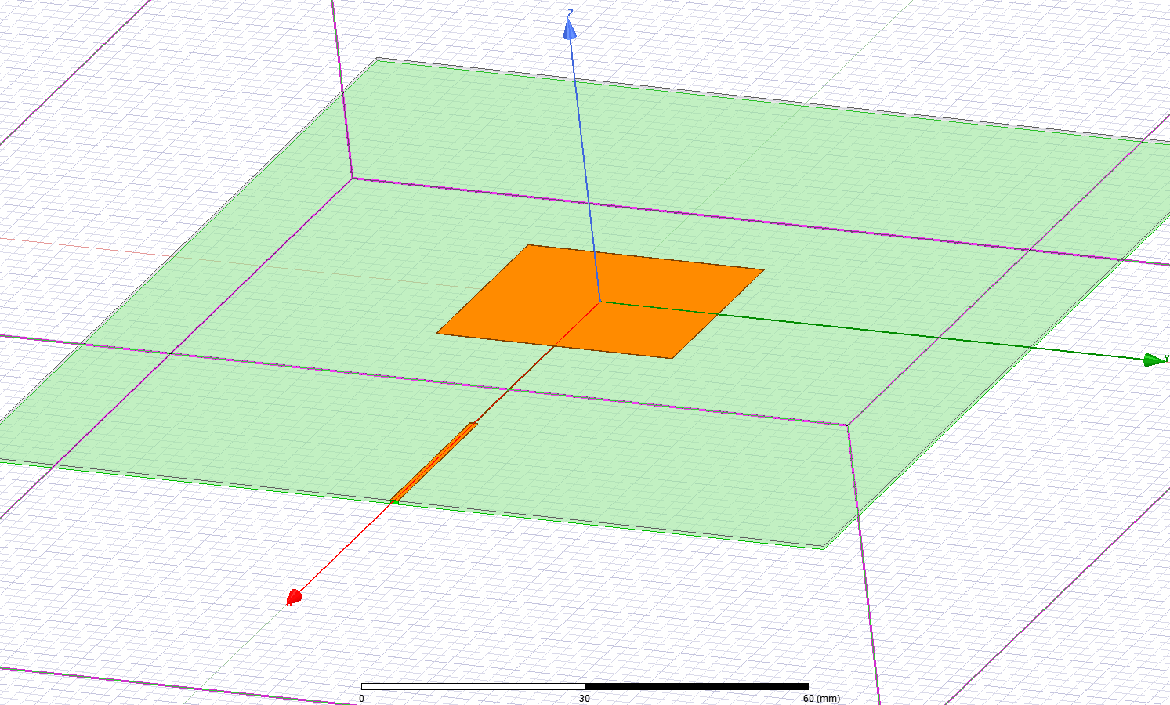

Transmission Line Patch Antenna.

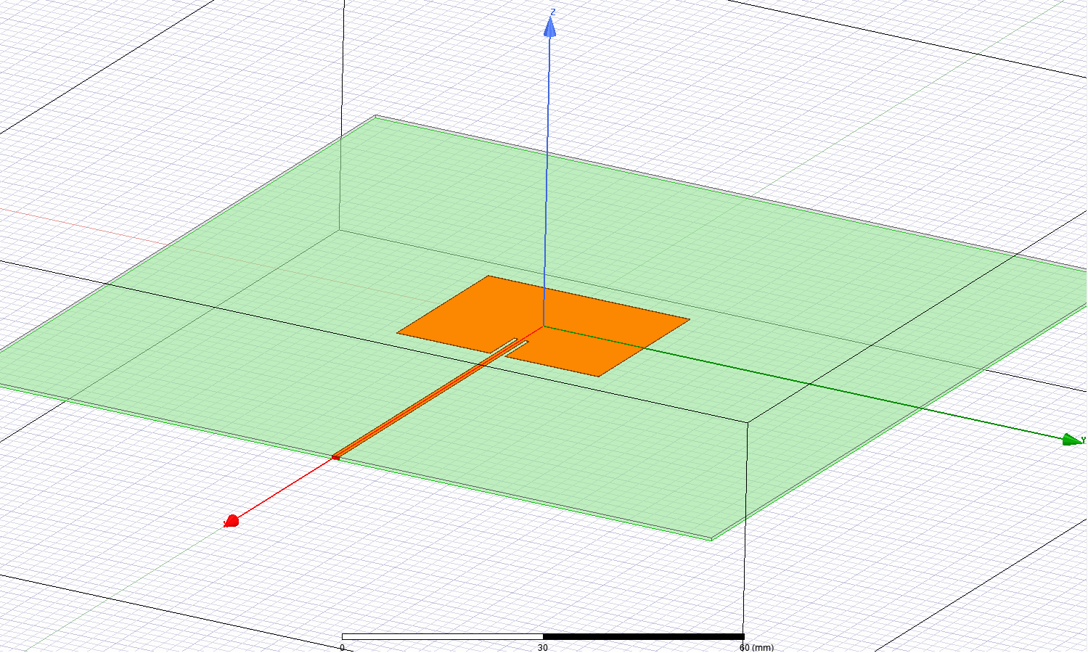

Recessed Patch Antenna.

4.a.

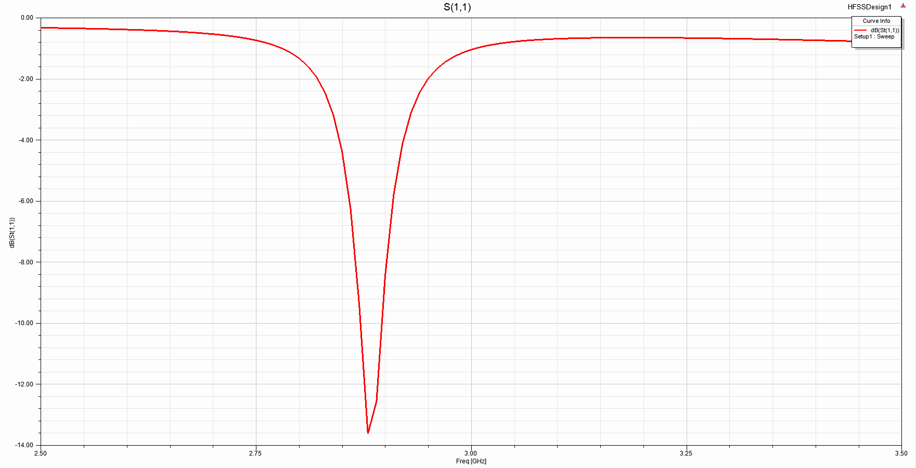

Unoptimized Transmission Line Patch Antenna S11. and . Resonant frequency off from 3 GHz by 3%.

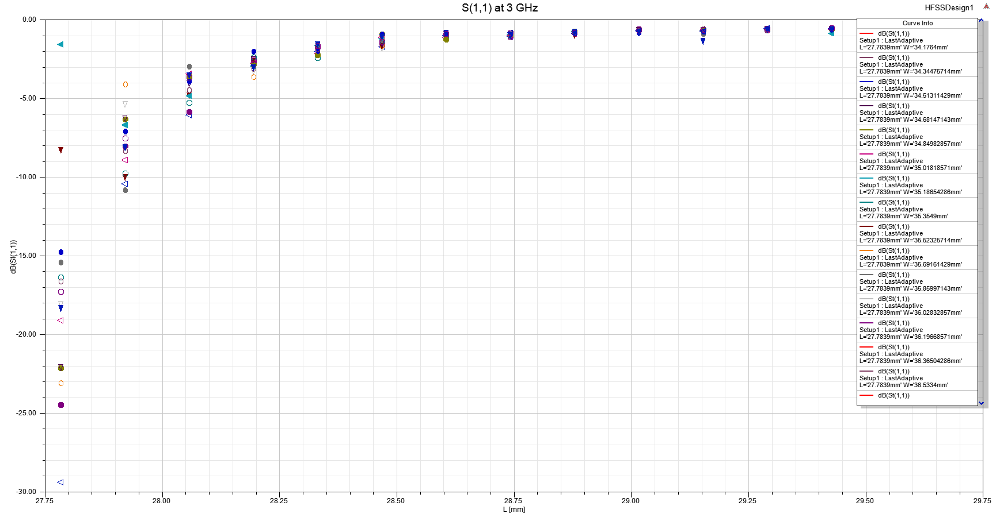

Transmission Line Patch Antenna L and W sweep using Optimetrics to plot S11 at 3 GHz. Minimum S11 at and

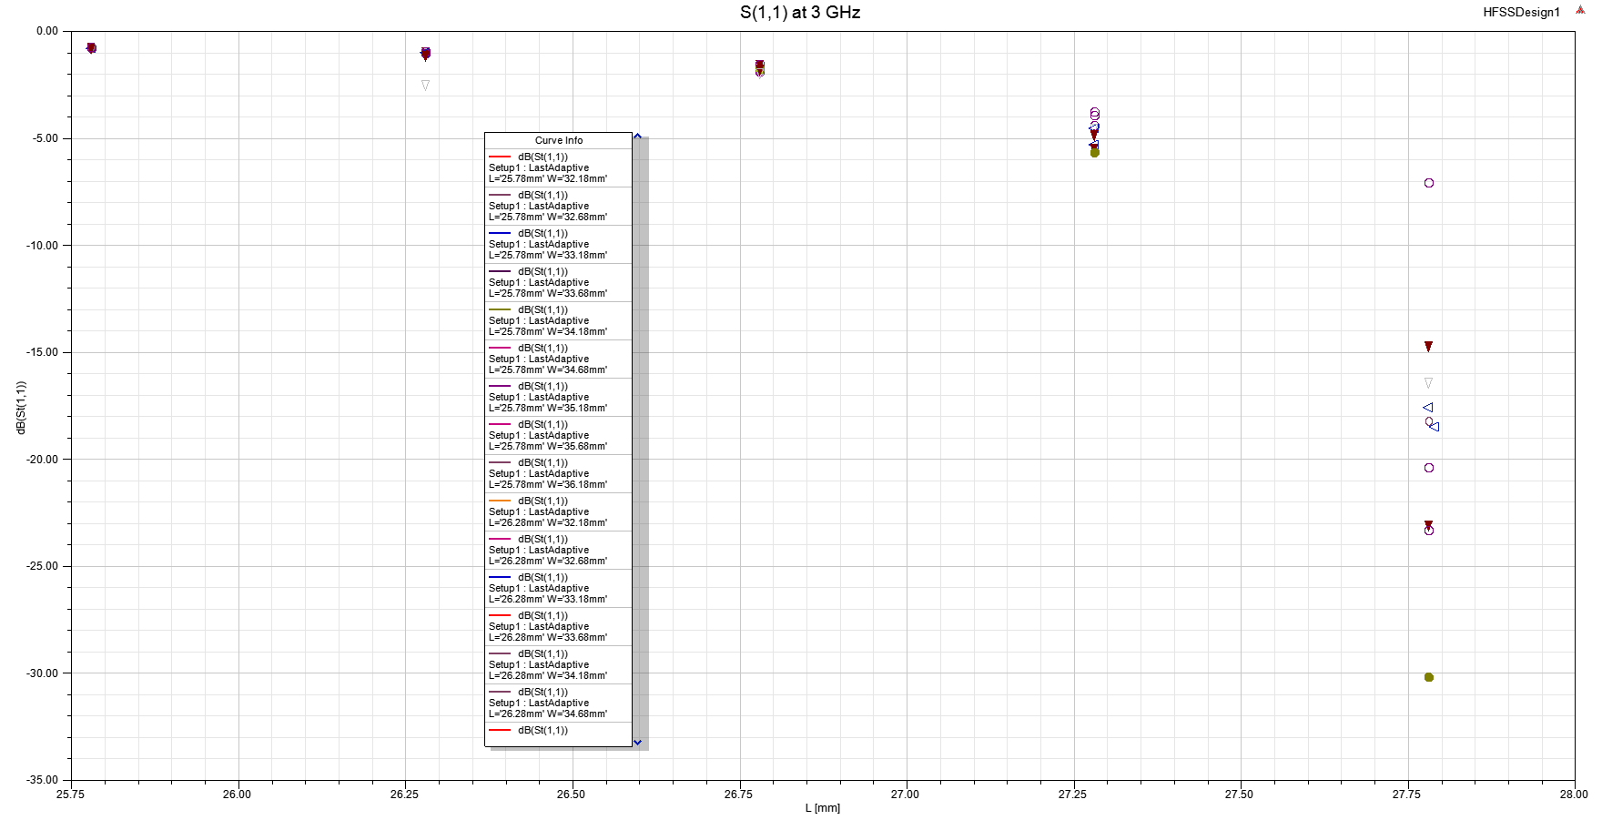

Transmission Line Patch Antenna Lower L and W sweep using Optimetrics to plot S11 at 3 GHz. Minimum S11 at and

Transmission Line Patch Antenna Final Dimensions:

, ,

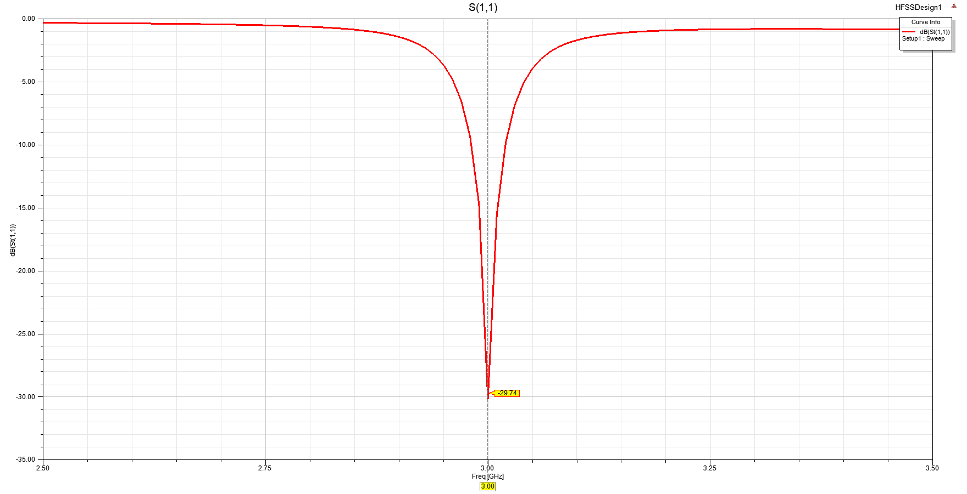

Transmission Line Patch Antenna S11. S11 = -29.74 dB at 3 GHz.

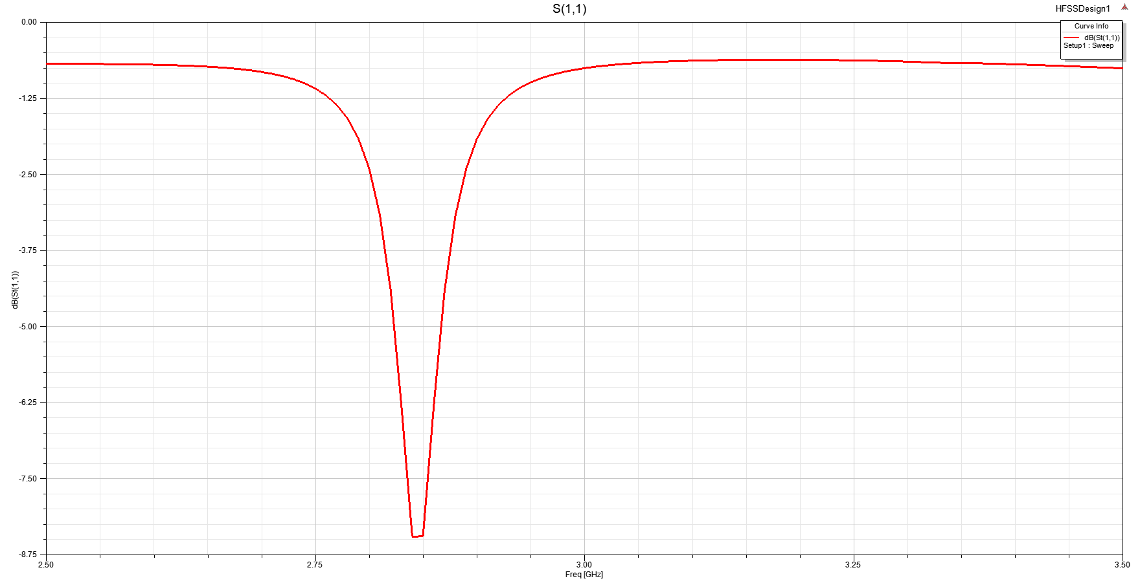

Unoptimized Recessed Patch Antenna S11. and . Resonant frequency off from 3 GHz by 6%.

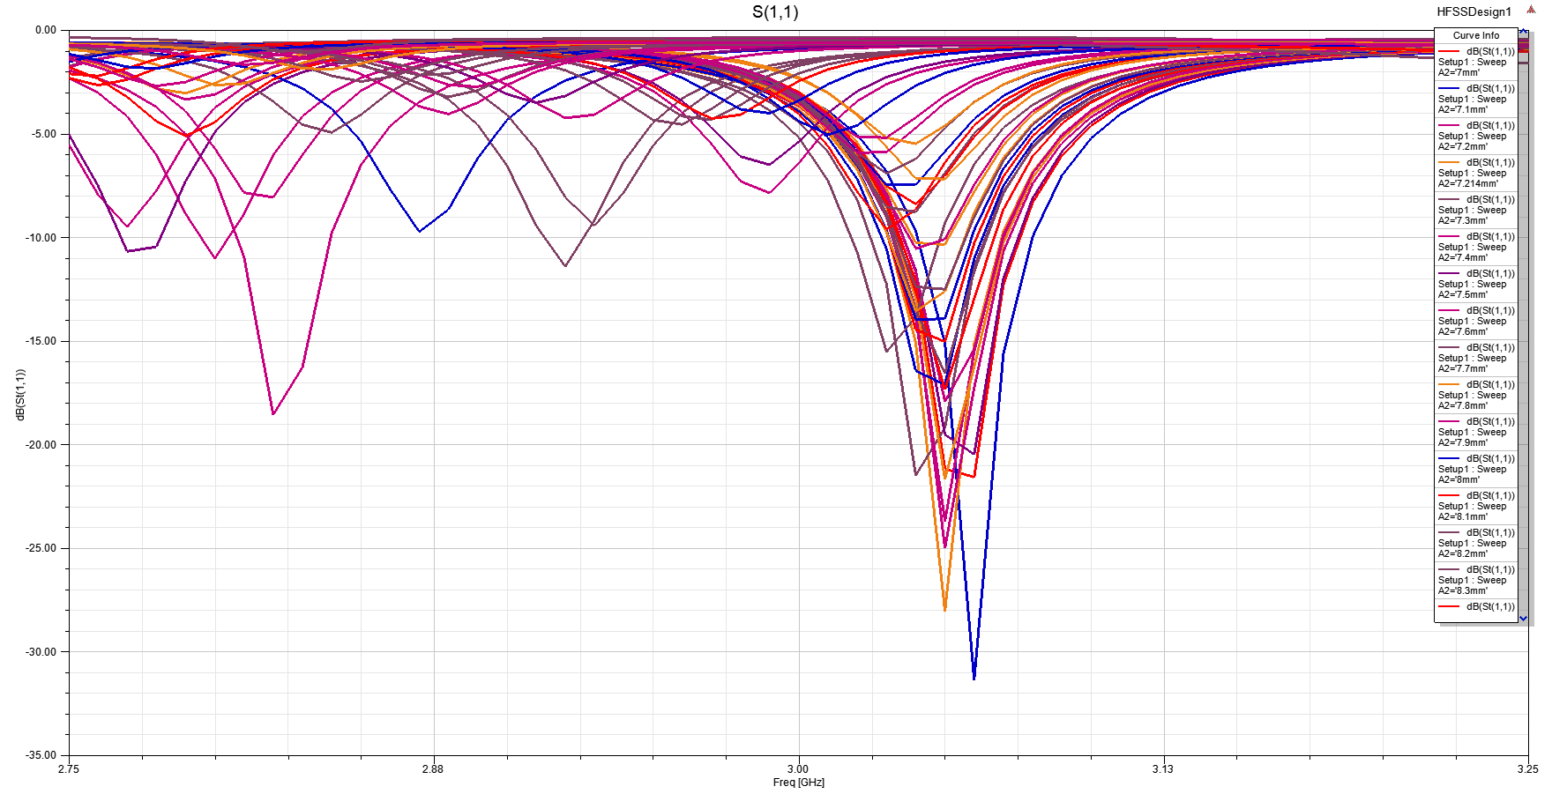

Recessed Patch Antenna sweep using Optimetrics to plot S11. chosen after trial and error. Try .

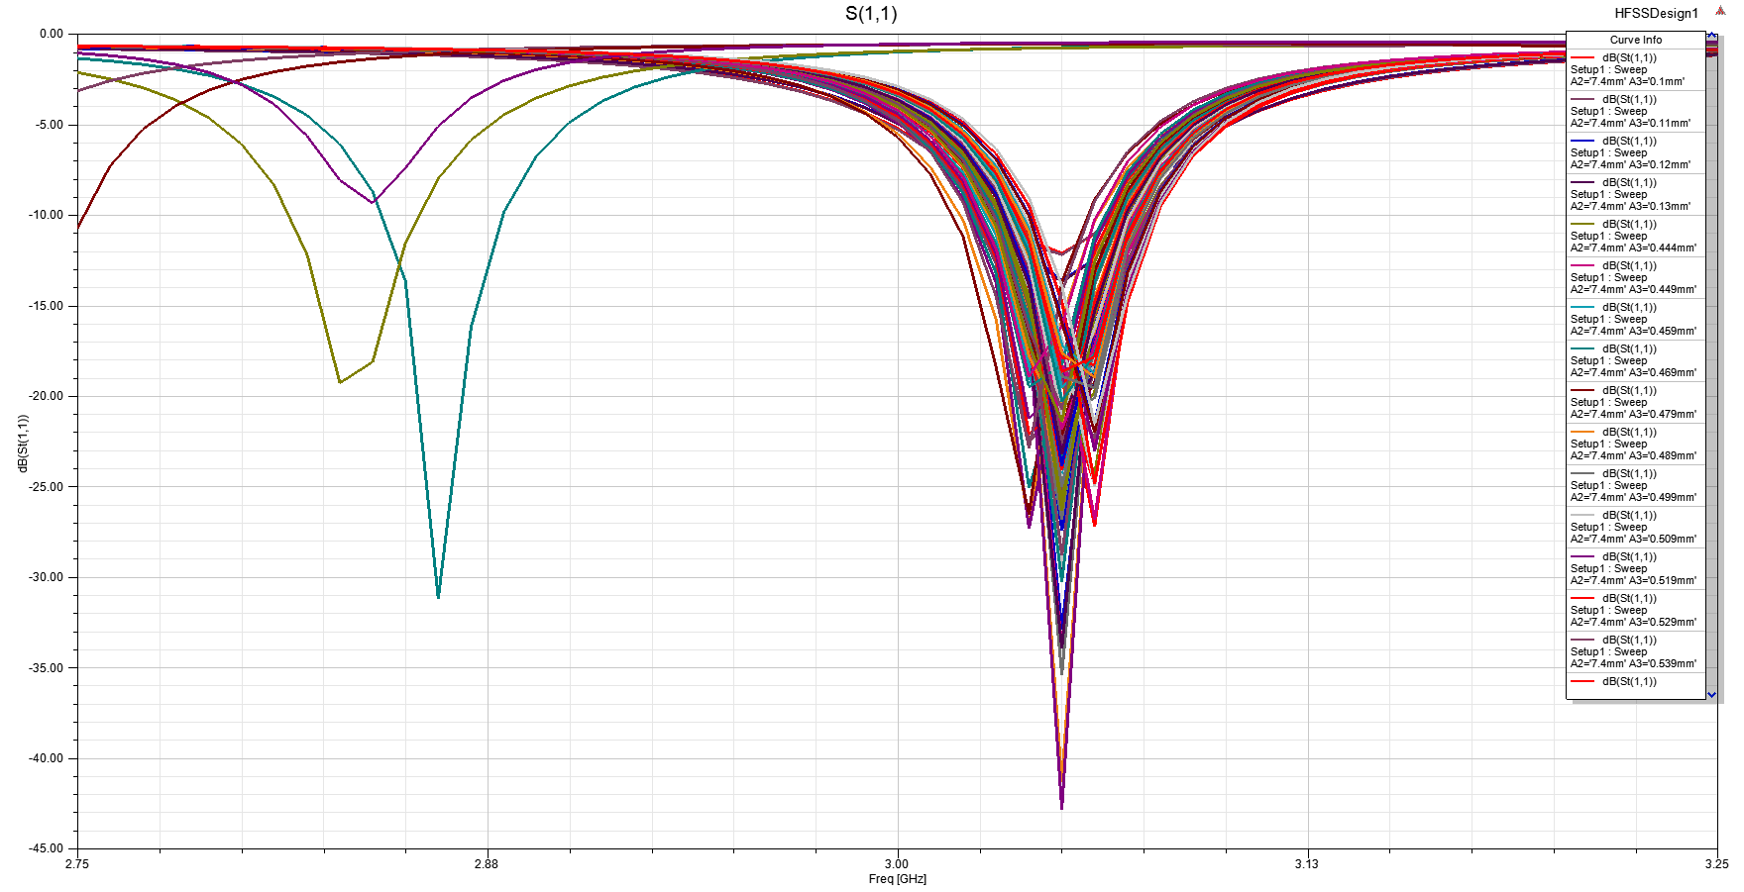

Recessed Patch Antenna sweep using Optimetrics to plot S11. chosen after trial and error. Try .

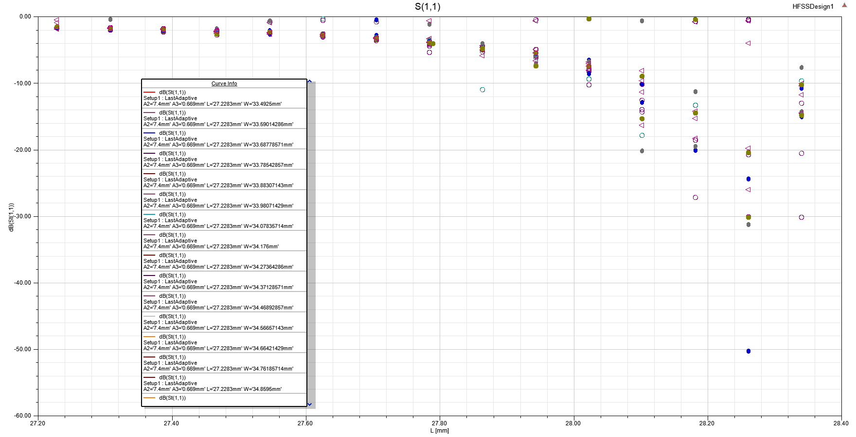

Recessed Patch Antenna L and W sweep using Optimetrics to plot S11 at 3 GHz. Minimum S11 at and

Recessed Patch Antenna Final Dimensions:

, ,

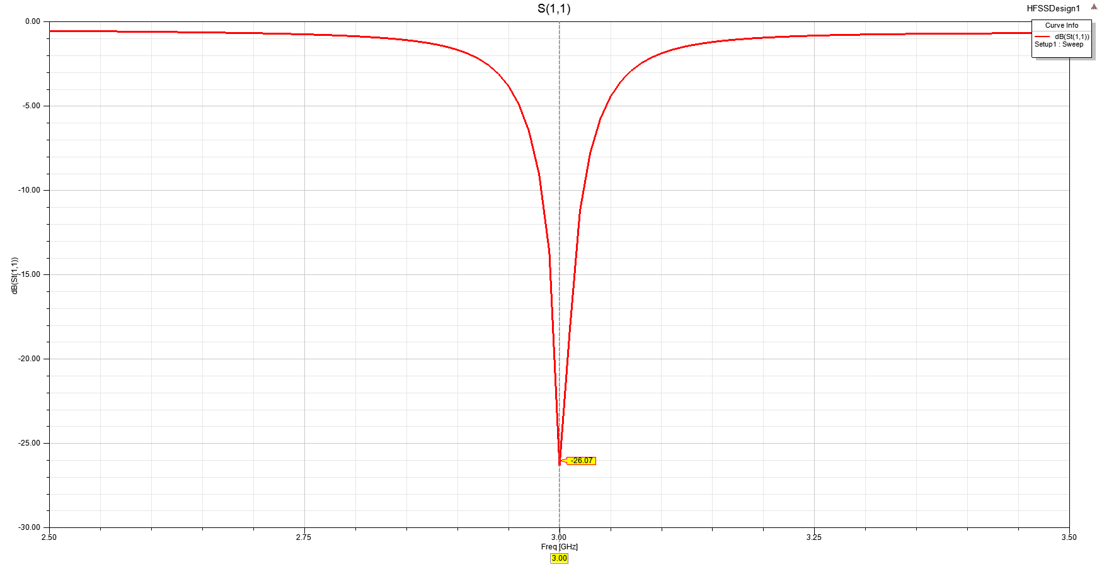

Recessed Patch Antenna S11. S11 = -26.07 dB at 3 GHz.

Transmission Line Patch Antenna gives a better return loss at resonant frequency.

4.b.

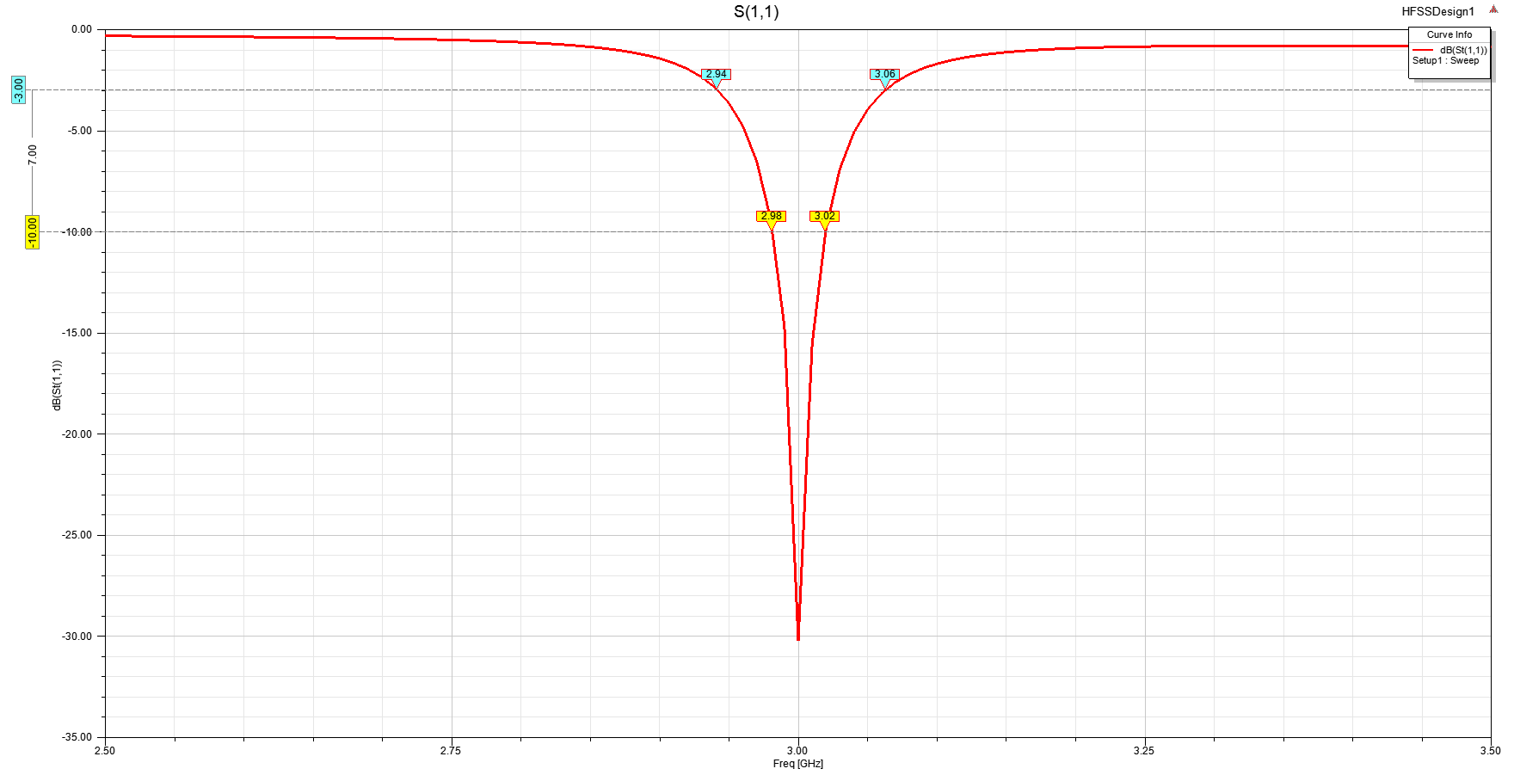

Transmission Line Patch Antenna S11.

Transmission Line Patch Antenna FBW comparison

Transmission Line Patch Antenna S11.

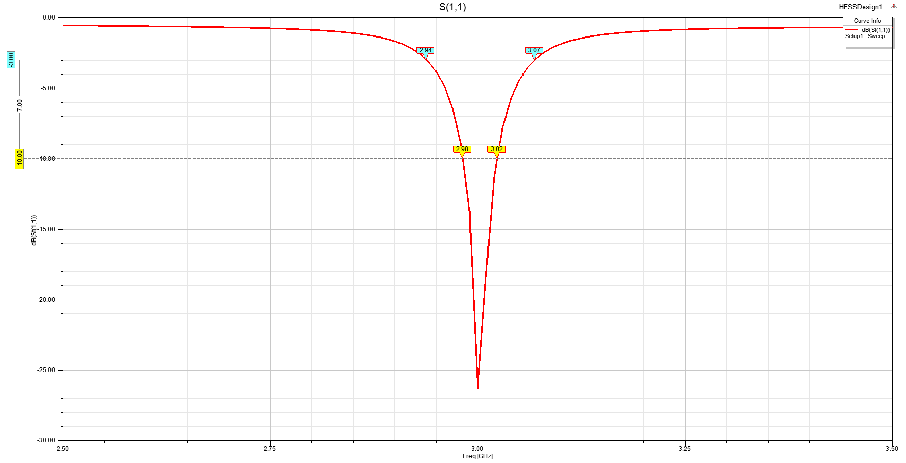

Recessed Patch Antenna S11.

Recessed Patch Antenna FBW comparison

Recessed Patch Antenna S11.

While the Transmission Line Patch Antenna gives a better return loss at resonant frequency, the Recessed Patch Antenna gives a better 3 dB bandwidth.

4.c.

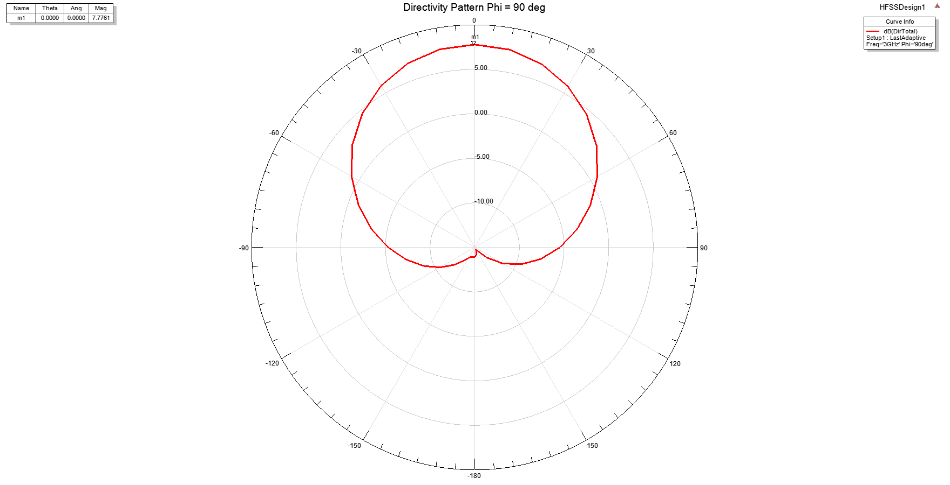

Transmission Line Patch Antenna Directivity Pattern.

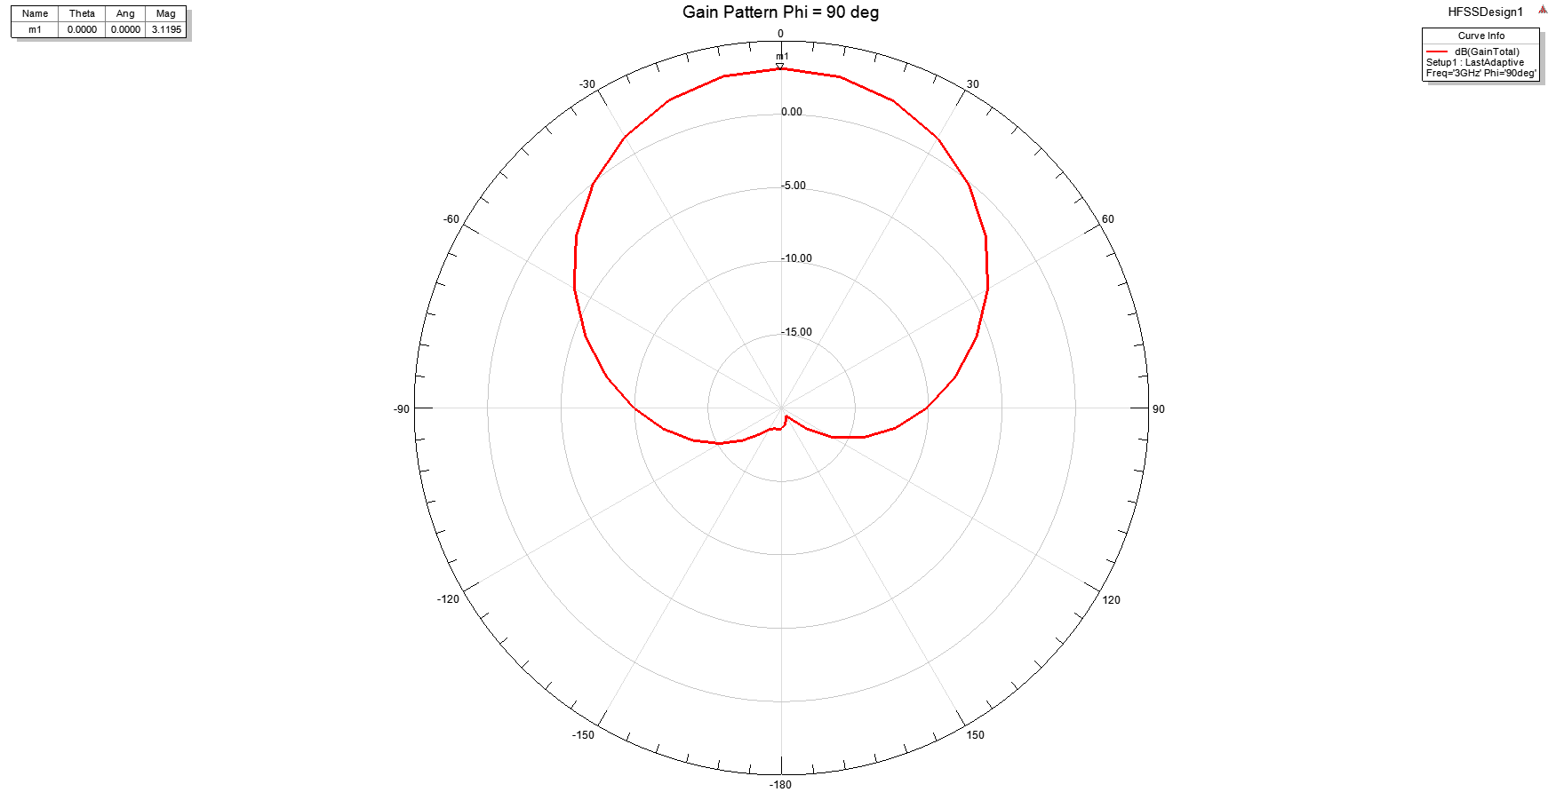

Transmission Line Patch Antenna Gain Pattern.

Transmission Line Patch Antenna Radiation Efficiency

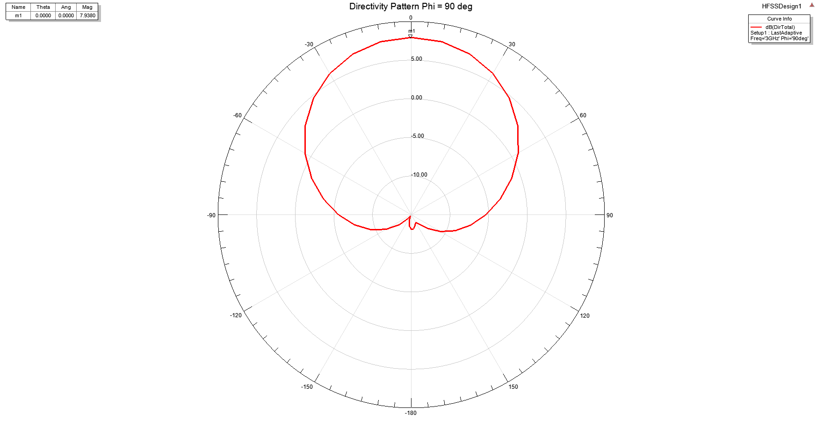

Recessed Patch Antenna Directivity Pattern.

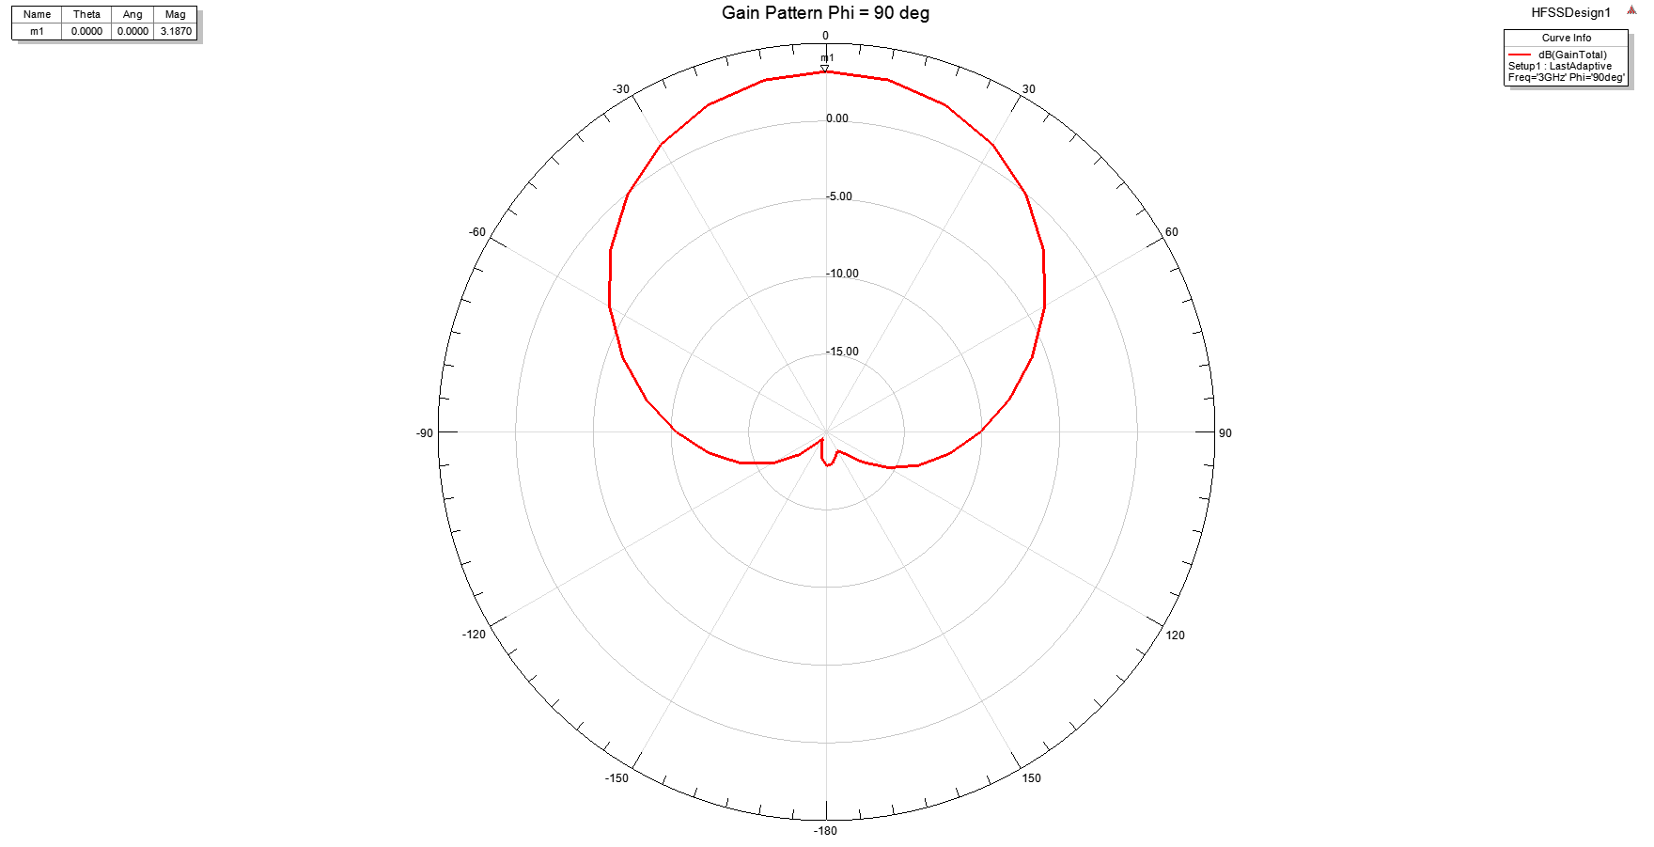

Recessed Patch Antenna Gain Pattern.

Transmission Line Patch Antenna Radiation Efficiency

4.d.

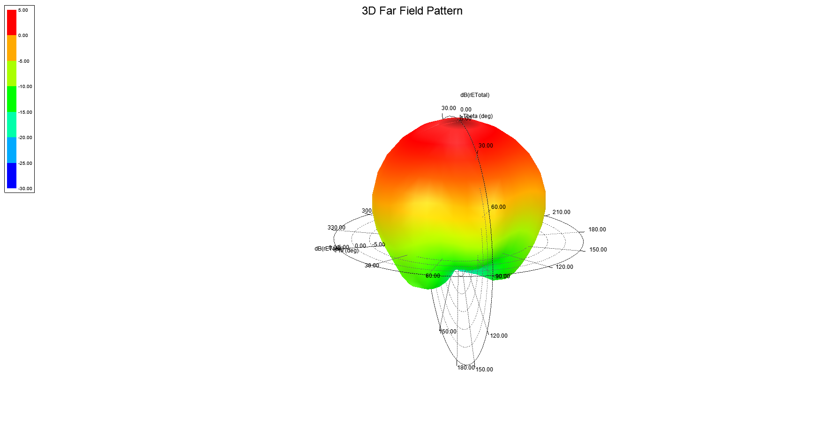

Transmission Line Patch Antenna 3D Far Field Pattern

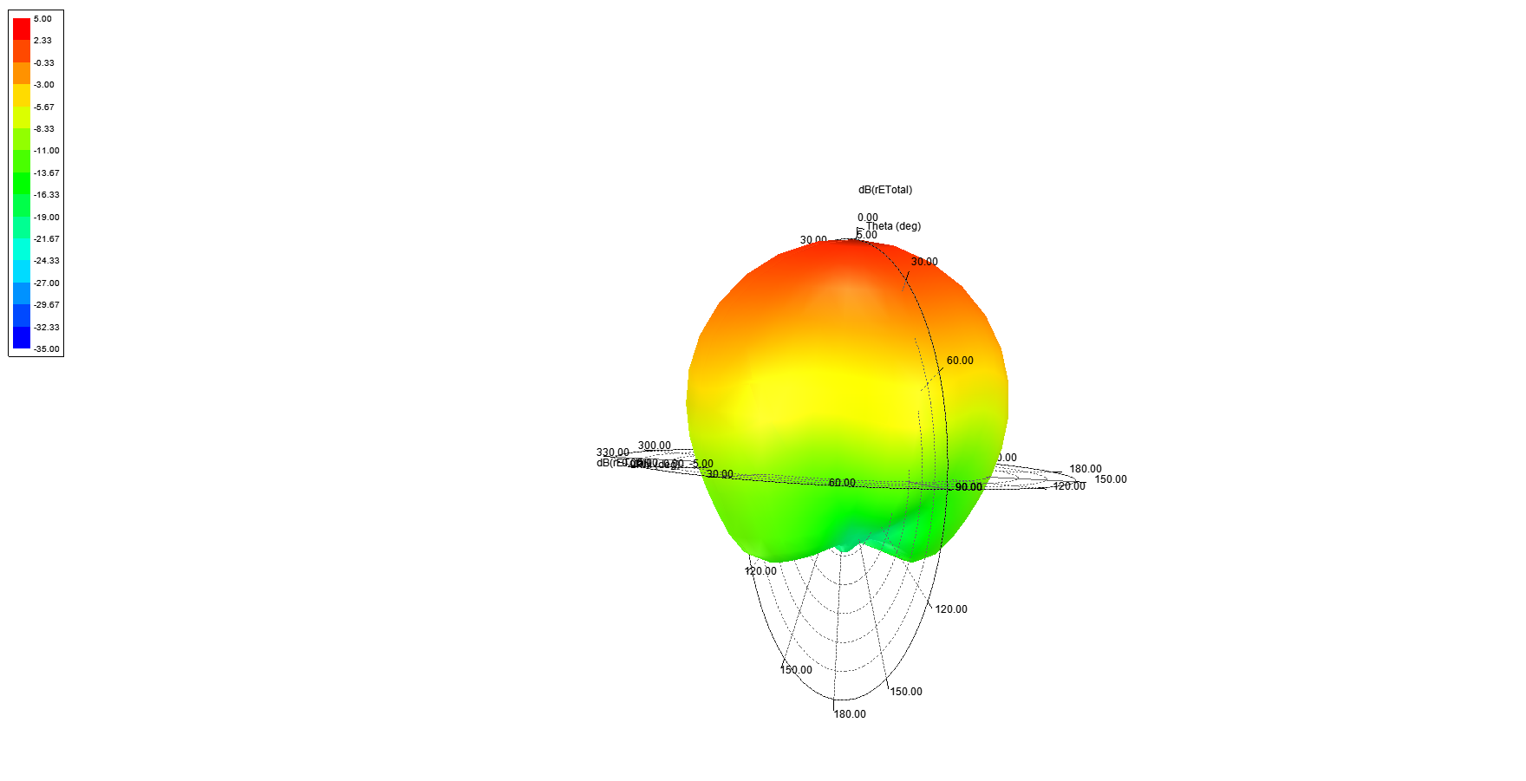

Recessed Patch Antenna 3D Far Field Pattern

4.e.

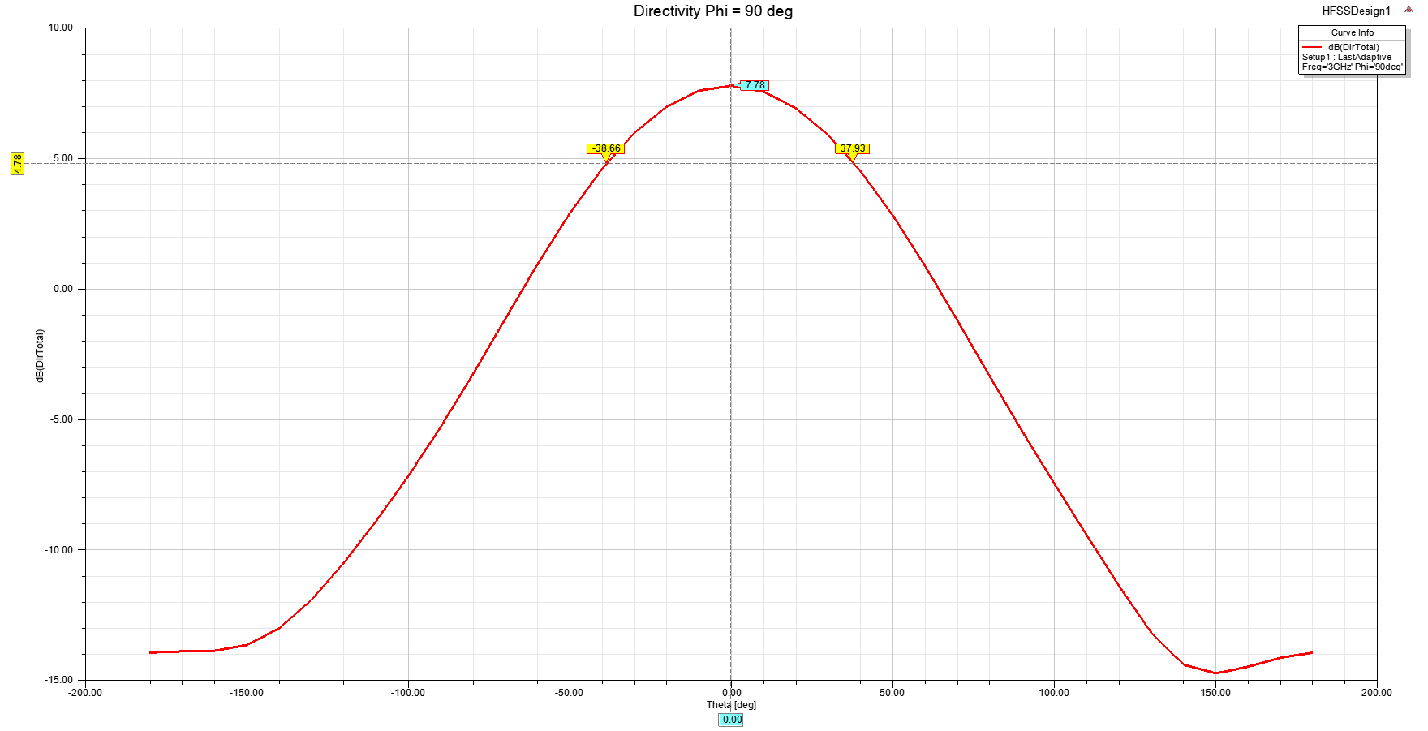

Transmission Line Patch Antenna Directivity at Phi =.

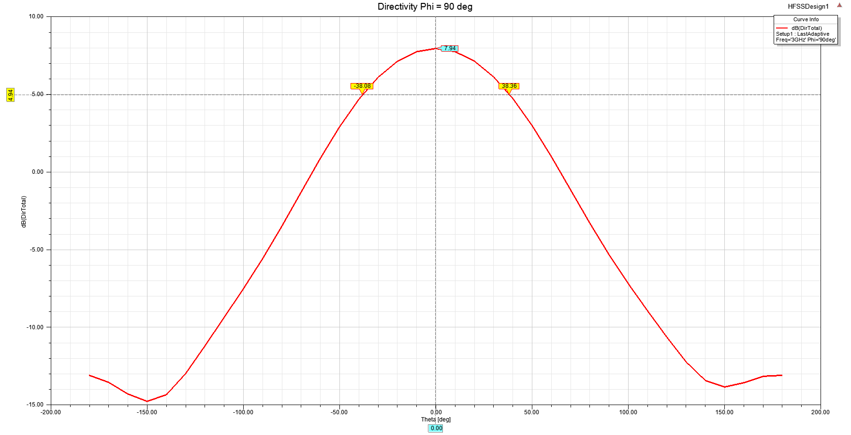

Recessed Patch Antenna Directivity at Phi =.

5.

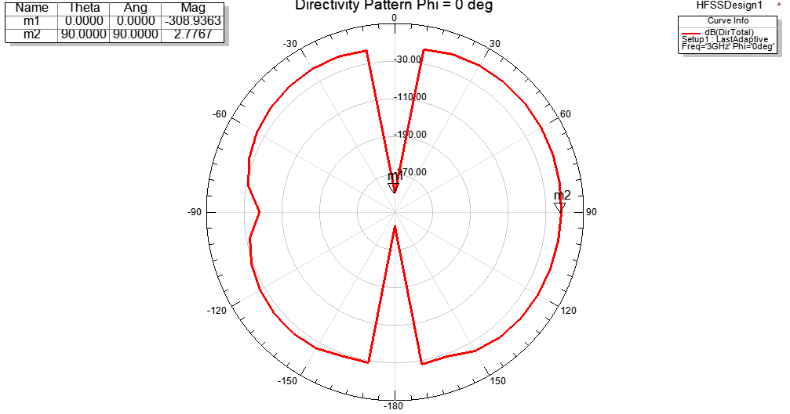

Recessed Patch Antenna N=4 Array Directivity Pattern.

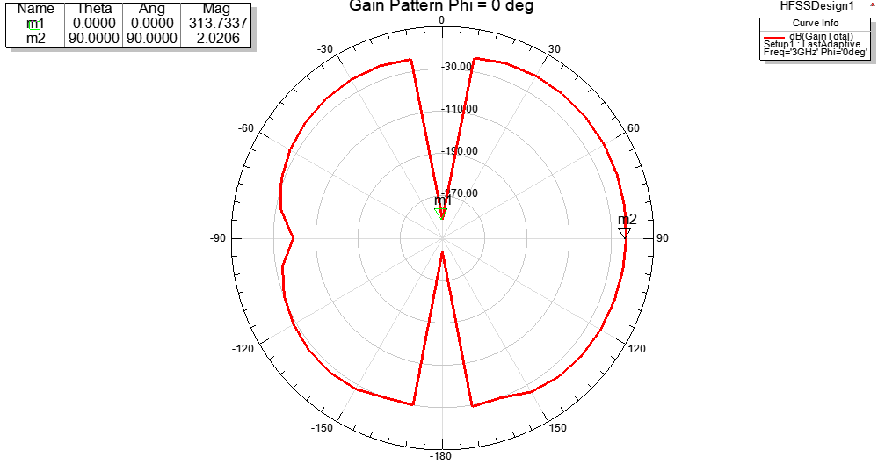

Recessed Patch Antenna N=4 array Gain Pattern.

Recessed Patch Antenna N=4 array Radiation Efficiency