Structural Design Patter

Adapter
Imagine you have a Class A with some methods. In order to execute the action action1, you should call the method1, method3 and method4.

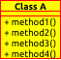
var instanceA = new ClassA();
// execute the action1
instanceA.method1();
instanceA.method3();
instanceA.method4();

It sens very complicated to the client isn't? So in this case perhaps we should use a class that turn this action more simple in the client side.

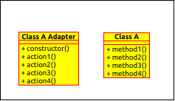
In this case, you can turn the stuffs more simple to the client. The constructor of the Class A Adapter return a instance of Class A.
var instanceA = new ClassAAdapter() ;
// execute the action 1
instanceA.action1() ;
the method action1 from the Class A Adapter will call
all methods from the class A needed to execute the action 1.

