TECHNICAL DOCUMENTATION
Supplier Portal
Application Login Process
────────────────────────────────────────

Application | Supplier Portal (Castali)
Module | Authentication – Login Process
URL | http://122.179.136.128:86/
Credentials | User ID: CTPLABAP
Prepared By | CTPL Team
Version | 2.0
Status | Active
Date | 02 June 2026

Table of Contents

1. Overview ....................................................... 3
2. Pre-requisites ................................................. 3
3. Step 1 – Open Application URL .................................. 4
4. Step 2 – Click the Login Button ................................ 5
5. Step 3 – Enter Credentials ..................................... 6
6. Step 4 – Authenticate & Access Dashboard ....................... 7
7. Troubleshooting ................................................ 8
8. Document Revision History ...................................... 8

1. Overview

This document provides a comprehensive, step-by-step guide for authenticating into the Supplier Portal (Castali). It is intended for end users, system administrators, and QA engineers who need to understand, test, or verify the login workflow.
The document captures the exact application state at each stage of the login process using real screenshots taken from the live environment, ensuring there is no ambiguity between documentation and actual behaviour.

Application Name | Supplier Portal (Castali)
Application URL | http://122.179.136.128:86/
Test User ID | CTPLABAP
Authentication Type | Username + Password (Session-based)
Post-Login Page | Supplier Dashboard (Home)

2. Pre-requisites

Ensure the following conditions are met before proceeding:
- An active internet connection is available.
- A supported web browser is installed (Chrome 110+, Edge 110+, Firefox 109+ recommended).
- Valid credentials (User ID & Password) have been provided by the system administrator.
- No VPN or firewall is blocking access to the application URL.
- Browser cookies and JavaScript are enabled.
ℹ NOTE | If you do not have credentials, contact the CTPL system administrator before attempting to log in.

STEP 1 | Open the Application URL

Action
Open your preferred web browser and navigate to the following URL:
http://122.179.136.128:86/

Expected Result
The Supplier Portal home page is displayed, showing the 'Welcome to the Supplier Portal' banner with Login and New User buttons, and a navigation footer.
Key UI Elements on This Page
Element | Type | Description
Supplier Portal Logo | Brand Logo | Top-left header
Welcome Banner | Text | Centre of the page
Login Button | Button | Primary CTA – opens login form
New User? Button | Button | Secondary CTA – for registration
Navigation Footer Links | Links | About, Contact Us, Portal Help …

📷 Figure 1 – Supplier Portal Home Page (http://122.179.136.128:86/)
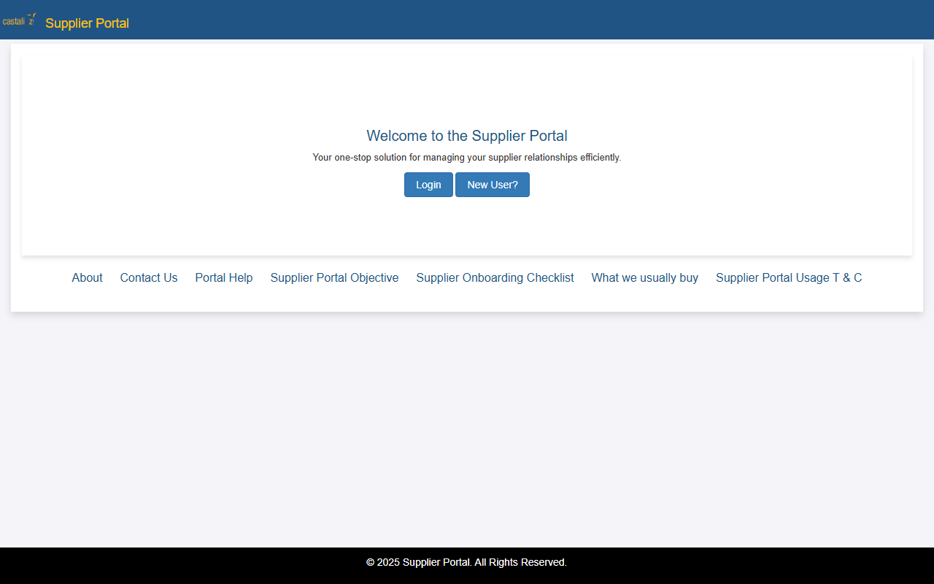

STEP 2 | Click the 'Login' Button

Action
Locate the blue 'Login' button in the centre of the page and click it to open the authentication form.
Expected Result
The Login modal / page is displayed, presenting a Username field, a Password field, a Login submit button, and a 'Forgot Password?' link.
⚠ TIP | The Login button is the primary (filled blue) button. Do NOT click 'New User?' as that leads to the registration workflow.

📷 Figure 2 – Login Button Highlighted (red border) on Home Page
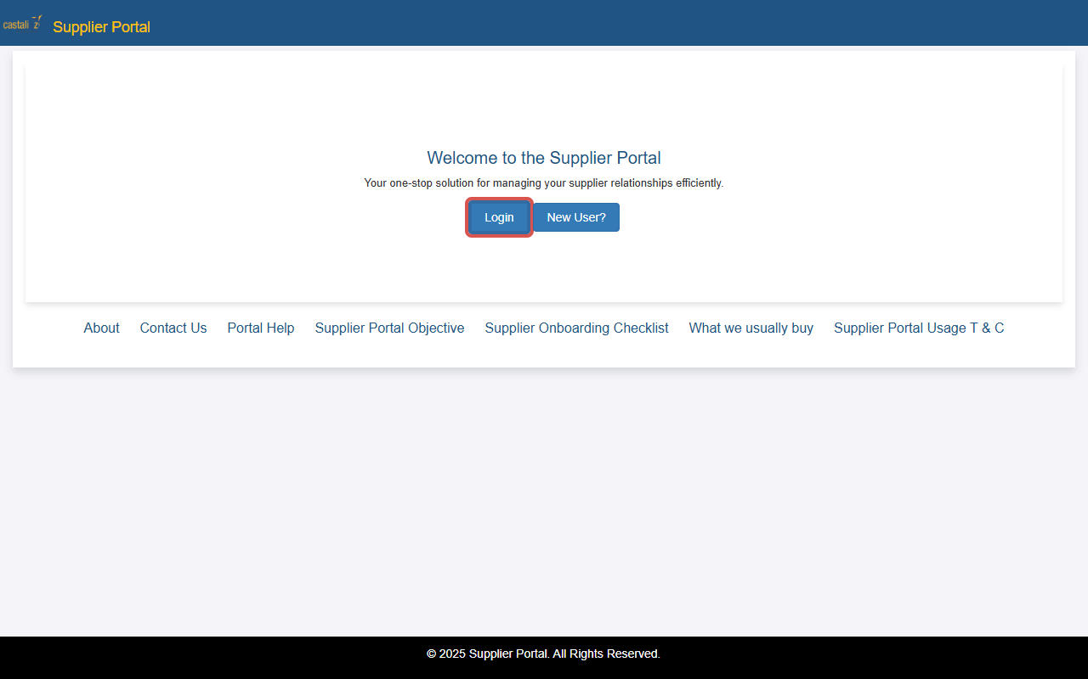

STEP 3 | Enter Credentials (User ID & Password)

Action
On the Login form, enter the credentials as follows:
Field | Value | Notes
Username | CTPLABAP | Case-sensitive – enter in UPPERCASE
Password | Testing | Alphanumeric – mixed case applies

Expected Result
The Username field shows 'CTPLABAP' (highlighted in orange in the current build) and the Password field shows masked characters (●●●●). No validation error should appear.
📷 Figure 3 – Login Form with Credentials Entered
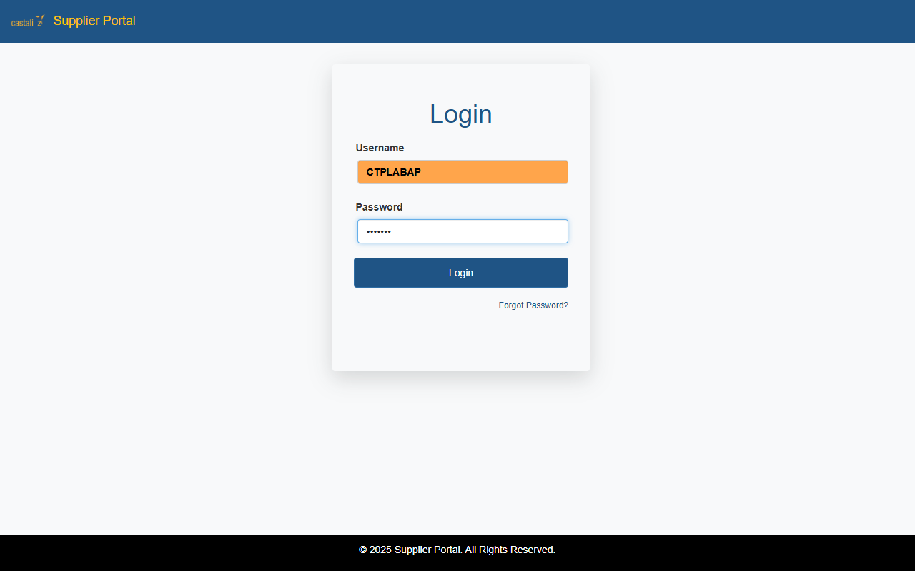

ℹ NOTE | The orange highlight on the Username field is part of the browser's autofill styling and is not an error indicator. The value is correctly populated.

STEP 4 | Authenticate & Access the Dashboard

Action
After entering both credentials, click the blue 'Login' button inside the form to submit the authentication request.
Expected Result
On successful authentication, the system redirects the user to the Supplier Portal Dashboard, which displays the following module tiles:
- Dashboard
- My Orders
- My Invoices
- My Deliveries
- Incoming RFQs
- My Quotations
- My Contracts
- My Messages
- My Reports
- My Company Info
- My Company Users
- Advance Shipping Notification

📷 Figure 4 – Supplier Portal Dashboard (Post-Login)
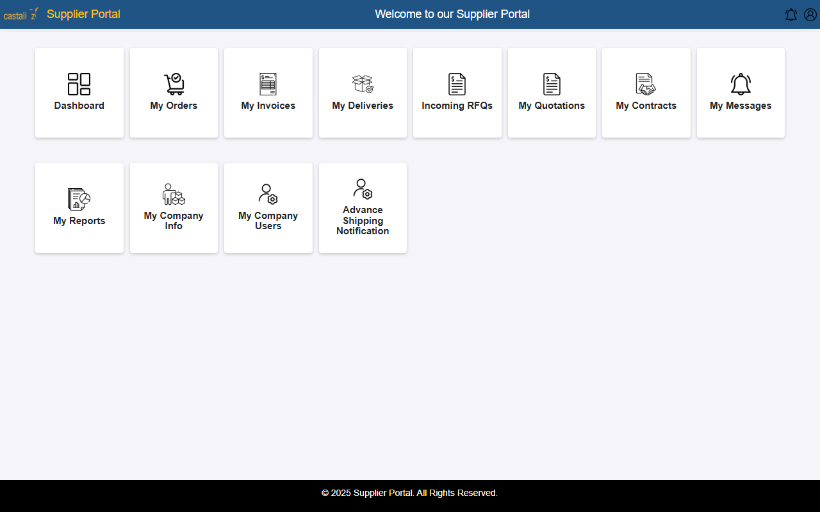

7. Troubleshooting

Issue | Possible Cause | Resolution
Page does not load | Network issue / incorrect URL | Verify internet connection; check the URL is exactly http://122.179.136.128:86/
'Invalid credentials' error | Wrong User ID or Password | Re-enter credentials. Ensure CAPS LOCK is off. Contact admin if locked.
Login button unresponsive | JavaScript disabled or browser compatibility | Enable JavaScript; try Chrome or Edge.
Blank page after login | Session/cookie issue | Clear browser cache and cookies, then retry.
'Account locked' message | Multiple failed login attempts | Wait 15 minutes or contact the CTPL administrator.

⚠ ESCALATION | If the issue persists after following the steps above, raise a support ticket with the CTPL helpdesk, providing a screenshot of the error and the exact time of occurrence.

8. Document Revision History

Version | Date | Author | Change Summary
1.0 | 01 June 2025 | CTPL Team | Initial draft – user manual format
2.0 | 02 June 2026 | CTPL Team | Rewrite as technical documentation; real screenshots embedded; troubleshooting & revision history added

