User Manual
Application Login Process

Introduction
This document provides step-by-step instructions for accessing and logging into the application. Users can follow the procedure below to successfully open the application and log in using the provided credentials. Screenshots are captured for each step to make the process easy to understand for end users.

Application Login Steps

Step 1: Open the Application URL
Open your preferred web browser and enter the following application URL in the address bar:
http://122.179.136.128:86/
After entering the URL, press the Enter key to open the application home page.
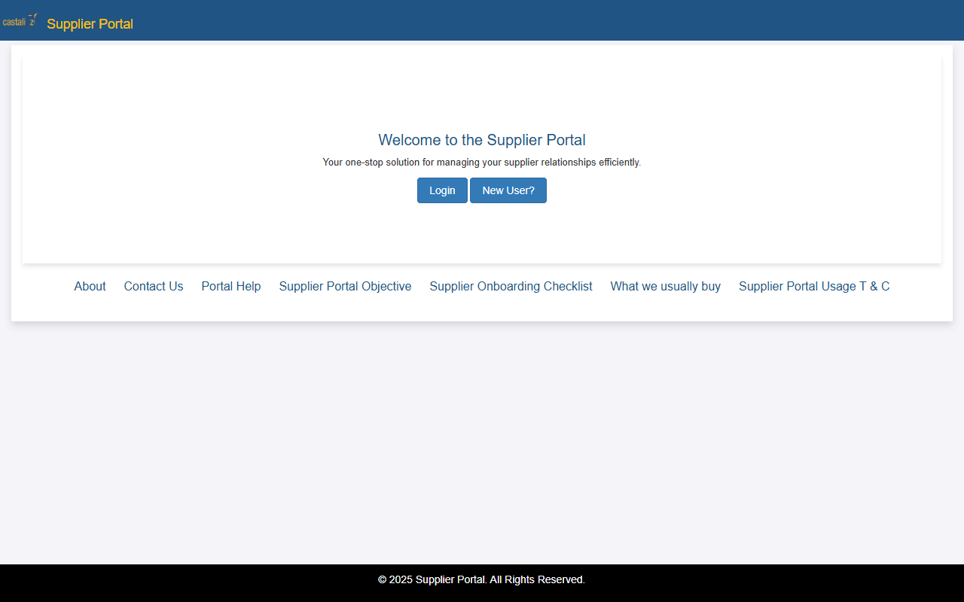
Figure 1: Application home landing page

Step 2: Click on the Login Button
Once the application home page is displayed, locate the Login button on the screen and click on it to proceed to the login page.
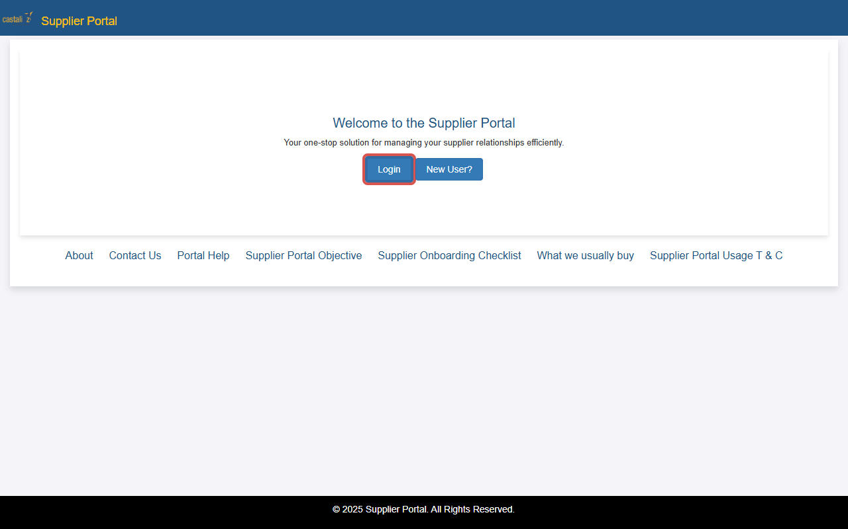
Figure 2: Supplier Portal home page with highlighted Login button

Step 3: Enter User Credentials
On the login page, enter the following login credentials:
- User ID: CTPLABAP
- Password: Testing
Ensure that the credentials are entered correctly in their respective fields.
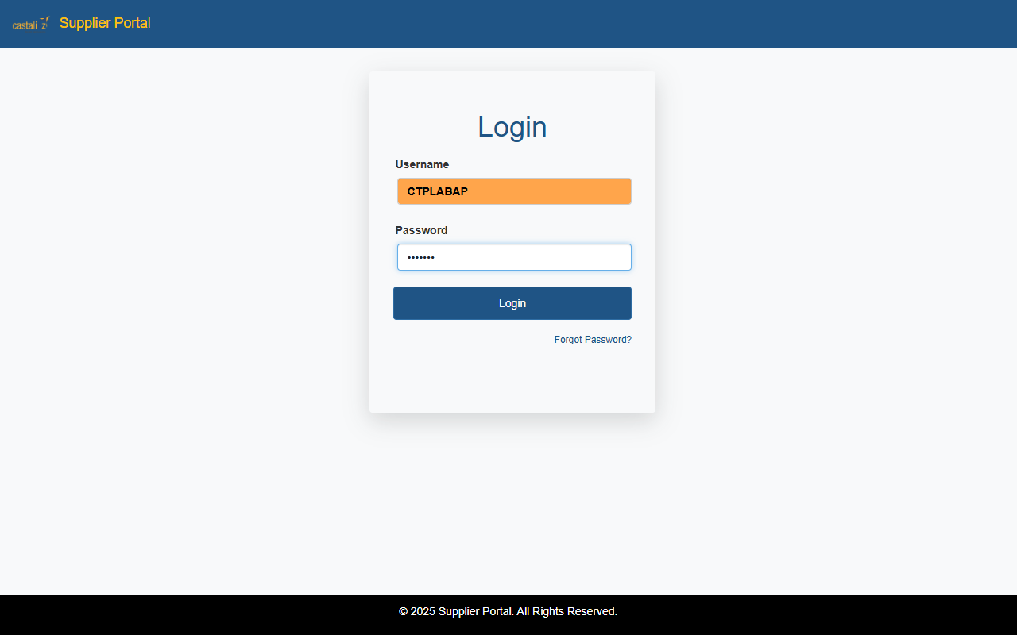
Figure 3: Login form with User ID and Password fields populated

Step 4: Click the Login Button
After entering the login credentials, click on the Login button to access the application dashboard. If the credentials are valid, the system will successfully authenticate and redirect you to the application home/dashboard page.
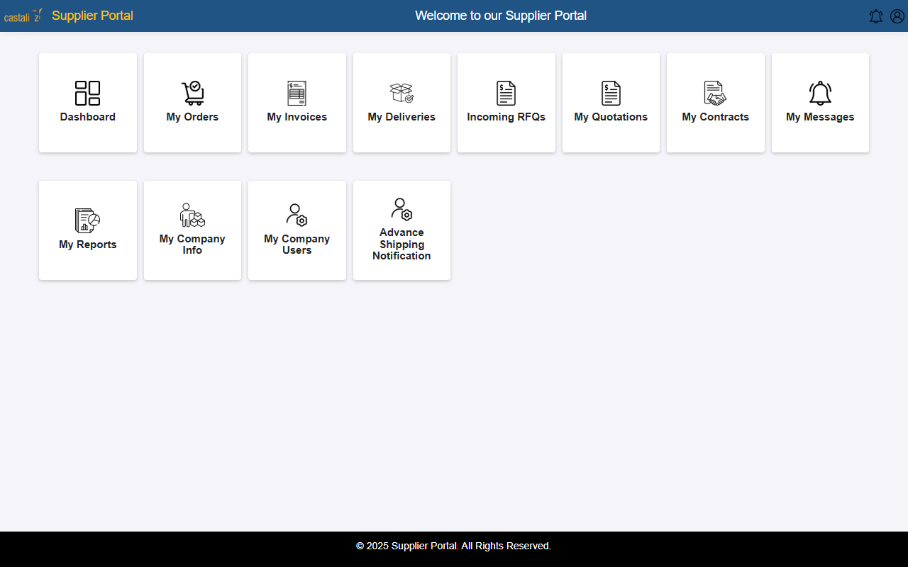
Figure 4: Supplier Portal dashboard page upon successful login

Important Notes
Please keep the following in mind:
• Ensure that you have a stable internet connection before accessing the application.
• Use the correct User ID and Password provided by the administrator.
• In case of login issues, contact the system administrator or support team.

