# 專題筆記(2016/8/8)

**程式執行樣式：**

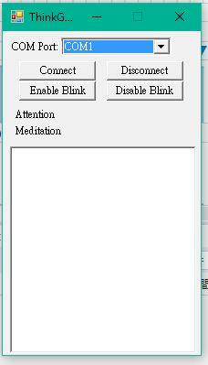

**程式碼：**

using System;

using System.IO.Ports;

using System.Threading;

using System.Windows.Forms;

using ThinkGearNET;//參考在lib資料夾的ThinkGearNET這個檔案

namespace FuckExample

{

public partial class Form1 : Form

{

private ThinkGearWrapper _thinkGearWrapper = new ThinkGearWrapper();//建立ThinkGearWrapper物件

public Form1()

{

InitializeComponent();

}

private void Form1_Load(object sender, EventArgs e)//讀取視窗

{

foreach(string port in SerialPort.GetPortNames())//foreach 迴圈，SerialPort.GetPortNames()取得電腦序列埠名稱

cboPort.Items.Add(port);//設定下拉式選單的內容

cboPort.SelectedIndex = 0;

}

private void btnConnect_Click(object sender, EventArgs e)//設定connect按鈕

{

_thinkGearWrapper = new ThinkGearWrapper();

// setup the event

_thinkGearWrapper.ThinkGearChanged += _thinkGearWrapper_ThinkGearChanged;

// connect to the device on the specified COM port at 57600 baud

if(!_thinkGearWrapper.Connect(cboPort.SelectedItem.ToString(), 57600, true))//當此連接阜不存在會跳出訊息

MessageBox.Show("Could not connect to headset.");

}

void _thinkGearWrapper_ThinkGearChanged(object sender, ThinkGearChangedEventArgs e)//抓取腦波attention&meditation的數值

{

// update the textbox and sleep for a tiny bit

BeginInvoke(new MethodInvoker(delegate

{

lblAttention.Text = "Attention: " + e.ThinkGearState.Attention;

lblMeditation.Text = "Meditation: " + e.ThinkGearState.Meditation;

txtState.Text = e.ThinkGearState.ToString();

}));

Thread.Sleep(10);

}

private void Form1_FormClosing(object sender, FormClosingEventArgs e)

{

_thinkGearWrapper.Disconnect();

}

private void btnDisconnect_Click(object sender, EventArgs e)

{

_thinkGearWrapper.Disconnect();

}

private void btnEnableBlink_Click(object sender, EventArgs e)

{

_thinkGearWrapper.EnableBlinkDetection(true);

}

private void btnDisableBlink_Click(object sender, EventArgs e)

{

_thinkGearWrapper.EnableBlinkDetection(false);

}

}

}