Design Document – Exercise 1

Wellness and Health Promotion Chatbot Based on an Open-Source LLM with RAG
Phase 4 - Advanced NLP Applications and Language Models

1. Problem Statement and Scope

1.1 Target Users
The chatbot is intended for university students and the general public interested in improving healthy lifestyle habits (sleep, physical activity, basic nutrition, and stress management), particularly individuals who do not have constant or immediate access to professional healthcare guidance and who seek reliable, fast, and easy-to-understand information.

1.2 Main Needs
- Obtain reliable information about healthy habits (sleep, exercise, nutrition, and stress management) without having to consult multiple scattered sources on the internet.
- Receive guidance available 24/7 in clear, non-technical language.
- Filter out the overload of unverified information circulating on social media and unreliable websites.
- Identify when a situation requires professional assistance rather than general informational support.

1.3 Specific Problems the Chatbot Will Address
- Difficulty in obtaining timely access to basic wellness and health-promotion guidance.
- Lack of a single point of access that consolidates recommendations based on recognized public sources (WHO, CDC, and open-access academic literature).
- Absence of mechanisms that warn users when they should seek professional help instead of relying solely on AI-generated information.

1.4 Scope and Explicit Limitations
The system provides educational information only on health promotion and general well-being based on public, non-sensitive sources. The chatbot does not diagnose medical conditions, does not prescribe medications or dosages, and does not replace consultation with a healthcare professional. In the presence of emergency situations or crisis indicators, the system activates an escalation protocol (see Section 2) instead of generating a free-form response from the language model.

2. User Stories and Interaction Flow

2.1 User Stories
- US1: As a university student with a demanding schedule, I want to receive quick recommendations to improve my sleep quality so that I can concentrate better on my studies.
- US2: As someone who is starting to exercise, I want to learn about WHO’s general physical activity recommendations so that I can begin a safe and progressive exercise routine.
- US3: As a user experiencing stress before exams or assignment deadlines, I want evidence-based stress management techniques so that I can apply them immediately.HU4 — Como usuario interesado en mejorar su alimentación, quiero recomendaciones generales sobre una dieta equilibrada, para adoptar hábitos alimenticios más saludables.
- US4: As a user interested in improving my diet, I want general recommendations about a balanced diet so that I can adopt healthier eating habits
- US5: As a user who submits an ambiguous query ("I feel unwell"), I want the chatbot to ask for clarification instead of inventing an answer so that I can receive information that is actually useful.

2.2 Common Use Cases
- Specific questions about sleep hygiene, general physical activity, basic nutrition, and relaxation techniques.
- Requests for summaries or lists of recommendations (e.g., "Give me 3 tips to sleep better").
- Follow-up questions within the same session that depend on the previous conversational context.

2.3 Edge Cases
- Ambiguous or incomplete queries ("I don't feel well", without additional context).
- Out-of-scope questions, such as requests for medical diagnoses, medication dosages, or interpretation of clinical test results.
- Messages that combine multiple unrelated topics within a single query.
- Colloquial language, regional expressions, or spelling errors that make interpretation more difficult.

2.4 Escalation Strategies
When the safety filter detects language associated with a potential emergency or crisis (for example, suicidal ideation, acute symptoms, or a medical emergency), the system bypasses free-form LLM generation and instead returns a fixed, verified response that recommends contacting crisis helplines or emergency services. The response explicitly states that the chatbot is not designed to handle crisis situations.
For out-of-scope requests (e.g., medical diagnoses or medication-related advice), the chatbot clearly communicates its limitations and recommends seeking guidance from a qualified healthcare professional.

3. Functional and Non-Functional Requirements

3.1 Functional Requirements

ID | Description
FR1 | The system must support multi-turn conversations while maintaining recent context (short-term memory).
FR2 | The system must retrieve relevant information from an external knowledge base before generating a response (RAG pipeline).
FR3 | The system must detect signs of emergencies or crisis situations and activate a fixed escalation protocol independently of the LLM.
FR4 | The system must log each interaction (query, response, metadata, and timestamp) for subsequent analysis.
FR5 | The system must allow model parameters (temperature, maximum tokens, top-k) to be configured through an external file without modifying the source code.
FR6 | The interface must visually distinguish between user and chatbot messages and display the conversation history.

3.2 Non-Functional Requirements
ID | Description
NFR1 (Responsiveness) | The target response time must be less than 8 seconds in a free-tier environment (Colab, Streamlit Community Cloud, or Hugging Face Spaces).
NFR2 (Robustness) | When faced with ambiguous questions, the system should request clarification instead of generating poorly grounded responses (hallucination reduction).
NFR3 (Privacy) | No personally identifiable information should be requested or stored; conversation logs must be anonymized.
NFR4 (Usability) | The interface must be simple and intuitive, providing clear messages about the chatbot’s purpose and limitations.
NFR5 (Maintainability) | The codebase must be modular, well-documented, and use centralized configuration through a single file.
NFR6 (Portability / Cost) | The entire solution must be deployable using exclusively free and open-source tools.

4. Architecture Diagram
The architecture is organized into five layers: presentation (frontend), application (backend/orchestration), language model, memory (short-term and long-term), and the Retrieval-Augmented Generation (RAG) pipeline supported by an external knowledge base. Configuration files feed both the backend and frontend components, while the logging module captures every interaction for subsequent analysis and evaluation.

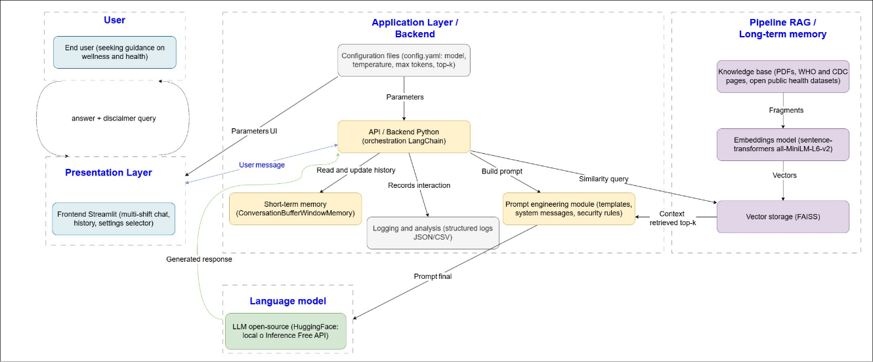

4.1 Component Description
- LLM: An instruction-tuned open-source language model, executed either locally (using Transformers) or through a free endpoint (Hugging Face Inference API).
- Embedding Model: sentence-transformers/all-MiniLM-L6-v2, which converts text into vector representations for semantic search.
- Vector Store: FAISS, used to store knowledge base embeddings and perform similarity searches (top-k retrieval).
- Memory Layer: Short-term memory (sliding window buffer) and an optional user profile mechanism for long-term memory.
- API/Backend: Orchestrates the application logic using LangChain and constructs the final prompt by combining system instructions, retrieved context, and conversation history.
- Frontend: A Streamlit-based interface for conversational interaction.
- Logging and Analytics: Stores each interaction in a structured log format (CSV/JSON) without collecting sensitive data.
- Configuration Files: Centralize model and interface parameters (e.g., config.yaml).

5. Technology Stack Selection
The technology stack was selected based on the following priorities:
- Zero cost
- Ability to run on free Google Colab resources
- Maturity and documentation of the libraries
- Suitability for the project scope

Component | Justification
Python | Primary language of the AI and NLP ecosystem, with extensive support for scientific computing and machine learning libraries.
LangChain | Orchestrates conversational memory, RAG pipelines, and integration with multiple open-source LLMs through a consistent interface; offers extensive documentation and an active community.
sentence-transformers | Lightweight embedding model (~80 MB), capable of running on CPU, with strong performance for semantic similarity tasks in both Spanish and English.
FAISS | Free and efficient vector store developed by Meta AI; suitable for small- to medium-sized knowledge bases without requiring cloud services.
Hugging Face Transformers / Inference API | Provides free access to open-source models, enabling either local execution in Colab or remote inference through a free endpoint, satisfying the project's restriction against paid APIs.
Streamlit | Lightweight framework for building conversational interfaces (st.chat_message, st.chat_input) with free deployment on Streamlit Community Cloud.

Alternatives Considered and Rejected:
- Gradio: Streamlit was preferred due to its native chat history management and simpler deployment process.
- LlamaIndex / Haystack: Rejected because of their steeper learning curve relative to the project's scope.
- Pinecone / Weaviate: Cloud-based services requiring registration and subject to usage limitations; local FAISS was preferred because it is completely free and has no external dependencies.

6. Model Selection and Licensing

6.1 Language Model (LLM)
- Primary Model (Local Execution in Colab):Qwen2.5-1.5B-Instruct Licensed under Apache 2.0 (commercial and research use permitted). Its relatively small size (1.5 billion parameters) enables execution on free Colab CPU/GPU resources while providing instruction-following capabilities.
- Alternative Model (via Free Hugging Face Inference API): Models such as Mistral-7B-Instruct or Zephyr-7B-Beta — Licensed under Apache 2.0 or MIT, offering higher response quality at the cost of requiring remote inference endpoints due to their larger size.

6.2 Embedding Model
- sentence-transformers/all-MiniLM-L6-v2 — Licensed under Apache 2.0, producing 384-dimensional embeddings and providing an effective balance between retrieval quality and computational efficiency for semantic search tasks in RAG systems.

6.3 Limitaciones
- Smaller models may exhibit lower coherence in lengthy responses or complex reasoning tasks compared to larger commercial models.
- Under no circumstances should these models be used for clinical diagnosis or personalized treatment recommendations.
- They must be supported by both the RAG pipeline and a carefully designed system prompt to reduce the risk of hallucinations in health-related contexts.

6.4 Suitability for the Use Case
The selected models are capable of following clear instructions (instruction-tuned), are lightweight enough to run on free infrastructure (Google Colab and the free Hugging Face Inference API), and are distributed under permissive licenses (Apache 2.0 and MIT) that allow educational and research use without restrictions that would hinder the development of this academic project.

