
MSCC Operator's Guide
Windows
Multus SDR Control Console for Proficio, Geminus and Ultimus transceivers
Windows local operation · MSCC 10.31.2 (installer R10.31.2)
Release 1 (DRAFT) · Revision date 11/1/26
Copyright © 2026 Multus SDR, LLC

About this guide
This guide covers installing and using MSCC, the Multus SDR Control Console, on a Windows PC with the radio plugged into that PC ("Windows local"). Remote operation and Linux / Raspberry Pi have their own guides.
It is written for MSCC 10.31.2 (installer mscc-net9-R10-31-2-install.exe). If your title bar shows a later number, most of this still applies.
How the guide is laid out. Chapters 1 to 3 get you installed and on the air. Chapter 4 shows how to operate (SSB, CW, digital and so on). Chapters 5 and 6 describe every control, by the name printed on it. Chapter 7 is calibration, in the order you should do it. Chapter 8 is troubleshooting.
What changed since Release 0. Calibration is now stored in the radio itself (QRP power, TX I/Q and RX I/Q), so a radio keeps its calibration when you move it to another PC. The TX IQ tab has a new PHASE control. The ALC switch is gone (ALC is always on). The S/W window has SMOOTHING instead of REFRESH. The chapters have been put in the order you need them.
DRAFT: DRAFT. Gray boxes like this one mark things still to confirm or pictures to retake. They are collected in Appendix C. Remove them before release.

Contents
1. What MSCC is 5
1.1 The two parts 5
1.2 What is kept where 5
1.3 Words used in this guide 6
1.4 Getting help 6
2. Installing and first start 7
2.1 What you need 7
2.2 Install the Microsoft .NET 9 runtime (once per PC) 7
2.3 Install MSCC 7
2.4 Install the USB driver with Zadig (first Multus radio on this PC) 8
2.5 First start 9
2.6 Check the radio's firmware 11
3. Updating the radio firmware 12
4. Operating 15
4.1 Connecting and disconnecting 15
4.2 Tuning 15
4.3 Receiving 16
4.4 Transmitting: the basics 16
4.5 SSB voice 16
4.6 CW 17
4.7 AM and FM 17
4.8 Digital modes (WSJT-X) 17
4.9 Using an amplifier 18
4.10 Favorites 18
5. The main window 19
5.1 Left rail 20
5.2 Meters and VFOs 21
5.3 Band buttons and tabs 22
5.4 MAIN tab: spectrum and waterfall 23
5.5 Right rail 23
6. The other tabs and windows 25
6.1 CW tab 25
6.2 RX/TX tab 26
6.3 FAVORITES tab 26
6.4 SETTINGS tab 26
6.5 Spectrum / Waterfall Controls window (S/W) 28
6.6 Debug Log window 30
6.7 Remote Audio window 30
6.8 Choose Color window 31
7. Calibration 32
7.1 What to calibrate, and in what order 32
7.2 FREQ CAL (frequency calibration) 32
7.3 RX IQ (receive image balance) 34
7.4 QRP CAL (power calibration; AMP must be off) 35
7.5 TX IQ (transmit image balance; AMP must be off) 37
7.6 AMP CAL (AMP must be on) 38
7.7 Save settings 38
7.8 Resetting calibration to factory values 39
8. Troubleshooting 40
Appendix A: For support: where files are kept 41
Appendix B: Using this PC as a host for a remote operator 42
Appendix C: Draft notes (remove before release) 43

1. What MSCC is
MSCC is the control program for Multus SDR, LLC transceivers: Proficio, Geminus and Ultimus, in both Legacy and MKII versions. It works only with Multus SDR equipment.
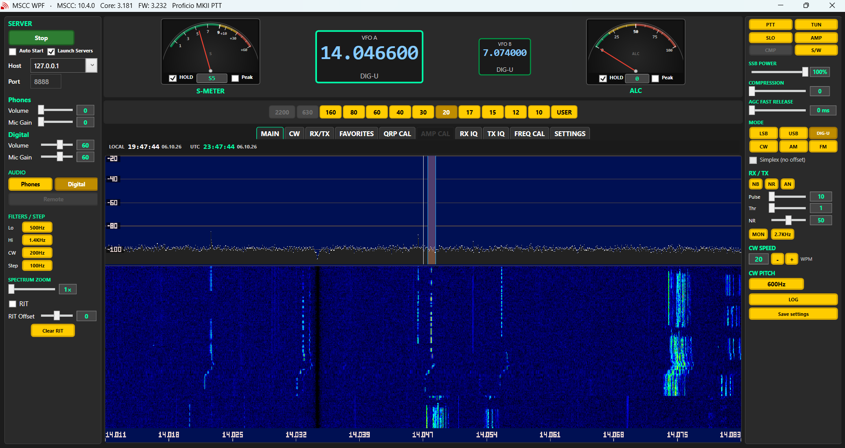
The MSCC window, MAIN tab

1.1 The two parts
- The servers. Small programs that talk to the radio over USB and do the receive and transmit signal processing. They run on the PC the radio is plugged into.
- The client. The window you operate from, called MSCC for Windows. It starts the servers for you when you press Start.
The client and the servers talk over the network, even when both run on the same PC. That is why the client can also run on another computer ("remote"; see the Remote guide).

1.2 What is kept where
This matters when you calibrate, move the radio to another PC, or reinstall.
What | Kept in | Notes
QRP power calibration | The radio (and a copy on the PC) | Stored in the radio when you accept a band on QRP CAL.
TX I/Q (image balance) | The radio (and a copy on the PC) | Stored in the radio when you press APPLY on TX IQ.
RX I/Q (image balance) | The radio (and a copy on the PC) | Stored in the radio when you press APPLY on RX IQ.
AMP calibration | The PC only | Save settings keeps a copy for this radio. Redo it (or copy the files) on another PC.
Frequency calibration (FREQ CAL) | The PC only | One value per PC, not per radio. Recheck it when you change radios.
Keyer settings and CQ memories | The radio | Written by the CW tab.
Frequencies, modes, filters, colors, favorites | The PC | Your Windows user profile.

When the servers start, values stored in the radio win. A band the radio has no value for uses the file on the PC, or the factory value for your radio model if there is no file.

1.3 Words used in this guide
Word | Meaning
Client | The MSCC window you operate from.
Servers | The programs that run the radio (see 1.1).
Host | The PC the radio is plugged into and the servers run on. For Windows local this is your PC, address 127.0.0.1.
QRP | Barefoot: the radio alone, up to 5 W. Same as AMP off.
AMP | An external amplifier in line. AMP on makes the radio use the AMP CAL power table so it doesn't overdrive the amplifier. (The RX/TX tab calls this button Full Power.)
TUN / TUNE | A steady carrier for your tuner or amplifier, at Tune Power.
Phones | The local audio path: your speaker or headphones and microphone. Settings calls these the Operator (phones) devices.
Digital | The audio path for WSJT-X, fldigi and similar programs, through a virtual audio cable.
DIG-U | Upper sideband for digital modes. Selecting it switches audio to Digital.
VAC | Virtual audio cable, for example VB-Audio CABLE. It connects MSCC's audio to a digital program. Not supplied with MSCC.
CAT | Computer control of the radio by a logging or digital program (frequency, mode, PTT). MSCC looks like a Kenwood TS-2000.
Virtual serial pair | Two linked COM ports, for example made with com0com. MSCC uses one end, your digital program the other. Not supplied with MSCC.
Image | A weak mirror copy of a signal, 24 kHz away from it. RX IQ (receive) and TX IQ (transmit) remove it.
ALC | Automatic level control. It stops the transmit audio from overdriving the radio. Always on.
USER / GEN | The band button for general coverage and time stations (WWV, CHU and others).
Save settings | The right-rail button that keeps a copy of this radio's calibration on the host (see 7.7).

1.4 Getting help
Post questions, bug reports and feature requests on the Multus forum: https://multussdr.groups.io/g/main/topics. Include the log files (see 8.13).

2. Installing and first start

2.1 What you need
- A Windows PC with a free USB port, and the radio's USB cable.
- A speaker or headphones. This is the only audio device MSCC needs.
- A microphone, to transmit voice (optional).
- A mouse with a wheel. MSCC has no menus or keyboard shortcuts; the wheel does the tuning.
- For calibration: a 50 Ω dummy load rated 5 W or more and a wattmeter. For TX IQ, a second receiver.
- For digital modes: a virtual audio cable and, for CAT, a virtual serial pair (see 1.3). MSCC does not install these.

2.2 Install the Microsoft .NET 9 runtime (once per PC)
MSCC needs this free Microsoft software.
1. Go to https://dotnet.microsoft.com/en-us/download/dotnet/9.0.
2. Find the heading .NET Desktop Runtime 9.0 (the number after 9.0 changes as Microsoft releases updates; any 9.0 version is fine).
3. In its Windows row, under Installers, download and run both the x64 and the x86 installer. MSCC may not start unless both are installed.
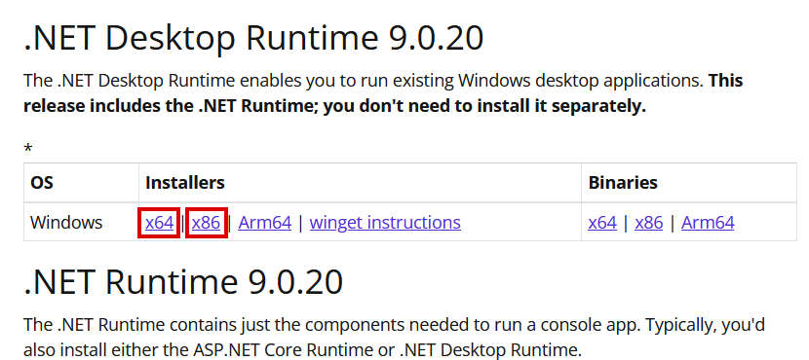
The .NET 9.0 download page: under .NET Desktop Runtime 9.0, Windows row, download both x64 and x86 (boxed in red)
The Desktop Runtime includes the plain ".NET Runtime", so you don't need that separately. If a runtime is already installed, its installer offers Repair or Uninstall instead; just close it.

2.3 Install MSCC
Run the newest installer you were given, for example mscc-net9-R10-31-2-install.exe. It installs the client and the Windows servers, normally in C:\mscc-net9, and puts an MSCC-NET9 shortcut on the desktop.
Note: How to read the version name. In mscc-net9-R10-31-2, net9 means it runs on .NET 9, and R10-31-2 is the release: month 10 (October), day 31, second build that day. A later date is newer. The window title bar shows the same number as 10.31.2.

To upgrade later, run the newer installer over the old one. Your settings in %LocalAppData%\MSCC-NET9 are kept; you don't need to delete anything.

2.4 Install the USB driver with Zadig (first Multus radio on this PC)
Each Windows PC needs the Multus SDR Control driver, installed once with Zadig. Do this the first time you connect a Multus radio to the PC.
1. Plug the radio's USB cable into the PC and power the radio off and on.
2. The radio appears in Windows Device Manager as a sound card named Multus IQ Sound (under Sound, video and game controllers). Windows installs it by itself.
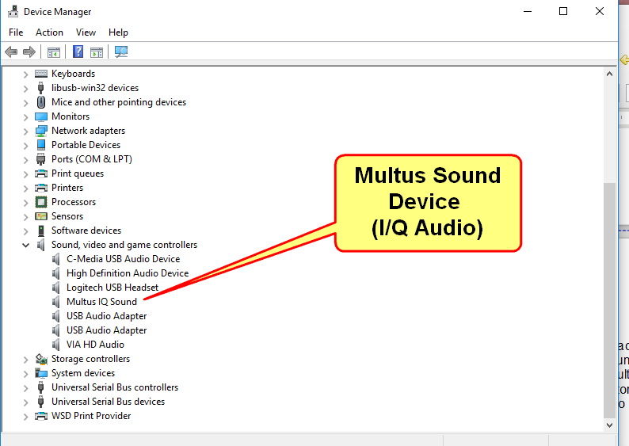
Device Manager: the radio's sound device
⚠ Don't run Zadig on the Multus IQ Sound device. It is the radio's I/Q link and must keep its Windows driver. Never pick it as a speaker or microphone either (MSCC hides it from its audio lists).

3. The radio also shows a Multus-Control device under Other devices, with no driver yet.
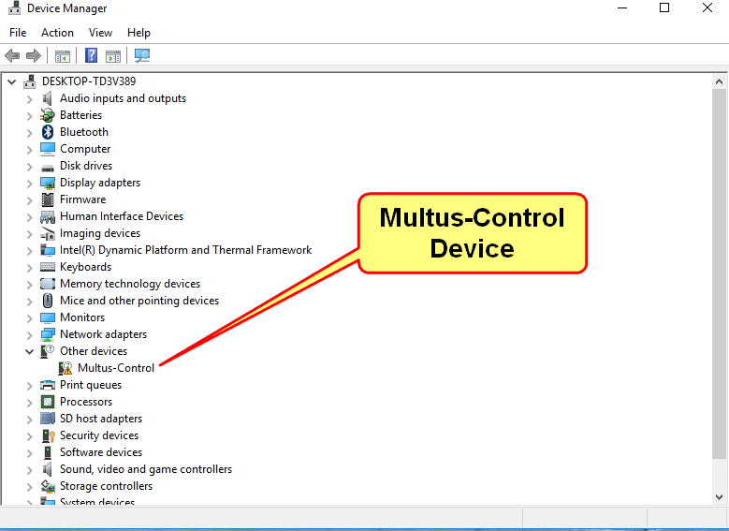
Device Manager before the driver: Multus-Control under Other devices
4. Download the current Zadig from https://zadig.akeo.ie/ and start it.
5. Multus SDR Control should show in Zadig's device box. If it isn't listed, click Options → List All Devices and choose it from the list. The driver box should show libusb-win32. Click Install Driver.
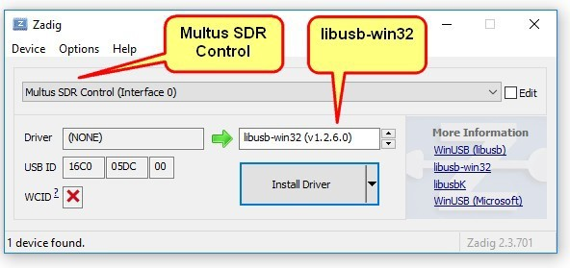
Zadig: Multus SDR Control, libusb-win32, Install Driver
6. When the driver installs, Zadig closes by itself. Device Manager now shows Multus SDR Control (Interface 0) under libusb-win32 devices.
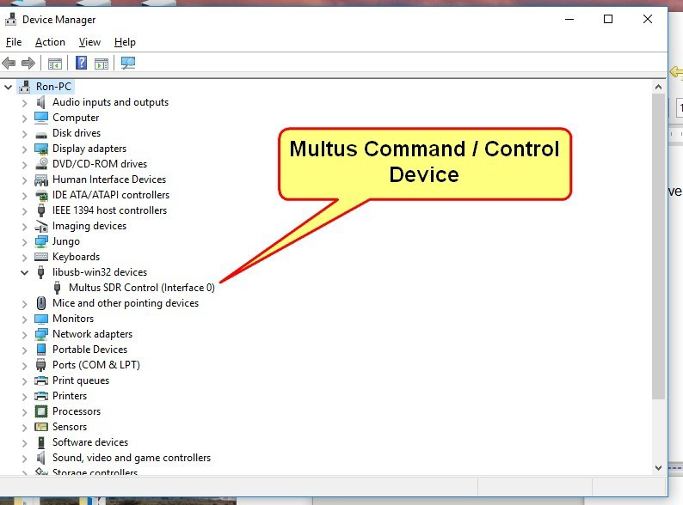
Device Manager after Zadig

2.5 First start
1. Plug in the radio and power it on.
2. Start MSCC from the MSCC-NET9 desktop shortcut. The first time, MSCC copies a starter set of settings into your Windows profile.
3. Windows Firewall asks "Do you want to allow public and private networks to access this app?" for MSCC.Wpf (the MSCC window). Click Allow.
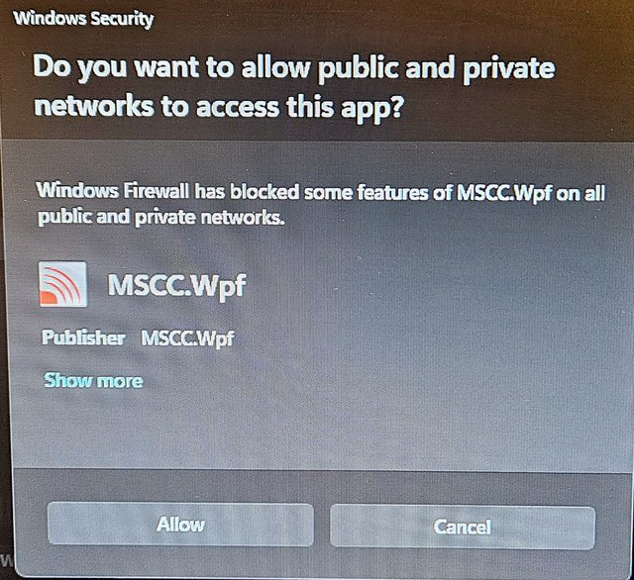
First open: the Windows Firewall prompt for MSCC.Wpf. Click Allow.
4. Open the SETTINGS tab and set the audio devices (6.4):
- Operator (phones) Out: your speaker or headphones. This is the only setting MSCC needs before Start.
- Operator (phones) Mic: your microphone. Needed to transmit voice. You can leave it at (none) and still receive, send CW and TUNE.
- Digital Out and Digital Mic: your virtual audio cable, if you run WSJT-X or fldigi. Otherwise leave them at (none).
- COM Port (optional): the serial port for CAT. Leave it blank if you don't use CAT.
5. Press Start at the top of the left side. Anything you haven't set yet is listed in an orange setup note under Start; it is only a reminder.
6. The first time you press Start, Windows Firewall asks the same question for each server: mscc-trans.exe, mscc-recv.exe and ms-sdr-mkii.exe. Click Allow on each, whether or not this PC will ever serve a remote operator.
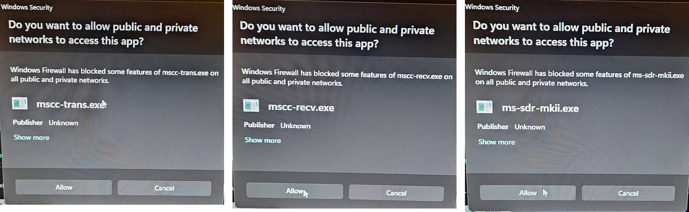
First Start: the firewall prompts for the three servers. Click Allow on each.
When the radio is connected, Start turns green and reads Stop, and the title bar shows your radio model and its firmware version (FW), for example FW: 3.242 Proficio MkII PTT. The FW number is the one to check in 2.6.
Only one copy of MSCC can run at a time ("MSCC is already running"). The window remembers its size and position, and your frequencies, modes, filters and display settings are remembered between sessions.

2.6 Check the radio's firmware
The radio's firmware must match this version of MSCC. After you connect, compare the FW number in the title bar with this table. If yours is lower, update it (Chapter 3).
Radio | Firmware
Proficio Legacy | 1.236
Geminus MKII | 2.153
Proficio MKII PTT | 3.242
Proficio MKII ATU | 4.243
Geminus Legacy | 5.120
Ultimus Legacy | 6.236
Ultimus MKII ATU | 7.243
Ultimus MKII PTT | 8.242

DRAFT: Confirm with Stew which firmware files installer R10.31.2 ships in C:\mscc-net9\PSoC Firmware, and that these numbers match them (MKII ATU 4.243 and the Ultimus MKII files were built 10-31 but not flashed yet).

The firmware files come with the installer, in C:\mscc-net9\PSoC Firmware, one folder per radio. Each file is named for the radio and date, for example Proficio-MKII-PTT-20261031.cyacd. If you were given a newer file, use it.

3. Updating the radio firmware
The radio's processor (a Cypress PSoC) holds two programs: the application, which is the radio firmware you update, and a small bootloader ("LOADER") that you normally never touch. Updating with a .cyacd file never changes the bootloader. Your calibration is kept.
DRAFT: Confirm that calibration stored in the radio survives a firmware update on every radio.

You need the radio, its USB cable plugged into the PC, and the .cyacd file for your radio (2.6).
⚠ Don't interrupt a firmware update. Once you click Program, don't unplug the USB cable, turn off the radio or close the program until the success message appears. It takes only a few seconds.

1. Stop MSCC (press Stop, then close the window).
2. Power the radio off. Always move the shunt (jumper) with the radio off. Leave the USB cable connected.
3. Put the shunt on the boot pins. Find the 3-pin BOOT1 header (labeled on the board). A small "U" printed on the board joins two of its pins: those are the boot pins. Put the plastic shunt across those two pins. The header's location differs by radio; on the Geminus MKII below it sits just right of connector P1, above U19.
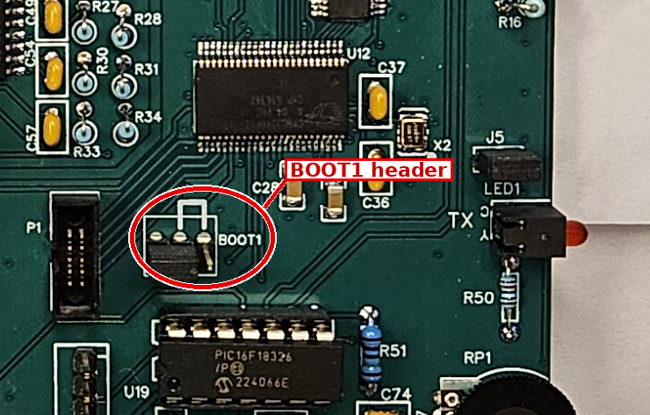
Example: Geminus MKII board, BOOT1 header circled
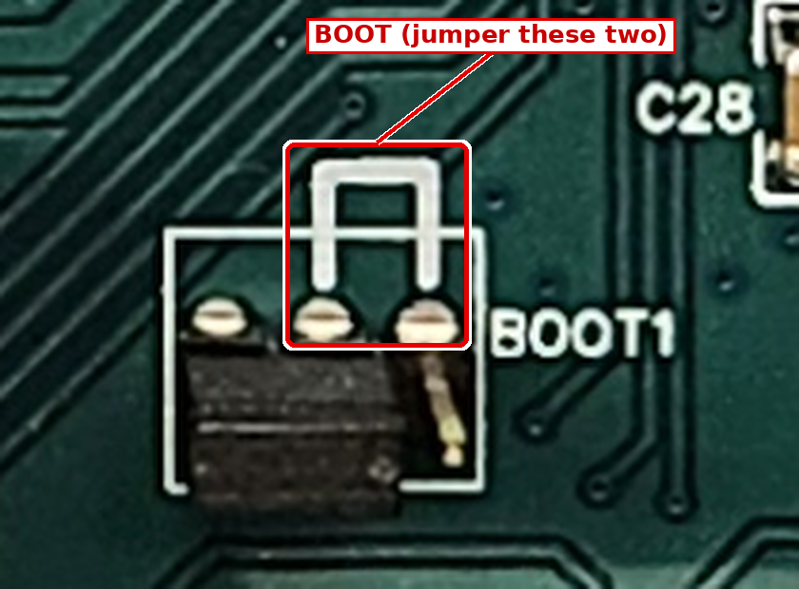
Close-up: the printed U joins the two boot pins
Note: The other pins are just grounds. The radio doesn't need a shunt to operate, and a shunt on the wrong pins doesn't hurt anything.

4. Power the radio on. The LED should blink LOADER in Morse code (very old firmware blinked "BOOT"). If it doesn't, the shunt is on the wrong pins: power off, move it, try again.
5. Start the upload program: bootloader.exe in C:\mscc-net9\utilities. Its window is titled USB Bootloader Host.
6. Wait for Connected. The USB HID State box (top right) must show Connected. If it doesn't, check the USB cable and that the LED blinks LOADER. Leave Vendor ID (4b4), Product ID (b71d) and Security Key (all zeros) as they are.
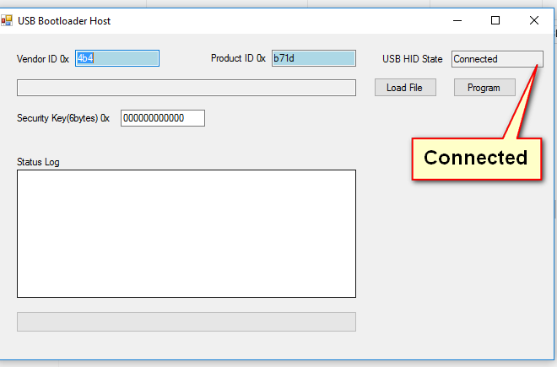
USB Bootloader Host, connected to the radio
7. Choose the file. Click Load File, go to C:\mscc-net9\PSoC Firmware, open the folder for your radio, pick the .cyacd file and click Open. The path shows in the long box. (The path in the picture is from an older install.)
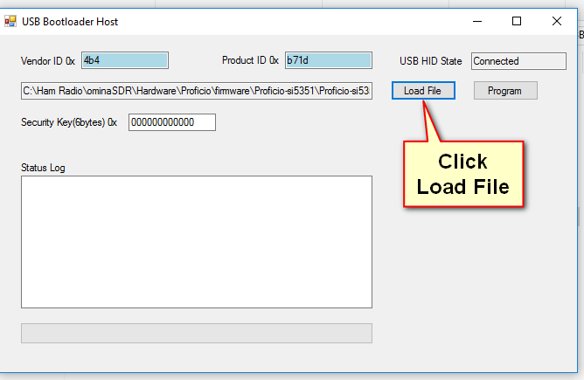
Click Load File and pick the .cyacd file for your radio
8. Click Program. In a few seconds the Status Log shows Bootload successful !! and the progress bar fills green.
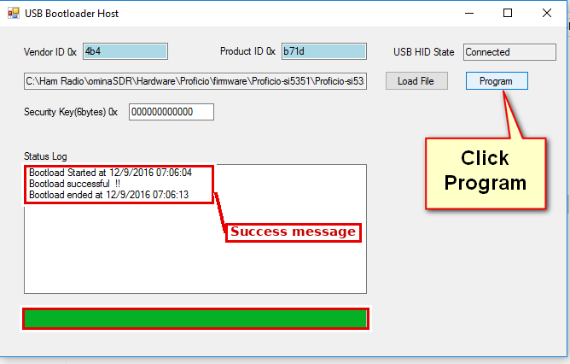
Update finished
9. Take the shunt off the boot pins. Power the radio off and remove the shunt (or park it on a single pin so it doesn't get lost). Power the radio on.
10. Check the version. Close bootloader.exe, start MSCC, press Start. The title bar should show the new FW number.

4. Operating
This chapter shows how to do things. Chapter 5 describes each control in detail.

4.1 Connecting and disconnecting
- Press Start (top of the left rail). With Launch Servers checked (normal for Windows local), MSCC starts the servers on this PC and connects. Start turns green and reads Stop.
- Press Stop to end the session. It closes only the servers this copy of MSCC started. Closing the window does the same.
- Tick Auto Start to have MSCC press Start for you whenever it opens.
- Host is the servers' address: 127.0.0.1 for Windows local. Port is 8888. After changing Host or Port, press Stop, then Start.
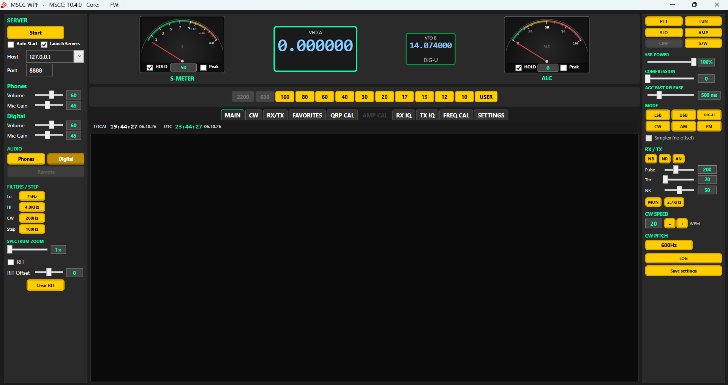
MSCC before Start: VFOs read 0.000000, the spectrum is empty and the title bar shows no FW number yet

4.2 Tuning
- Pick a band with the band buttons above the tabs. Each band button returns to the frequency, mode and filters you last used there, separately for VFO A and VFO B.
- VFO digits: point at a digit and roll the mouse wheel. That digit changes and the digits to its right go to zero. Over the 1 kHz digit you tune in 1 kHz steps.
- Spectrum: left-click a signal to tune to it. On the MAIN tab, rolling the wheel anywhere that isn't a control tunes VFO A by the Step value (left rail).
- VFO A / VFO B: click a VFO to make it the active one (bright border).
- RIT: tick RIT on the left rail and move RIT Offset (±500 Hz) to move the receiver without moving your transmit frequency. Clear RIT sets it back to 0.
- General coverage and time stations: the USER band button. The first click goes to general coverage; each further click steps through WWV 5/10/15/20 MHz, CHU 3.330/7.850 MHz, RWM 9.996 MHz and your own last general-coverage frequency (Geminus: 198, 660 and 880 kHz).

4.3 Receiving
- Filters: Lo and Hi (left rail) set the low and high edges of the receive filter; CW sets the CW bandwidth. Each click moves to the next value. They are remembered for each mode and band.
- AGC: the SLO / MED / FST button cycles the AGC speed. AGC FAST RELEASE sets how fast it recovers (default 500 ms).
- Noise blanker (NB) removes short pulses such as ignition or power-line clicks. Thr sets how far above the normal signal level a pulse must be before it is blanked: a higher Thr blanks less, a lower Thr blanks more but can distort strong signals. Pulse sets how long each blank lasts: wider removes longer pulses but can make the audio choppy. Turn NB off when you don't need it.
- Noise reduction (NR) lowers steady background hiss. NR level (0-100) sets the strength. Start around 50 and use the lowest level that helps; too much makes voices sound watery.
- Automatic notch (AN) removes steady carriers (tuners-up, heterodynes) from the audio.
- Spectrum zoom (left rail, 1×-4×) magnifies the spectrum and waterfall around your frequency. Use the cursor readout, not the axis labels, for exact frequencies.
DRAFT: The Windows receive server still has the old noise reduction (an adaptive filter that can distort at high levels). The Pi has a new one (spectral subtraction, recv 3.151). Update this paragraph when Windows gets it.

4.4 Transmitting: the basics
- Power slider (right rail): the label follows what you are doing (TUNE POWER, CW POWER, AM CARRIER, FM POWER or SSB POWER). The number is not watts: it is a percentage of the power you set on QRP CAL. 100 % = the 5 W you calibrated.
- QRP or AMP: AMP off (normal) = the radio alone, up to 5 W. Turn AMP on only with an amplifier in line (4.9).
- ALC is always on. It keeps your audio from overdriving the radio. Watch the ALC meter while you set mic gain or digital level.
- PTT (right rail) keys the transmitter; it is red while on. It is grayed if a hardware PTT or a CAT program has taken over transmit.
- With no microphone set, PTT in LSB, USB, AM or FM shows "Set up audio (Mic) in the Settings tab to transmit voice." and doesn't key. In DIG-U with no Digital Mic set it asks for that instead. TUN and CW always work.
- TUN sends a steady carrier at Tune Power for your tuner or amplifier. Click again to go back.
- SWR fault: if the optional external SWR meter (6.4) reports a fault, the reading box under the S-meter turns into a red RESET button and transmit is blocked until you click it.
DRAFT: ALC target: Release 0 said "set the level so the ALC meter is just into the yellow". With the new ALC ceiling and Stew's peak meter, what should the operator aim for? (Ask Stew.)

4.5 SSB voice
1. Pick the band and LSB or USB (LSB below 10 MHz, USB at 10 MHz and above, by habit).
2. Set SSB POWER (right rail) to the power you want, as a percentage of 5 W.
3. Make sure the Phones audio path is selected (left rail, AUDIO).
4. Key with PTT (or your footswitch / hand mic) and speak normally. Set Phones Mic Gain (left rail) so the ALC meter moves on voice peaks without pinning.
5. CMP turns the speech compressor on; COMPRESSION (0-24) sets how much. More compression gives more average power but more background noise.
6. TX BW (2.4 / 2.7 / 3.0 / 5.5 kHz) sets the transmit bandwidth. 2.4 or 2.7 kHz is normal.
7. MON lets you hear your own transmit audio.

4.6 CW
1. Select CW. Plug your paddle into the radio's Key jack (MKII radios have a built-in keyer).
2. Set CW POWER, CW SPEED (5-60 WPM) and CW PITCH (400 / 600 / 800 / 1000 Hz) on the right rail.
3. Set the CW bandwidth with the CW filter button (200 Hz / 400 Hz / 1.8 kHz).
4. Keyer mode, spacing, paddle direction, weight and HOLD are on the CW tab (6.1). The CW carrier is keyed by the radio; PTT is not used.
5. CQ memories: type a message in one of the four slots on the CW tab (up to 48 characters), press R to store it in the radio, and P to send it once. Touch the paddle to stop it.
Using an external keyer, or a Legacy radio? Tick Use external electronic keyer (legacy) on the CW tab and let MSCC restart the servers.

4.7 AM and FM
- AM: set AM CARRIER on the power slider. The receive filter is ± the Hi value around the carrier.
- FM is narrow FM. By default it transmits 100 kHz below the receive frequency (repeater split), shown on VFO B. Tick Simplex (no offset) to transmit on the receive frequency. Set FM POWER on the power slider.

4.8 Digital modes (WSJT-X)
MSCC looks like a Kenwood TS-2000 to your digital program; that is how the program sets frequency and mode and keys the transmitter (CAT). Audio goes through a virtual audio cable.
One-time setup
1. Install a virtual audio cable (for example VB-Audio CABLE) and, for CAT, a virtual serial pair (for example com0com). MSCC doesn't supply these.
2. In MSCC SETTINGS: Digital Out = the cable's input (for example CABLE Input), Digital Mic = the cable's output (for example CABLE Output), COM Port = your end of the serial pair. Press Stop, then Start.
3. In WSJT-X:
WSJT-X setting | Value
Rig | Kenwood TS-2000
Serial port | The other end of the virtual serial pair
Baud / handshake | 9600, none
PTT method | CAT
Mode | None (select DIG-U yourself in MSCC)
Split | None
Audio Input | CABLE Output
Audio Output | CABLE Input

4. In WSJT-X click Test CAT, then Test PTT.
Each session
1. In MSCC select DIG-U. The audio path switches to Digital for you (leaving DIG-U puts back what you had).
2. Choose a Hi filter. In DIG-U you can narrow it to 1.4k or 1.0k.
3. Put the WSJT-X TX tone around 1500 Hz, inside the TX filter.
4. Press Tune in WSJT-X and set Digital Mic Gain (left rail) so the ALC meter shows the level you want (see the note in 4.4). Digital Volume sets the receive level going to WSJT-X.
5. Compression is off on the Digital path.

4.9 Using an amplifier
The radio has two power tables: QRP (barefoot, up to 5 W) and AMP (the drive your amplifier needs). AMP on the right rail switches between them (the RX/TX tab shows the same switch as QRP / Full Power).
⚠ Don't overdrive your amplifier. Multus amplifiers give full output with about 75 % of the radio's power. The full 5 W QRP output overdrives them. Calibrate the AMP table for each band first (7.6), and always turn AMP on when the amplifier is in line. A band with no AMP calibration gets the full QRP drive.

- AMP on and AMP off each remember their own Tune Power.
- QRP CAL and TX IQ need AMP off; AMP CAL needs AMP on. MSCC grays the tabs you can't use.
- POTENTIA / QSK (CW tab) is for Potentia 50 / 100 amplifiers only (6.1).

4.10 Favorites
The FAVORITES tab stores named settings for each band: frequency, mode, filters and VFO. Type a name (up to 32 characters), press SAVE; pick one from the list and press RECALL; DELETE removes it. Each band has its own list, so "FT8" on 20 m and "FT8" on 15 m are separate. Favorites are kept on this PC only.
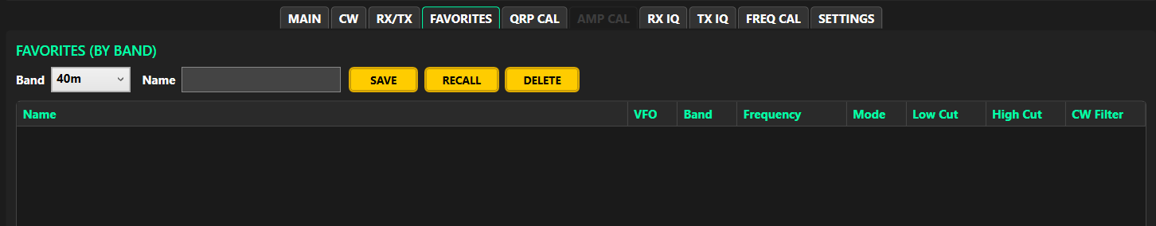
FAVORITES tab

5. The main window
The main window: left rail, center (meters, VFOs, bands, tabs) and right rail
The window has three columns. Both rails stay visible on every tab.
- Left rail: connection, audio, filters, zoom and RIT.
- Center: meters and VFOs at the top, the band buttons, then the tabs.
- Right rail: the operating controls (PTT, TUN, modes, noise controls, CW).
Button colors: bright gold = off; darker gold with white text = on or selected; red = transmitting, or a transmit switch that is on (PTT, TUN, AMP, calibration TX); gray = not available right now.
Mouse wheel: over a slider, one notch moves it one small step. Over a VFO digit it tunes that digit.
The controls below are listed by the name printed on them, top to bottom.

5.1 Left rail
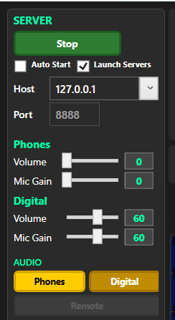
Left rail, top
Start / Stop | Connects to the radio, and starts the servers first if Launch Servers is checked. Green "Stop" while connected (4.1).
Setup note (orange) | Lists what isn't set up yet: COM port not found, no Operator Mic (voice transmit off), no digital devices. Only a missing Operator Out stops Start; MSCC then offers to open Settings. Hidden when all is set.
Auto Start | Presses Start automatically when MSCC opens.
Launch Servers | Checked: Start also runs the servers on this PC (normal). Unchecked: Start only connects to servers that are already running. Checking it turns Remote off.
Host | The servers' address (127.0.0.1 for local). Press Enter or click elsewhere to accept; then press Stop and Start. The arrow next to it lists recent hosts.
Port | Server port, normally 8888. Locked while connected.
Phones Volume / Mic Gain | Headphone or speaker volume, and microphone gain, for the Phones path (0-100). Saved on the host a few seconds after you stop moving them.
Digital Volume / Mic Gain | Receive level to your digital program and transmit level from it (0-100). Grayed while Remote is on.
AUDIO: Phones | Use your speaker or headphones and microphone.
AUDIO: Digital | Use the virtual audio cable. Compression turns off. Selecting DIG-U switches to Digital for you.
Remote | Makes this PC the operator position for a radio on another computer, and opens the Remote Audio window (6.7). Grayed when Launch Servers is checked or Host is 127.0.0.1. See the Remote guide.

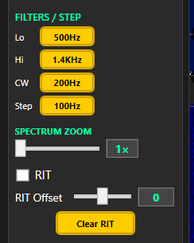
Filters, step, zoom and RIT
Lo | Low edge of the receive filter. Each click: 75 → 100 → 200 → 300 → 500 Hz, then back to 75.
Hi | High edge of the receive filter. DIG-U: 1.0k → 1.4k → 2.4k → 2.7k → 3.0k → 4.0k → 5.5k (1.0k and 1.4k are DIG-U only). Other modes: 2.4k → 2.7k → 3.0k → 4.0k → 5.5k. In AM the filter is ± the Hi value around the carrier; FM always uses at least ±5.5 kHz.
CW | CW bandwidth: 200 Hz → 400 Hz → 1.8 kHz. Lo, Hi and CW are remembered for each mode and each band.
Step | Mouse-wheel tuning step on the MAIN tab: 1 Hz to 100 kHz.
SPECTRUM ZOOM | Magnifies the spectrum and waterfall around your frequency (1×-4×).
RIT | Turns the receive offset on for the selected VFO.
RIT Offset | -500 to +500 Hz; the wheel moves it 10 Hz per notch.
Clear RIT | Turns RIT off and sets the offset to 0.

5.2 Meters and VFOs
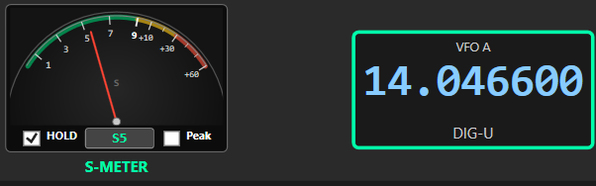
S-meter and VFO A
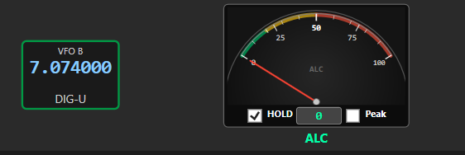
VFO B and the ALC meter
S-meter | Received signal strength. With the optional external SWR meter (6.4), it shows forward power while you transmit and the reading box shows SWR.
Reading box | S units (S9, S9+10) or dBm: click it to switch; the choice is remembered. Shows SWR on transmit. On an SWR fault it becomes a red RESET button; transmit is blocked until you click it.
HOLD | The needle falls back slowly. On by default.
Peak | An orange peak needle holds the highest reading for about 2 seconds.
Meter label | S-METER, FWD / SWR or SWR FAULT.
VFO A / VFO B | Click to make active (bright border). Point at a digit and roll the wheel to tune. Each VFO remembers its own band. In FM repeater mode VFO B shows the transmit frequency.
RIT readout | The RIT offset in Hz (yellow), shown only while RIT is on.
Mode | The VFO's mode: LSB, USB, DIG-U, CW, AM, FM or TUNE.
ALC meter | Transmit ALC level; rests at zero on receive. HOLD, reading box and Peak work as on the S-meter.

5.3 Band buttons and tabs
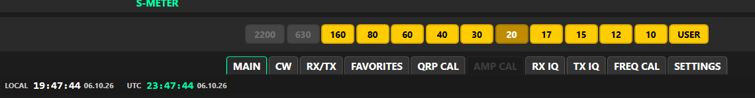
Band buttons, tab strip and clock
Band buttons | 2200, 630, 160, 80, 60, 40, 30, 20, 17, 15, 12, 10 and USER. Bands your radio can't use are grayed: Proficio and Ultimus are HF (160-10 m), Geminus is LF/MF (2200 m and 630 m). First visit: 2200 m 136.000 kHz, 630 m 474.200 kHz, 160 m 1.800, 80 m 3.500, 60 m 5.350, 40 m 7.000, 30 m 10.100, 20 m 14.000, 17 m 18.100, 15 m 21.000, 12 m 24.900, 10 m 28.000 MHz. After that each returns to your last settings there.
USER | General coverage and time stations (4.2). Good references for FREQ CAL.
Tabs | MAIN, CW, RX/TX, FAVORITES, QRP CAL, AMP CAL, RX IQ, TX IQ, FREQ CAL, SETTINGS. QRP CAL and TX IQ are grayed while AMP is on; AMP CAL while AMP is off. When you leave a calibration tab, MSCC puts back the frequency, mode, filters and power you had.

5.4 MAIN tab: spectrum and waterfall
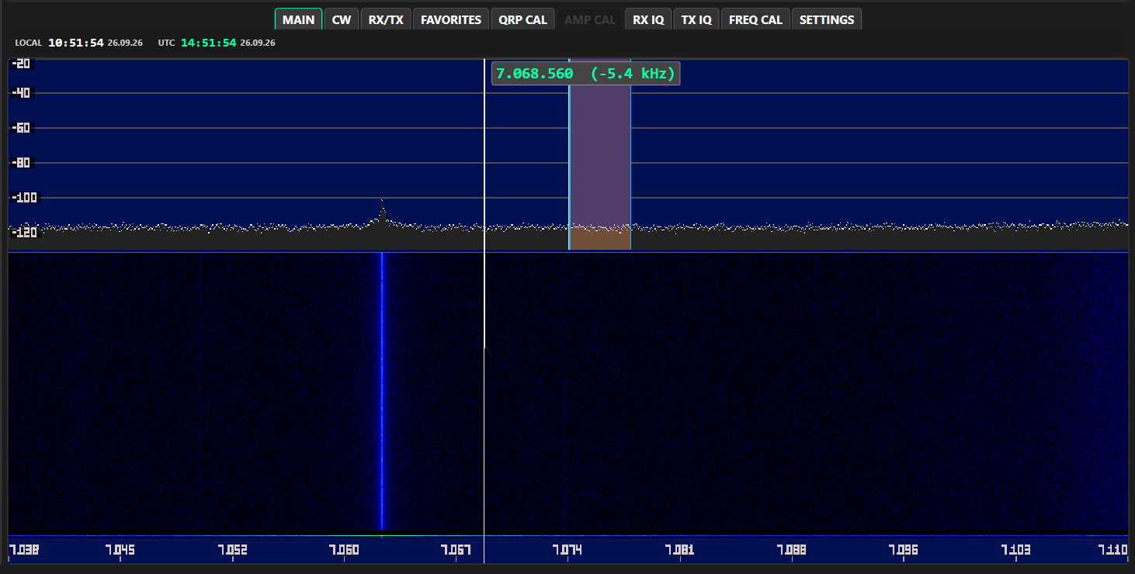
Hovering over the spectrum shows a cursor line with its frequency and offset from center
Clock | Local and UTC time above the spectrum. Turn on with TIME DISPLAY in the S/W window.
Left-click | Tunes to the signal. With AUTO SNAP on (S/W window) the frequency rounds to 1 kHz, 500 Hz or 100 Hz (not in CW).
Right-click | Marks the nearest peak and shows its frequency and level at the top left (PEAK MARKER on in the S/W window).
Hover | A cursor line shows the frequency under the mouse and its offset from center.
Wheel | Tunes VFO A by the Step value when the pointer isn't over a control.
Shaded band | Your receive passband.

5.5 Right rail
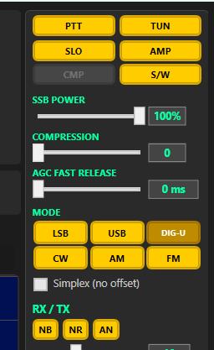
Right rail, top
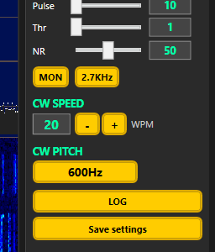
Right rail, bottom
PTT | Transmit on/off; red while on (4.4).
TUN | Steady carrier at Tune Power; red while on. Click again to return to your mode.
SLO / MED / FST | Cycles the AGC speed.
AMP | Switches between the QRP and AMP power tables; red while on (4.9).
CMP | Speech compressor on/off. Grayed on the Digital path.
S/W | Opens the Spectrum / Waterfall Controls window (6.5).
Power slider | 0-100 % of your QRP CAL power. Label follows the mode: TUNE POWER, CW POWER, AM CARRIER, FM POWER or SSB POWER (LSB, USB and DIG-U). Same settings as the RX/TX tab.
COMPRESSION | Compressor amount, 0-24. Grayed on the Digital path.
AGC FAST RELEASE | 0-2000 ms, default 500. How fast the AGC recovers.
Mode buttons | LSB, USB, DIG-U, CW, AM, FM. Each mode remembers its own filters.
Simplex (no offset) | FM only: transmit on the receive frequency.
NB / NR / AN | Noise blanker, noise reduction and automatic notch on/off (4.3).
Pulse | Noise blanker pulse width (10-510).
Thr | Noise blanker threshold (1-1009). Higher = blanks less.
NR | Noise reduction level (0-100, default 50).
MON | Hear your own transmit audio.
TX BW | Transmit bandwidth: 2.4 → 2.7 → 3.0 → 5.5 kHz.
CW SPEED - / + | Keyer speed, 5-60 WPM.
CW PITCH | 400 → 600 → 800 → 1000 Hz: the tone you hear and where CW signals sit in the filter.
LOG | Opens the Debug Log window (6.6).
Save settings | Keeps a copy of this radio's calibration on the host (7.7).

6. The other tabs and windows

6.1 CW tab
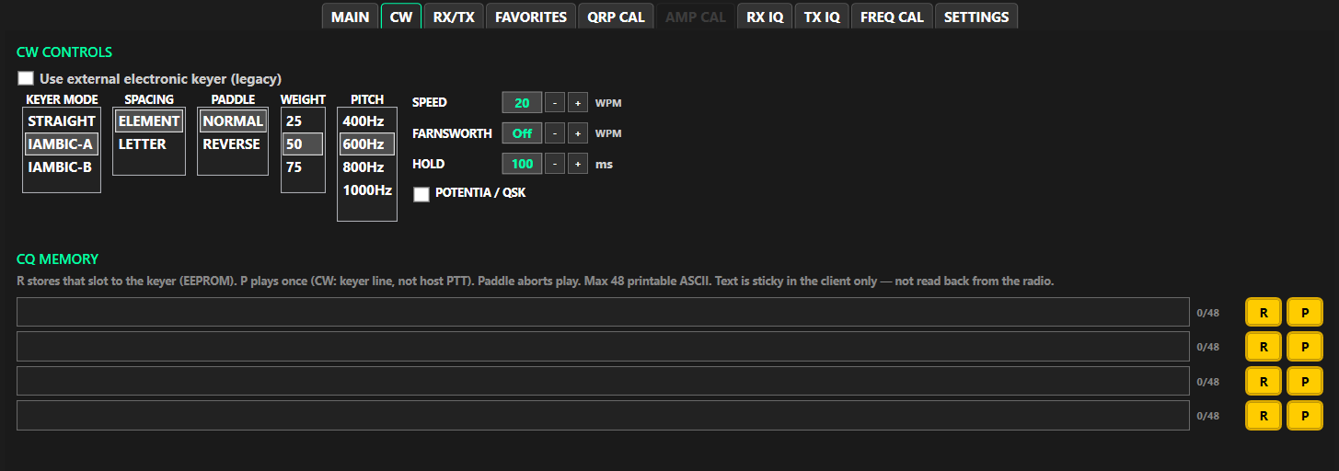
CW tab
Use external electronic keyer (legacy) | Tick this if you key with your own external keyer or have a Legacy (non-MKII) radio. The built-in keyer controls gray out; HOLD still works. The servers read this only when they start, so MSCC offers to Stop and Start for you.
KEYER MODE | STRAIGHT, IAMBIC-A (default) or IAMBIC-B.
SPACING | ELEMENT or LETTER.
PADDLE | NORMAL or REVERSE (swaps dot and dash).
WEIGHT | 25, 50 (default) or 75.
PITCH | 400, 600, 800 or 1000 Hz. Same as CW PITCH on the right rail.
SPEED - / + | 5-60 WPM. Same as the right rail.
FARNSWORTH - / + | Off, or 5-60 WPM. Adds space between letters and words when playing CQ memories only; paddle sending isn't affected.
HOLD - / + | 1-500 ms in steps of 10 (default 100). How long the radio stays in transmit after you stop keying. With an amplifier (POTENTIA / QSK off) it also sets how long the radio waits after keying the amplifier before RF starts, so the amplifier's relay can change over.
POTENTIA / QSK | Only for Potentia 50 / 100 amplifiers (full break-in). On: the radio keys the amplifier line and its own output together. Off (default): amplifier line first, then RF after the HOLD delay, for relay-switched amplifiers. Leave it off unless a Potentia is attached.
CQ MEMORY slots 0-3 | Text box (up to 48 characters), character count, R stores the text in the radio's keyer (kept with power off), P sends it once. Touch the paddle to stop. R and P work only while connected. The radio can't send the text back to MSCC, so MSCC remembers what you typed.
Memory status line | For example "Storing slot..." or "Not connected -- Start session first".

6.2 RX/TX tab
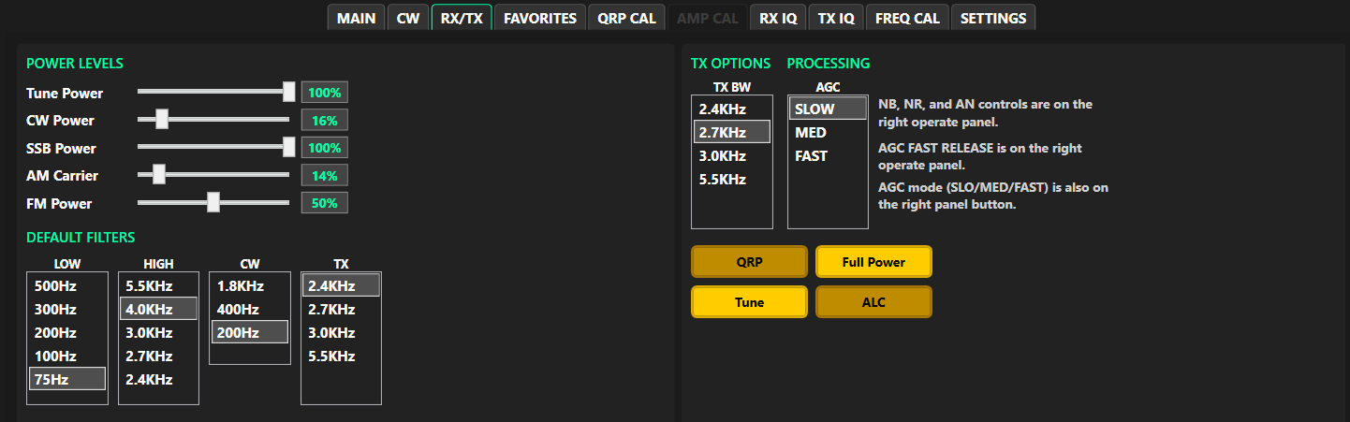
RX/TX tab (older picture: the ALC button at bottom right is gone; ALC is always on)
Tune Power | Drive for TUNE only (0-100 %). Kept separately for AMP on and AMP off.
CW Power / SSB Power / AM Carrier / FM Power | 0-100 % of your QRP CAL power. SSB Power covers LSB, USB and DIG-U with any audio path.
DEFAULT FILTERS: LOW, HIGH, CW, TX | The radio's stored default filters, applied each time MSCC starts. Day to day you use the Lo / Hi / CW buttons on the left rail.
TX BW | Same as the TX BW button on the right rail.
AGC | SLOW / MED / FAST. Same as the right-rail button.
QRP | Barefoot power: the same switch as AMP off. 100 % = the 5 W you set on QRP CAL.
Full Power | The amplifier setting: the same switch as AMP on. It uses the AMP CAL table, which lowers the drive for the amplifier; it never drives above your QRP CAL level. One of QRP or Full Power is always lit.
Tune | Same as TUN on the right rail.

6.3 FAVORITES tab
See 4.10.

6.4 SETTINGS tab
The SETTINGS page scrolls.
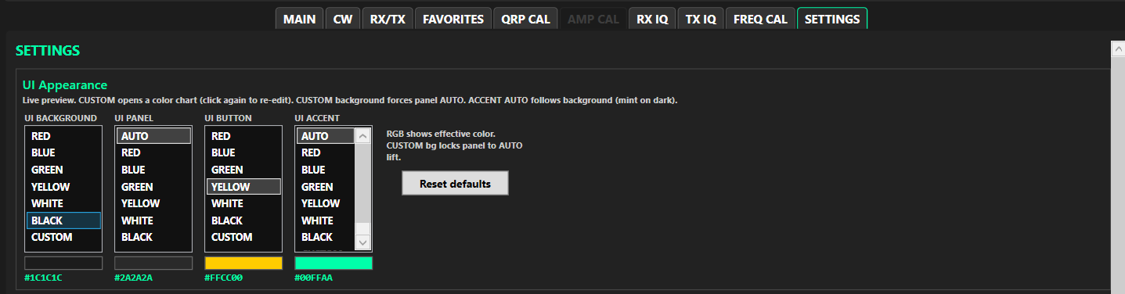
SETTINGS, UI Appearance
UI Appearance (changes show at once)
UI BACKGROUND | Window background color, or CUSTOM (opens Choose Color, 6.8).
UI PANEL | Panel color; AUTO is a little lighter than the background.
UI BUTTON | Button color; YELLOW is the classic Multus gold.
UI ACCENT | Color of headings, readouts and the VFO border.
Reset defaults | Back to the standard colors.

Audio (press Stop, then Start after changes)
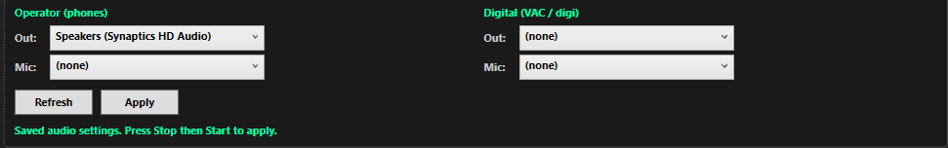
SETTINGS, Audio (Operator Mic and both Digital lists at (none))
Operator (phones) Out | Your speaker or headphones. Required: the only device Start needs.
Operator (phones) Mic | Your microphone, for voice transmit. Optional.
Digital Out | For example CABLE Input (VB-Audio). Needed for digital modes; otherwise (none).
Digital Mic | For example CABLE Output. Needed to transmit in DIG-U; otherwise (none).
Refresh | Looks for audio devices again (after plugging in a headset, for example).
Apply | Saves your choices (changing a list also saves).

The radio's own USB sound device (Multus IQ Sound) is not offered in these lists. It must never be used as a speaker or mic.
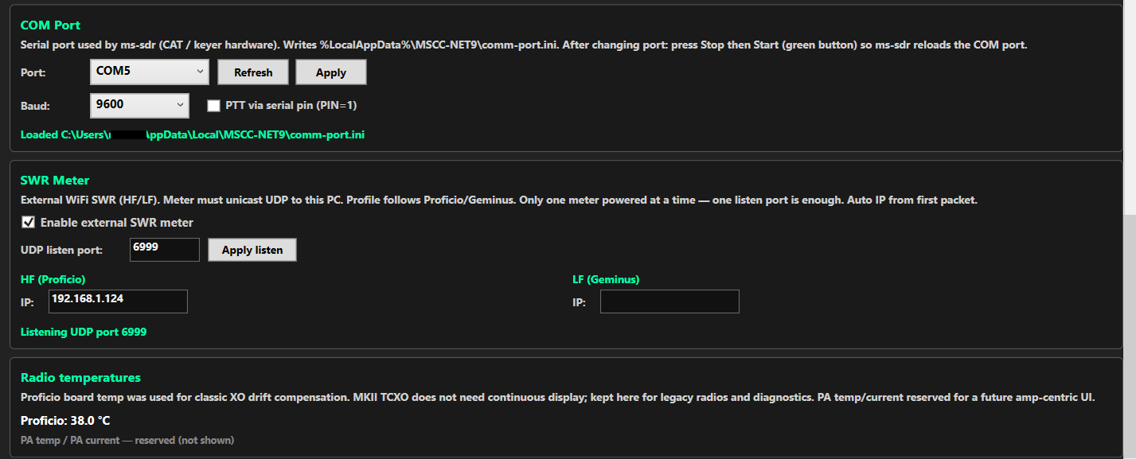
SETTINGS, COM Port, SWR Meter and Radio temperatures
COM Port (optional; Stop and Start after changes)
Port | The serial port the servers use for CAT. Leave blank if you don't use CAT (no CAT, no pop-ups). If the port isn't found, the setup note says so, but Start still works.
Baud | Default 9600.
PTT via serial pin | Lets a program key the radio with a serial pin (PIN=1).

SWR Meter (optional external Wi-Fi SWR meter)
Enable external SWR meter | Turns the meter on.
UDP listen port / Apply listen | The port MSCC listens on for the meter.
HF (Proficio) IP / LF (Geminus) IP | Fill in by themselves when the meter is heard.

Radio temperatures
Transceiver temperature | Labeled with the radio name, for example "Proficio: 38.0 °C".
Amplifier temperature and current | Reserved for a future amplifier.

Configuration
Reset configuration to defaults... | Wipes MSCC's settings on this PC (logs are kept) and closes MSCC. A last resort. Calibration stored in the radio is not wiped (see 7.8).

6.5 Spectrum / Waterfall Controls window (S/W)
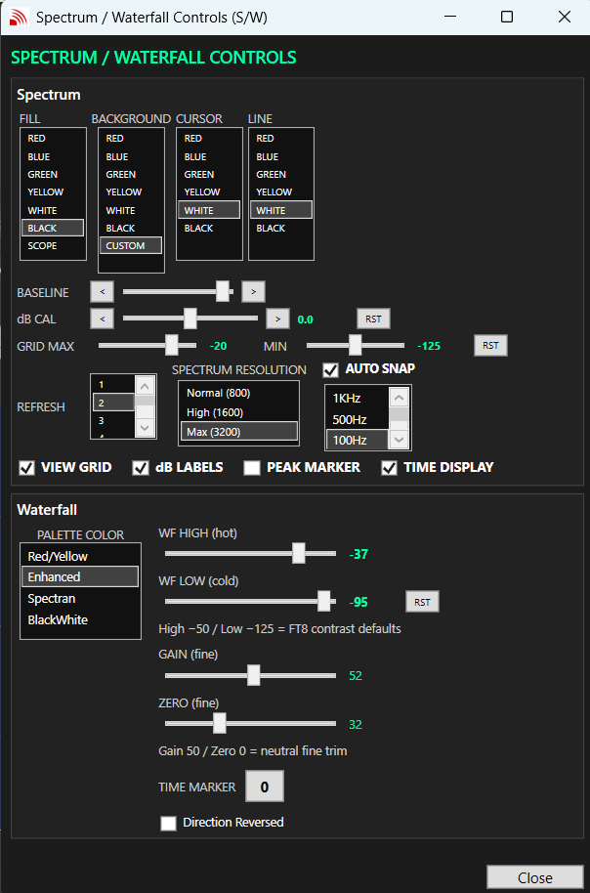
S/W window (older picture: REFRESH is now SMOOTHING, SPECTRUM RESOLUTION is gone, "Direction Reversed" is now "Climbing")
These settings are kept separately for HF and LF bands. BASELINE and the waterfall levels are also remembered for each band.
FILL / BACKGROUND / CURSOR / LINE | Colors of the area under the trace (SCOPE = classic look), the background (CUSTOM opens Choose Color), the cursor line and the trace.
BASELINE < > | Raises or lowers the noise floor on the display (50 = neutral).
dB CAL < > RST | Trims the dB scale ±20 dB. 0 = factory center; RST returns to 0. Set it once with a known signal if you need exact levels.
GRID MAX / MIN / RST | Top (-80 to 0 dBm, default -20) and bottom (-160 to -90, default -155) of the spectrum. RST returns to -20 / -155.
SMOOTHING | 0, 1, 2, 3 (default), 4, 6, 8, 10, 15, 20, 30. Calms the spectrum and waterfall (each step = 25 ms of averaging; 0 = light). The display always runs at full speed.
AUTO SNAP / step | Rounds click-to-tune to 1 kHz, 500 Hz or 100 Hz (not in CW).
VIEW GRID / dB LABELS | dB grid lines and the dB numbers at the left.
PEAK MARKER | Turns on right-click peak marking.
TIME DISPLAY | Clock above the MAIN spectrum.
PALETTE COLOR | Waterfall colors: Red/Yellow, Enhanced, Spectran, BlackWhite.
WF HIGH / WF LOW / RST | Signals at WF HIGH show in the hottest color; WF LOW is the background level. RST returns to the starting levels.
GAIN / ZERO | Fine brightness and lift (50 / 0 = neutral). Use WF HIGH / LOW first.
TIME MARKER | Click to cycle 0-5. At 1-5 a white line labeled with the UTC time (mm:ss) crosses the waterfall every 1-5 seconds.
Climbing | Unticked (default, Falling): newest line at the top, moving down. Ticked: newest line at the bottom, moving up.

DRAFT: Retake the S/W window picture with MSCC 10.31.2.

6.6 Debug Log window
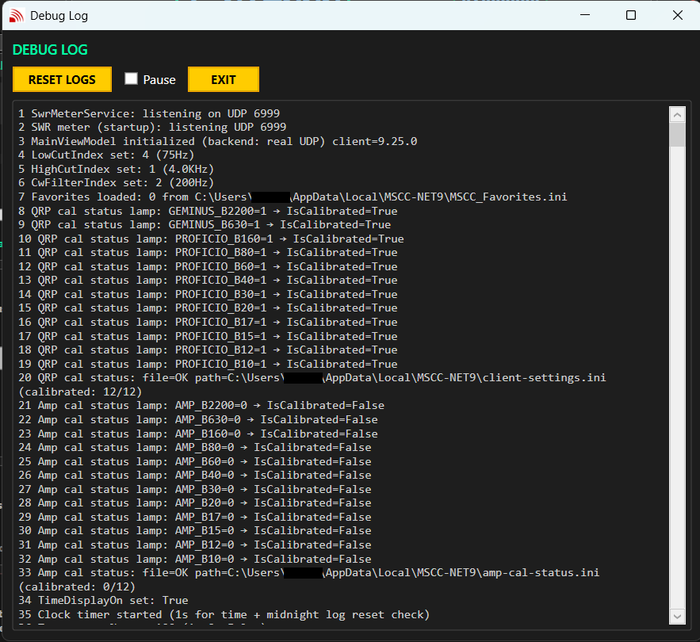
Debug Log window (older picture)
RESET LOGS | Clears the display and starts a new log file.
Pause | Freezes the display; the log file keeps recording.
EXIT | Closes the window.

Log files are in %LocalAppData%\MSCC-NET9\logs. Send them with any problem report.

6.7 Remote Audio window
This window opens when you turn on Remote (left rail), for operating a radio on another computer. It is covered in the Remote guide.

6.8 Choose Color window
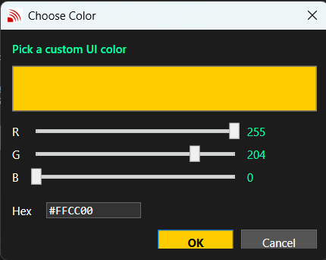
Choose Color window
Set the color with the R, G and B sliders (0-255) or type a code such as #FFD700 in Hex and press Enter. OK (Enter) or Cancel (Esc).

7. Calibration

7.1 What to calibrate, and in what order
Factory values for your radio model are loaded automatically, so calibration is a touch-up, not a must-do on day one. When you do it, go in this order:
1. FREQ CAL: frequency accuracy. Everything else depends on being on frequency.
2. RX IQ: receive image balance.
3. QRP CAL: output power on each band (dummy load and wattmeter).
4. TX IQ: transmit image balance (needs QRP CAL done; second receiver).
5. AMP CAL: only if you use an amplifier (needs QRP CAL done).
6. Save settings: keeps a copy on the PC.
QRP power, RX I/Q and TX I/Q are stored in the radio the moment you accept or APPLY them; AMP and FREQ calibration are stored on the PC (see 1.2).
Note: While a FREQ CAL run is going, don't change tabs or settings. MSCC won't open QRP CAL, AMP CAL or TX IQ until it finishes.

7.2 FREQ CAL (frequency calibration)
You need a strong, steady carrier of known frequency: a time station at S7 or better. WWV or CHU on HF; 198 / 660 / 880 kHz on a Geminus.
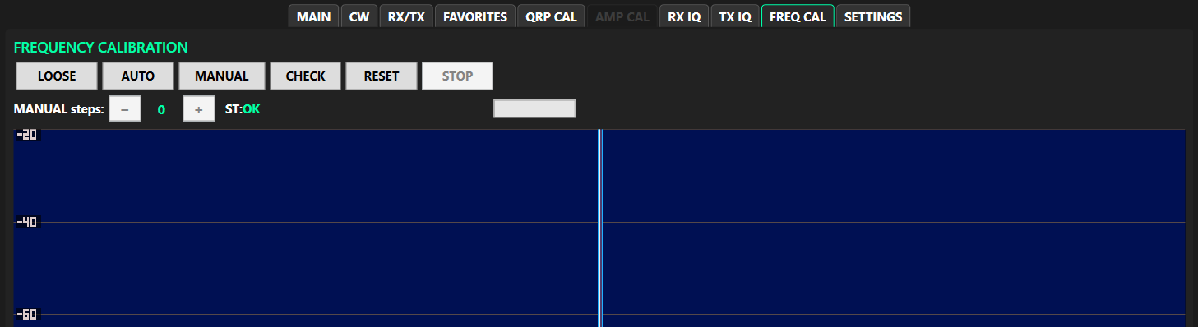
FREQ CAL tab, idle
Opening FREQ CAL switches the radio to CW with a 600 Hz pitch and the 200 Hz filter, which the measurement needs. When you leave the tab your mode, filter and pitch come back.
Procedure
1. Click USER on the band bar until you reach a strong time station (the example uses WWV 10.000 MHz).
2. Open FREQ CAL.
3. Click AUTO and choose Yes (COARSE): ±250 Hz in 5 Hz steps. Wait for AUTO COMPLETED.
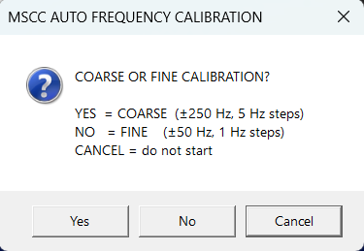
AUTO asks COARSE (Yes), FINE (No) or Cancel
4. Click AUTO again and choose No (FINE): ±50 Hz in 1 Hz steps. Wait for AUTO COMPLETED.
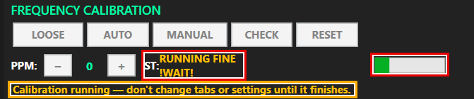
AUTO FINE running: amber status, progress bar filling, reminder line
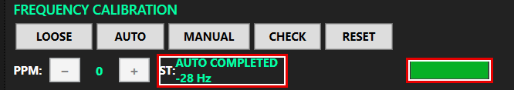
AUTO FINE finished: "AUTO COMPLETED"
5. Click CHECK to confirm. CHECK COMPLETED with an error of a few Hz is a good result ("(good)" is shown at ±5 Hz or less).
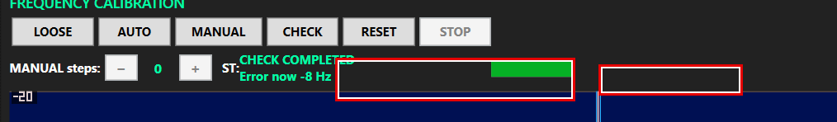
CHECK completed: Error now -8 Hz
6. Stay on the tab until each run finishes. Press STOP to abort a run; the calibration stays as it was.
The buttons
LOOSE / TIGHT | How close the measurement must get before it calls the job done. AUTO and CHECK use it.
AUTO | Automatic calibration against the carrier on your current frequency (COARSE or FINE).
MANUAL | Adjust by ear: the carrier is heard as a 600 Hz tone. Use MANUAL steps − / + one step at a time, then click MANUAL again; MSCC asks "ACCEPT THIS MANUAL CALIBRATION SETTING?". You can't leave the tab while MANUAL is on.
CHECK | Measures the error without changing anything. It looks only within ±50 Hz; if the radio is further off (for example right after RESET) CHECK fails and suggests AUTO (COARSE).
RESET | Returns to the factory calibration, after asking.
STOP | Ends an AUTO or CHECK run. The calibration is not changed.
Status | RUNNING / CHECKING in amber, then COMPLETED (green) with a number in Hz, FAILED (red) or STOPPED.

7.3 RX IQ (receive image balance)
An unbalanced receiver shows a weak mirror copy (image) of a strong signal 24 kHz away. RX IQ moves the image down into the noise.
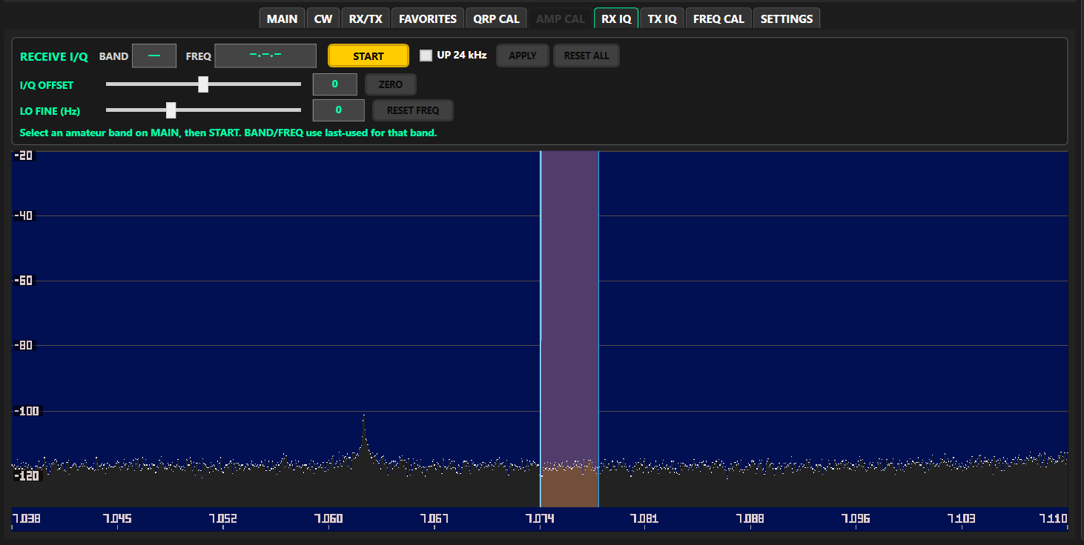
RX IQ tab (older picture: RESET ALL is now APPLY ALL, START reads ACTIVE while running)
Procedure
1. On the MAIN tab choose an amateur band (on a Geminus, 2200 m or 630 m) and tune near a strong steady signal. RX IQ doesn't work in general coverage.
2. Open RX IQ and press START (it reads ACTIVE). Find the image on the spectrum: 24 kHz from the signal. UP 24 kHz shifts the receiver to help you find it.
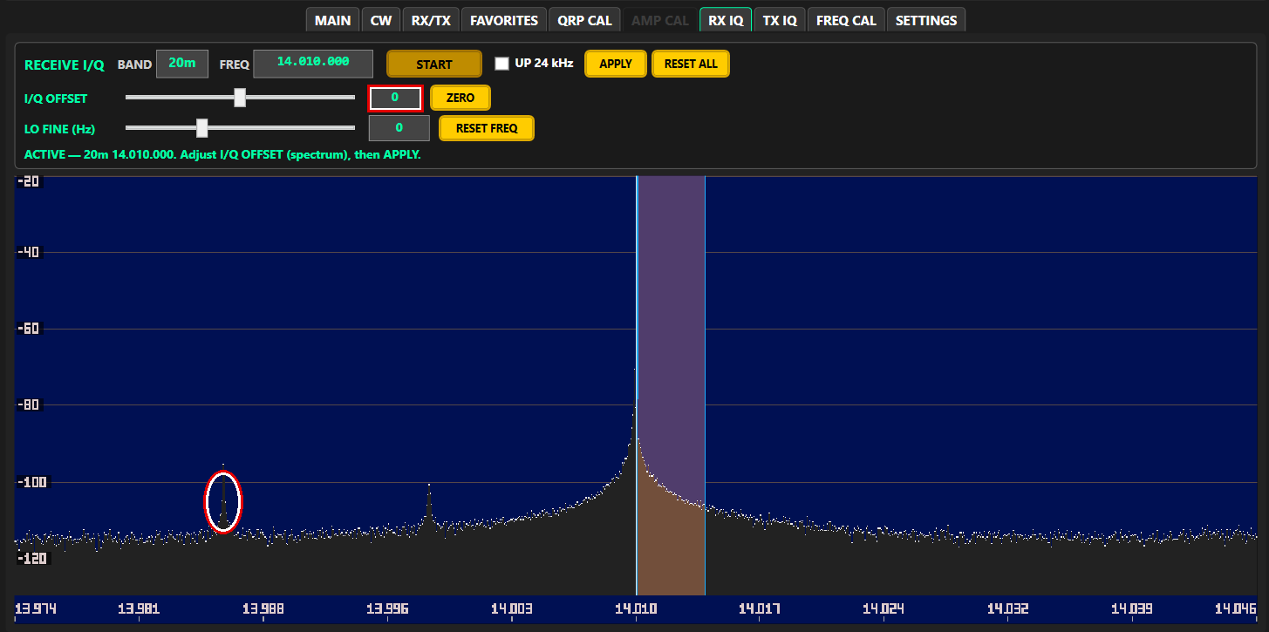
Before: I/Q OFFSET 0, image visible (red ring)
3. Move I/Q OFFSET until the image drops into the noise. The best value is different for every radio and band (127 in this example).
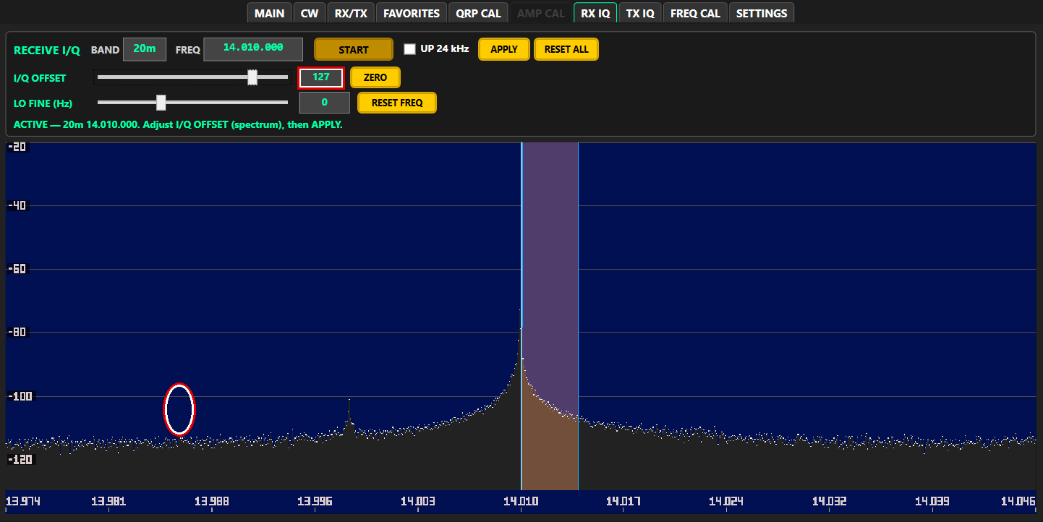
After: I/Q OFFSET 127, image gone
4. Press APPLY and answer Yes to "APPLY THE CURRENT I/Q VALUE?". The value is stored in the radio for this band. No keeps the old value.
5. Repeat for each band you use.
BAND / FREQ | Band and frequency being balanced.
START / ACTIVE | Starts or ends the session. The other controls work only while ACTIVE.
UP 24 kHz | Shifts the receiver up 24 kHz to help find the image.
APPLY | Saves the value for this band (in the radio), after asking.
APPLY ALL | Copies the current value to all bands, after a warning.
I/Q OFFSET | -200 to +200. Adjust for the smallest image.
ZERO | Sets the offset to 0 and saves it.
LO FINE (Hz) | -1000 to +2009 Hz. Fine retune during the session.
RESET FREQ | Clears LO FINE.

7.4 QRP CAL (power calibration; AMP must be off)
This sets the radio's full output, 5 W, on each band. Everything else (the power sliders, AMP CAL) is a percentage of it.
⚠ Do not set more than 5 W. More than 5 W causes spurious emissions, on all current models.

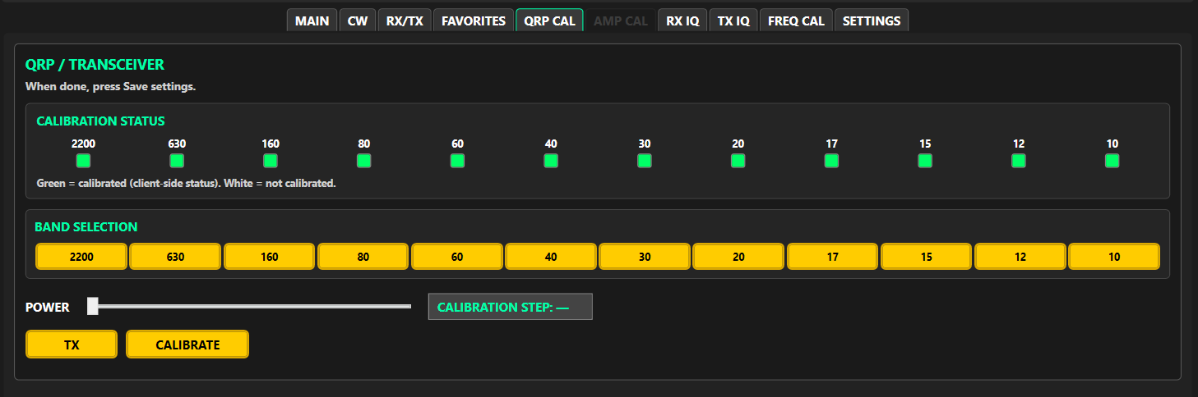
QRP CAL tab
Procedure
1. Turn AMP off.
2. Connect a 50 Ω dummy load (5 W or more) through a wattmeter.
3. Open QRP CAL and pick a band. The radio tunes to that band's calibration frequency.
4. Click CALIBRATE. The radio transmits and the POWER slider comes alive. (The first time, MSCC asks you to confirm a dummy load or matched antenna is connected.)
5. Move POWER until the wattmeter reads 5 W, not more.
6. Click CALIBRATE again. MSCC asks "ACCEPT THIS CALIBRATION?": Yes stores it in the radio and the band's lamp turns green; No leaves the band uncalibrated; Cancel puts back the previous setting.
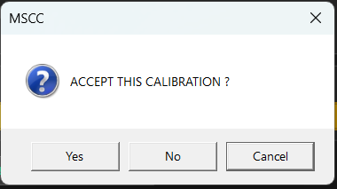
Accept this calibration?
7. Repeat for each band.
Calibration status lamps | One per band: green = calibrated, white = not yet.
Band buttons | Pick the band to calibrate.
POWER | Adjusts the output; works only while CALIBRATE is on.
CALIBRATION STEP | The current setting as reported by the radio.
TX | Sends a test carrier (red TX ON while on).
CALIBRATE | Starts calibration; click again to accept or reject.

7.5 TX IQ (transmit image balance; AMP must be off)
An unbalanced transmitter sends a weak image 24 kHz from your signal. You need a second receiver to see it, because MSCC can't hear its own transmit image. Use a dummy load and keep the second receiver's antenna well away so it doesn't overload. Do QRP CAL first.
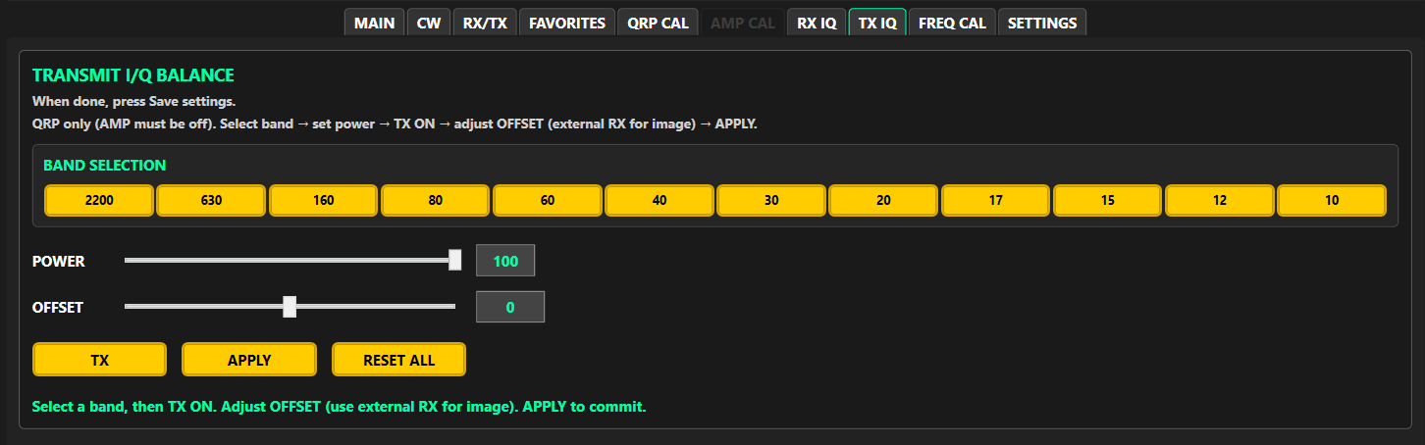
TX IQ tab (older picture: there is now a PHASE slider under OFFSET)
DRAFT: Retake the TX IQ picture with the PHASE slider (client 10.30.0 or later), and an example with real before / after values (the Release 0 example showed OFFSET 6 both before and after).

Procedure
1. Turn AMP off. Open TX IQ and pick a band. The radio tunes to that band's TX IQ frequency (the status line shows it, for example "TX ON @ 7.150 MHz").
2. Tune the second receiver about 24 kHz from the displayed frequency to find the image.
3. Set POWER (default 100) and press TX.
4. Move OFFSET for the weakest image on the second receiver.
5. Step PHASE one click at a time for the weakest image, then recheck OFFSET. Go back and forth until neither improves it.
6. Press APPLY and answer Yes to "APPLY THE CURRENT I/Q VALUE?". The value is stored in the radio for this band.
7. Press TX again to stop the carrier. Repeat for each band.
Band buttons | Tune to the band's TX IQ frequency. Locked while TX is on.
POWER | Test carrier power, 0-100 (default 100).
OFFSET | -200 to +200: amplitude balance. Works only while TX is on.
PHASE | ±100 steps of 0.05° (±5°): phase balance. Set OFFSET first, then PHASE.
TX | Starts or stops the test carrier.
APPLY | Saves this band's values (in the radio), after asking.
RESET ALL | Returns all bands to the factory values, after a warning; TX must be off. See 7.8.

7.6 AMP CAL (AMP must be on)
This sets the drive the radio uses when AMP is on, so your amplifier reaches its rated output without being overdriven. A band must have QRP CAL (green lamp) first; otherwise MSCC shows "QRP / TRANSCEIVER HAS NOT BEEN CALIBRATED FOR THIS BAND".
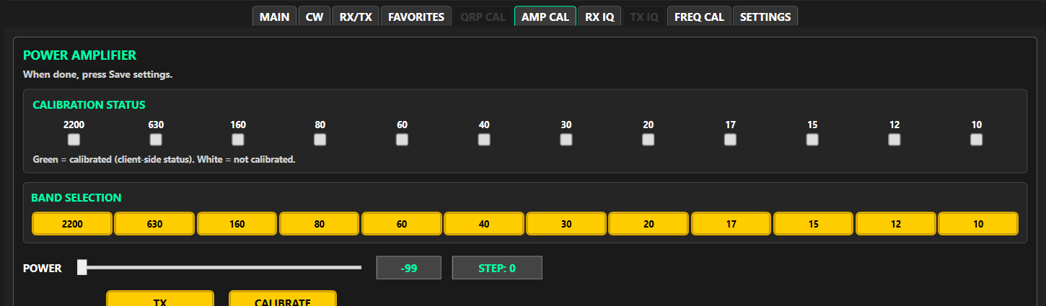
AMP CAL tab
Procedure
1. Put the amplifier in line with a dummy load and wattmeter on its output. Turn AMP on.
2. Open AMP CAL, pick a band and click CALIBRATE.
3. Move POWER (-99 to 0) until the amplifier just reaches its rated output. Not more.
4. Click CALIBRATE again and accept (Yes / No / Cancel as on QRP CAL).
5. Repeat for each band you use with the amplifier, then press Save settings (7.7).
AMP calibration is kept on the PC, not in the radio. If you move the radio to another PC, redo AMP CAL there (or copy the files, Appendix A).

7.7 Save settings
Save settings (right rail, under LOG) keeps a copy of this radio's calibration on the PC. MSCC uses that copy when you switch between radios on the same PC. Press it after AMP CAL, and whenever you finish calibrating.
- If the radio isn't connected, MSCC says "Connect the radio first so MSCC knows which radio these files belong to." Press Start, wait for the FW number in the title bar, try again.
- When connected, MSCC confirms that the host was asked to save the calibration for your radio (for example proficio-mkii).
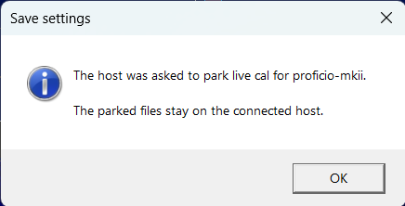
Save settings: saved on the host

7.8 Resetting calibration to factory values
- FREQ CAL → RESET returns the frequency calibration to the factory value for your radio.
- TX IQ → RESET ALL and SETTINGS → Reset configuration reset the files on the PC. They do not yet clear the values stored in the radio, and at the next start the radio's values win. So for now these resets last only until MSCC is restarted.
DRAFT: Stew: reset to factory must also clear the values stored in the radio. Until that is fixed this section has to warn as above.

8. Troubleshooting
8.1 Start won't run / "Setup needed". Set Operator Out (your speaker or headphones) in SETTINGS → Audio. It is the only setting Start needs. The orange setup note about the COM port, the mic or the digital devices is only a reminder.
8.2 PTT says "Set up audio (Mic) in the Settings tab to transmit voice." No Operator Mic is set. Choose your microphone in SETTINGS → Audio, then press Stop and Start. In DIG-U the message names the Digital Mic instead. TUN and CW work without a mic.
8.3 I clicked Cancel on a Windows Firewall prompt. Open Windows Security → Firewall & network protection → Allow an app through firewall, click Change settings, and tick the program you cancelled (MSCC.Wpf, mscc-trans, mscc-recv or ms-sdr-mkii). Close MSCC, open it again and press Start.
8.4 "Server keep-alive lost". MSCC stopped hearing from the servers. Answer Yes to keep waiting or No to close MSCC. Check the USB cable and radio power, then Stop and Start.
8.5 No firmware version (FW) in the title bar after connecting. MSCC offers to ask the radio again; say Yes. If it still doesn't show, check the radio's USB cable and power, then Stop and Start.
8.6 I changed Host but MSCC still talks to the old radio. Press Stop, then Start.
8.7 Remote is grayed out. Host is 127.0.0.1 or Launch Servers is checked. Remote is only for a radio on another computer.
8.8 WSJT-X keys the radio but power is very low.
- Put the WSJT-X TX tone around 1500 Hz, inside the TX filter (default up to 2.7 kHz).
- Check AMP: off = normal QRP 5 W. Use AMP on only with an amplifier in line and a calibrated AMP table.
- Raise Digital Mic Gain until the ALC meter moves (4.8).
- Check SSB POWER on the power slider.
8.9 Strange audio after plugging in or removing USB devices. SETTINGS → Audio → Refresh, re-pick your devices, then Stop and Start.
8.10 CW paddle does nothing. With an external keyer or a Legacy radio, tick Use external electronic keyer (CW tab) and let MSCC restart the servers. For an MKII radio with a paddle, leave it unticked. Also check you are in CW mode.
8.11 Audio is mushy after switching computers, or someone else's session seems to be in use. Restart the servers once: Stop, then Start.
8.12 Everything is confused. Last resort: SETTINGS → Reset configuration to defaults. Your logs are kept.
8.13 Sending a problem report. Don't restart MSCC first. Collect the logs from %LocalAppData%\MSCC-NET9\logs and post the problem at https://multussdr.groups.io/g/main/topics with the logs attached.

Appendix A: For support: where files are kept
You only need this if support asks you for a file. Everything is in %LocalAppData%\MSCC-NET9\ on the PC the radio is plugged into, unless noted.
What | File
Client settings (display, window, Remote Audio, last used) | MSCC_Client.ini
Last-used frequency, mode and filters per band | MSCC_LastUsed.ini, MSCC_LastUsed_VFOB.ini
Favorites | MSCC_Favorites.ini
Audio and COM choices | operator-speaker.ini, operator-microphone.ini, digital-speaker.ini, digital-microphone.ini, comm-port.ini
Server settings | mscc.ini
TX I/Q (copy; the radio holds the master) | iq.ini
RX I/Q (copy; the radio holds the master) | recv-iq.ini
QRP power (copy; the radio holds the master) | power_cal.ini
AMP calibration | amplifier_cal.ini
Frequency calibration | freq_cal.ini
Saved calibration per radio model (Save settings) | cal\<radio model>\ (for example cal\proficio-mkii\) holds iq.ini, power_cal.ini and amplifier_cal.ini; cal\LAST_LINE.txt names the last one
Factory values | C:\mscc-net9\factory\
Logs | logs\ (mscc.log and the server logs)

Switching between radios on one PC. MSCC loads the right calibration for each radio by itself. Frequency calibration is one value for the PC: recheck FREQ CAL after changing radios.
Remote setups: calibration lives on the radio's host; client settings live on the computer you operate from (see the Remote guide).

Appendix B: Using this PC as a host for a remote operator
To let a remote client reach the radio plugged into this PC:
1. Leave Launch Servers checked and Host at 127.0.0.1.
2. Press Start and leave MSCC open. Closing MSCC stops the servers it launched.
3. Make sure the Windows Firewall prompts were answered with Allow (2.5).
4. Find this PC's IPv4 address with ipconfig in PowerShell or Command Prompt. Give the Wi-Fi or Ethernet IPv4 address to the remote operator as Host. A Tailscale (or other VPN) adapter may also be listed; use the LAN address unless you are both using that VPN on purpose.
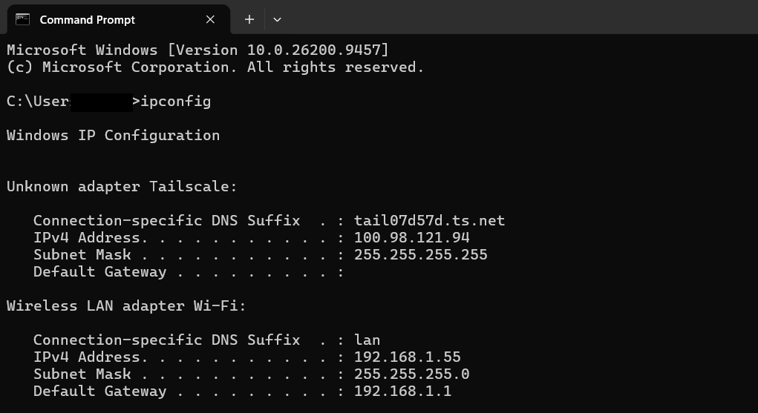
ipconfig showing Wi-Fi and Tailscale IPv4 addresses
A host that must keep serving with MSCC closed uses MSCC-Remote.exe, Start-MsccServers.bat or Install-MsccServers-AtBoot.bat in C:\mscc-net9 (see the Remote guide).

Appendix C: Draft notes (remove before release)
To confirm
1. Firmware table (2.6): the files and versions installer R10.31.2 ships.
2. Calibration stored in the radio survives a firmware update (Chapter 3).
3. ALC target reading for voice and digital (4.4, 4.8): Release 0 said "just into the yellow".
4. Windows noise reduction: still the old adaptive filter; update 4.3 when the new one is ported.
5. Reset to factory (7.8): needs the radio-side clear; until then resets last only until restart.
6. AMP CAL target: "amplifier just reaches its rated output" (7.6), or a set drive such as 75 %?
Pictures to retake with MSCC 10.31.2
- Main window and title bar (2.5, 4.1, 5) with current version numbers.
- RX/TX tab without the ALC button (6.2).
- S/W window with SMOOTHING and Climbing (6.5).
- RX IQ tab with APPLY ALL (7.3).
- TX IQ tab with PHASE, plus a before / after example (7.5).
- Debug Log (6.6; the old one shows client 9.25.0).
- Bootloader with a C:\mscc-net9 path (Chapter 3).
- AMP CAL tab: the old picture is cropped through the TX and CALIBRATE buttons (7.6).
Label notes for Stew (client)
- RX/TX tab "Full Power" means AMP on, which lowers drive. Suggest "AMP" to match the right rail.
- RX IQ says APPLY ALL, TX IQ says RESET ALL, and they do different things; fine, but worth a tooltip check.
- Start button tooltip still says it is "disabled until COM + operator speaker/mic are set"; since 10.8.1 only Operator Out is required.
- The QRP CAL, AMP CAL and TX IQ tabs say "When done, press Save settings"; with calibration in the radio this is only needed for AMP CAL.
- POTENTIA / QSK tooltip says "Amplifier PIN diode T/R switching"; see 6.1 for what it does.

