
MSCC Operator's Guide
Remote Operation
Windows
Multus SDR Control Console for Proficio, Geminus and Ultimus transceivers
Windows client and Windows host · MSCC 10.31.2
Release 1 (DRAFT) · Revision date 11/1/26
Copyright © 2026 Multus SDR, LLC

About this guide
This guide covers remote operation: you sit at one computer (the client) while the radio and the MSCC servers run on another computer (the host) on your home network.
This guide is for Windows only: MSCC for Windows on both computers. Remote operation with a Raspberry Pi or Linux host works differently and has its own guide.
It is written for MSCC for Windows 10.31.2. If your title bar shows a later number, most of this still applies.
Not in this guide: installing MSCC, calibrating the radio and updating its firmware. Do those at the host first, with the MSCC Operator's Guide - Windows.
How the guide is laid out. Chapter 1 explains what runs where. Chapter 2 is done at the host, chapter 3 at the client. Chapter 4 sets up remote audio, chapter 5 digital modes with WSJT-X. Chapter 6 is troubleshooting. Appendix A lists the network ports.
What changed since Release 0. The Remote Audio window now has its own Phones / Digital choice (one at a time); the Phones and Digital buttons on the main window are for local use and turn Remote off. Remote must be turned on again each time MSCC starts. Only one client can be connected at a time. For digital modes the client's SETTINGS → COM Port is the CAT port. The chapters have been put in the order you need them.
DRAFT: DRAFT. Gray boxes like this one mark things still to confirm or pictures to retake. They are collected in Appendix C. Remove them before release.

Contents
1. How remote operation works 4
1.1 What runs where 4
1.2 What goes over the network 4
1.3 Before you start 4
1.4 Getting help 5
2. On the host 6
2.1 Start the servers 6
2.2 Find the host's address 6
2.3 One client at a time 6
3. Connecting from the Windows client 8
3.1 First start on the client 8
3.2 Connect 8
3.3 Changing the host 10
3.4 Disconnecting 10
4. Remote audio 11
4.1 Turn Remote on 11
4.2 Phones: listen and talk 11
4.3 Digital: WSJT-X and other programs 12
5. Digital modes with WSJT-X 14
5.1 One-time setup 14
5.2 Each session 15
6. Troubleshooting 17
Appendix A: Network ports 18
Appendix B: Related guides 19
Appendix C: Draft items (remove before release) 20

1. How remote operation works

1.1 What runs where
MSCC has two parts, and in remote operation they are on different computers:
- The servers run on the host, the computer the radio's USB cable is plugged into. Their names are ms-sdr-mkii.exe, mscc-recv.exe and mscc-trans.exe; you may see them in messages. They talk to the radio and do all the signal processing.
- The client runs on the PC you sit at. It shows the spectrum and the controls, sends your settings to the host, plays the receive audio and sends your microphone.
What | Where
Radio USB cable, calibration, firmware | Host
Receive processing: filters, AGC, noise blanker (NB), noise reduction (NR) | Host (you set them from the client as usual)
Spectrum and waterfall | Measured on the host, drawn on the client
Your headphones / speaker and microphone | Client
WSJT-X, virtual audio cable, virtual COM pair | Client

1.2 What goes over the network
Everything travels as UDP over your network, on three ports:
Port | Direction | Carries
8888 | Client → host (and the replies back) | Control, spectrum, waterfall, meters, and CAT (frequency, mode, PTT)
9100 | Host → client | Receive audio (Phones or Digital)
9101 | Client → host | Transmit audio (your microphone, or WSJT-X)

Appendix A has the details for firewalls.
Home network only. These instructions are for a client and host on the same network. Don't open these ports to the internet. To operate from away, use a VPN into your home network.

1.3 Before you start
- The radio works at the host: installed, calibrated and on current firmware, using the Windows guide.
- The host and the client are on the same network, and you know the host's address (2.2).
- MSCC for Windows is installed on the client (Windows guide, chapter 2). The client PC needs no radio, no USB driver and no Zadig.
- Headphones or a speaker, and a microphone if you will transmit voice, on the client.
- For digital modes: a virtual audio cable and a virtual COM pair on the client (chapter 5).

1.4 Getting help
Post questions, bug reports and feature requests on the Multus forum: https://multussdr.groups.io/g/main/topics. The forum is also the place to ask about setting up a virtual audio cable or virtual COM ports; MSCC doesn't supply them.

2. On the host
Do this at the Windows PC the radio is plugged into.

2.1 Start the servers
1. Power the radio on and check its USB cable.
2. Start MSCC on that PC with Launch Servers checked and press Start, as in the Windows guide. Operator Out (SETTINGS → Audio) must be set; the rest is optional.
3. The first time, Windows Firewall asks about mscc-trans.exe, mscc-recv.exe and ms-sdr-mkii.exe. Click Allow on each, or the client can't reach the host.
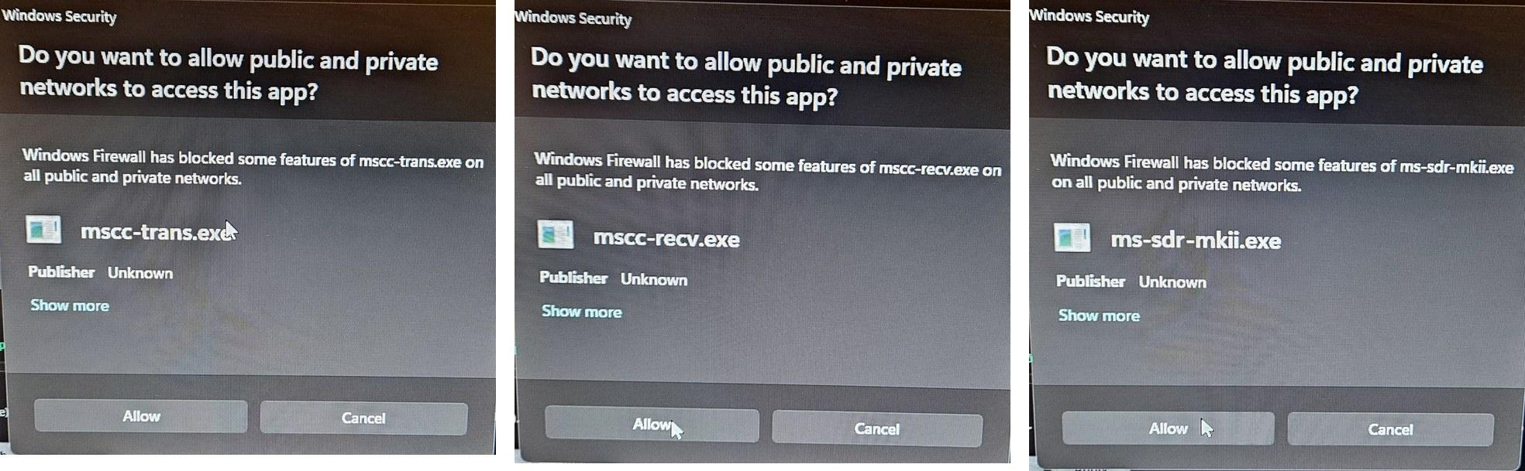
Windows host, first Start: a Firewall prompt for each server. Click Allow on each.
DRAFT: Windows host: only one client can be connected (2.3), so the MSCC window on the host must let go of the servers before the remote client can connect. Confirm how: does Stop on the host also stop the servers? Write the exact steps.

Auto Start on the host only starts the servers after the host reboots. The client can't start the servers over the network.

2.2 Find the host's address
The client needs the host's network (IP) address.
Open Settings → Network & internet and read the IPv4 address (four numbers, like 192.168.1.234), or type ipconfig in a Command Prompt and read IPv4 Address. Ignore the long IPv6 addresses with colons.
DRAFT: Add a picture of ipconfig (or Settings → Network) on the Windows host.

The addresses in this guide's pictures are examples from one test network. Use your own.
DRAFT: Suggest giving the host a fixed address in the home router (DHCP reservation), so the client's Host field never needs changing. Add a short how-to or leave it to the forum?

2.3 One client at a time
The host accepts one client at a time. If MSCC is still connected from another PC (or on the host itself), press Stop there first. If that PC was just switched off or lost the network, the host frees the connection by itself after about 45 seconds.
DRAFT: Confirm what the second client shows when the host refuses it (the host log says "SESSION IN USE - SINGLE CLIENT ONLY"; the client may just fail to connect). Add that text to chapter 6.

3. Connecting from the Windows client

3.1 First start on the client
1. Install MSCC for Windows if it isn't there yet (Windows guide, 2.2 and 2.3).
2. Start MSCC. The first time, Windows Firewall asks whether to allow MSCC.Wpf. Click Allow: the client needs it to receive the audio from the host (port 9100).
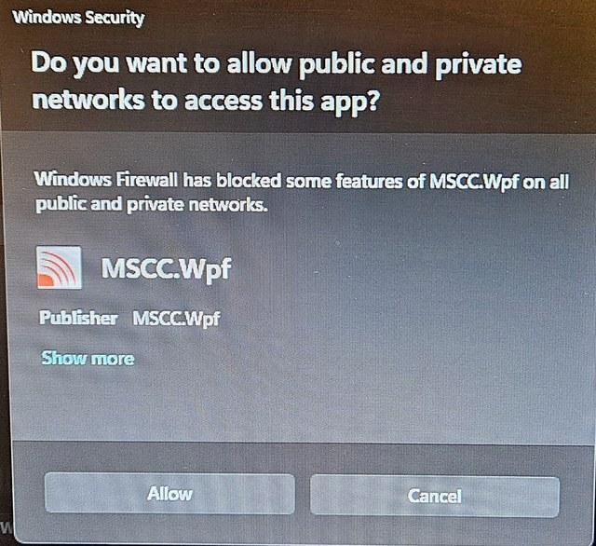
Client first start: the Firewall prompt for MSCC.Wpf. Click Allow.
A client used only for remote needs nothing set in SETTINGS → Audio. Remote audio uses the devices you pick in the Remote Audio window (chapter 4). The pop-up "Set up audio (Mic) in the Settings tab to transmit voice" is for local operation; it doesn't stop remote audio.

3.2 Connect
1. In the SERVER panel (top left), uncheck Auto Start and Launch Servers. The servers run on the host, not on this PC.
2. Set Host to the host's address (2.2).
3. Leave Port at 8888.
4. Press Start.
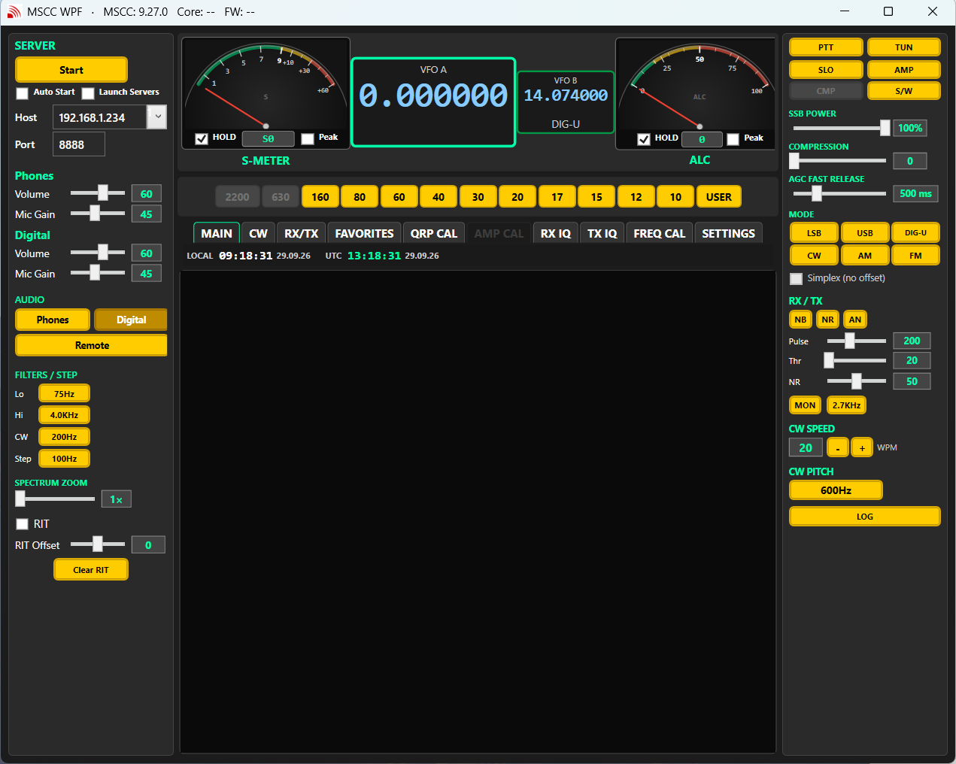
Before connecting: Host and Port set, Auto Start and Launch Servers unchecked
When it connects, Start changes to Stop, the spectrum and waterfall come alive, and the title bar shows the server (Core) and radio firmware (FW) versions. If nothing happens, see chapter 6.
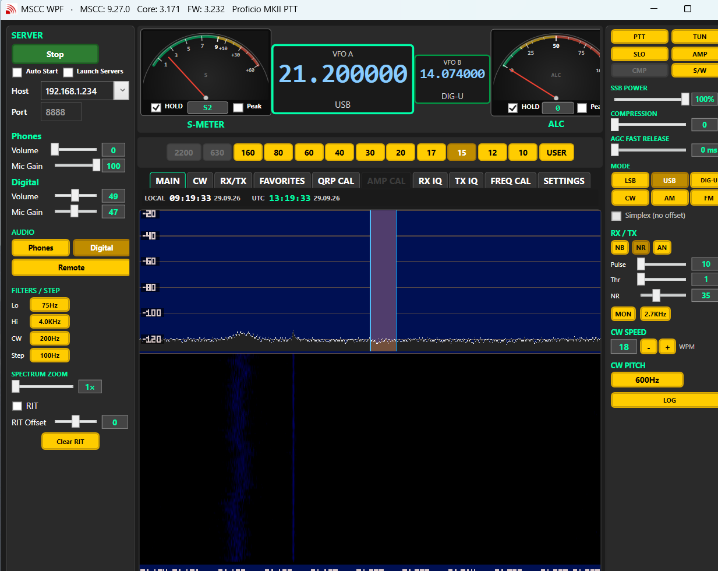
Connected: live spectrum, Core and FW in the title bar
DRAFT: Retake the chapter 3 pictures (Windows client) with 10.31.2 (they show 9.27.0; the left rail has changed a little).

3.3 Changing the host
If you change Host or Port while connected, MSCC reminds you to press Stop, then Start, to connect to the new address.
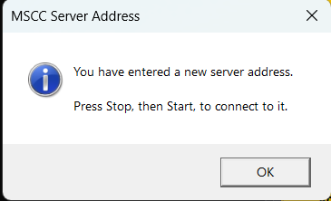
Host changed while connected: press Stop, then Start

3.4 Disconnecting
Press Stop. This frees the host at once for another client (2.3). The servers keep running on the host.

4. Remote audio

4.1 Turn Remote on
1. After connecting, press Remote in the AUDIO section of the left rail. The Remote Audio window opens.
2. At the top of that window choose Phones (listen and talk) or Digital (WSJT-X and other digital programs). One at a time; you can switch at any moment.
3. Pick the devices as described in 4.2 or 4.3. MSCC remembers them.
Things to know:
- Use the Phones / Digital choice inside the Remote Audio window. The Phones and Digital buttons on the main window are for local operation; pressing one turns Remote off.
- Remote is off each time MSCC starts. Press Remote again after Start.
- Remote works only with a remote host: it stays off if Host is 127.0.0.1 or Launch Servers is checked.
- Closing the Remote Audio window doesn't stop the audio. Press Remote to turn remote audio off; press it again to bring the window back.

4.2 Phones: listen and talk
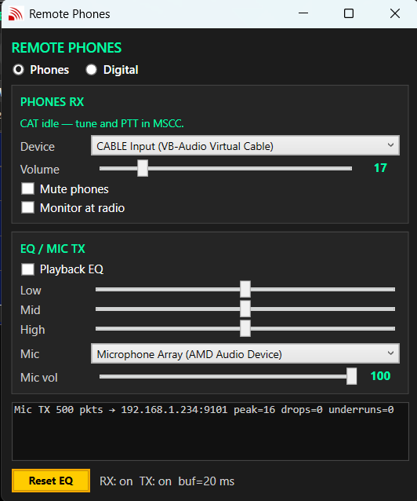
Remote Audio window, Phones
Control | What it does
Device | Where the receive audio plays: your headphones or speaker.
Volume | Receive audio level on this PC.
Mute phones | Silences the receive audio here.
Monitor at radio | Also keeps the speaker at the host playing. Off = the host is quiet.
Playback EQ, Low / Mid / High | Tone control for the receive audio. Reset EQ puts the sliders back to the middle.
Mic | This PC's microphone, for voice transmit.
Mic vol | Microphone level sent to the host. Set it with the ALC meter (below).
Status box | Shows "Mic TX ... → host:9101" while your microphone is being sent to the host.

Setting the mic level: in SSB, talk normally while transmitting into a dummy load or on a clear frequency, and set Mic vol so the ALC meter moves on voice peaks but doesn't sit at the top. COMPRESSION and SSB POWER on the right rail work as in local operation.
DRAFT: Confirm the mic-level advice with the Windows trans ALC (voice ceiling 0.45 x drive since trans 3.152). Same wording as the Windows guide 4.4?

4.3 Digital: WSJT-X and other programs
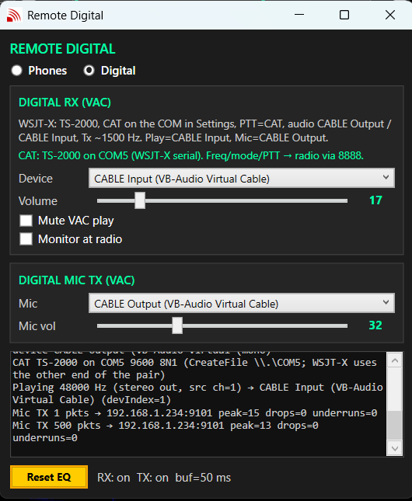
Remote Audio window, Digital
Control | What it does
Device | Where the receive audio goes: the input end of your virtual audio cable (for example CABLE Input). WSJT-X listens on the other end.
Volume | Receive audio level going to WSJT-X.
Mute VAC play | Silences the audio to WSJT-X.
Monitor at radio | Also keeps the speaker at the host playing.
Mic | The output end of the virtual audio cable that WSJT-X transmits into (for example CABLE Output).
Mic vol | Transmit audio level sent to the host. Set it with the ALC meter (5.2).
Green line | Shows the CAT port in use (from SETTINGS → COM Port on this PC).

The hint at the top of the window repeats the WSJT-X settings: TS-2000, CAT on the COM port from SETTINGS, PTT = CAT, tone around 1500 Hz.

5. Digital modes with WSJT-X
In remote operation everything for WSJT-X is on the client: WSJT-X, the virtual audio cable and the virtual COM pair. MSCC looks like a Kenwood TS-2000 to WSJT-X; frequency, mode and PTT go to the radio over port 8888.

5.1 One-time setup
1. Install a virtual audio cable (for example VB-Audio CABLE) and a virtual COM pair (for example com0com) on the client. MSCC doesn't supply them; ask on the forum if you need help.
2. In MSCC on the client, SETTINGS → COM Port: pick your end of the COM pair. In remote operation this is the CAT port.
3. Turn Remote on, choose Digital, and set Device and Mic to the two ends of the cable (4.3).
4. In WSJT-X Settings → Radio:
- Rig: Kenwood TS-2000.
- Serial Port: the other end of the COM pair (not the one MSCC uses).
- PTT Method: CAT. Mode: None, so MSCC keeps control of the mode. Split: None.
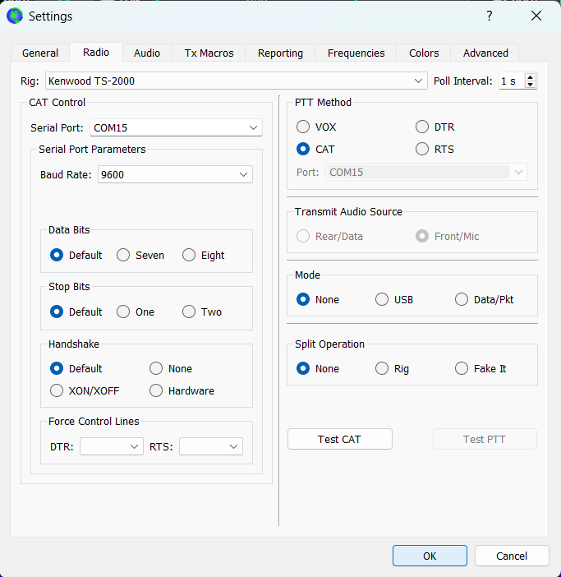
WSJT-X Radio tab: TS-2000, PTT CAT, Mode None, Split None
5. In WSJT-X Settings → Audio: Input = the cable's output end (for example CABLE Output), Output = the cable's input end (for example CABLE Input).
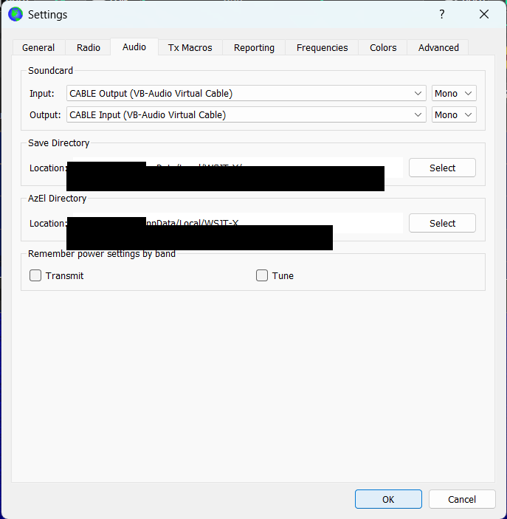
WSJT-X Audio tab (VB-Audio CABLE example)
6. In WSJT-X click Test CAT, then Test PTT.
The device and port names in the pictures are examples. Use the names of your own cable and COM pair.
DRAFT: Check: in the WSJT-X Audio picture, In and Out look the same way round as the Remote Digital window (MSCC plays to CABLE Input, so WSJT-X Input = CABLE Output). Retake if not.

5.2 Each session
1. Press Start, then Remote, and choose Digital in the Remote Audio window.
2. In MSCC select DIG-U and tune to the frequency (for example 14.074 MHz on 20 m).
3. In WSJT-X pick the same band and press Monitor. Decodes should appear within a minute.
4. Put the WSJT-X TX tone around 1500 Hz.
5. Before the first transmission, press Tune in WSJT-X and set Mic vol in the Remote Audio window so the ALC meter shows the level you want. Then press Tune again to stop.
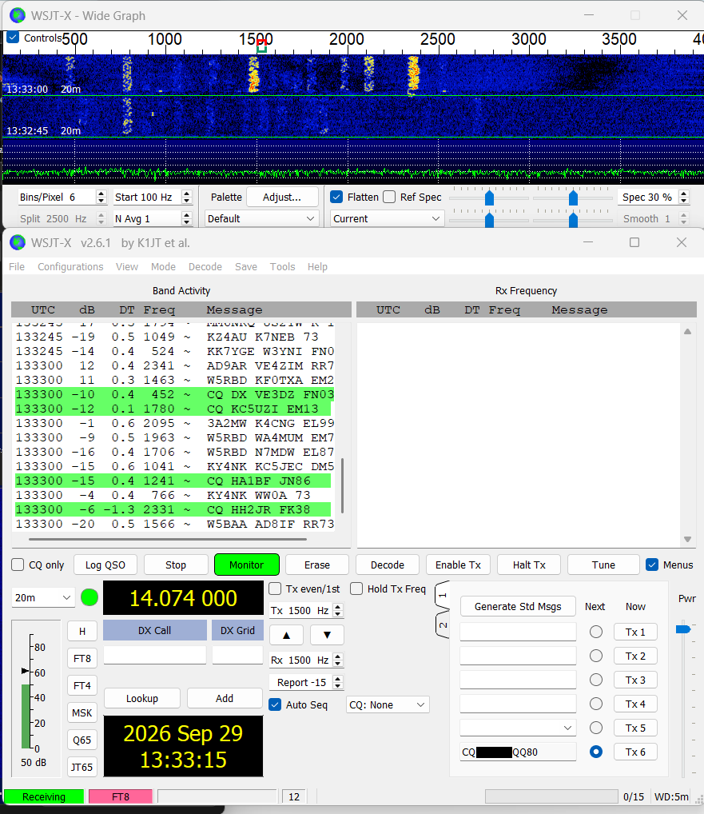
WSJT-X decoding 20 m FT8 with MSCC running remotely
Transmit only where your license allows, and keep an eye on ALC.

6. Troubleshooting
Problem | Check
Start does nothing; no spectrum | Are the servers running on the host (2.1)? Is Host the host's address and Port 8888? Same network? Is another client still connected (2.3)? On the host, were the Firewall prompts answered with Allow?
Connected, but no audio | Is Remote on (it is off after each start)? Phones or Digital chosen in the Remote Audio window? Right Device? Volume up, Mute off? Did the client's Firewall prompt for MSCC.Wpf get Allow (port 9100)?
Remote turned itself off | Pressing Phones or Digital on the main window turns Remote off. Use the choice inside the Remote Audio window.
Remote button does nothing | Host is 127.0.0.1, or Launch Servers is checked. Clear them for remote.
Receive works, transmit audio doesn't reach the radio | Is the right Mic picked and Mic vol up? Does the status box show "Mic TX ... → host:9101"? Is a firewall on the host blocking UDP 9101?
WSJT-X: no decodes | Digital chosen in the Remote Audio window? Cable ends swapped (5.1)? WSJT-X Input = the end MSCC plays into.
WSJT-X: CAT or PTT fails | SETTINGS → COM Port on the client = your end of the pair, WSJT-X = the other end? Remote on and Digital chosen (CAT runs only then)? Test CAT in WSJT-X.
Changed Host but still on the old one | Press Stop, then Start (3.3).

Appendix A: Network ports
Port (UDP) | Who listens | Used for
8888 | Host (ms-sdr-mkii.exe) | Control, spectrum, waterfall, meters, CAT. The client sends from its port 8889 and the host replies to the port the client sent from.
9100 | Client (MSCC.Wpf) | Receive audio from the host (Phones or Digital), sent by mscc-recv.exe.
9101 | Host (mscc-trans.exe) | Transmit audio from the client.

On the host, 8888 and 9101 must be reachable from the client. On the client, 9100 must be reachable from the host. On a home network, answering Allow to the Windows Firewall prompts is all that is needed: on the host for the three servers (2.1), on the client for MSCC.Wpf (3.1).
The other ports the servers use (9000, 9200, 9600, 9700, 9800) stay inside the host; you don't open them.
Keep all of these on your home network or inside a VPN. Don't open them to the internet.

Appendix B: Related guides
- MSCC Operator's Guide - Windows: install, firmware and calibration on a Windows PC, and every control on the main window.
- MSCC Operator's Guide - Remote Operation, Raspberry Pi and Linux: remote operation with a Pi or Linux host (separate guide).
- Virtual audio cable and virtual COM help: the Multus forum, https://multussdr.groups.io/g/main/topics

Appendix C: Draft items (remove before release)
To confirm (each also marked with a gray box in the text):
1. Windows host: only one client can be connected (2.3), so the MSCC window on the host must let go of the servers before the remote client can connect. Confirm how: does Stop on the host also stop the servers? Write the exact steps.
2. Add a picture of ipconfig (or Settings → Network) on the Windows host.
3. Suggest giving the host a fixed address in the home router (DHCP reservation), so the client's Host field never needs changing. Add a short how-to or leave it to the forum?
4. Confirm what the second client shows when the host refuses it (the host log says "SESSION IN USE - SINGLE CLIENT ONLY"; the client may just fail to connect). Add that text to chapter 6.
5. Retake the chapter 3 pictures (Windows client) with 10.31.2 (they show 9.27.0; the left rail has changed a little).
6. Confirm the mic-level advice with the Windows trans ALC (voice ceiling 0.45 x drive since trans 3.152). Same wording as the Windows guide 4.4?
7. Check: in the WSJT-X Audio picture, In and Out look the same way round as the Remote Digital window (MSCC plays to CABLE Input, so WSJT-X Input = CABLE Output). Retake if not.

