
MSCC Operator's Guide
Linux
Raspberry Pi and Ubuntu
Multus SDR Control Console for Proficio, Geminus and Ultimus transceivers
Linux local operation · servers mscc 1.0.72 · MSCC Init 1.0.18
Release 1 (DRAFT) · Revision date 11/1/26
Copyright © 2026 Multus SDR, LLC

About this guide
This guide covers installing and using MSCC, the Multus SDR Control Console, on a Raspberry Pi (4 or 5, 64-bit Raspberry Pi OS) or an Ubuntu Desktop PC, with the radio plugged into that computer. The Pi and Ubuntu are set up the same way; only the package file names differ.
Appendix B shows how to use the Pi as the host for a Windows client, the most common station setup. Other remote setups have their own guides. If you are not sure which setup you have, read MSCC Configurations first.
It is written for the servers in package mscc 1.0.72 and MSCC Init 1.0.18. MSCC UI (the Linux window) works like MSCC for Windows 10.31.2. If your versions are later, most of this still applies.
How the guide is laid out. Chapters 1 to 3 get you installed and on the air. Chapter 4 shows how to operate. Chapters 5 and 6 describe every control, by the name printed on it. Chapter 7 is calibration, in the order you should do it. Chapter 8 is troubleshooting.
What changed since Release 0. Calibration is now stored in the radio itself (QRP power, TX I/Q and RX I/Q). The install kit is installed with apt in a fixed order (no install-mscc.sh step). MSCC Init can also run as a text wizard over ssh. MSCC Volume sets the digital audio levels. The WSJT-X audio devices are corrected (Input VirtualA.monitor, Output VirtualB). The noise blanker and noise reduction are new. The chapters have been put in the order you need them.
DRAFT: DRAFT. Gray boxes like this one mark things still to confirm or pictures to retake. They are collected in Appendix C. Remove them before release.

DRAFT: This draft assumes two things (Ron, 11/1/26): MSCC UI is brought in line with MSCC for Windows 10.31.2, and the Ubuntu kit is brought in line with the Raspberry Pi kit. The pictures are from Release 0 (Ubuntu, MSCC UI 0.6.72); retake them when both are done.

Contents
1. What MSCC is 5
1.1 The client and the servers 5
1.2 What is kept where 5
1.3 Words used in this guide 6
1.4 Getting help 6
2. Installing and first start 7
2.1 What you need 7
2.2 Install the packages 7
2.3 Log out and back in (first install only) 8
2.4 MSCC Init: set up this computer 8
2.5 The MSCC menu: Start, Stop, Status and Volume 11
2.6 First start of MSCC UI 12
2.7 Check the radio's firmware 13
3. Updating the radio firmware 15
4. Operating 18
4.1 Connecting and disconnecting 18
4.2 Tuning 18
4.3 Receiving 18
4.4 Transmitting: the basics 18
4.5 SSB voice 19
4.6 CW 19
4.7 AM and FM 19
4.8 Digital modes (WSJT-X) 19
4.9 Using an amplifier 20
4.10 Favorites 20
5. The main window 22
5.1 Left rail 22
5.2 Meters and VFOs 23
5.3 Band buttons and tabs 23
5.4 MAIN tab: spectrum and waterfall 23
5.5 Right rail 24
6. The other tabs and windows 25
6.1 CW tab 25
6.2 RX/TX tab 26
6.3 FAVORITES tab 26
6.4 SETTINGS tab 26
6.5 Spectrum / Waterfall Controls window (S/W) 28
6.6 Debug Log window 29
6.7 Custom colors 29
7. Calibration 30
7.1 What to calibrate, and in what order 30
7.2 FREQ CAL (frequency calibration) 30
7.3 RX IQ (receive image balance) 31
7.4 QRP CAL (power calibration; AMP must be off) 32
7.5 TX IQ (transmit image balance; AMP must be off) 33
7.6 AMP CAL (AMP must be on) 34
7.7 Save settings 35
7.8 Resetting calibration to factory values 35
8. Troubleshooting 36
Appendix A: For support: where files are kept 37
Appendix B: Using this Pi as the host for a Windows client 38
Appendix C: Draft notes (remove before release) 39

1. What MSCC is
MSCC is the control program for Multus SDR, LLC transceivers: Proficio, Geminus and Ultimus, in both Legacy and MKII versions. It works only with Multus SDR equipment.
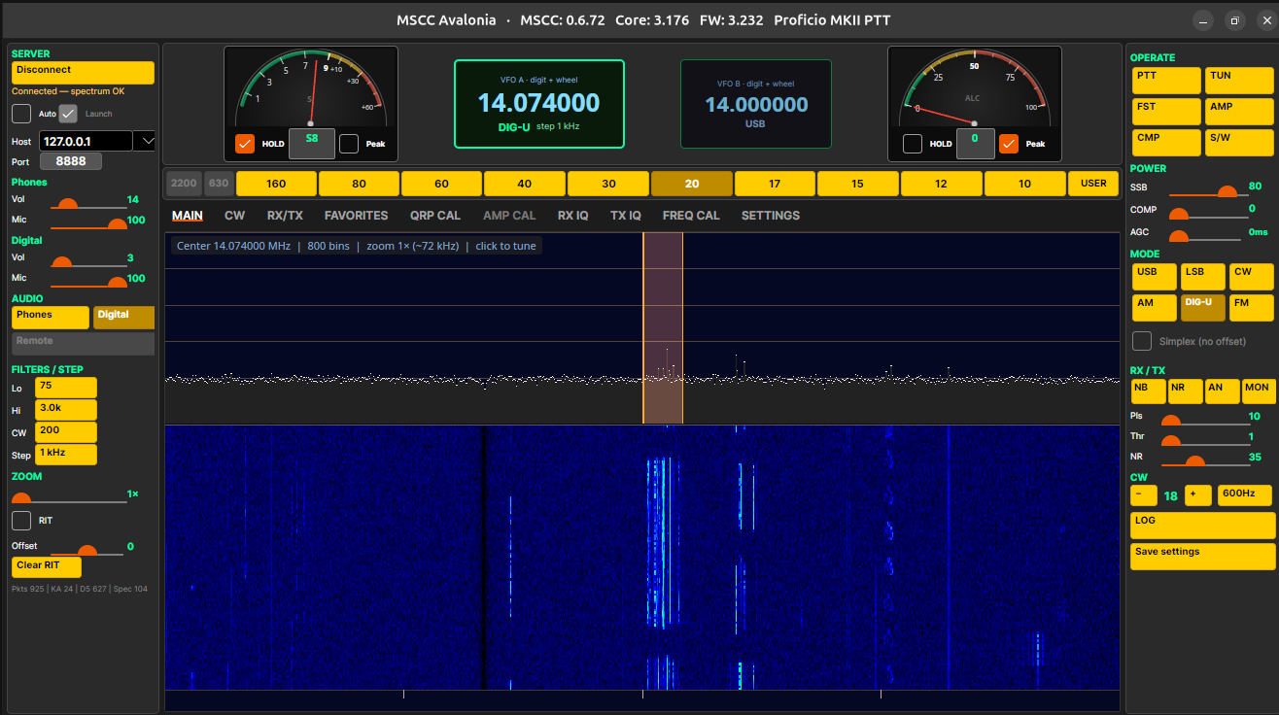
MSCC UI connected to the radio, MAIN tab

1.1 The client and the servers
MSCC is always made of several programs that work together (the MSCC Configurations document explains this in more detail):
- The servers (ms-sdr, sdrcore-recv and sdrcore-trans) talk to the radio over USB and do all the radio work. They have no window. They run on the computer the radio is plugged into.
- The client is the window you operate from. On Linux it is called MSCC UI (its title bar says MSCC Avalonia). It never touches the radio; it sends your settings to the servers.
- MSCC Init is a set-up program. It tells the servers which radio, serial port, speaker and microphone to use. You run it once after installing, and again when you change audio devices.
The client and the servers talk over the network, even on the same computer. That is why the client can also run on another computer, for example MSCC for Windows on a PC (Appendix B).

1.2 What is kept where
What | Kept in | Notes
QRP power calibration | The radio (and a copy on the computer) | Stored in the radio when you accept a band on QRP CAL.
TX I/Q (image balance) | The radio (and a copy) | Stored in the radio when you press APPLY on TX IQ.
RX I/Q (image balance) | The radio (and a copy) | Stored in the radio when you press APPLY on RX IQ.
AMP calibration | The computer only | Save settings keeps a copy for this radio.
Frequency calibration | The computer only | One value per computer. Recheck it when you change radios.
Keyer settings and CQ memories | The radio | Written by the CW tab.
Audio devices, CAT port, radio type | The computer | Written by MSCC Init.
Frequencies, modes, filters, colors, favorites | The computer | MSCC UI settings.

When the servers start, values stored in the radio win. A band the radio has no value for uses the file on the computer, or the factory value for your radio model.

1.3 Words used in this guide
Word | Meaning
Client / MSCC UI | The window you operate from.
Servers | The programs that run the radio (1.1).
Host | The computer the radio is plugged into. For Linux local this is your Pi or PC, address 127.0.0.1.
MSCC Init | The set-up program (2.4).
QRP / AMP | QRP = the radio alone, up to 5 W (AMP off). AMP = an amplifier in line; AMP on uses the AMP CAL power table.
Phones | The local audio path: your speaker or headphones and microphone ("operator" devices in MSCC Init).
Digital | The audio path for WSJT-X and similar programs, through two virtual sound devices.
VirtualA / VirtualB | The two virtual sound devices MSCC creates for digital programs. The servers play into VirtualA and listen to VirtualB; WSJT-X listens to VirtualA.monitor and plays into VirtualB.
CAT | Computer control of the radio (frequency, mode, PTT). MSCC looks like a Kenwood TS-2000.
/dev/tnt pair | Two linked virtual serial ports (for example /dev/tnt0 and /dev/tnt1). The servers use one end for CAT, your digital program the other.
DIG-U | Upper sideband for digital modes. Selecting it switches audio to Digital.
Image | A weak mirror copy of a signal, 24 kHz away. RX IQ and TX IQ remove it.
ALC | Automatic level control: stops the transmit audio from overdriving the radio. Always on.
Save settings | The right-rail button that keeps a copy of this radio's calibration on the computer (7.7).

1.4 Getting help
Post questions, bug reports and feature requests on the Multus forum: https://multussdr.groups.io/g/main/topics. Include a picture of MSCC Status and the log files (8.12).

2. Installing and first start

2.1 What you need
- Raspberry Pi 4 or 5 with 64-bit Raspberry Pi OS (desktop), or an Ubuntu Desktop 64-bit PC.
- The radio and its USB cable.
- A speaker or headphones, and a microphone if you will transmit voice.
- The MSCC install kit for your computer, in one folder: the Raspberry Pi kit (files ending _arm64.deb) or the Ubuntu kit (_amd64.deb). Files ending _all.deb are the same in both.
- A network connection the first time (apt fetches a few libraries).
- A mouse with a wheel. MSCC has no menus or keyboard shortcuts; the wheel does the tuning.
- For calibration: a 50 Ω dummy load rated 5 W or more and a wattmeter. For TX IQ, a second receiver.
⚠ Never install `_arm64` files on an Ubuntu PC or `_amd64` files on a Pi.

Speaker and microphone on a Raspberry Pi 4
The radio already uses the Pi's USB for its signal. On a Pi 4, a second USB sound device (a USB headset or dongle) can interrupt it under load: the spectrum and audio freeze while the servers still look "running". On a Pi 4 use an I²S audio HAT or the Pi's headphone jack for phones. A USB headset is usually fine on a Pi 5. Digital modes use the virtual devices and are fine on both.

2.2 Install the packages
You install MSCC by typing a few commands in a Terminal. Open the folder with the install files, right-click an empty spot and choose Open in Terminal. When a command starts with sudo, type your login password (nothing shows while you type; that is normal).
Run these one at a time, in this order, waiting for each to finish. The * means "whatever version is in the folder". On Ubuntu, use the same commands with amd64 in place of arm64.
# | Command | What it installs
1 | sudo apt install -y ./mscc-portaudio_*_arm64.deb | The audio library MSCC needs. Required, first.
2 | sudo apt install -y ./mscc_*_arm64.deb | The servers, the MSCC menu entries, the virtual sound devices and the /dev/tnt serial pairs, and the firmware upload program.
3 | sudo apt install -y ./mscc-init_*_all.deb | MSCC Init. Recommended.
4 | sudo apt install -y ./mscc-ui_*_arm64.deb | MSCC UI. Optional on a Pi you operate from a Windows PC.
5 | sudo apt install -y ./mscc-volume_*_all.deb | MSCC Volume (digital audio levels). Optional.
6 | sudo apt install -y ./mscc-firmware_*_all.deb | Radio firmware files for Chapter 3. Optional.

If apt prints a "Notice" about _apt but the install ends with "MSCC installed" or "done", ignore the notice. On a computer where a package is already installed, apt says it is already the newest version; that is fine.
DRAFT: Ubuntu: today the Ubuntu kit still installs the servers with install-mscc.sh and MSCC Init as mscc-init-gui 1.0.13. This section assumes Stew changes it to match the Pi kit.

2.3 Log out and back in (first install only)
The install gives your user permission to use the radio's serial and audio ports. That only takes effect after you log out and log back in (or restart). Skip it and CAT fails with "permission denied" and the radio may look missing.
Always log in to the desktop: the virtual sound devices for digital modes start with your desktop session.

2.4 MSCC Init: set up this computer
Run MSCC Init from the MSCC menu once after installing, and again when you change your speaker, microphone or radio. It has four steps and a review page. Use Next → and ← Back; Cancel leaves without changing anything. The heading says "configure this Pi" even on Ubuntu.
If the servers are running, MSCC Init asks to stop them first. Yes stops them and continues; No exits without changing anything.
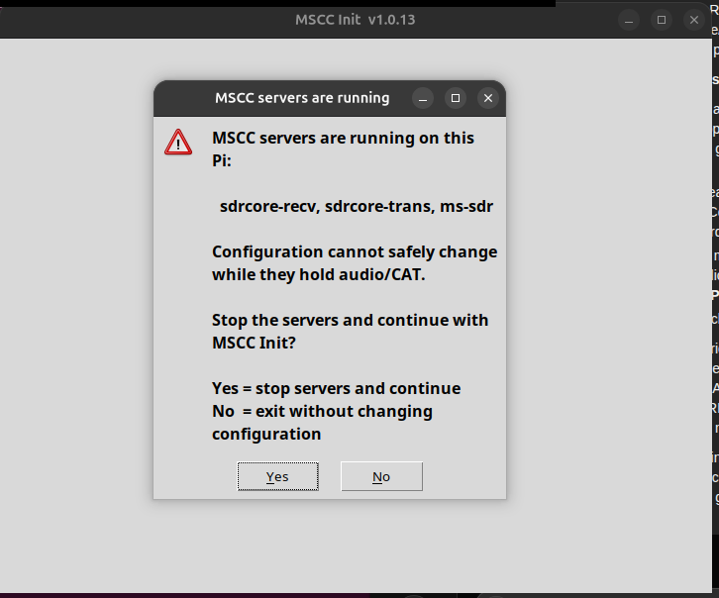
MSCC Init: the servers are running. Yes stops them and continues.
Step 1 of 4: Transceiver USB (optional)
Click Scan USB with the radio plugged in and on. MSCC Init shows the radio's serial number. The fixed digital devices (VirtualA and VirtualB.monitor) are shown too; you don't pick them.
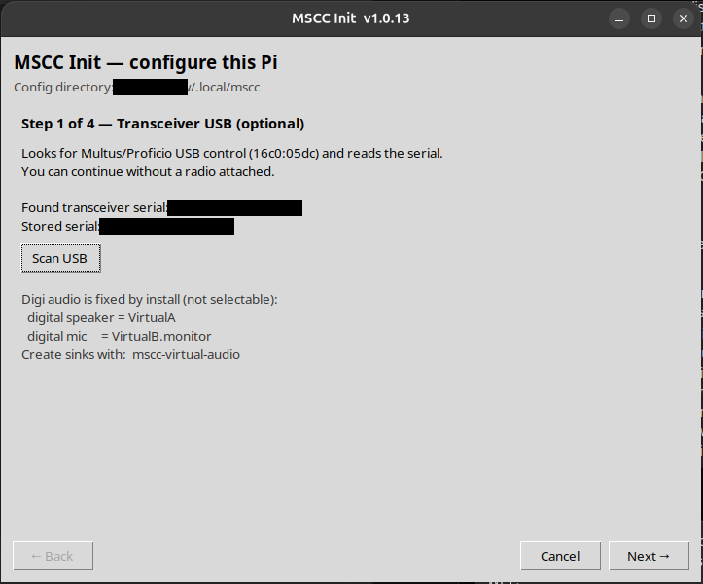
Step 1 after Scan USB (serial number blacked out)
Step 2 of 4: Radio family and keyer
- Proficio MKII transceiver is attached. Tick for an MKII radio, untick for a Legacy radio.
- Proficio MKII keyer is installed. Tick to use the radio's built-in keyer (paddle in the Key jack). Untick if you use your own external keyer.
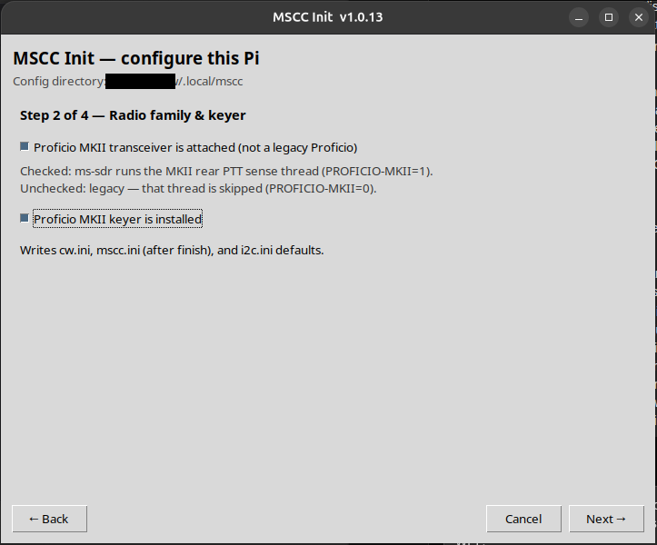
Step 2: radio family and keyer
Step 3 of 4: Kenwood CAT port and PTT pin
The serial port the servers use for CAT. Pick one of the /dev/tnt ports; they come in pairs (tnt0 with tnt1). The servers use the end you pick; your digital program uses the other end. PTT pin: 1 CTS. SETTINGS in MSCC UI shows which end is which (6.4).
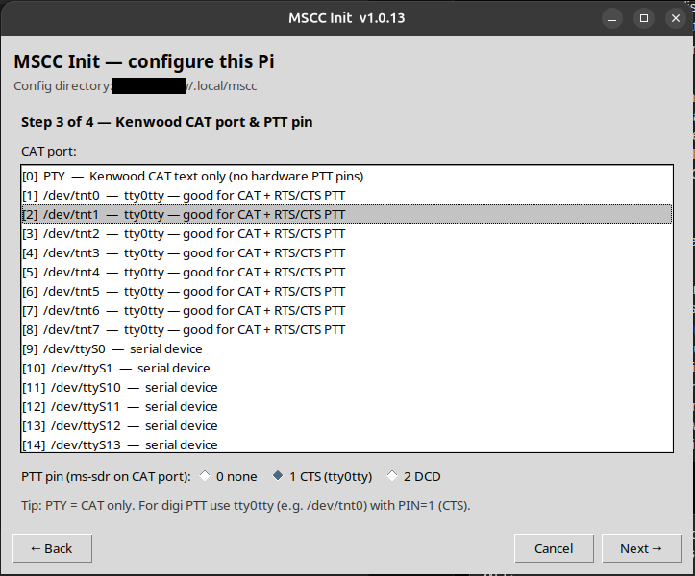
Step 3: CAT port /dev/tnt1 and PTT pin 1 CTS
Step 4 of 4: Operator audio
Pick the Operator speaker and Operator microphone: your HAT, the computer's audio or your headset (2.1). Not an HDMI output, and never the radio's own USB sound device (MSCC Init hides it). Any sample rate is fine. Refresh audio devices looks again after you plug something in. Click Review →.
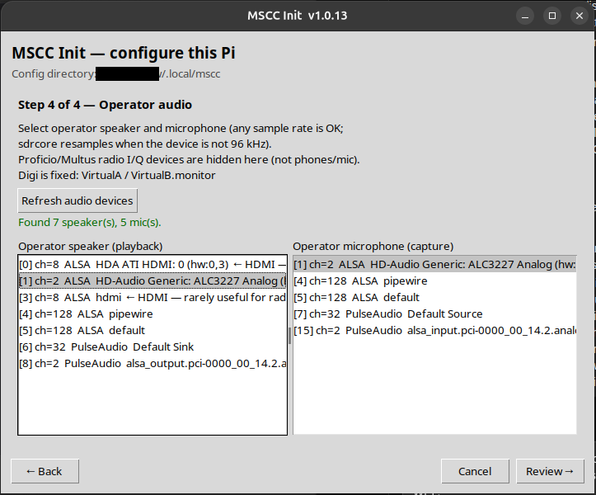
Step 4: operator speaker and microphone
Review
Check your choices and click Write config. MSCC Init then asks "Start MSCC servers now?" Yes starts them; No finishes without starting them. It also turns the speaker and microphone levels up to full, so the MSCC UI volume controls set the loudness.
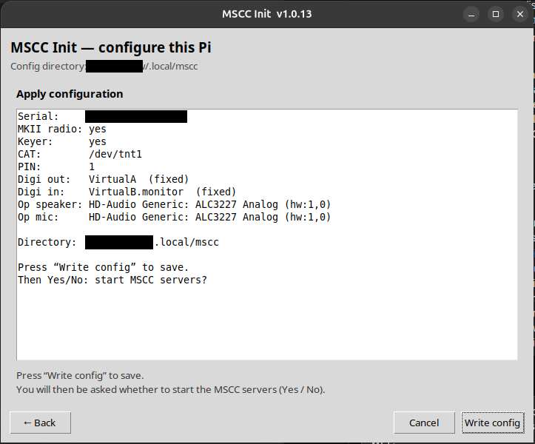
Review page: Write config
Running MSCC Init again keeps any other settings in your configuration (for example the SWR meter lines). Over ssh, with no desktop, the same set-up runs as a text wizard: type mscc-init.

2.5 The MSCC menu: Start, Stop, Status and Volume
The MSCC entries are in the applications menu, in an MSCC folder (Ubuntu: Show Apps). Log out and in once if the folder isn't there yet.
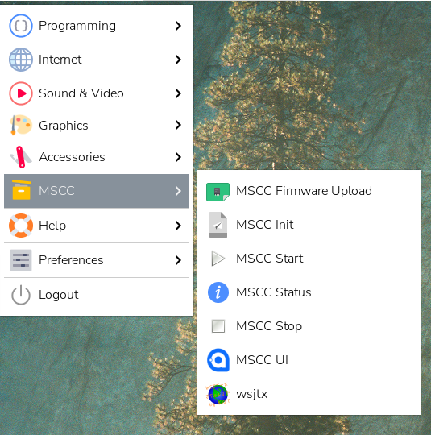
Raspberry Pi menu, MSCC folder
Menu entry | What it does
MSCC Start | Starts the virtual sound devices and the three servers. Also sets the speaker and microphone levels to full again (useful after a reboot).
MSCC Stop | Stops the servers. Stop them before you run MSCC Init or update the firmware.
MSCC Status | Opens a Terminal with a health check (below).
MSCC Init | Sets up this computer (2.4).
MSCC Volume | Levels of VirtualA (receive audio to WSJT-X) and VirtualB (transmit audio from WSJT-X). Save keeps them; Forget sets both to 100 %.
MSCC Firmware Upload | Loads new firmware into the radio (Chapter 3).
MSCC UI | The operating window.
wsjtx | WSJT-X, if installed.

The same commands work in a Terminal: mscc start, mscc stop, mscc restart, mscc status.
MSCC Status reports whether each server is running, the settings MSCC Init wrote, whether your audio devices and CAT port were found, and the radio's USB device. Lines start with OK, WARN or FAIL; the summary should read "MSCC status: OK" with "FAIL=0 WARN=0". A picture of this window is very useful with a problem report. Press Enter to close it.
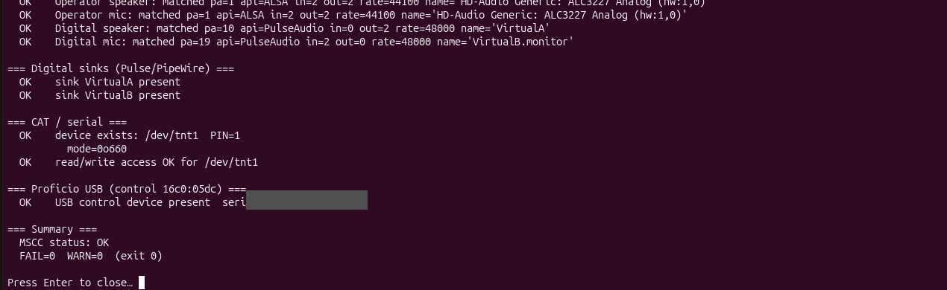
MSCC Status, end of the report: summary OK

2.6 First start of MSCC UI
1. Plug in the radio and power it on.
2. Start MSCC UI from the MSCC menu.
3. Leave Launch ticked and Host at 127.0.0.1 (normal for Linux local; 4.1).
4. Press Connect.
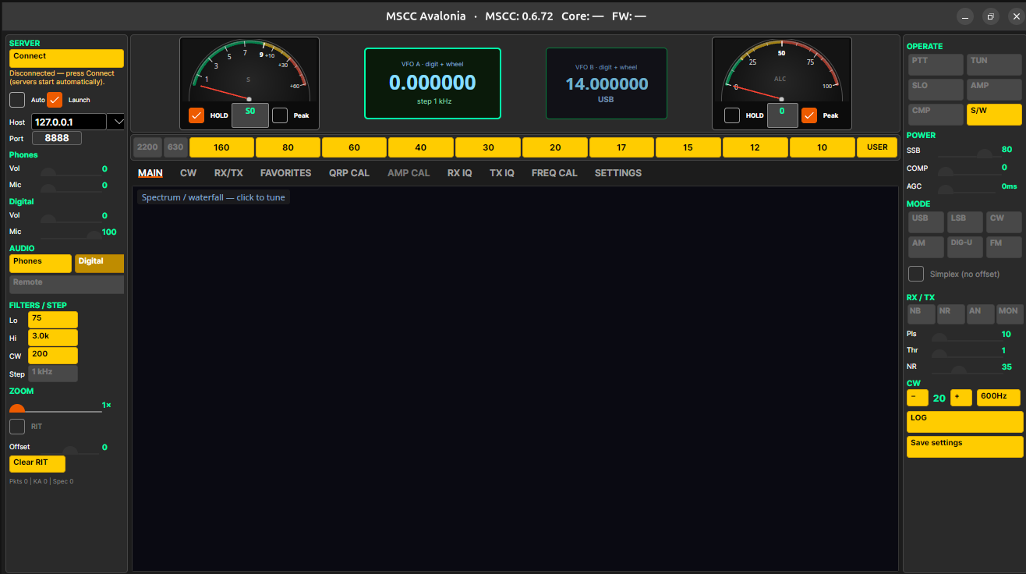
MSCC UI just opened, not connected
When the radio is connected, the button reads Disconnect, the status line reads "Connected - spectrum OK", and the title bar shows your radio model and its firmware version (FW), for example FW: 3.242 Proficio MKII PTT. The FW number is the one to check in 2.7.
If MSCC Init hasn't been run, Connect shows "MSCC is not set up on this computer yet." Click OK and run MSCC Init when you can.
Only one copy of MSCC UI should be open at a time. The window remembers its size and position, and your frequencies, modes, filters and display settings are remembered between sessions.
DRAFT: Retake the MSCC UI pictures with the version that matches MSCC for Windows 10.31.2 (button names, title bar). Confirm the Connect / Launch / Auto names stay as they are on Linux.

2.7 Check the radio's firmware
The radio's firmware must match this version of MSCC. After you connect, compare the FW number in the title bar with the table. If yours is lower, update it (Chapter 3).
Radio | Firmware | File in mscc-firmware 1.0.2
Proficio Legacy | 1.236 | Proficio-Legacy-20260822.cyacd
Geminus MKII | 2.153 | Geminus-mkii-20260903.cyacd
Proficio MKII PTT | 3.242 | Proficio-MKII-PTT-20261022.cyacd
Proficio MKII ATU | 4.243 | Proficio-MKII-ATU-20260822.cyacd
Geminus Legacy | 5.120 | Geminus-Legacy-20260920.cyacd
Ultimus Legacy | 6.236 | Ultimus-Legacy-20260920.cyacd
Ultimus MKII ATU | 7.243 | Ultimus-MKII-ATU-20260920.cyacd
Ultimus MKII PTT | 8.242 | Ultimus-MKII-PTT-20260920.cyacd

DRAFT: The firmware numbers are from the Windows guide draft; the file dates are from mscc-firmware 1.0.2 and are older than the Windows files for some radios. Confirm which version each file holds and bring the Linux firmware package up to date.

The firmware files are installed by the mscc-firmware package in /usr/share/mscc/firmware/, one folder per radio. A newer mscc-firmware package brings newer files.

3. Updating the radio firmware
The radio's processor (a Cypress PSoC) holds two programs: the application, which is the radio firmware you update, and a small bootloader ("LOADER") that you normally never touch. Updating with a .cyacd file never changes the bootloader, and your calibration stored in the radio is kept. No extra driver is needed on Linux.
⚠ Don't interrupt a firmware update. Once you click Program, don't unplug the USB cable, turn off the radio or close the program until the success message appears. It takes only a few seconds.

1. Stop MSCC. Disconnect and close MSCC UI, then MSCC Stop from the menu.
2. Power the radio off. Always move the shunt (jumper) with the radio off. Leave the USB cable connected.
3. Put the shunt on the boot pins. Find the 3-pin BOOT1 header. A small "U" printed on the board joins two of its pins: those are the boot pins. Put the shunt across them. The header's place differs by radio; the pictures show a Geminus MKII board.
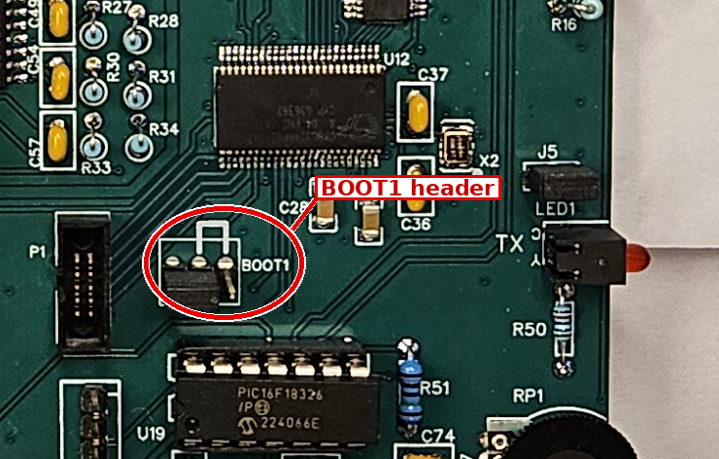
Example: Geminus MKII board, BOOT1 header circled
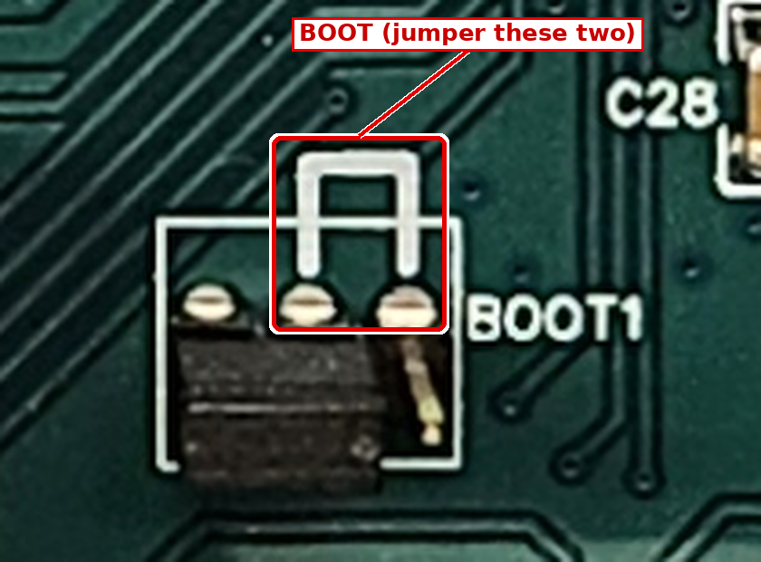
Close-up: the printed U joins the two boot pins
The other pins are just grounds. A shunt on the wrong pins doesn't hurt anything.
4. Power the radio on. The LED should blink LOADER in Morse code. If it doesn't, power off and move the shunt.
5. Start MSCC Firmware Upload from the MSCC menu. Its window is called USB Bootloader.
6. Wait for Connected on the line above the progress bar. Leave Vendor ID (04B4), Product ID (B71D) and Security Key (all zeros) as they are.
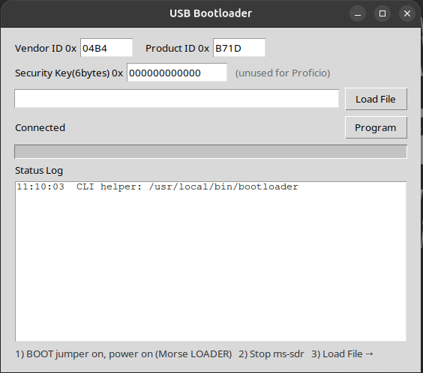
USB Bootloader, connected to the radio in boot mode
7. Choose the file. Click Load File. The window opens at /usr/share/mscc/firmware. Open your radio's folder, pick its .cyacd file and click Open.
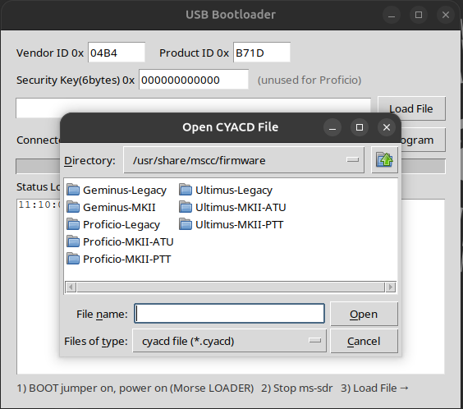
Load File: one folder per radio
8. Click Program. In a few seconds the message "Bootload successful !! Power off, remove BOOT jumper, power on." appears. Click OK.
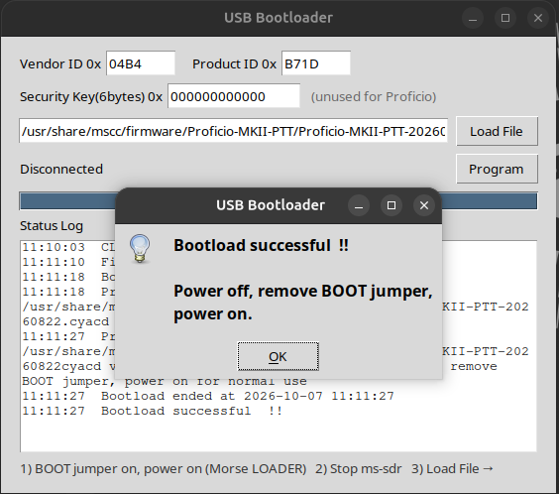
Bootload successful
9. Take the shunt off with the radio powered off, then power on.
10. Check the version. MSCC Start, then Connect in MSCC UI. The title bar shows the new FW number.
Terminal alternative for steps 5 to 8: psoc-bootloader /usr/share/mscc/firmware/<radio>/<file>.cyacd (radio in boot mode).

4. Operating
This chapter shows how to do things. Chapter 5 describes each control in detail.

4.1 Connecting and disconnecting
- Press Connect (top of the left rail). With Launch ticked (normal for Linux local) it also starts the servers if they aren't running. The button then reads Disconnect.
- Disconnect ends the session. If MSCC UI started the servers (Launch), it stops them too; closing the window does the same. Servers you started with MSCC Start keep running.
- Untick Launch to connect only to servers that are already running (MSCC Start).
- Tick Auto to have MSCC UI press Connect for you whenever it opens.
- Host is the servers' address: 127.0.0.1 for Linux local. Port is 8888. A change takes effect on the next Connect.

4.2 Tuning
- Pick a band with the band buttons above the tabs. Each band returns to the frequency, mode and filters you last used there, separately for VFO A and VFO B.
- VFO digits: point at a digit and roll the mouse wheel. That digit changes and the digits to its right go to zero.
- Spectrum: left-click a signal to tune to it. On the MAIN tab, the wheel anywhere that isn't a control tunes VFO A by the Step value.
- VFO A / VFO B: click a VFO to make it the active one (bright border).
- RIT: tick RIT and move the offset (±500 Hz) to move the receiver without moving your transmit frequency. Clear RIT sets it back to 0.
- USER: general coverage and time stations. Each click steps through WWV 5/10/15/20 MHz, CHU 3.330 / 7.850 MHz, RWM 9.996 MHz and your own last general-coverage frequency.

4.3 Receiving
- Filters: Lo and Hi (left rail) set the edges of the receive filter; CW sets the CW bandwidth. Each click moves to the next value. They are remembered for each mode and band.
- AGC: the SLO / MED / FST button cycles the AGC speed. AGC FAST RELEASE sets how fast it recovers.
- Noise blanker (NB) removes short clicks and pops (ignition, electric fences, power-line noise). It works out the band's normal level by itself and blanks only short pulses that stand well above it; signals are never blanked. Thr sets how sensitive it is: left = only big pulses, right = smaller pulses too. The middle is a good start. Pulse is the longest pulse it removes, in microseconds; about 200 is a good start.
- Noise reduction (NR) lowers the steady hiss between words. The NR level sets the strength: about 15 is gentle, 50 is a good middle, 85 is strong. Higher levels give a little "warble" on voices; use the lowest level that helps.
- Automatic notch (AN) removes steady carriers (tuners-up, heterodynes).
- Spectrum zoom (left rail, 1×-4×) magnifies the spectrum and waterfall around your frequency.

4.4 Transmitting: the basics
- Power slider (right rail): the label follows what you are doing (TUNE, CW, AM, FM or SSB). The number is not watts: it is a percentage of the power you set on QRP CAL. 100 % = the 5 W you calibrated.
- QRP or AMP: AMP off (normal) = the radio alone, up to 5 W. Turn AMP on only with an amplifier in line (4.9).
- ALC is always on. It keeps your audio from overdriving the radio. Watch the ALC meter while you set the mic or digital level.
- PTT keys the transmitter; it is red while on. PTT and TUN lock while a digital program or hardware PTT has control ("Server owns TX - PTT/TUN locked").
- TUN sends a steady carrier at Tune Power for your tuner or amplifier.
DRAFT: ALC target: Release 0 said "just into the yellow". With the current ALC (ceiling 0.89 on the Pi) and the peak meter, what should the operator aim for? Same answer as the Windows guide.

4.5 SSB voice
1. Pick the band and LSB or USB (LSB below 10 MHz, USB at 10 MHz and above, by habit).
2. Set SSB POWER on the right rail.
3. Make sure the Phones audio path is selected (left rail, AUDIO).
4. Key with PTT and speak normally. Set Phones Mic so the ALC meter moves on voice peaks without sitting at the top.
5. CMP turns the speech compressor on; COMPRESSION (0-24) sets how much.
6. TX BW (2.4 / 2.7 / 3.0 / 5.5 kHz) sets the transmit bandwidth. 2.4 or 2.7 kHz is normal.
7. MON lets you hear your own transmit audio.

4.6 CW
1. Select CW. Plug your paddle into the radio's Key jack (MKII radios have a built-in keyer).
2. Set CW POWER, CW SPEED (5-60 WPM) and CW PITCH (400 / 600 / 800 / 1000 Hz) on the right rail.
3. Set the CW bandwidth with the CW filter button (200 Hz / 400 Hz / 1.8 kHz).
4. Keyer mode, spacing, paddle, weight and HOLD are on the CW tab (6.1).
5. CQ memories: type a message in a slot on the CW tab (up to 48 characters), press R to store it in the radio and P to send it once. Touch the paddle to stop.
External keyer or Legacy radio: tick Use external electronic keyer (legacy) on the CW tab and restart the servers (Disconnect and Connect with Launch, or MSCC Stop and MSCC Start).

4.7 AM and FM
- AM: set AM CARRIER on the power slider. The receive filter is ± the Hi value around the carrier.
- FM is narrow FM. By default it transmits 100 kHz below the receive frequency (repeater split), shown on VFO B. Tick Simplex (no offset) to transmit on the receive frequency.

4.8 Digital modes (WSJT-X)
WSJT-X runs on the same computer as the servers. MSCC looks like a Kenwood TS-2000 to it (CAT), and the audio goes through the two virtual sound devices MSCC Init set up. Nothing extra to install.
One-time setup in WSJT-X
Look up your CAT port first: SETTINGS → Radio host → CAT (WSJT-X) in MSCC UI (6.4). The orange hint line there repeats these settings.
WSJT-X setting | Value
Rig | Kenwood TS-2000
Serial port | The CAT (WSJT-X) port from SETTINGS, for example /dev/tnt0. Never the servers' end.
Baud / handshake | 9600, none
PTT method | CAT
Mode | None (select DIG-U yourself in MSCC)
Split | None
Audio Input | VirtualA.monitor
Audio Output | VirtualB

Then click Test CAT and Test PTT in WSJT-X.
Each session
1. In MSCC select DIG-U. The audio path switches to Digital for you (leaving DIG-U puts back what you had).
2. Choose a Hi filter. In DIG-U you can narrow it to 1.4k or 1.0k.
3. Put the WSJT-X TX tone around 1500 Hz.
4. Press Tune in WSJT-X and set Digital Mic (left rail) so the ALC meter shows the level you want (4.4). Digital Vol sets the receive level going to WSJT-X.
5. If the WSJT-X receive level is still low, raise VirtualA in MSCC Volume (2.5).
Pi 4: MSCC already uses real processor time. If FT8 decodes fall behind, lower the number of decoder threads in WSJT-X. A Pi 5 has more room.

4.9 Using an amplifier
The radio has two power tables: QRP (barefoot, up to 5 W) and AMP (the drive your amplifier needs). AMP on the right rail switches between them.
⚠ Don't overdrive your amplifier. Multus amplifiers give full output with about 75 % of the radio's power. Calibrate the AMP table for each band first (7.6), and always turn AMP on when the amplifier is in line. A band with no AMP calibration gets the full QRP drive.

- QRP CAL and TX IQ need AMP off; AMP CAL needs AMP on. MSCC grays the tabs you can't use.
- POTENTIA / QSK (CW tab) is for Potentia 50 / 100 amplifiers only (6.1).

4.10 Favorites
The FAVORITES tab stores named settings for each band: frequency, mode, filters and VFO. Type a name, press SAVE; pick one from the list and press RECALL; DELETE removes it. Each band has its own list. Favorites are kept on this computer.
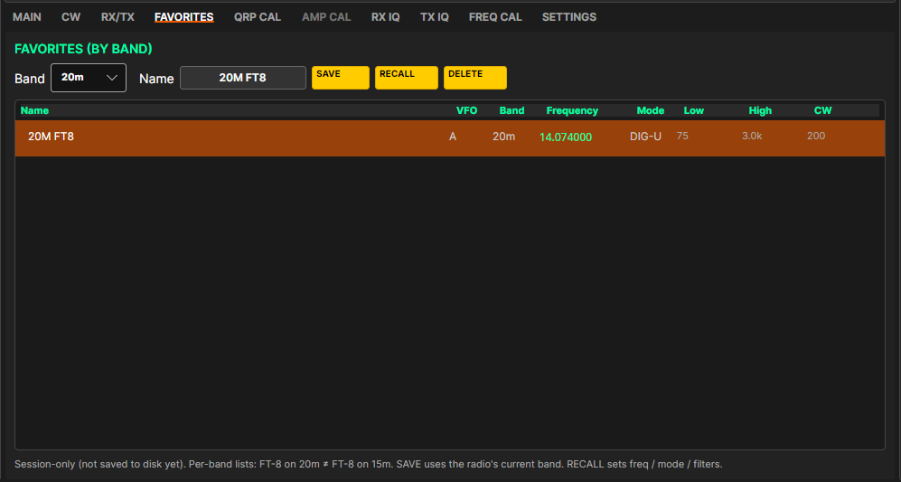
FAVORITES tab with one saved favorite

5. The main window
The main window: left rail, center (meters, VFOs, bands, tabs) and right rail
The window has three columns. Both rails stay visible on every tab.
- Left rail: connection, audio, filters, zoom and RIT.
- Center: meters and VFOs at the top, the band buttons, then the tabs.
- Right rail: the operating controls (PTT, TUN, modes, noise controls, CW).
Button colors: bright gold = off; darker gold = on or selected; red = transmitting, or a transmit switch that is on; gray = not available right now. Mouse wheel: over a slider, one notch moves it one small step. Hover over a control to see a short tip.

5.1 Left rail
Control | What it does
Connect / Disconnect | Connects to the radio (4.1). The status line under it says what Connect will do and shows the connection state.
Auto | Presses Connect automatically when MSCC UI opens.
Launch | Ticked: Connect also starts the servers on this computer, and Disconnect stops them. Works only with Host 127.0.0.1 and only while disconnected.
Host | The servers' address (127.0.0.1 for local). ▼ lists hosts you used before.
Port | Normally 8888.
Phones Vol / Mic | Speaker or headphone volume and microphone gain for the Phones path (0-100).
Digital Vol / Mic | Receive level to your digital program and transmit level from it (0-100).
AUDIO: Phones | Use your speaker or headphones and microphone.
AUDIO: Digital | Use the digital path (VirtualA / VirtualB). Selecting DIG-U switches to Digital for you.
Remote | For operating a radio on another computer. Grayed for local operation (Host 127.0.0.1).
Lo | Low edge of the receive filter: 75 → 100 → 200 → 300 → 500 Hz.
Hi | High edge. DIG-U: 1.0k → 1.4k → 2.4k → 2.7k → 3.0k → 4.0k → 5.5k (1.0k and 1.4k are DIG-U only). Other modes: 2.4k → 2.7k → 3.0k → 4.0k → 5.5k.
CW | CW bandwidth: 200 Hz → 400 Hz → 1.8 kHz.
Step | Mouse-wheel tuning step: 10 Hz to 100 kHz. Double-clicking VFO A also changes it.
ZOOM | Magnifies the spectrum and waterfall (1×-4×).
RIT / Offset / Clear RIT | Receive offset on, -500 to +500 Hz, and back to 0.
Counters | "Pkts | KA | DS | Spec": data arriving from the servers. Useful in problem reports.

5.2 Meters and VFOs
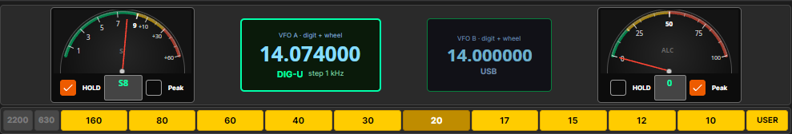
Meters and VFOs
Control | What it does
S-meter | Received signal strength, with HOLD (slow fall-back, on by default), the reading box and Peak.
VFO A / VFO B | Click to make active. Point at a digit and roll the wheel to tune. Each VFO remembers its own band. In FM repeater mode VFO B shows the transmit frequency.
Mode | The VFO's mode, under the frequency.
ALC meter | Transmit ALC level; rests at zero on receive. HOLD and Peak as on the S-meter.

5.3 Band buttons and tabs
Control | What it does
Band buttons | 2200, 630, 160, 80, 60, 40, 30, 20, 17, 15, 12, 10 and USER. Bands your radio can't use are grayed (Proficio and Ultimus: 160-10 m; Geminus: 2200 and 630 m).
USER | General coverage and time stations (4.2). Good references for FREQ CAL.
Tabs | MAIN, CW, RX/TX, FAVORITES, QRP CAL, AMP CAL, RX IQ, TX IQ, FREQ CAL, SETTINGS. QRP CAL and TX IQ are grayed while AMP is on; AMP CAL while AMP is off.

5.4 MAIN tab: spectrum and waterfall
Control | What it does
Left-click | Tunes to the signal.
Wheel | Tunes VFO A by the Step value when the pointer isn't over a control.
Top line | Center frequency, resolution, zoom and "click to tune".
Shaded band | Your receive passband.

5.5 Right rail
Control | What it does
PTT | Transmit on/off; red while on (4.4).
TUN | Steady carrier at Tune Power; red while on.
SLO / MED / FST | Cycles the AGC speed.
AMP | Switches between the QRP and AMP power tables; red while on (4.9).
CMP | Speech compressor on/off. Phones path only.
S/W | Opens the Spectrum / Waterfall Controls window (6.5).
Power slider | 0-100 % of your QRP CAL power. The label follows the mode: TUNE, CW, AM, FM or SSB (LSB, USB, DIG-U).
COMP | Compressor amount, 0-24.
AGC | AGC fast release, in ms.
Mode buttons | USB, LSB, CW, AM, DIG-U, FM. Each mode remembers its own filters.
Simplex (no offset) | FM only: transmit on the receive frequency.
NB / NR / AN / MON | Noise blanker, noise reduction, automatic notch and monitor, each on/off (4.3).
Pulse | Noise blanker: longest pulse removed, 10-510 microseconds.
Thr | Noise blanker sensitivity. Left = only big pulses, right = more.
NR | Noise reduction level (0-100).
CW - / speed / + | Keyer speed, 5-60 WPM.
CW pitch | 400 → 600 → 800 → 1000 Hz.
LOG | Opens the Debug Log window (6.6).
Save settings | Keeps a copy of this radio's calibration on the computer (7.7).

DRAFT: Right rail: confirm the Thr slider range and labels once MSCC UI matches the Windows client (Windows: 1-1009; Release 0 MSCC UI showed 1-100, which the new noise blanker would barely react to).

6. The other tabs and windows

6.1 CW tab
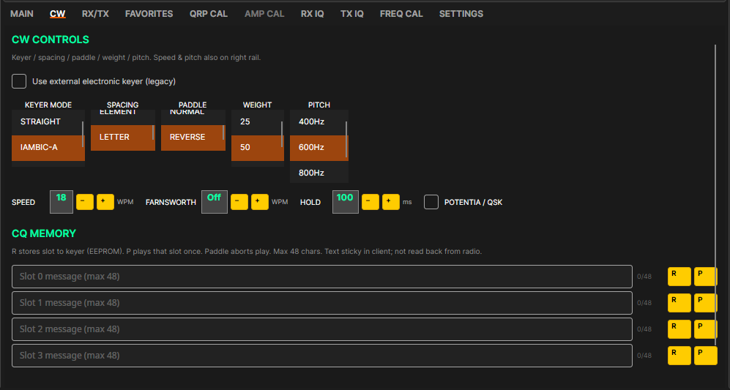
CW tab
Control | What it does
Use external electronic keyer (legacy) | Tick if you key with your own external keyer or have a Legacy radio. The built-in keyer controls gray out; HOLD still works. The servers read this only when they start: Disconnect and Connect again (with Launch), or MSCC Stop and MSCC Start.
KEYER MODE | STRAIGHT, IAMBIC-A (default) or IAMBIC-B.
SPACING | ELEMENT or LETTER.
PADDLE | NORMAL or REVERSE (swaps dot and dash).
WEIGHT | 25, 50 (default) or 75.
PITCH | 400, 600, 800 or 1000 Hz. Same as CW pitch on the right rail.
SPEED - / + | 5-60 WPM. Same as the right rail.
FARNSWORTH - / + | Off, or 5-60 WPM. Extra space between letters and words, for CQ memories only.
HOLD - / + | 1-500 ms in steps of 10 (default 100). How long the radio stays in transmit after you stop keying. With an amplifier (POTENTIA / QSK off) it also sets how long the radio waits after keying the amplifier before RF starts.
POTENTIA / QSK | Only for Potentia 50 / 100 amplifiers (full break-in). On: the radio keys the amplifier line and its own output together. Off (default): amplifier line first, then RF after the HOLD delay. Leave it off unless a Potentia is attached.
CQ MEMORY slots 0-3 | Text (up to 48 characters), character count, R stores it in the radio's keyer (kept with power off), P sends it once. Touch the paddle to stop. R and P work only while connected.

6.2 RX/TX tab
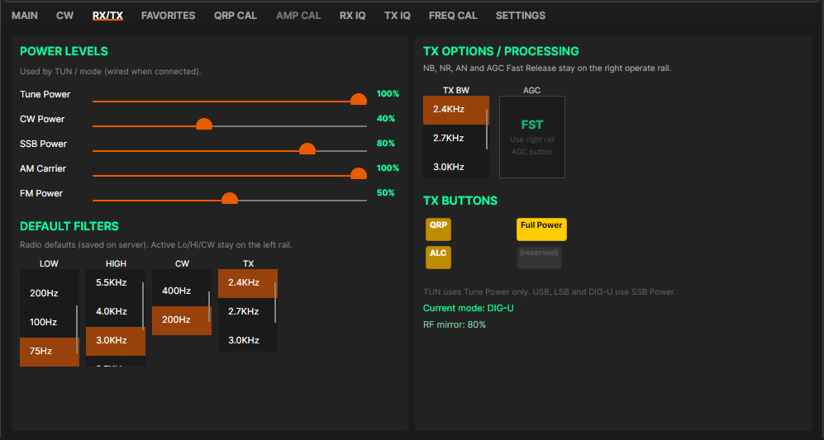
RX/TX tab (older picture: the ALC button is gone; ALC is always on)
Control | What it does
Tune Power | Drive for TUNE only (0-100 %).
CW Power / SSB Power / AM Carrier / FM Power | 0-100 % of your QRP CAL power. SSB Power covers LSB, USB and DIG-U.
DEFAULT FILTERS: LOW, HIGH, CW, TX | The radio's stored default filters. Day to day you use the Lo / Hi / CW buttons on the left rail.
TX BW | Transmit bandwidth: 2.4k, 2.7k, 3.0k or 5.5k.
AGC | Shows the AGC speed; change it on the right rail.
QRP / Full Power | The same switch as AMP off / AMP on.

6.3 FAVORITES tab
See 4.10.

6.4 SETTINGS tab
The SETTINGS page scrolls. Unlike MSCC for Windows, the serial port and audio devices are not chosen here: MSCC Init sets them (2.4), and SETTINGS shows them.
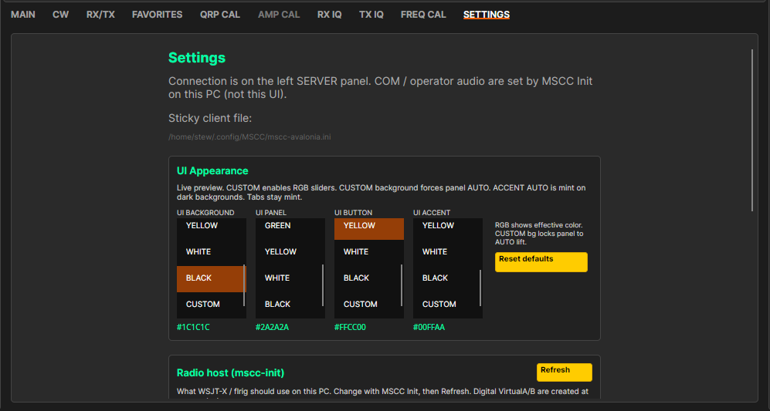
SETTINGS, top: settings file and UI Appearance
Control | What it does
Sticky client file | Where MSCC UI keeps its settings (~/.config/MSCC/mscc-avalonia.ini).
UI BACKGROUND / PANEL / BUTTON / ACCENT | Colors of the window, panels, buttons and headings. CUSTOM shows R, G, B sliders (6.7). YELLOW is the classic Multus gold.
Reset defaults | Back to the standard colors.

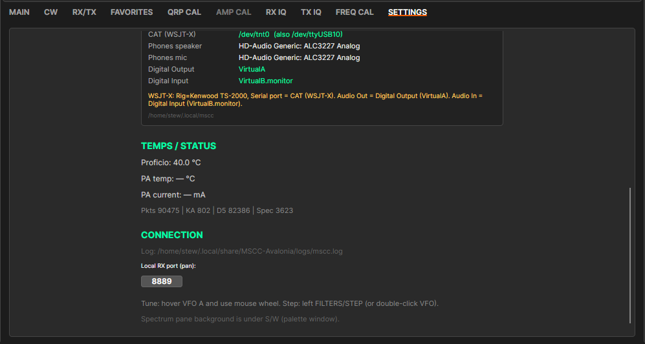
SETTINGS, scrolled: Radio host, temperatures and connection
Control | What it does
Radio host (mscc-init) and Refresh | A read-only view of what MSCC Init set. Change it with MSCC Init, then press Refresh.
CAT (WSJT-X) | The port your digital program uses: the other end of the servers' pair, for example /dev/tnt0.
Phones speaker / Phones mic | The operator devices from MSCC Init.
Digital Output / Digital Input | VirtualA and VirtualB.monitor (the servers' ends).
WSJT-X hint (orange) | The settings to use in WSJT-X (4.8).
Transceiver temperature | For example "Proficio: 40.0 °C".
Local RX port (pan) | Default 8889. Leave it alone.

6.5 Spectrum / Waterfall Controls window (S/W)
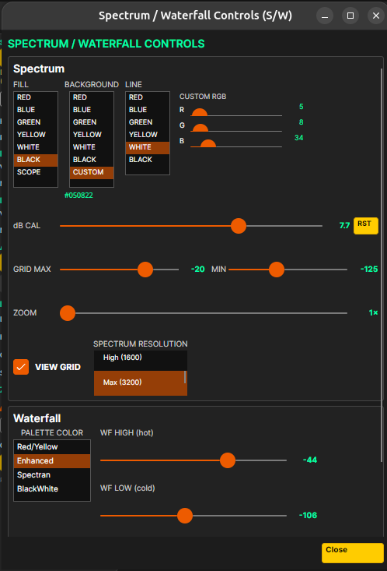
S/W window (older picture)
Control | What it does
FILL / BACKGROUND / LINE | Spectrum colors (FILL SCOPE = line only, the classic look).
dB CAL and RST | Trims the dB scale ±20 dB.
GRID MAX / MIN | Top and bottom of the display in dBm.
ZOOM | Same as the left rail.
VIEW GRID | dB grid lines.
PALETTE COLOR | Waterfall colors: Red/Yellow, Enhanced, Spectran or BlackWhite.
WF HIGH / WF LOW | Signals at WF HIGH show in the hottest color; WF LOW is the background level.
Show waterfall / Direction | Waterfall on/off, and which way it scrolls.

DRAFT: Retake the S/W picture and update this list once MSCC UI matches the Windows client (Windows has SMOOTHING, BASELINE, AUTO SNAP, PEAK MARKER, TIME DISPLAY, TIME MARKER and Climbing).

6.6 Debug Log window
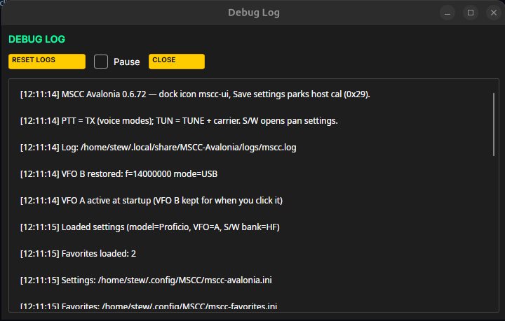
Debug Log window
RESET LOGS clears the display, Pause freezes it (the log file keeps recording), CLOSE closes it. MSCC UI's log file is ~/.local/share/MSCC-Avalonia/logs/mscc.log; the servers keep their own logs in ~/.local/mscc/.

6.7 Custom colors
Any color list with a CUSTOM choice shows R, G and B sliders (0-255) under it; the change shows at once. The color code (for example #1C1C1C) is the color in use.

7. Calibration

7.1 What to calibrate, and in what order
Factory values for your radio model are loaded automatically, so calibration is a touch-up, not a must-do on day one. When you do it, go in this order:
1. FREQ CAL: frequency accuracy. Everything else depends on being on frequency.
2. RX IQ: receive image balance.
3. QRP CAL: output power on each band (dummy load and wattmeter).
4. TX IQ: transmit image balance (needs QRP CAL done; second receiver).
5. AMP CAL: only if you use an amplifier (needs QRP CAL done).
6. Save settings: keeps a copy on the computer.
QRP power, RX I/Q and TX I/Q are stored in the radio the moment you accept or APPLY them; AMP and FREQ calibration are stored on the computer (1.2).

7.2 FREQ CAL (frequency calibration)
You need a strong, steady carrier of known frequency: a time station at S7 or better (WWV or CHU on HF). Opening FREQ CAL switches to CW with a 600 Hz pitch and the 200 Hz filter; leaving the tab puts back what you had. While a run is going, don't change tabs or settings.
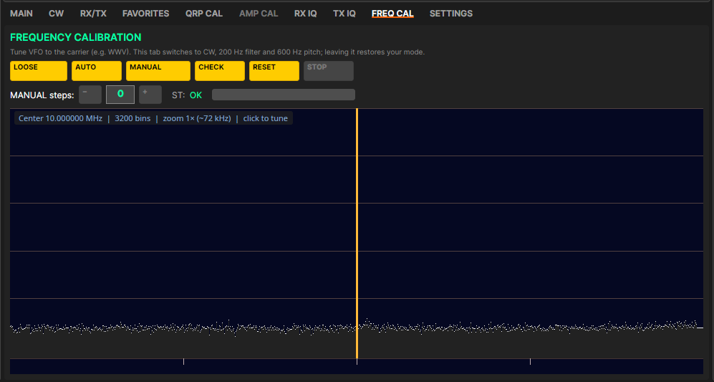
FREQ CAL tab
1. Click USER until you reach a strong time station.
2. Open FREQ CAL.
3. Click AUTO → Coarse ±250 Hz and wait for AUTO COMPLETED.
4. Click AUTO → Fine ±50 Hz and wait for AUTO COMPLETED.
5. Click CHECK. A few Hz of error is a good result.
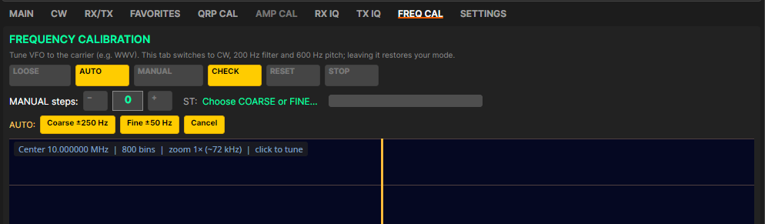
AUTO: choose Coarse or Fine
Control | What it does
LOOSE / TIGHT | How close the measurement must get. LOOSE locks more easily on a weak carrier.
AUTO | Automatic calibration against the carrier on your frequency (Coarse or Fine).
MANUAL | Adjust by ear with MANUAL steps - / +, then click MANUAL again and accept.
CHECK | Measures the error without changing anything (±50 Hz range).
RESET | Returns to the factory calibration, after you confirm.
STOP | Stops an AUTO or CHECK run. The calibration is not changed.
Status | RUNNING COARSE / RUNNING FINE / CHECKING, then COMPLETED with a number in Hz, or FAILED.

7.3 RX IQ (receive image balance)
An unbalanced receiver shows a weak mirror copy (image) of a strong signal 24 kHz away. RX IQ moves the image down into the noise.
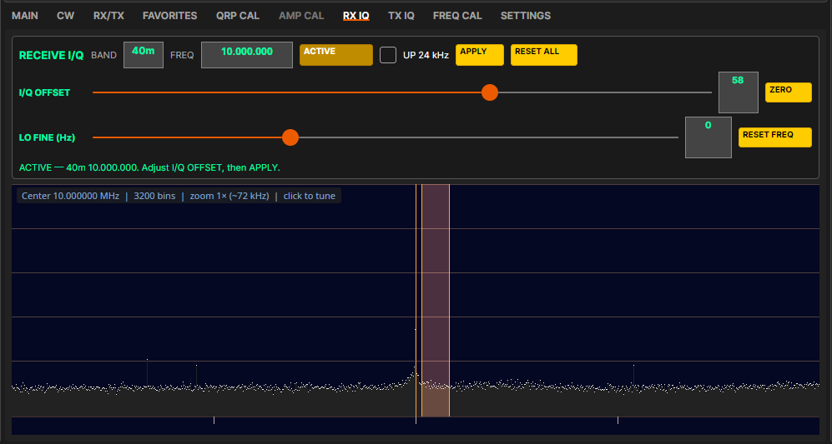
RX IQ tab, ACTIVE on 40 m (older picture: RESET ALL is now APPLY ALL)
1. On the MAIN tab choose an amateur band (not USER) and tune near a strong steady signal.
2. Open RX IQ and press START (it reads ACTIVE). Find the image 24 kHz from the signal; UP 24 kHz helps.
3. Move I/Q OFFSET until the image drops into the noise.
4. Press APPLY and answer Yes. The value is stored in the radio for this band.
5. Repeat for each band you use.
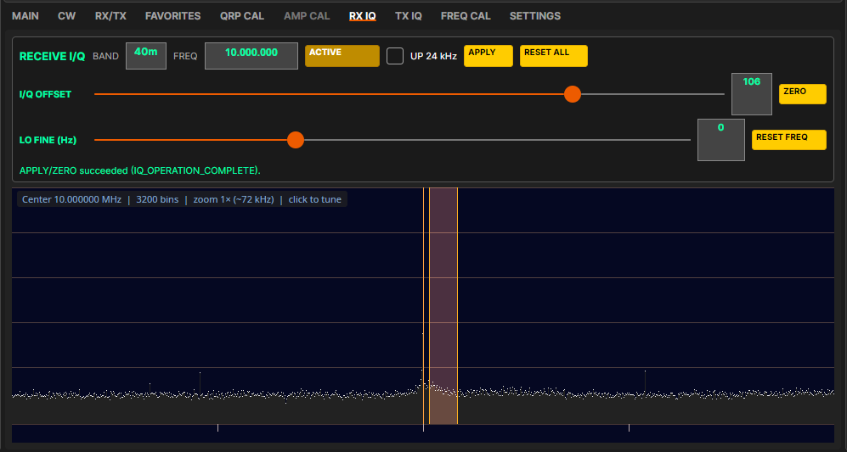
After APPLY
Control | What it does
START / ACTIVE | Starts or ends the session.
UP 24 kHz | Shifts the receiver up 24 kHz to help find the image.
APPLY | Saves the value for this band (in the radio), after asking.
APPLY ALL | Copies the current value to all bands, after a warning.
I/Q OFFSET | -200 to +200. Adjust for the smallest image.
ZERO | Sets the offset to 0 and saves it.
LO FINE / RESET FREQ | Fine retune during the session, and clear it.

7.4 QRP CAL (power calibration; AMP must be off)
This sets the radio's full output, 5 W, on each band. Everything else (the power sliders, AMP CAL) is a percentage of it.
⚠ Do not set more than 5 W. More than 5 W causes spurious emissions.

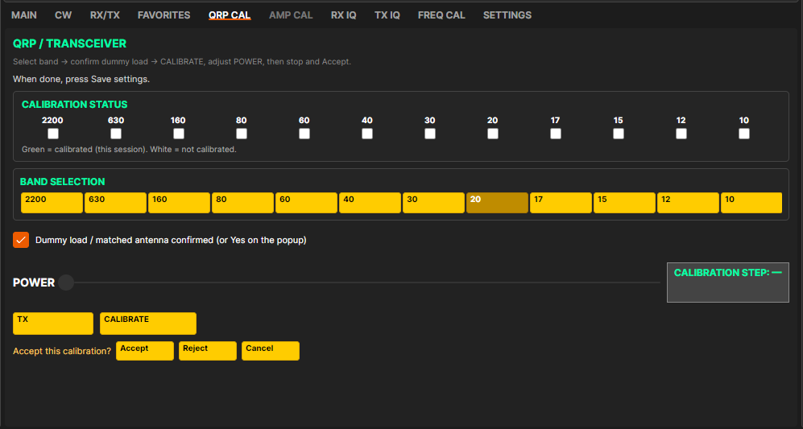
QRP CAL tab
1. Turn AMP off. Connect a 50 Ω dummy load (5 W or more) through a wattmeter.
2. Open QRP CAL and pick a band. The radio tunes to that band's calibration frequency.
3. Click CALIBRATE. The first time in a session MSCC asks you to confirm a dummy load or matched antenna is attached: click Yes.
4. Move POWER until the wattmeter reads 5 W, not more. The first move can take a few seconds.
5. Click CALIBRATE again and Accept. The value is stored in the radio and the band's lamp turns green. Reject leaves the band uncalibrated; Cancel puts back the previous setting.
6. Repeat for each band.
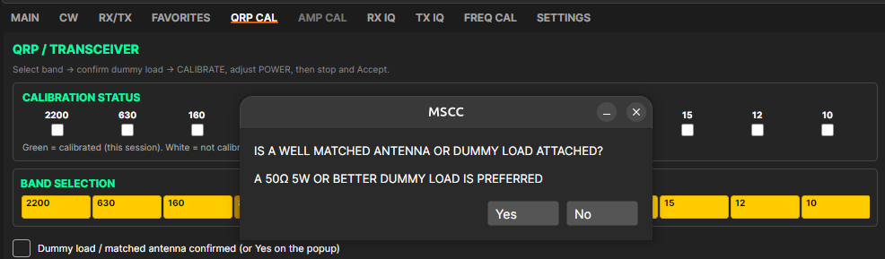
Dummy load question, asked once per session

7.5 TX IQ (transmit image balance; AMP must be off)
An unbalanced transmitter sends a weak image 24 kHz from your signal. You need a second receiver to see it. Use a dummy load and keep the second receiver's antenna well away. Do QRP CAL first.
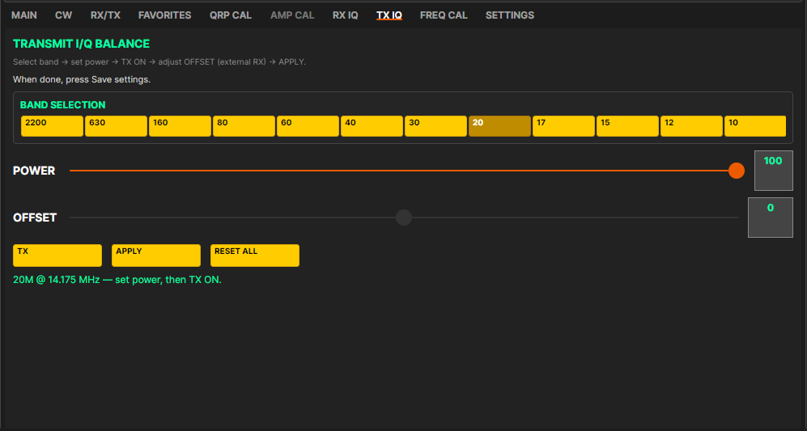
TX IQ tab (older picture: there is now a PHASE slider under OFFSET)
1. Turn AMP off. Open TX IQ and pick a band.
2. Tune the second receiver about 24 kHz from the displayed frequency.
3. Set POWER and press TX.
4. Move OFFSET for the weakest image on the second receiver.
5. Step PHASE one click at a time for the weakest image, then recheck OFFSET. Go back and forth until neither improves it.
6. Press APPLY and answer Yes. The values are stored in the radio for this band.
7. Press TX again to stop the carrier. Repeat for each band.
Control | What it does
POWER | Test carrier power, 0-100 (default 100).
OFFSET | -200 to +200: amplitude balance. Works only while TX is on.
PHASE | Phase balance. Set OFFSET first, then PHASE.
TX | Starts or stops the test carrier.
APPLY | Saves this band's values (in the radio), after asking.
RESET ALL | Returns all bands to the factory values, after a warning; TX must be off. See 7.8.

DRAFT: Retake the TX IQ picture with the PHASE slider.

7.6 AMP CAL (AMP must be on)
This sets the drive the radio uses when AMP is on, so your amplifier reaches its rated output without being overdriven. A band needs QRP CAL (green lamp) first.
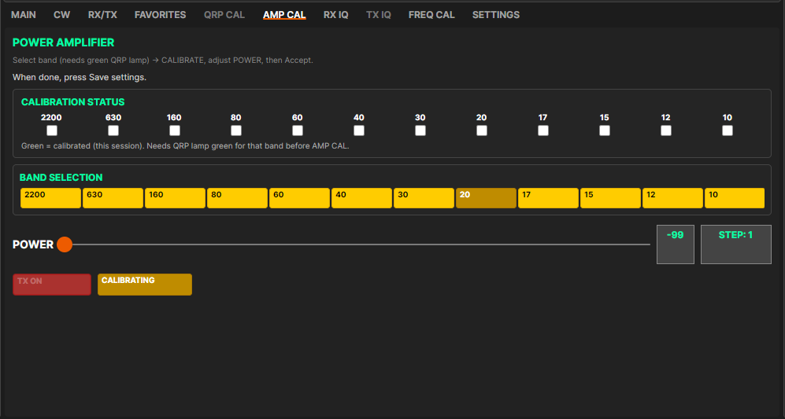
AMP CAL tab
1. Put the amplifier in line with a dummy load and wattmeter on its output. Turn AMP on.
2. Open AMP CAL, pick a band and click CALIBRATE (answer Yes to the dummy load question).
3. Raise POWER (-99 to 0) slowly until the amplifier just reaches its rated output. Not more.
4. Click CALIBRATE again and Accept.
5. Repeat for each band, then press Save settings (7.7).
AMP calibration is kept on the computer, not in the radio.

7.7 Save settings
Save settings (right rail, under LOG) keeps a copy of this radio's calibration on the computer. MSCC uses that copy when you switch radios on the same computer. Press it after AMP CAL, and whenever you finish calibrating.
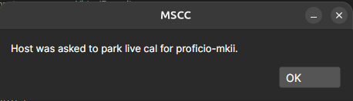
Save settings: saved on the host
If the radio isn't connected, MSCC says "Connect the radio first." Connect, wait for the FW number in the title bar, and try again.

7.8 Resetting calibration to factory values
- FREQ CAL → RESET returns the frequency calibration to the factory value for your radio.
- TX IQ → RESET ALL resets the files on the computer. It does not yet clear the values stored in the radio, and at the next start the radio's values win. For now this reset lasts only until the servers restart.
DRAFT: Reset to factory must also clear the values stored in the radio (same open item as the Windows guide). Until then this section has to warn as above.

8. Troubleshooting
8.1 "MSCC is not set up on this computer yet." Run MSCC Init (2.4). You can click OK and keep going meanwhile.
8.2 Connect does nothing, or the spectrum stays empty. Check the radio's power and USB. Open MSCC Status and look for FAIL lines. With Launch unticked, run MSCC Start first.
8.3 "WARNING: keep-alive lost". MSCC UI stopped hearing from the servers. Check the radio's power and USB, then Disconnect and Connect. If needed, mscc restart.
8.4 Spectrum and audio freeze, but MSCC Status says the servers are running. Usually the USB audio dropped under load. On a Pi 4, don't use a USB headset next to the radio (2.1). Then MSCC Stop, MSCC Start and Connect again.
8.5 No firmware version (FW) in the title bar. Check USB and power, then Disconnect and Connect (or restart the servers).
8.6 No sound, or the wrong speaker or microphone. Run MSCC Init again (it stops the servers for you), pick the right devices in step 4, Write config, and start the servers. Check SETTINGS → Radio host.
8.7 Phones quiet after a reboot. Use MSCC Start (it turns the levels up again), or run MSCC Init again.
8.8 WSJT-X: no decodes or weak receive. WSJT-X Audio Input must be VirtualA.monitor and Output VirtualB (4.8). Raise VirtualA in MSCC Volume. If VirtualA / VirtualB are missing, log out and in, or run mscc-virtual-audio.
8.9 WSJT-X can't open the serial port. Use the CAT (WSJT-X) port from SETTINGS, not the servers' end. Make sure you logged out and back in after the first install (2.3). If /dev/tnt0 is missing, reboot once.
8.10 WSJT-X keys the radio but power is very low. Put the TX tone around 1500 Hz; check AMP (off = normal 5 W); raise Digital Mic until the ALC meter moves; check SSB POWER.
8.11 CW paddle does nothing. With an external keyer or a Legacy radio, tick Use external electronic keyer and restart the servers. For an MKII radio with a paddle in the Key jack, leave it unticked. Also check you are in CW.
8.12 Sending a problem report. Don't restart first. Collect a picture of MSCC Status, the MSCC UI log (~/.local/share/MSCC-Avalonia/logs/mscc.log) and the server logs (~/.local/mscc/*.log), and post the problem at https://multussdr.groups.io/g/main/topics with the logs attached.

Appendix A: For support: where files are kept
You only need this if support asks you for a file. The ~ means your home folder. Folders starting with a dot are hidden; press Ctrl+H in Files to show them.
What | Where
MSCC UI settings (window, display, last used, colors) | ~/.config/MSCC/mscc-avalonia.ini
Favorites | ~/.config/MSCC/mscc-favorites.ini
MSCC UI log | ~/.local/share/MSCC-Avalonia/logs/mscc.log
Settings written by MSCC Init | ~/.local/mscc/ (mscc.ini, comm-port.ini, cw.ini, operator-speaker.ini, operator-microphone.ini, digital-speaker.ini, digital-microphone.ini)
TX I/Q, RX I/Q, QRP power (copies; the radio holds the master) | ~/.local/mscc/iq.ini, recv-iq.ini, power_cal.ini
AMP calibration, frequency calibration | ~/.local/mscc/amplifier_cal.ini, freq_cal.ini
Saved calibration per radio (Save settings) | ~/.local/mscc/cal/<radio line>/ and cal/LAST_LINE.txt
MSCC Volume levels | ~/.local/mscc/volume-levels.conf
Server programs | ~/mscc/
Server logs | ~/.local/mscc/sdrcore-recv.log, sdrcore-trans.log, ms-sdr.log
Factory tables | /usr/share/mscc/factory/
Radio firmware files | /usr/share/mscc/firmware/<radio>/

Upgrades never overwrite your settings. To upgrade, Disconnect, install the newer packages with the same commands (2.2; only the ones that changed), then MSCC Stop and MSCC Start (or mscc restart). Run MSCC Init again only if your audio devices or radio changed.

Appendix B: Using this Pi as the host for a Windows client
The most common station: the radio on a Raspberry Pi, operated from MSCC for Windows on a PC (setup 3 in MSCC Configurations).
1. On the Pi: install the packages (MSCC UI is optional), log out and in, run MSCC Init.
2. Start the servers with MSCC Start and leave them running. They keep running with no client connected.
3. Find the Pi's address: open a Terminal and type hostname -I. The first address (four numbers, for example 192.168.1.193) is the one you want.
4. On the Windows PC: untick Auto Start and Launch Servers, set Host to the Pi's address and Port 8888, press Start, then Remote → Phones to hear the radio on the PC.
MSCC Start is in the Pi's MSCC menu
- One client at a time. If MSCC UI is connected on the Pi, Disconnect it first.
- Digital modes run on the Pi. MSCC Init has set up their CAT port and audio (4.8). From the PC, use VNC to see the Pi's desktop and run WSJT-X there.
- The Pi's speaker keeps playing only if "Monitor at radio" is ticked in the Windows Remote Audio window.
DRAFT: Confirm what the Windows operator does so the Pi's digital audio reaches WSJT-X (select DIG-U in the Windows client?).

Appendix C: Draft notes (remove before release)
To confirm (each also marked with a gray box in the text):
1. This draft assumes two things (Ron, 11/1/26): MSCC UI is brought in line with MSCC for Windows 10.31.2, and the Ubuntu kit is brought in line with the Raspberry Pi kit. The pictures are from Release 0 (Ubuntu, MSCC UI 0.6.72); retake them when both are done.
2. Ubuntu: today the Ubuntu kit still installs the servers with install-mscc.sh and MSCC Init as mscc-init-gui 1.0.13. This section assumes Stew changes it to match the Pi kit.
3. Retake the MSCC UI pictures with the version that matches MSCC for Windows 10.31.2 (button names, title bar). Confirm the Connect / Launch / Auto names stay as they are on Linux.
4. The firmware numbers are from the Windows guide draft; the file dates are from mscc-firmware 1.0.2 and are older than the Windows files for some radios. Confirm which version each file holds and bring the Linux firmware package up to date.
5. ALC target: Release 0 said "just into the yellow". With the current ALC (ceiling 0.89 on the Pi) and the peak meter, what should the operator aim for? Same answer as the Windows guide.
6. Right rail: confirm the Thr slider range and labels once MSCC UI matches the Windows client (Windows: 1-1009; Release 0 MSCC UI showed 1-100, which the new noise blanker would barely react to).
7. Retake the S/W picture and update this list once MSCC UI matches the Windows client (Windows has SMOOTHING, BASELINE, AUTO SNAP, PEAK MARKER, TIME DISPLAY, TIME MARKER and Climbing).
8. Retake the TX IQ picture with the PHASE slider.
9. Reset to factory must also clear the values stored in the radio (same open item as the Windows guide). Until then this section has to warn as above.
10. Confirm what the Windows operator does so the Pi's digital audio reaches WSJT-X (select DIG-U in the Windows client?).
Pictures to retake (MSCC UI matching MSCC for Windows 10.31.2)
- Main window and title bar (1, 2.6, 5).
- RX/TX tab without the ALC button (6.2).
- S/W window (6.5).
- RX IQ with APPLY ALL (7.3).
- TX IQ with PHASE (7.5).
- MSCC Init 1.0.18 steps, if they look different (2.4).
- Debug Log with current versions (6.6).
Corrections from Release 0
- WSJT-X audio was the wrong way round (Input VirtualB.monitor / Output VirtualA). Correct: Input VirtualA.monitor, Output VirtualB (Pi install guide, MSCC Volume).
- Pi install used install-mscc.sh and proficio-flash-tools; the Pi kit installs with apt and proficio-flash-tools was replaced in mscc 1.0.69.
- Save settings no longer "parks" TX IQ and QRP: they are stored in the radio.

