
MSCC Configurations
Which setup is yours?
Multus SDR Control Console for Proficio, Geminus and Ultimus transceivers
Windows, Raspberry Pi and Linux · read this before the install guides
DRAFT · Revision date 11/1/26
Copyright © 2026 Multus SDR, LLC

About this document
MSCC can be set up in five different ways. They differ in which computer the radio is plugged into and which computer you sit at. This document explains the five setups in plain words, so you can pick yours and know which guide to read next.
Chapter 1 explains how MSCC is built (one client and three servers), because every setup follows from that. Chapter 2 helps you pick your setup; chapter 3 describes each one.
It doesn't tell you how to install or calibrate anything; the guides listed for each setup do that.
DRAFT: DRAFT. Gray boxes like this one mark things still to confirm. They are collected in Appendix A. Remove them before release.

Contents
1. How MSCC is built: a client and servers 4
1.1 What a server is 4
1.2 What the client is 4
1.3 How they work together 5
1.4 Always client and servers, in every setup 5
1.5 Words used here 5
2. Choosing your setup 6
2.1 Two questions decide your setup 6
2.2 The big difference: who owns the digital programs 6
3. The five setups 7
3.1 Setup 1: Windows local (one Windows PC) 7
3.2 Setup 2: Windows remote (two Windows PCs) 7
3.3 Setup 3: Windows client, Raspberry Pi / Linux host 8
3.4 Setup 4: Raspberry Pi / Linux local (one machine) 9
3.5 Setup 5: Raspberry Pi / Linux remote (two machines) 10
4. All five side by side 11
5. Rules for every setup 12
Appendix A: Draft items (remove before release) 13

1. How MSCC is built: a client and servers
Most radio programs are one program: you start it and it talks to the radio. MSCC is different. It is always made of several programs that work together: one client and three servers. This way of building software is called client-server. It is the key to understanding every setup in this document.
Think of a ship. The engine room does the work; the bridge is where the captain gives orders and watches the gauges. The two are connected by a line. The captain never goes down to the engine room, and the engine room never decides where to go. In MSCC the servers are the engine room and the client is the bridge.
Why client-server? For the most freedom in how you set up your station. The client and the servers are separate programs that talk over a network connection, so each can run wherever suits you:
- The servers run on the computer connected to the radio: a Windows PC, a Linux PC, or the Pi inside the Proficio.
- The client runs wherever you want to sit: on that same computer, on another PC in the shack, or on a PC far away.
The programs are the same in every case; only where they run changes. That is why this document can describe five different setups.

1.1 What a server is
A server is a program that waits for requests and does the work. It has no window; you never see it on screen, it just runs in the background.
Here "server" means a small program, not a big computer in a data center. MSCC's servers run on your own Windows PC, Raspberry Pi or Linux PC: the one the radio's USB cable is plugged into. That computer is called the host.
MSCC has three servers, each with its own job:
Server | Name on Windows | Its job
ms-sdr | ms-sdr-mkii.exe | The controller. Takes the client's commands (frequency, mode, transmit, all settings), controls the radio, and hands work to the other two.
sdrcore-recv | mscc-recv.exe | Receive. Turns the radio's signal into the audio you hear and the spectrum you see. Filters, AGC, noise blanker and noise reduction happen here.
sdrcore-trans | mscc-trans.exe | Transmit. Turns your voice, CW or WSJT-X audio into the signal the radio sends.

The servers must always run on the host, because they need the radio's USB connection.

1.2 What the client is
The client is the program you see and use: the MSCC window with the dial, the spectrum, the meters and the buttons. On Windows it is called MSCC for Windows; on a Raspberry Pi or Linux PC it is MSCC UI (its window title says MSCC Avalonia). The two look and work the same way.
The client never touches the radio. Every knob you turn and every button you press becomes a message to the servers. The servers do it and send back what to show: the frequency, the meters, the spectrum. The audio comes back the same way.

1.3 How they work together
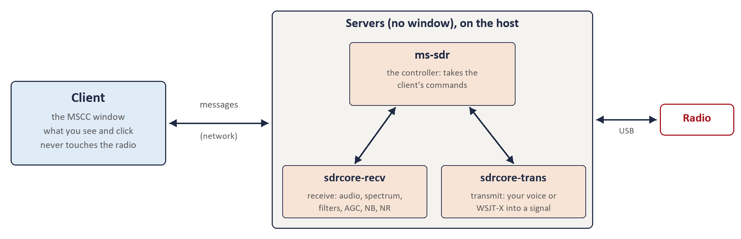
The client sends messages over the network; the servers on the host do the work and talk to the radio
The client and the servers talk over the network: the same network your computers use for the internet at home. That is what lets the client sit on another computer in the house.

1.4 Always client and servers, in every setup
MSCC is client-server even when everything is on one computer. With one PC, the client and the servers still run as separate programs and still send each other messages; the messages simply never leave the computer. (The address 127.0.0.1 means "this same computer".)
So the same rules apply whatever your setup:
- The servers must be running before the client can connect. On a Windows PC with the radio plugged in, the client starts them for you when you press Start (Launch Servers). In every other case they are started on the host.
- The client's Host field says where the servers are: 127.0.0.1 if they are on this computer, or the host's address if they are on another one.
- Start connects the client to the servers; Stop disconnects.
- You will see the servers' names in Windows Firewall prompts and in some messages. That is normal; it is the engine room introducing itself.
- Only one client at a time can be connected to the servers.

1.5 Words used here
Word | Meaning
Client | The MSCC window you operate from. Never touches the radio.
Servers | The three background programs that do the radio work (ms-sdr, sdrcore-recv, sdrcore-trans). No window.
Host | The computer the radio's USB cable is plugged into. The servers run here.
Local | Client and servers on the same computer.
Remote | Client on one computer, servers on another, on your home network.
Digital programs | WSJT-X, fldigi and the like. They need a COM port (CAT: frequency, mode, transmit) and an audio path to MSCC.

2. Choosing your setup
Because the client and the servers are separate, they can be on one computer or on two. Together with Windows versus Raspberry Pi / Linux, that gives five setups.

2.1 Two questions decide your setup
1. Which computer is the radio plugged into? A Windows PC, or a Raspberry Pi / Linux PC. That is your host.
2. Where do you want to sit? At the host itself, or at another computer in the house (Windows, or Pi / Linux).
Radio plugged into | You sit at | Setup
Windows PC | That same PC | 1. Windows local
Windows PC | Another Windows PC | 2. Windows remote
Raspberry Pi / Linux PC | A Windows PC | 3. Windows client, Pi / Linux host
Raspberry Pi / Linux PC | That same machine | 4. Pi / Linux local
Raspberry Pi / Linux PC | Another Pi / Linux machine | 5. Pi / Linux remote

2.2 The big difference: who owns the digital programs
Where the host is a Windows PC, the client looks after the digital programs' COM port. You pick it in the client's SETTINGS → COM Port. In remote operation (setup 2), WSJT-X runs on the computer you sit at.
Where the host is a Raspberry Pi or Linux PC, the host owns everything around the radio. mscc-init (run once when MSCC is installed on the Pi) sets up the COM ports and audio devices for digital programs, and the digital programs run on the Pi itself. A client on another computer only operates the radio and plays the receive audio; it has no say over COM ports. To use WSJT-X on the Pi from another computer, you look at the Pi's desktop with VNC.

3. The five setups

3.1 Setup 1: Windows local (one Windows PC)
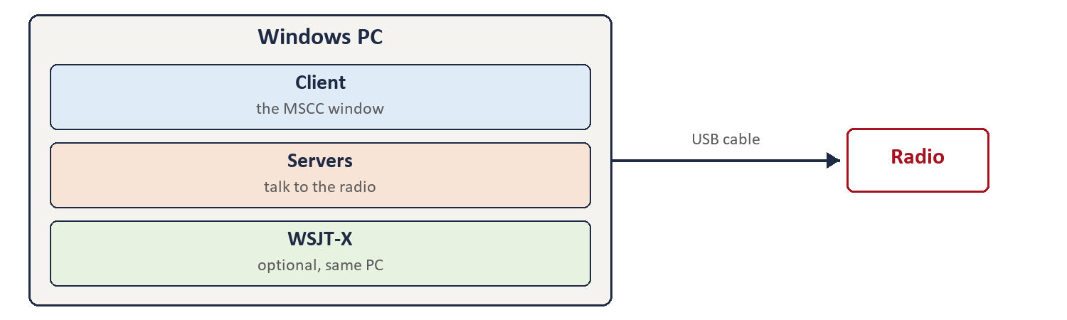
Setup 1
Who it is for
The simplest setup: one Windows PC with the radio plugged in, and you sit at it.
What runs where
- Client, servers and (if you use them) digital programs all on one Windows PC.
Client settings
- Launch Servers checked: pressing Start also starts the servers.
- Host 127.0.0.1 (this PC), Port 8888.
- Auto Start if you want MSCC to connect by itself when it opens.
- Remote stays off.
Audio
Plays on the PC's speaker or headphones, chosen in SETTINGS → Operator Out. Your microphone is SETTINGS → Operator Mic.
Digital programs (WSJT-X)
On the same PC. You need a virtual audio cable and a virtual COM pair. In MSCC SETTINGS set Digital Out / Digital Mic to the cable and COM Port to your end of the pair.
Read
MSCC Operator's Guide - Windows.

3.2 Setup 2: Windows remote (two Windows PCs)
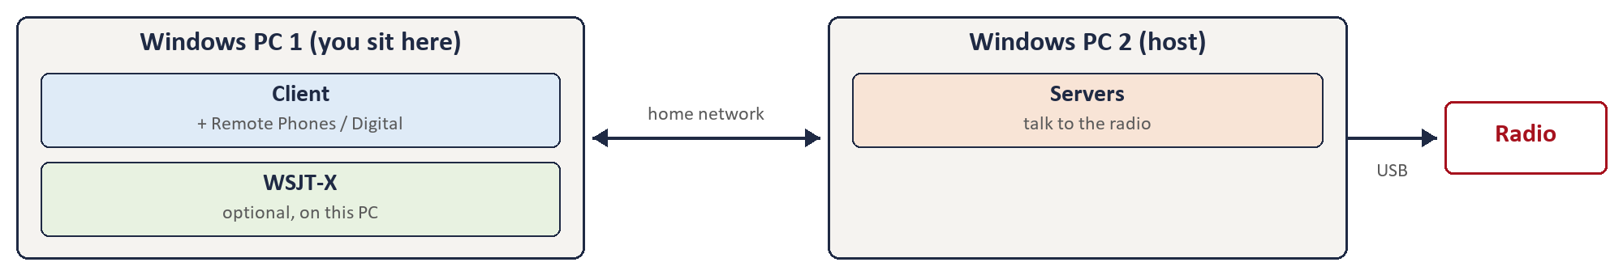
Setup 2
Who it is for
The radio is on one Windows PC (for example in the shack) and you operate from another Windows PC in the house.
What runs where
- PC 2 (host): the radio and the servers.
- PC 1 (where you sit): the client, and the digital programs if you use them.
Client settings
- On PC 1: Launch Servers and Auto Start unchecked.
- Host = PC 2's address (for example 192.168.1.234), Port 8888.
- After Start, press Remote and choose Phones or Digital in the Remote Audio window.
- Remote is off each time MSCC starts; press it again.
Audio
Sent over the network to PC 1 and played on its speaker or headphones (Remote → Phones). Your microphone on PC 1 is sent back to the host.
Digital programs (WSJT-X)
On PC 1, where you sit. The virtual audio cable and COM pair are on PC 1. Choose Digital in the Remote Audio window; the client's SETTINGS → COM Port is the CAT port.
Read
MSCC Operator's Guide - Windows (to install both PCs), then MSCC Operator's Guide - Remote Operation (Windows).
DRAFT: Setup 2: on the host PC, Stop also stops the servers that copy of MSCC started (Windows guide 4.1), and only one client can be connected. Confirm how the host keeps its servers running for the remote client.

3.3 Setup 3: Windows client, Raspberry Pi / Linux host
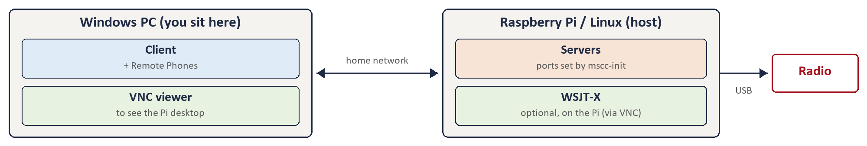
Setup 3
Who it is for
The radio is on a Raspberry Pi (or Linux PC); you operate from a Windows PC with MSCC for Windows.
What runs where
- Pi (host): the radio, the servers, and the digital programs.
- Windows PC (where you sit): the client, and a VNC viewer to see the Pi's desktop.
Client settings
- On the Windows PC: Launch Servers and Auto Start unchecked.
- Host = the Pi's address, Port 8888.
- Start the servers on the Pi first (MSCC Start).
- After Start, press Remote and choose Phones to hear the radio on the Windows PC.
Audio
Sent over the network to the Windows PC (Remote → Phones). Your microphone on the Windows PC is sent back to the Pi.
Digital programs (WSJT-X)
On the Pi, not on the Windows PC. mscc-init on the Pi sets up the COM ports and audio devices (and the Phones devices); nothing is set for them in the Windows client. Open the Pi's desktop with VNC and run WSJT-X there. WSJT-X settings on the Pi: Radio Kenwood TS-2000, CAT port /dev/tnt1, PTT method RTS on /dev/tnt1 (MSCC itself uses the other end of the pair, /dev/tnt0); audio Input VirtualA.monitor, Output VirtualB, both Mono. The Windows client's COM Port and Remote → Digital are not used.
Read
MSCC Operator's Guide - Linux and Raspberry Pi (to install the Pi), MSCC Operator's Guide - Windows (to install the client), and the Remote Operation guide for a Pi / Linux host (to come).

3.4 Setup 4: Raspberry Pi / Linux local (one machine)
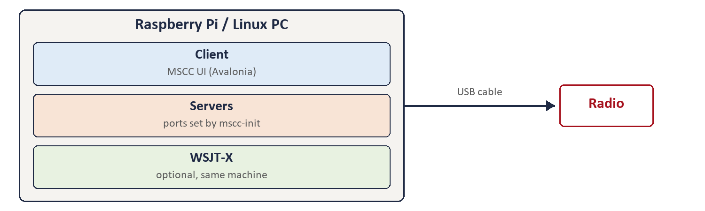
Setup 4
Who it is for
One Raspberry Pi or Linux PC with the radio plugged in, a screen, keyboard and mouse, and you sit at it.
What runs where
- Client (MSCC UI), servers and digital programs all on the one machine.
Client settings
- Launch checked: Connect also starts the servers on this machine (or leave Launch unchecked and start them yourself with MSCC Start).
- Host 127.0.0.1 (this machine), Port 8888.
- Auto if you want MSCC UI to connect by itself when it opens.
- Remote stays off.
Audio
Plays on the machine's own speaker or headphones, chosen in MSCC Init (step 4).
Digital programs (WSJT-X)
On the same machine. MSCC Init has set them up. WSJT-X uses the other end of the port pair from MSCC: if SETTINGS shows /dev/tnt0 (MSCC's end), WSJT-X's CAT port is /dev/tnt1, with PTT by RTS on /dev/tnt1. WSJT-X audio Input is VirtualA.monitor and Output is VirtualB. Select DIG-U in MSCC UI.
Read
MSCC Operator's Guide - Linux and Raspberry Pi.

3.5 Setup 5: Raspberry Pi / Linux remote (two machines)
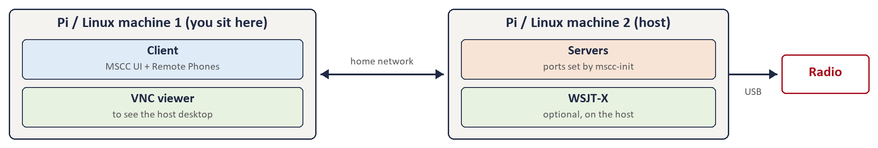
Setup 5
Who it is for
The radio is on one Pi or Linux PC; you operate from another Pi or Linux machine with MSCC UI.
What runs where
- Machine 2 (host): the radio, the servers, and the digital programs.
- Machine 1 (where you sit): MSCC UI, and a VNC viewer to see the host's desktop.
Client settings
- On machine 1: Auto and Launch unchecked.
- Host = machine 2's address, Port 8888.
- Start the servers on machine 2 first (MSCC Start).
- After Connect, press Remote and choose Phones.
Audio
Sent over the network to machine 1 (Remote → Phones).
Digital programs (WSJT-X)
On the host, as in setup 3: run them there through VNC.
Read
MSCC Operator's Guide - Linux and Raspberry Pi, and the Remote Operation guide for a Pi / Linux host (to come).

4. All five side by side
 | 1 | 2 | 3 | 4 | 5
Radio plugged into | Windows PC | Windows PC 2 | Pi / Linux | Pi / Linux | Pi / Linux 2
You sit at | Same PC | Windows PC 1 | Windows PC | Same machine | Pi / Linux 1
Client | MSCC for Windows | MSCC for Windows | MSCC for Windows | MSCC UI | MSCC UI
Launch Servers | On | Off | Off | On | Off
Host field | 127.0.0.1 | PC 2 address | Pi address | 127.0.0.1 | Machine 2 address
Remote button | Off | On | On (Phones) | Off | On (Phones)
Digital programs run on | Same PC | PC 1 (you) | The Pi (VNC) | Same machine | The host (VNC)
COM ports set by | Client SETTINGS | Client SETTINGS | mscc-init | mscc-init | mscc-init

5. Rules for every setup
- The servers run on the host, always. The client can't start servers on another computer. Start them at the host first.
- One client at a time. The servers accept one client. Press Stop on one computer before connecting from another. If a computer was switched off without Stop, the servers free themselves after about 45 seconds.
- Port 8888. Leave Port at 8888 in every setup. Remote audio also uses ports 9100 and 9101.
- Home network only. Remote setups are for computers in the same house. To operate from away, use a VPN into your home network; never open these ports to the internet.
- Install and calibrate at the host first. Firmware updates and calibration are done with the radio's host; the remote guides assume that is done.

Appendix A: Draft items (remove before release)
1. Setup 2: on the host PC, Stop also stops the servers that copy of MSCC started (Windows guide 4.1), and only one client can be connected. Confirm how the host keeps its servers running for the remote client.

