
NAME: LOUIS WANYOIKE
ADM NO: BSCCS/2024/52266
COURSE: BACHELOR OF SCIENCE IN COMPUTER SCIENCE
PROJECT TITLE: WAN SHOES INVENTORY MANAGEMENT SHOES
DEPARTMENT: COMPUTING AND INFORMATICS
LECTURER : MICHAEL NYORO
GITHUB LINK: https://github.com/w4nlouis/wan-shoes-repository

Contents
WEEK 1 CHECKLIST 3
Fig 1.1 3
Fig 1.2: 3
Fig 1.3 4
Fig 1.4 5
Fig 1.5 5
Fig 1.6 6
Week 1 Student Reflection 7
WEEK 2 7
Fig 2.1 7
Fig 2.2 8
Fig 2.3 9
FIG 2.4 10
WEEK 2 REFLECTION 11
Project Proposal Summary 11

WEEK 1 CHECKLIST

Fig 1.1
XAMPP Control Panel showing Apache and MySQL services running with green indicators.
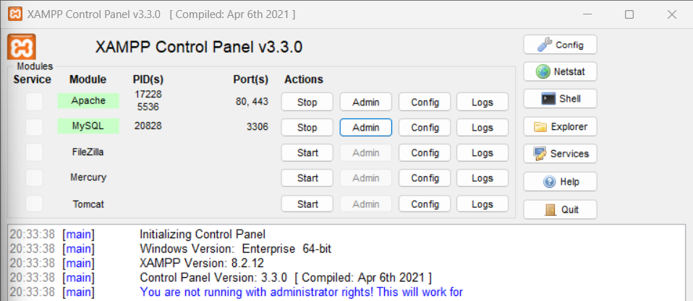
Figure 1XAMPP Control Panel

Fig 1.2:
Browser accessing http://localhost/phpmyadmin displaying phpMyAdmin dashboard. This confirms MySQL server is running and accessible via web interface.
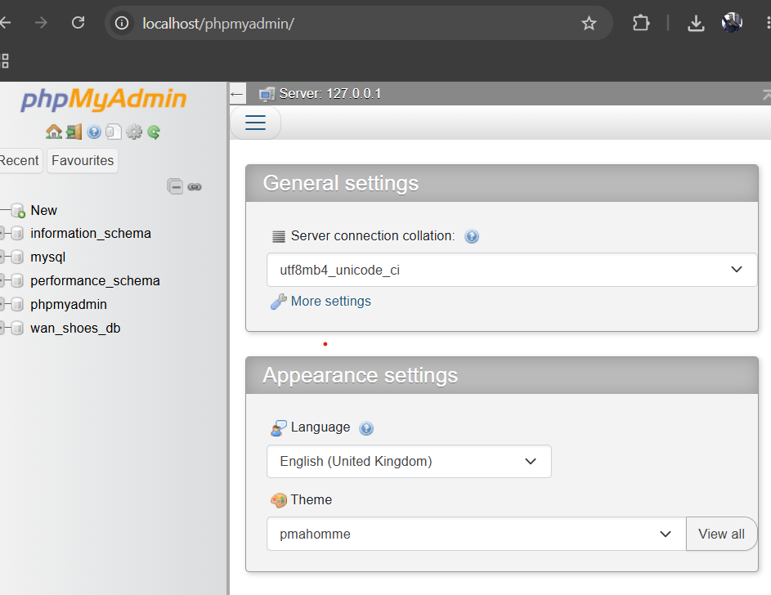
Figure 2phpmyadmin interface

Fig 1.3
Test page http://localhost/wan_shoes/index.php outputting "Hello World" from PHP. The <?php echo "Hello World from PHP"; ?> script executed successfully, confirming PHP processing is working.
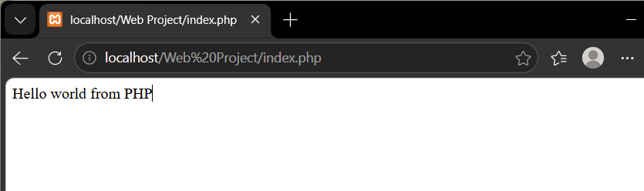
Figure 3Proof of PHP working

Fig 1.4
PhpMyAdmin interface showing wan_shoes_db database created with utf8_general_ci collation. The database contains five tables: admins, employees, products, sales, and stock_records
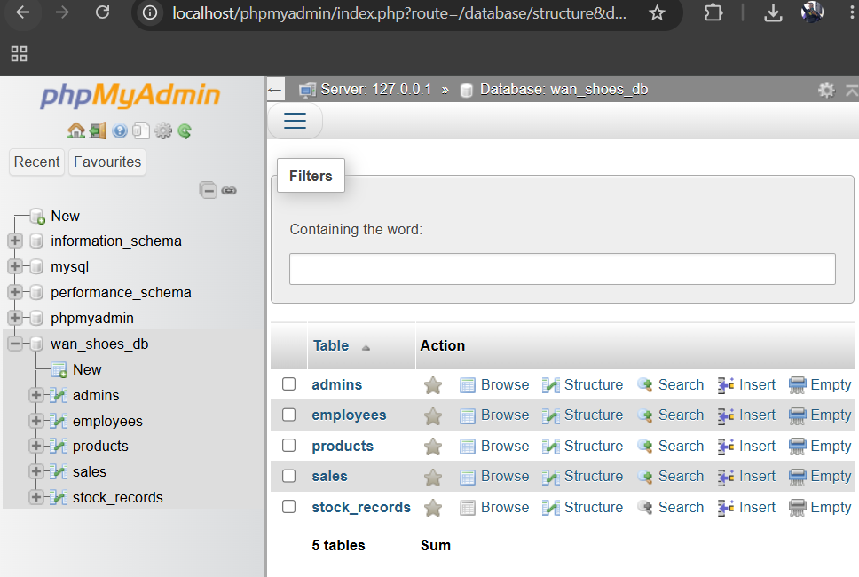
Figure 4 wan_shoes_d

Fig 1.5
S Code folder structure showing wan_shoes project root with subdirectories: admin/, css/, images/, js/, products/, sales/, stock/, and includes/. This follows professional web development organization standards.
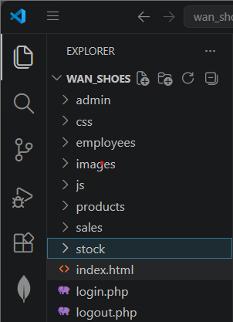
Figure 5 Folder Organization

Fig 1.6
GitHub repository at https://github.com/w4nlouis/wan-shoes-repository showing all project files uploaded including PHP scripts, CSS styling, JavaScript validation, and database export file.
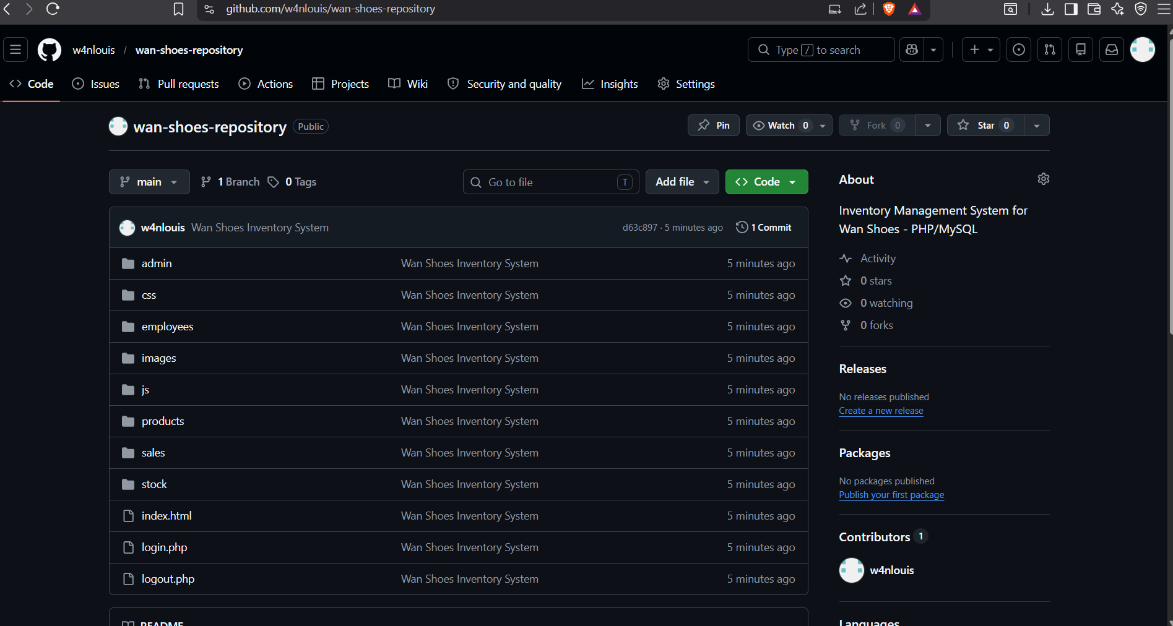

Week 1 Student Reflection
I installed XAMPP on Windows 11 to create a local web development environment for the Wan Shoes inventory system. Fig 1.1 shows Apache and MySQL services running without port conflicts, which is essential for PHP processing and database connectivity. Fig 1.3 demonstrates successful PHP execution where a simple echo statement rendered "Hello World" in the browser, confirming the server properly parses PHP code. Fig 1.4 displays wan_shoes_db created in phpMyAdmin with five relational tables: admins, employees, products, sales, and stock_records. The folder structure in Fig 1.5 follows MVC-inspired organization with separate directories for CSS, JavaScript, and feature modules. Finally, Fig 1.6 shows the GitHub repository containing all project code, fulfilling the version control requirement. XAMPP provides a stable foundation for developing the complete inventory management system.

WEEK 2

Fig 2.1
Digital wireframe of the login page showing email field, password field, and sign-in button centered on the page. The design uses a clean card layout with brand title "WAN SHOES" at the top.
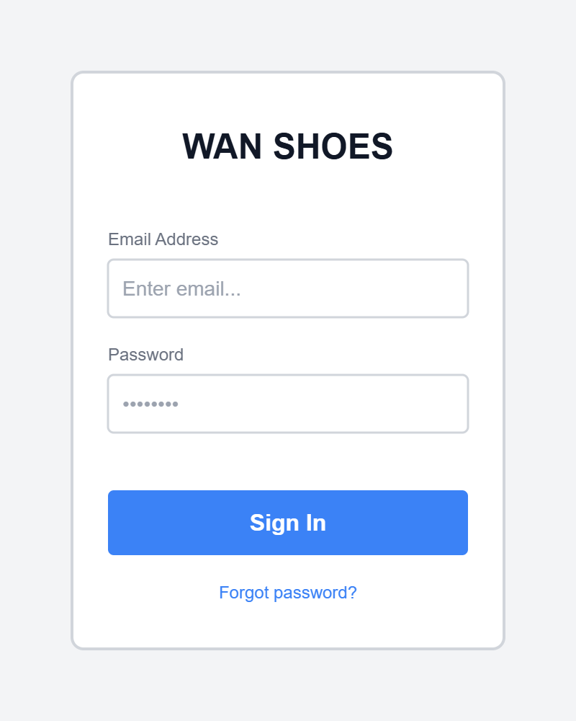
Figure 6Login wirefreame

Fig 2.2
Wireframe of the admin dashboard displaying three statistics cards (Products Count, Inventory Value, Staff Count) and three action buttons (Manage Products, Manage Employees, View Sales). Navigation follows a vertical card layout.
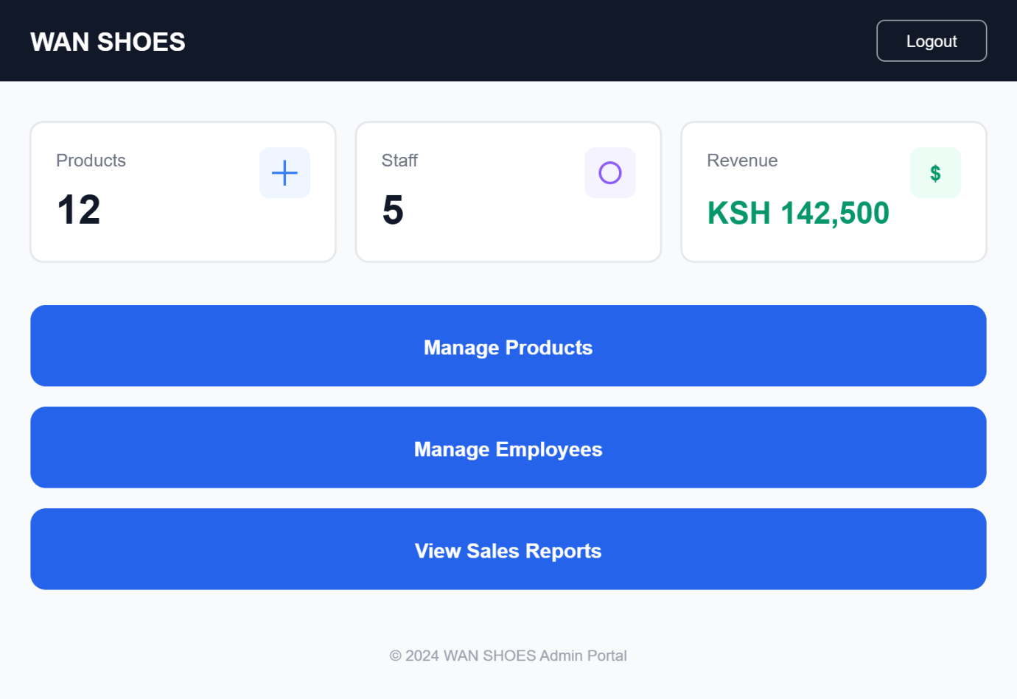
Figure 7 Dashboaard

Fig 2.3
Wireframe of the products management page for admin role showing an "Add New Product" form with fields for name, brand, size, price, and stock quantity, followed by a data table displaying existing products with edit and delete actions.
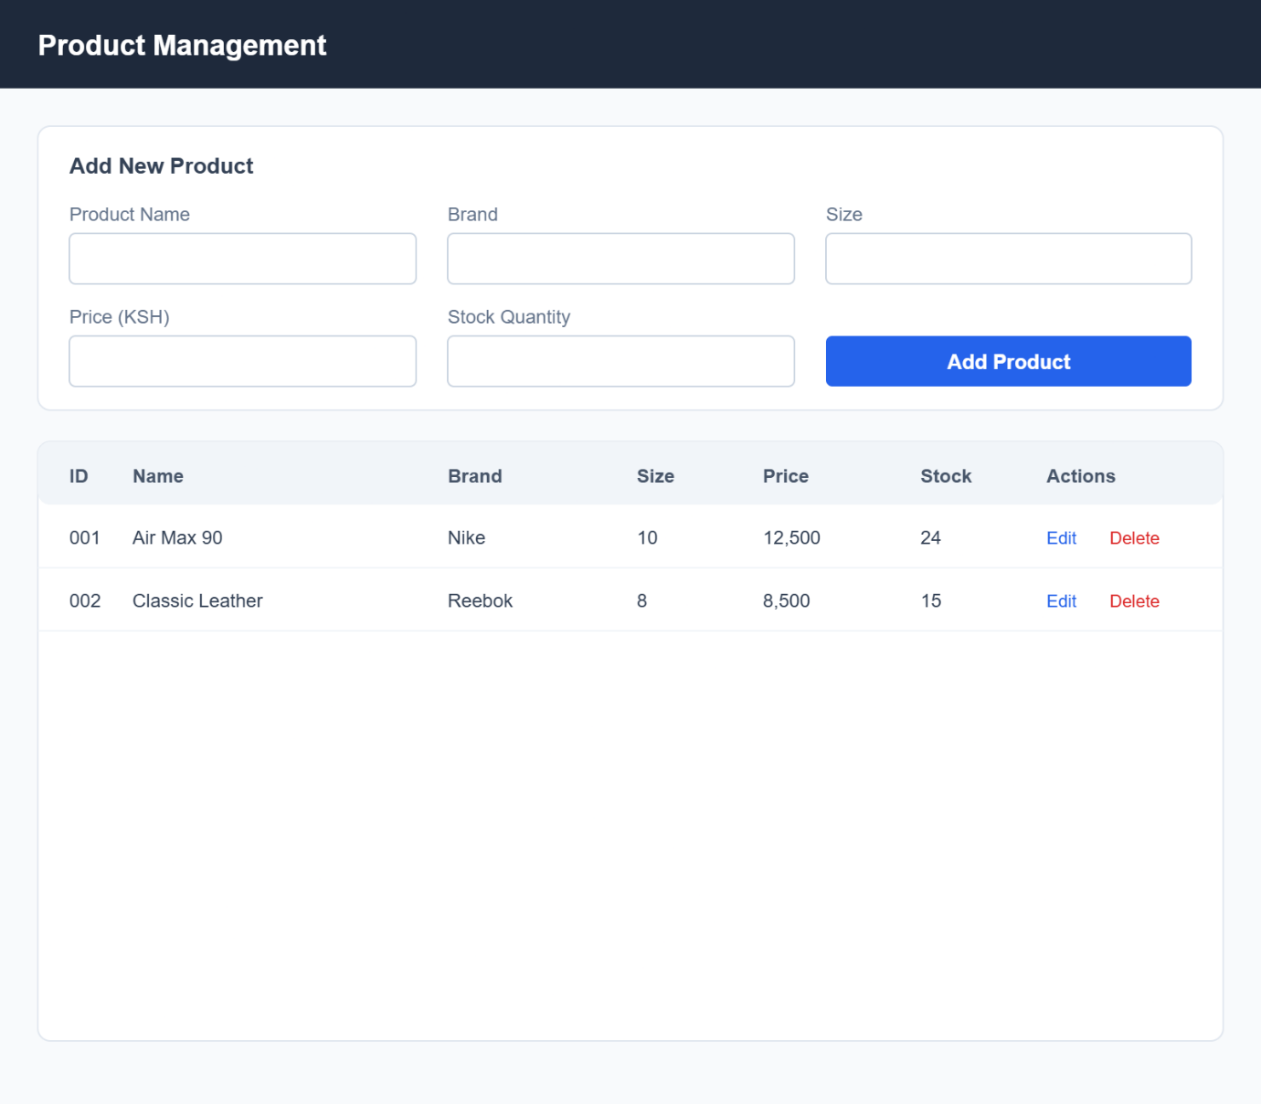
Figure 8 Products wireframe

FIG 2.4
GUI COLOR SCHEME
Element | Color | Usage
Primary Background | Dark Black | Body background
Card Background | White | Forms, containers, dashboards
Accent Color | Gold | Borders, hover effects, highlights
Button Primary | Black | Normal buttons
Button Danger | Red | Logout, delete actions
Text Primary | Black | Headings, labels
Text Secondary | Gray | Subtitles, helper text

WEEK 2 REFLECTION
Week 2 focused on UI/UX planning and system design for Wan Shoes inventory system. I created five digital wireframes covering login, admin dashboard, products page, sales recording, and sales reports. These wireframes establish the user flow for three roles: admin manages products and employees, clerks record sales, and stock managers add inventory. Fig 2.4 documents the GUI color scheme using black, white, and gold for a professional premium aesthetic. The project proposal summary defines technical specifications including PHP/MySQL stack and five database tables

Project Proposal Summary
Project Title: Wan Shoes Inventory Management System
Target Users: Internal staff only — Administrators, Clerks, and Stock Managers. No customer-facing module.
Purpose: Track shoe products, manage inventory levels, record sales transactions, monitor stock additions, and generate sales reports with revenue totals.
Tech Stack: PHP, MySQL, HTML5, CSS3, JavaScript NE, XAMPP local server, GitHub for version control.
Key Features:
- Role-based authentication (Admin, Clerk, Stock Manager)
- Product CRUD operations (Create, Read, Update, Delete)
- Employee account management (Admin only)
- Sales recording with automatic stock deduction (Clerk only)
- Stock addition with audit trail (Stock Manager only)
- Sales reports with revenue calculation (Admin only)
- Password strength validation
- Responsive design supporting mobile and desktop
Database Tables: admins, employees, products, sales, stock_records
Expected Outcomes: A fully functional internal inventory system that allows staff to manage shoes, process sales, track stock, and view sales analytics in real-time.

