**Velocity Report**

**Burndown Chart:**

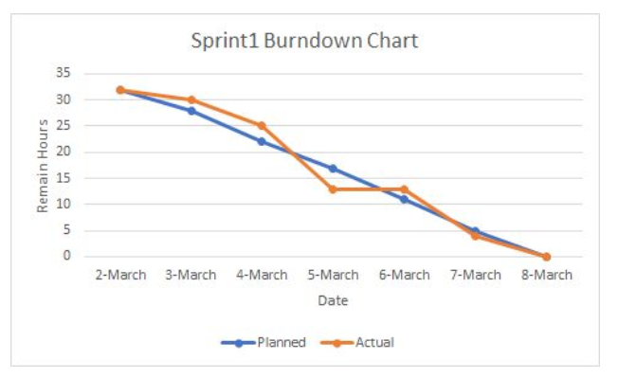

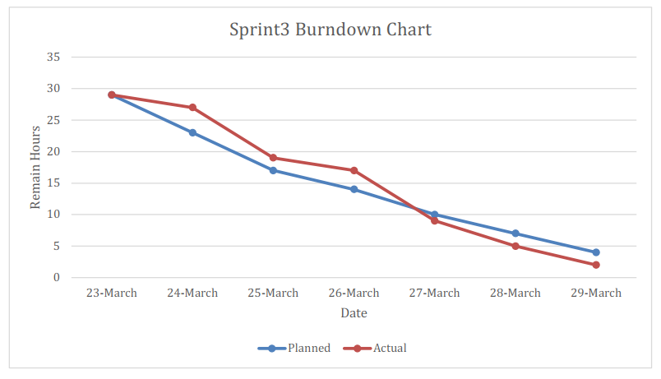

**Velocity** = (32 + 39 + 29) / 3 = 33.3 (story points/sprint)

**Estimate** (sprint 4) = 10 / 33.3 = 0.3 (sprint)

According to the estimate calculated above, we estimate that all the user stories of Sprint4 can be completed within 2 days. As it went well, it was actually completed in one day. The reason for the mismatch is that we overestimated the difficulty of Sprint4.