Artificial General Intelligence (AGI) in Healthcare
Name: Annette Bazan
Course: ITAI 2372
Date: 04/17/2025

Artificial General Intelligence (AGI) refers to machines with the ability to perform any intellectual task that a human can do. Unlike narrow AI, which is specialized for specific tasks, AGI can generalize knowledge across domains, adapt to new situations, and reason abstractly. Its emergence could revolutionize industries by offering adaptable, scalable intelligence. In healthcare, AGI holds the promise of enhancing diagnostics, personalizing treatment, and reducing systemic inefficiencies, making it a prime candidate for transformative innovation. The healthcare industry today is characterized by technological advancement and increasing demand. However, it also faces several systemic issues such as:
- - Shortage of healthcare professionals
- - Rising costs and inefficiencies
- - Limited access in rural/underserved areas
- - Administrative burdens on providers
- - Inconsistent quality of care and medical errors
Current Use of AI in Healthcare:
- - Diagnostic tools (e.g., radiology, pathology image recognition)
- - Predictive analytics (e.g., patient risk stratification)
- - Virtual health assistants and chatbots
- - Robotic surgery
- - Administrative automation (e.g., billing, scheduling)
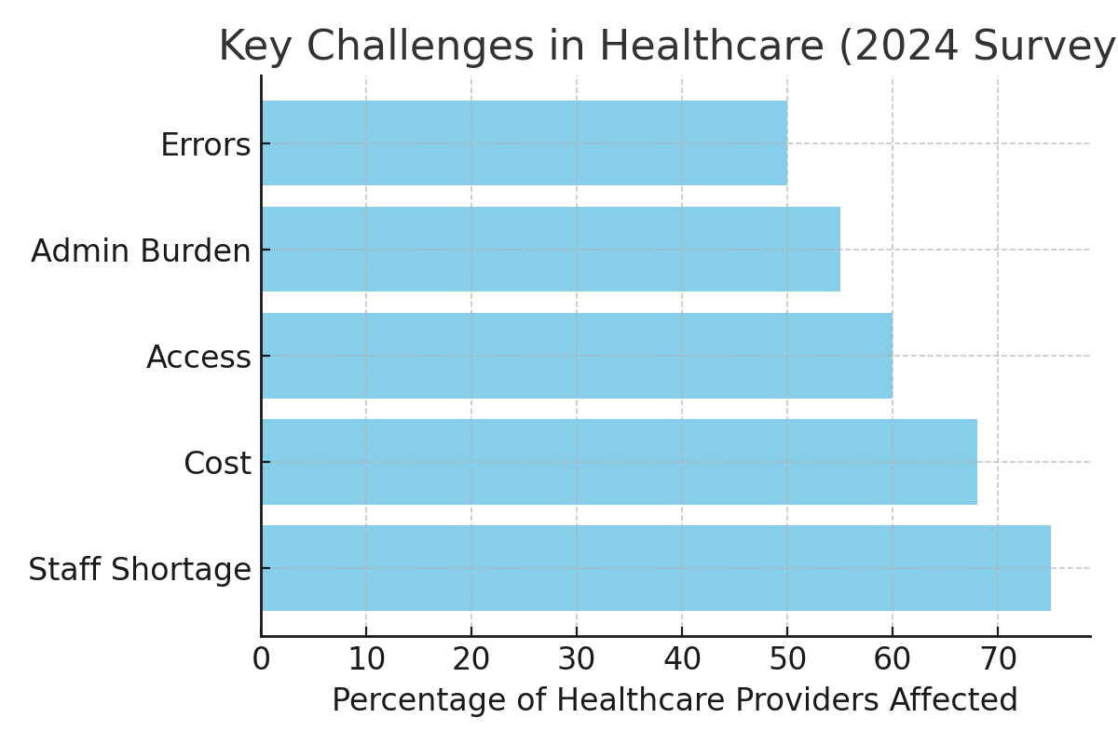
Figure 1: Survey of top healthcare challenges among 500 global healthcare professionals (2024).

Artificial intelligence has gradually evolved within the healthcare sector over the past several decades. Initially limited to rule-based expert systems in the 1970s and 1980s, AI has since transformed with the advent of machine learning and deep learning models. Tools like IBM Watson demonstrated early promise by analyzing large datasets to assist in cancer treatment recommendations. More recently, companies like Google DeepMind and OpenAI have developed sophisticated language and image models capable of supporting diagnostic decisions. These innovations laid the foundation for Artificial General Intelligence (AGI), which aspires to mimic human cognitive abilities across domains, signaling a potential paradigm shift in healthcare delivery.
In a recent statistic of 2024 about 80% of hospitals use AI to enhance patient care and workflow efficiency and 46% of US healthcare organizations are in the early stages of generative AI implementation. The AI healthcare market reached approximately $32.34 billion in 2024 and is projected to rise to $431.05 billion by the year 2032. This potential exponential growth of the AGI market in healthcare is all thanks to the roles of cost efficiency, precision medicine, and research acceleration. There are collaborations between pharmaceutical companies and AI startups to accelerate the drug discovery process and clinical trials. AGI-powered virtual health assistants are already being used to manage chronic conditions and improve patient engagement. Meaning AGI can reduce clinician burnout by automating routine administrative tasks, a key concern as healthcare demands rise. There is gradual measured introduction of AGI in patient-facing roles to build trust and safeguard care quality.
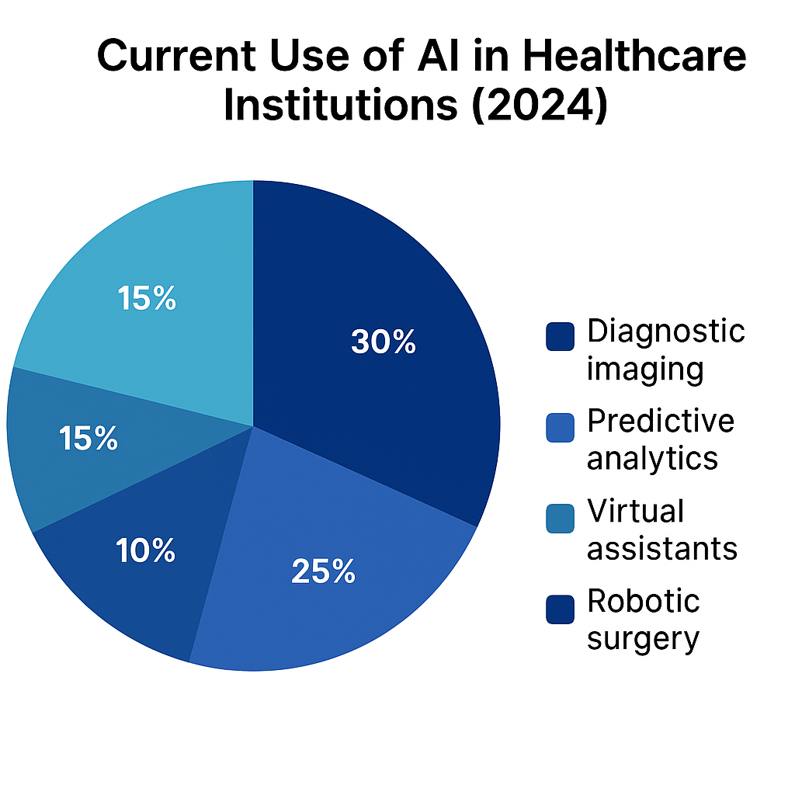
Figure 2: Current Use of AI in Healthcare Institutions (2024)
AI is most applied in diagnostic imaging (30%) and predictive analytics (25%), followed by administrative automation, virtual assistants, and robotic surgery.
Source: McKinsey & Company, 2024
One notable example of AI integration is Mayo Clinic's collaboration with Google Cloud to develop AI algorithms for radiology and cardiology diagnostics. These models assist physicians by flagging abnormalities in medical imaging with high accuracy. Another instance is the UK's National Health Service (NHS), which has piloted AI-driven triage tools to reduce emergency room congestion. Meanwhile, companies like Tempus and PathAI are applying machine learning to cancer genomics and pathology, improving precision in both diagnosis and treatment planning. While these technologies are not fully autonomous AGI, they demonstrate the trajectory toward more generalizable, intelligent systems in medicine. Growing interest from investors in AGI-powered healthcare solutions like diagnostic tools, treatment recommendation systems and patient management platforms. AGI is capable of reasoning, understanding context, and learning across diverse domains, much like a human. It differs from traditional AI, which is task-bound and relies heavily on pre-trained models and datasets.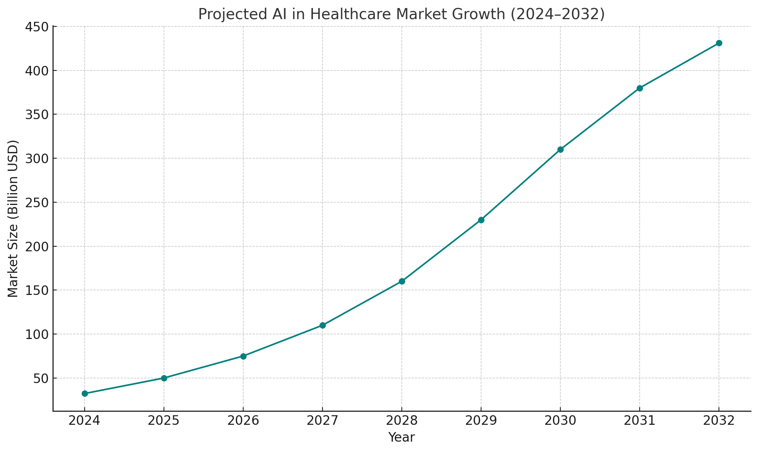
Figure 1: Projected AI in Healthcare Market Growth (2024–2032)
The global AI in the healthcare market is expected to grow from $32.34 billion in 2024 to over $431.05 billion by 2032, driven by innovations in diagnostics, telemedicine, and patient management.
Source: Statista
Potential Applications of AGI in Healthcare:
1. Universal Diagnostic Assistant
An AGI-powered system could interpret a patient’s full medical history, symptoms, test results, and lifestyle data to provide accurate, personalized diagnoses—beyond what any specialist could offer.
2. Adaptive Treatment Planning
Unlike traditional AI, AGI could dynamically adjust treatment plans based on patient response, coexisting conditions, or newly emerging research—without needing specific retraining.
3. Healthcare System Optimization
AGI could analyze large-scale hospital operations data in real time, improving staff allocation, supply chain management, and patient throughput.
4. 24/7 Global Telehealth Companion
A multilingual AGI assistant could deliver culturally sensitive, reliable medical advice globally, especially to remote or underserved populations.
Anticipated Benefits of AGI in Healthcare:
- Improved diagnostic accuracy and personalized treatment
- Reduced clinician burnout through automation of administrative tasks
- Increased access to quality care in remote regions
- Accelerated drug discovery and clinical trials through advanced modeling

The introduction of AGI into healthcare brings varied implications for different stakeholders. Physicians may transition from direct diagnosticians to supervisors of AGI-generated insights, requiring new skillsets in critical evaluation and system oversight. Patients could benefit from more tailored care, increased engagement, and faster access to information. Hospitals and healthcare systems stand to improve operational efficiency and reduce costs through real-time resource optimization. However, these benefits are contingent on building trust, ensuring transparency in AGI systems, and fostering collaborative human-machine interaction.
Potential Risks and Ethical Concerns:
- Data privacy and the secure handling of sensitive medical information
- Potential bias in AGI decision-making models
- Dependence on AGI and de-skilling of healthcare professionals
- Legal liability and accountability for AGI-driven decisions

Legal and regulatory frameworks must evolve to accommodate AGI’s presence in healthcare. For instance, determining liability in cases where AGI recommendations result in harm poses significant challenges. Should responsibility fall on developers, healthcare providers, or the system itself? Additionally, privacy laws such as HIPAA and GDPR may need revisions to address data-sharing protocols for AGI training. Ensuring AGI systems are explainable and auditable is crucial for maintaining transparency and public trust. Ethical concerns also include maintaining clinician judgment, protecting vulnerable populations, and ensuring equal access to advanced AI-powered care.
By 2040, AGI could enable a shift from reactive to proactive healthcare systems. Predictive health monitoring powered by wearable devices and AGI analysis may detect disease risks before symptoms appear. Personalized digital twins—virtual simulations of a patient's biology—could test treatment responses in silico, revolutionizing therapeutic design. Mental health care may be democratized through always-available AGI counselors. While some roles may be automated, human oversight, empathy, and decision-making will remain integral. The symbiosis of AGI and human intelligence could reshape medicine into a more efficient, personalized, and universally accessible domain.
The integration of Artificial General Intelligence into the healthcare sector could redefine the delivery, efficiency, and accessibility of medical services. While its applications—from diagnostics to systems management—offer promising solutions to longstanding challenges, cautious implementation is vital. Addressing the ethical, legal, and technical risks associated with AGI will ensure its benefits are harnessed responsibly. As AGI continues to develop, healthcare stands to become not only smarter, but also more inclusive, humane, and effective.
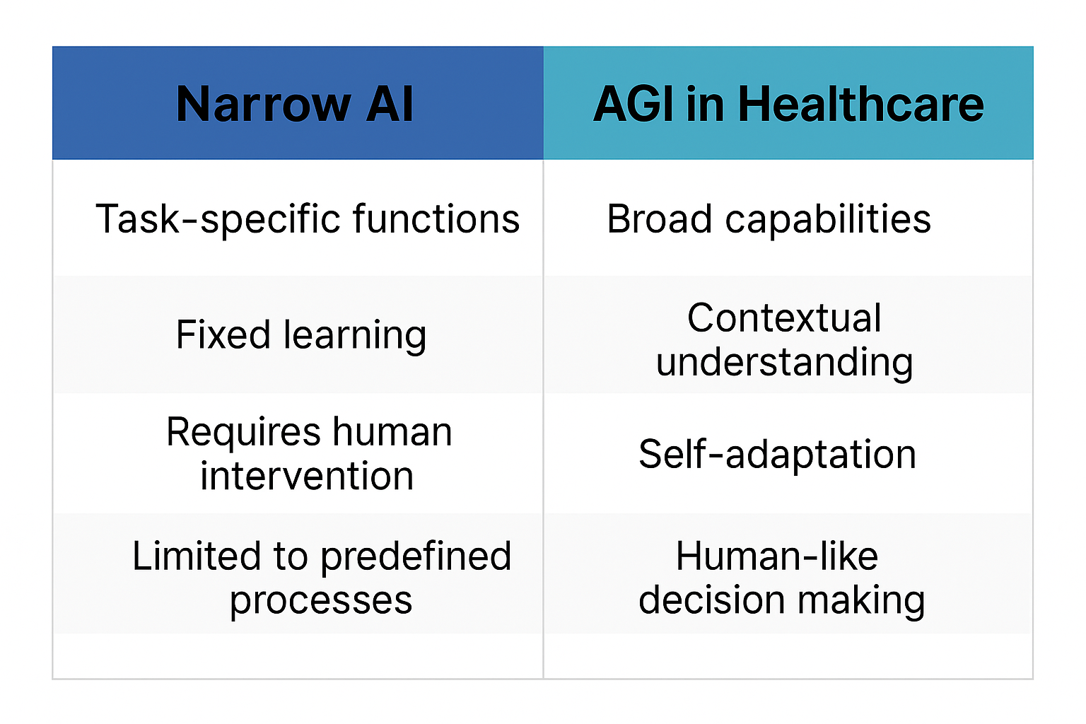Figure 3: Comparison of Narrow AI vs AGI in Healthcare
AGI introduces capabilities beyond narrow AI, including contextual understanding, self-adaptation, and human-like decision making, which is crucial for personalized and adaptive healthcare.
Source: Adapted from World Economic Forum, 2023
CIATIONS:
World Health Organization. (2023). Global health workforce statistics. https://www.who.int
Harvard Business Review. (2024). How AGI Could Transform the Future of Work. https://hbr.org

