Constructing the Temperature–Filling Phase Diagram
From transport data (Fig. 3a) to the phase diagram (Fig. 3e) — worked example at E = −103 mV nm⁻¹ (https://www.nature.com/articles/s41586-025-10049-3/figures/4)
This note describes how a single temperature–filling phase diagram is built from raw transport data, using the E = −103 mV nm⁻¹ cut as the example. The workflow is: read the resistivity map to find the features; coarsely sample the whole map with linecuts that cover every feature; identify the phases; pin down the representative (extremal) linecut for each phase; sample the fillings between anchors and extract each characteristic temperature with continuity-enforced fits; and plot them onto the (T, ν) plane.

Step 1 — Map the resistivity and read off the features
Plot the longitudinal resistivity ρ_{xx} as a colour map versus temperature T (vertical) and hole filling ν (horizontal). Before any fitting, simply look at the map and catalogue what is present. At E = −103 mV nm⁻¹ it shows:
- A prominent resistive peak (red) at ν = 1 — the candidate Mott / antiferromagnetic insulator.
- Shoulders of intermediate resistivity flanking the peak

- Two dark-blue (low-resistivity) lobes, one on each side of the peak — candidate superconducting domes.
This visual survey defines where the features are and what phases to expect.
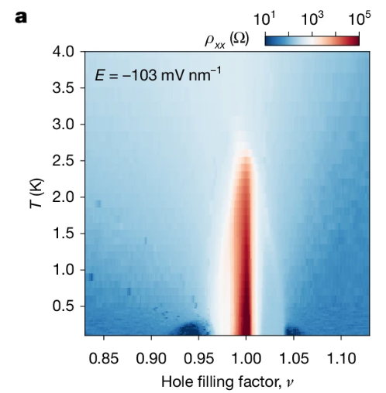

Step 2 — Coarsely sample the whole map
Take a coarse set of temperature linecuts spanning the whole filling range — on the order of 20 fillings — making sure that at least a few land inside each feature identified in Step 1 (the insulator, both shoulders, both domes). Each linecut is ρ_{xx}(T) at a fixed ν, i.e. a vertical slice through the map. At this stage the aim is complete coverage, not precision.

Step 3 — Identify the phases from the sampled linecuts
Look at the whole set of sampled curves and classify each one by the slope and functional form of ρ_{xx}(T):
- Sign of dρ/dT: dρ/dT > 0 → metal; dρ/dT < 0 → insulator.
- For metals, the power law sets the type: ρ ∝ T² → Fermi liquid; ρ ∝ T (linear) → strange metal; sublinear in T → “stranger” / sublinear metal.
- If ρ drops toward zero at low temperature (R → 0, e.g. below ~20 Ω) → superconductor.
- If there is a local resistance minimum and the sample turns metallic again at the lowest T → antiferromagnetic (AF) metal.
A key subtlety: the same filling can be different phases over different temperature windows — e.g. Fermi-liquid (T²) at low T crossing over to strange-metal (T-linear) at higher T. Classification is therefore made per temperature range, and each crossover is itself a temperature scale to record. This pass gives the rough layout of which phase lives where.

Step 4 — Pin down the representative (extremal) linecut for each phase
With the phases identified, search around each region to find its representative linecut — the filling where the phase is most cleanly defined, i.e. at its extreme:
- Fermi liquid — the filling with the highest coherence temperature T_{coh}.
- AF insulator — the filling with the highest Néel temperature T_{N}.
- Strange metal — the filling that is linear in T over the largest range, down to the lowest T.
- Superconductor — the filling with the highest critical temperature T_{c}.
These extremal linecuts anchor the “peak” of each phase. Representative examples at E = −103 mV nm⁻¹:
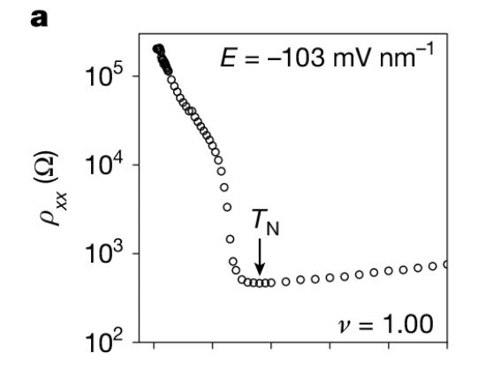  AF insulator (ν = 1.00): ρ rises by orders of magnitude at low T; local minimum marks T_{N} — the highest-T_{N} anchor. | 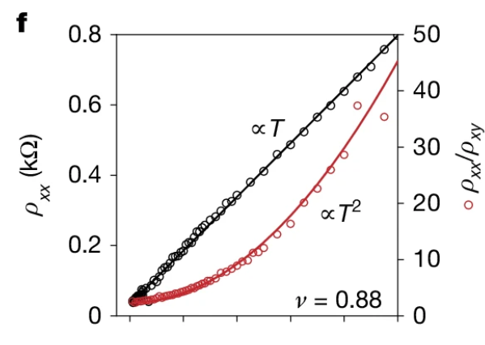  Strange metal (ν = 0.88): ρ ∝ T (linear) over the full range down to the lowest T; ρ_{xx}/ρ_{xy} ∝ T².
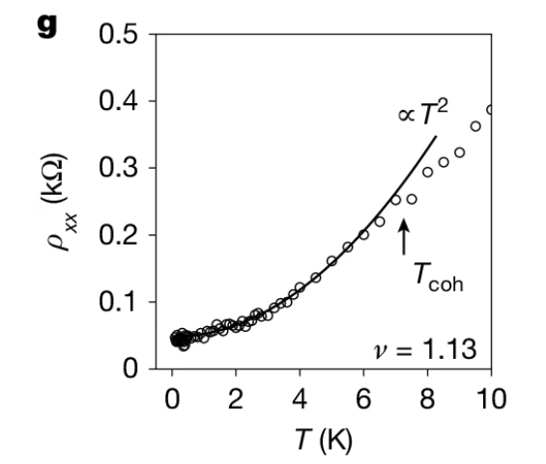  Fermi liquid (ν = 1.13): ρ = ρ₀ + AT²; deviation from T² marks T_{coh} — the highest-T_{coh} anchor. | 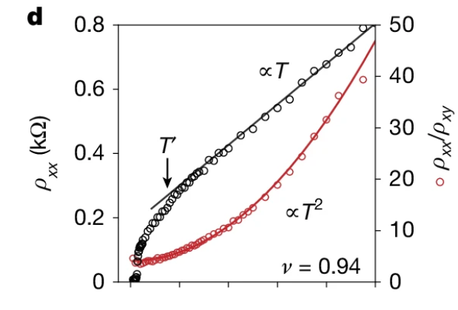  Intermediate / crossover (ν = 0.94): ρ ∝ T above T′, sublinear below — a sublinear metal between anchors.
Fig. 4 — representative ρ_{xx}(T) linecuts. The SC anchor (highest T_{c}) is fixed from the separate superconducting characterization rather than a single ρ(T) curve.

Step 5 — Sample between the anchors and fit for continuously evolving temperatures
Once the anchors are fixed, sample the fillings between one anchor and the next, plot their ρ(T) curves, and fit them — assuming the critical temperature changes continuously from anchor to anchor, and adjusting the fitting range accordingly.
Each linecut yields a characteristic temperature: T_{N} (Néel, from the local resistivity minimum / insulating onset), T_{coh} (Fermi-liquid coherence, 10% deviation from the T² fit), T′ (strange-metal crossover, 10% deviation from the T-linear fit), and T_{c} (superconducting transition, R → 0).
Because these scales must evolve continuously, the fit range is the practical handle for tuning them. Going from a Fermi liquid toward a strange metal, T_{coh} must decrease, so the window over which the quadratic (T²) fit is applied is shrunk progressively — making T_{coh} descend smoothly to zero rather than jump. The same continuity requirement fixes T_{N}, which must fall continuously from the AF insulator into the doped-AF metal and vanish smoothly.
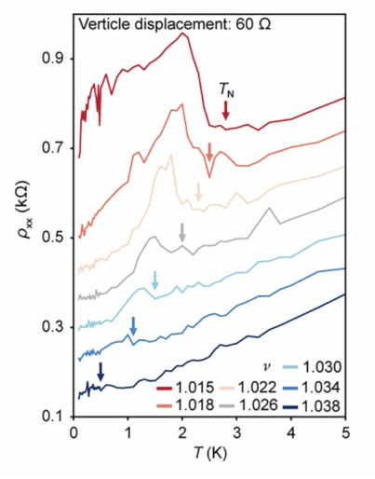  AF metal: ρ_{xx}(T) waterfall with T_{N} arrows marching down as doping increases. | 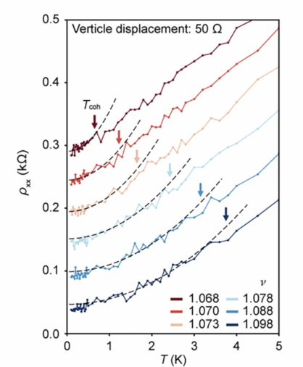  Fermi liquid → strange metal: T² fits (dashed) with the fit range shrinking; arrows mark T_{coh} decreasing smoothly.
Extended Data Fig. 6 — tuning the fit range keeps T_{coh} evolving continuously.

Step 6 — Plot the temperatures onto the (T, ν) plane
Collect every characteristic temperature from every linecut and plot it at its filling. T_{N} traces the AF dome around ν = 1, T_{coh} bounds the Fermi liquids at the edges, T′ caps the stranger-metal regions, and T_{c} marks the superconducting domes. The result is the finished phase diagram (Fig. 3e).
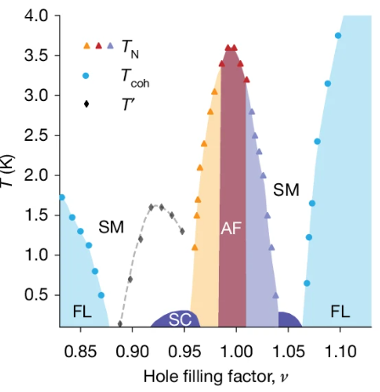
Fig. 3e — the assembled phase diagram. AF insulator at ν = 1, doped-AF (T_{N}) shoulders, strange metals (SM), Fermi liquids (FL) at the edges, and superconducting domes (SC).

In one line
Map → coarsely sample the whole diagram (~20 cuts, every feature covered) → identify phases → pin the extremal linecut per phase (max T_{coh}, max T_{N}, most-linear SM, max T_{c}) → sample between anchors and fit assuming the critical T changes continuously while adjusting the fit range → plot them = phase diagram.

