CITRIX XENAPP

INSTRUCTION GUIDE

Version 1, Release 1.4

26 April 2013

Developed by DISA for the DoD

Database Reference Number: __________________ CAT I: _____

Database entered by: ____________________Date:_______ CAT II: _____

Technical Q/A by: ______________________Date:_______ CAT III: _____

Final Q/A by: __________________________Date:_______ TOTAL: _____
Unclassified UNTIL FILLED IN

CIRCLE ONE

FOR OFFICIAL USE ONLY (mark each page)

CONFIDENTIAL and SECRET (mark each page and each finding)

Classification is based on classification of system reviewed:

Unclassified System = FOUO Checklist
Confidential System = CONFIDENTIAL Checklist
Secret System = SECRET Checklist
Top Secret System = SECRET Checklist

Site Name:_____________________________________
Date of SRR:_____________________
Reviewer |  |  |  |  |  | Phone/Location
Number of Current Open Findings
Site Name
Address
Phone
Position | Name |  | Phone Number |  | Email |  | Area of Responsibility
IAM
IAO
System Administrator

TABLE OF ConTENTS
SUMMARY OF CHANGES vi
1. Citrix XENAPP INtroDUCTION 7
1.1 Citrix XenApp Solution 7
1.2 XenApp Client Types 8
1.3 XenApp Secure Gateway 9
1.4 XenApp Web Interface 9
1.5 Citrix XenApp Server Versions 10
1.6 Citrix XenApp Checklist Organization 10
1.7 Citrix XenApp SRR Requirements 11
1.8 Data Collection and Assessment procedures 11
1.9 VMS SRR Data Entry Procedures 12
APPENDIX A. References 16
APPENDIX B. DOD CERTIFICATES 17
APPENDIX C. ACRONYM LIST 21

This page is intentionally left blank.

SUMMARY OF CHANGES

April 2013

- CTX0430 – Updated the vulnerability and check to include instructions for Windows 2008 Server and remove references to Gold Disk.
- Instruction Guide – Updated to remove references to Gold Disk and allow use of the STIG with Windows 2008 Server.

January 2013

- CTX0420 – Updated the vulnerability to resolve a conflict with CTX0410.

October 2009

- CTX0030 – Updated the vulnerability, check, and fixes verbiage.
- CTX0230 – Updated the check procedure on how to find the CtxSta.config file, and corrected millisecond number to 100000.
- CTX0240 – Updated the check procedure with guidance on how to find the CtxSta.config file.
- CTX0250 – Updated the check procedure with guidance on how to find the CtxSta.config file.
- CTX0310 – Updated the check procedure with guidance on how to find the Cshadow.exe file.
- CTX0410 – Updated the fixes procedure with specific commands to configure authentication for auto-client reconnect.
- CTX0420 – Added fixes procedure with specific commands to configure logging.
- CTX0430 – Updated the check procedure with new MaxInstanceCount setting.
- CTX0570 - Updated the check procedure with guidance on how to find the MF20.mdb or IMALHC.mdb files.
- CTX0600 – Updated vulnerability discussion.
- CTX0610 - Updated the check procedure with guidance on how to find the Ctxload.exe and CMilaunch.exe files.
- CTX0650 – Updated the check procedure with the proper Citrix user permissions.
- CTX0735 – New requirement that checks whether the Secure Gateway Server is registered in VMS or vulnerability management database.
- CTX0770– Updated check procedure removing the condition that is CTX0680 is a finding, this would be a finding as well.
- CTX0835 - New requirement that checks whether the Secure Gateway Server is registered in VMS or vulnerability management database.
- CTX0840 – Updated check procedure removing the condition that is CTX0680 is a finding, this would be a finding as well.

July 2009

- INITIAL RELEASE OF INSTRUCTION GUIDE

Citrix XENAPP INtroDUCTION
Citrix XenApp Server or Citrix Presentation Server 4.5 is a product from Citrix Systems. Citrix XenApp 5.0 was just recently released. Citrix chose to re-brand the Presentation Server line in 2008 to go along with its new XenServer label. Citrix XenApp Server is a third-party add-on for Microsoft’s Window Terminal Services. It provides advanced remote access capabilities for system administrators by interacting with the underlying architecture of Terminal Services to improve the remote application process.

Citrix XenApp Solution
XenApp Server is an extension for Windows Terminal Services environment. Windows Terminal services still lacks some enterprise functionality and ease of use that XenApp Server can provide. XenApp Server fills in the gaps that exist in Terminal Services. These gaps deal primarily with load balancing, client access methods, and application availability. XenApp also provides some added features such as role management, advanced reporting, and application packaging.

The XenApp architecture is comprised of server farms that all connect to the same data store. XenApp farms are similar to domains in that they are a collection of servers that provide a similar service or function. The XenApp farm provides redundancy in case a server would crash. Within the farm model are two technologies that make the on-demand enterprise function: Independent Management Architecture (IMA) and Independent Computing Architecture (ICA).

IMA is a centralized management subsystem that provides granular control over the elements in the farm. IMA is described as a framework service due to the modular design used to create the service. Each module provides specific functionality within the farm. For instance, the Citrix Licensing subsystem assists in enforcing licensing, and the Program Neighborhood subsystem provides for application set enumeration based on user credentials. IMA is also the name of the protocol used for communication between servers over Transmission Control Protocol (TCP) port 2512.

The IMA service is made up of several components. The first component of the IMA is the data store. The data store is used to store information within the Citrix XenApp Server farm that remains relatively static. Items such as published applications, administrator names and permissions, and server listings are things found in the data store. The data store may reside on a Citrix XenApp Server or on a dedicated host.

The next component of the IMA is the local host cache (LHC). The LHC is a partial copy of the data store database that every XenApp Server maintains locally. The partial local replica is stored in MS Access format and is encrypted. The LHC allows XenApp servers to continue to run if the data store database becomes unavailable, and it increase performance to users accessing applications.

Data collectors are another component of the IMA. The data collector is used to manage information that changes frequently, such as current sessions, active licenses, and server and application load values within a zone.

ICA is the communication protocol used by the ICA client software and the XenApp servers. It provides the transport of data between devices. The Transmission Control Protocol/Internet Protocol (TCP/IP) header encapsulates the ICA packets. ICA intercepts and transports screens from the server that a published application runs on to the client personal computer (PC). It takes the user’s return input and transmits it back to the server for processing. ICA traffic consists of mouse movements, clicks, typing, and anything that would cause a screen to refresh.

Figure 1-1 illustrates ICA and IMA traffic patterns within a XenApp farm.

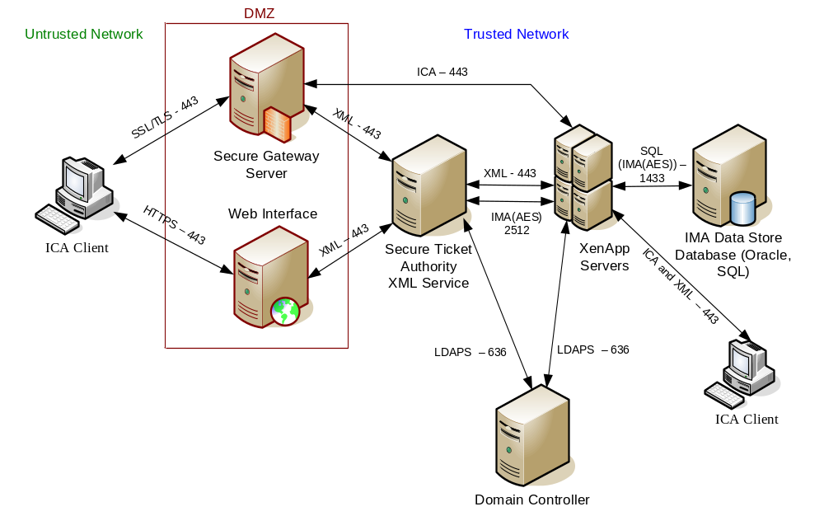
Figure 1-1: XenApp Architecture

XenApp Client Types
The XenApp Server Client package contains the Win32 client-side component of the Citrix XenApp Server. The client is used to connect to the XenApp Server and to access published resources. Published resources include applications and documents that are published on the XenApp Server. The XenApp Server may be accessed through three types of clients: Program Neighborhood Client, Program Neighborhood Agent, and Web Interface.

The Program Neighborhood Client is configured and managed by each individual user. The Program Neighborhood cannot be configured from a centralized site such as the Program Neighborhood Agent site; thus, it does not require a Web Interface for the Presentation Server.

The Program Neighborhood Agent is a client that supports the full XenApp Server feature set. The Program Neighborhood Agent allows users to access all of their published resources from a familiar Windows desktop environment. Users work with published resources the same way they work with local applications and files. Published resources are represented throughout the client desktop, including the Start menu and the Windows notification area, by icons that behave just like local icons. Users can double-click, move, and copy icons and create shortcuts in their locations of choice. The Program Neighborhood Agent works in the background. Except for a shortcut menu available from the notification area, it does not have a user interface.

The Program Neighborhood Agent functionality is centrally administered and configured in the Citrix Access Suite Console, using a Web Interface Program Neighborhood Agent Site. Security settings can be dictated by the Web Interface, but client security settings always take precedence. The Program Neighborhood Agent works in the background. Data transfer from the client to the Web Interface occurs over Hypertext Transfer Protocol (HTTP) or Hypertext Transfer Protocol Secure (HTTPS) methods.

The Web Client is a smaller client that allows for quick distribution. It is available in .cab file format for Internet Explorer (IE) users for quick downloads. The Web Client does not require user configuration and does not have a user interface. Users can access published resources from within the Web browser by clicking links on corporate Intranet or Internet pages accessed via HTTP or HTTPS. A Web Interface must be configured for this client to work.

XenApp Secure Gateway
The Secure Gateway is a Citrix component used to secure access to the XenApp Server. Typically, to secure access to published resources in a server farm, the Secure Gateway is placed in the Demilitarized Zone (DMZ). The Secure Gateway manages authentication and authorization and is responsible for creating a secure channel for data exchanged between the client device and computers running Citrix XenApp Server in a secure network. All data traversing the Internet between a remote workstation and the Secure Gateway is encrypted using the Secure Sockets Layer (SSL) or Transport Layer Security (TLS) protocol, protecting against data tampering and theft.

XenApp Web Interface
The Web Interface server provides users with access to XenApp Server applications and content through a standard Web browser or through the Program Neighborhood Agent. The Web Interface employs Java and .NET technology executed on a Web server to dynamically create a Hypertext Markup Language (HTML) depiction of server farms for XenApp Server sites. Users are presented with all the published applications made available in the server farm(s). Using the Program Neighborhood Agent in conjunction with the Web Interface, administrators may integrate published resources with users’ desktops. It is centrally administered and configured in the Access Management Console using a Program Neighborhood Agent site created in association with a site for the server running the Web Interface.

The Web Interface server functions as a Program Neighborhood interface for connecting to one or more server farms. The server running the Web Interface queries server farms for application set information and then formats the results into HTML pages that users can view in a Web browser. To communicate with server farms, the server running the Web Interface communicates with the Citrix Extensible Markup Language (XML) Service running on one or more servers. The Citrix XML Service is a XenApp component that provides published application information to clients and servers running the Web Interface using TCP/IP and HTTP. This service functions as the contact point between the server farm and the server running the Web Interface.

Citrix XenApp Server Versions
There are four versions of XenApp Server. These include the Standard, Advanced, Enterprise, and Platinum. It is important to check the XenApp Server version when doing the security readiness review since some checks may be not applicable. Listed below are the features that are available for the different versions.

- Application Streaming: Platinum, Enterprise, Advanced (Provides application isolation and streaming over SMB) Advanced doesn't allow for offline application access.

- Profile Management Software: Platinum and Enterprise (Profile Management Solution)

- SSL-VPN through Access Gateway: Platinum (Licenses are included with Platinum, however the device must be purchased)

- EdgeSight: Platinum (Performance Monitor product)

- Configuration Logging: Platinum, Enterprise, Advanced

- Provisioning Server: Platinum (Provides provisioning of servers)

- EdgeSight for Load Testing: Platinum, Enterprise (Provides load testing of servers)

- SmartAuditor: Platinum

- Password Manager: Platinum (Provides single sign-on to applications)

Citrix XenApp Checklist Organization
The XenApp Server Checklist document is composed of four sections. The organizational breakdown is as follows:

Section 1 | XenApp Policy Checklist
 | Contains all the Non-Computing checks for the XenApp Server.
Section 2 | XenApp Server Checklist
 | Contains all the Computing checks for the XenApp Server.
Section 3 | Web Interface Checklist
 | Contains all the Computing checks for the Web Interface Server.
Section 4 | Secure Gateway Checklist
 | Contains all the Computing checks for the Secure Gateway Server.

Citrix XenApp SRR Requirements
The following section presents the data collection and analysis methodology for a Citrix XenApp Security Readiness Review (SRR). The items reviewed as part of this SRR are based upon the requirements published by DoD Directive (DoDD) 8500.1, paragraph 4.18. The DoD Directive, DoDD 8500.1 requires guidelines to be developed by Defense Information Systems Agency (DISA) Field Security Operations (FSO) in accordance with DoD-approved security configuration as specified in the DoD Directive O-8530.1

The requirements to perform a Citrix XenApp SRR are as follows:

- Citrix XenApp SRR Checklist – A comprehensive list of checks that provide step-by-step procedures on performing a Citrix XenApp SRR. The checklist may be downloaded from Information Assurance Support Environment (IASE) Web site located at http://iase.disa.mil or the Defense Knowledge Online (DKO) Web site located at https://www.us.army.mil/suite/portal/index.jsp.
- User access to the Vulnerability Management System (VMS) which is located at https://vms.disa.mil/
- The review team will need Operating System (OS) (Windows), Web Server (Internet Information Service [IIS]), and Database reviewers to review all the components of the Citrix XenApp system.
- The XenApp Server Checklist applies to XenApp Server 4.5 and 5 running on Windows 2003 Server, Windows 2008 Server, or Windows 2008 R2 Server.

Data Collection and Assessment procedures
The initial data collection is achieved through the Citrix XenApp SRR Checklist. The Citrix XenApp checklist provides the procedures for evaluating XenApp Servers and their potential security vulnerabilities. The general steps involved in performing a Citrix XenApp SRR are as follows:

- Prior to arriving onsite, acquire the latest printed copy of the Citrix XenApp Checklist, Web Server (IIS) Checklist, Database Checklist, and Windows 2003, 2008, or 2008R2 STIG.
- Ensure that you have a valid VMS account.
- If possible, acquire a current copy of the site’s XenApp Server topology (network diagram) prior to arriving onsite or obtain a copy as soon as possible after arriving onsite.
- During or soon after the in-brief at the site, obtain the name(s) and phone number(s) of the onsite points-of-contact for the XenApp review.

The reviewer is responsible for coordinating with site personnel in arranging the review of the site’s network. The procedures for the collection of SRR data are as follows:

- Interview the SAs/Information Assurance Officers (IAOs), either individually or as a group, to complete the SRR XenApp Policy (non-computing) and XenApp Server, Web Interface, Secure Gateway, and Program Neighborhood Client Computing checks.
- The Team Lead will create a VMS Visits folder and provide the visit names to the reviewer.
- After all of the data for the Citrix XenApp SRR is collected and the Citrix XenApp Checklist is complete, enter the information into VMS.
- Enter the XenApp SRR results into the proper VMS visit by cross-referencing the Vulnerability Identification (ID) with the Security Technical Implementation Guide (STIG) ID located on the XenApp SRR Checklist.
- After the vulnerabilities have been entered into VMS, the reviewer will verify that no vulnerabilities are in the Not Reviewed (NR) status. Any NR vulnerabilities will be reviewed again to ensure it has been entered correctly.
- Open findings will be reviewed to ensure the “Finding Details” field has accurate text. If the “Finding Details” field is empty, the reviewer will enter appropriate text explaining the cause of the Open Finding.
- The reviewer will discuss with the site personnel the feasibility of closing all Category I findings before the team leaves the site. The reviewer will keep the Team Lead informed of all Category I findings and provide additional emphasis and clarity when explaining why some Category I findings cannot be closed immediately.
- Floppy disks, compact discs (CDs), Digital Versatile Discs (DVDs), Universal Serial Bus (USB) drives, data entry forms, and reports will be handled and protected in accordance with their level of classification.
- The reviewer will communicate to the Team Lead the status of VMS data entry through the daily meetings and will send an e-mail to the Team Lead only if the VMS data entry cannot be completed on site.

VMS SRR Data Entry Procedures
Verify the asset is registered in VMS under the correct organization. Assets not registered will need to be created. When creating the asset, the asset ownership defaults to the person creating the asset. It is recommended that the SA create the asset. If the reviewer creates the asset, the permissions will need to be reassigned to the SA.

- Creating the Asset

- Expand Asset Findings Maintenance.
- Expand Assets/Findings.
- Expand Visits to display sub-folders. (Reviewer Only) SA will expand Location.
- Expand the sub-folder assigned. Each subfolder represents individual visits in VMS assigned for review.
- Expand the visit and display the location summaries for the visit. Within the location, assets are divided into computing, non-computing, and Computer Network Defense Service (CNDS).

1.1 Creating a Non-Computing Asset

- Click the yellow folder icon located at the right of ‘Non-Computing’.
- Click the General tab.
- Enter the Display name. The standard name for network non-computing asset will be: “SiteName_XenApp_Policy”.
- Verify “Location”.
- Verify “Owner”: Used to register asset to parent or child location.
- Verify “Managed By”: Used for remote locations being managed.
- Verify Mac level, Confidentiality, and Classification are correct.
- Click the ‘Asset Posture’ tab to add functions to the asset.
- Expand Non-computing.
- Expand ‘Application’.
- Click ‘XenApp Policy’.
- Click ‘>>’ to move it to the ‘Selected’ window.
- Click the Systems / Enclaves tab.
- For registered enclaves, choose the correct enclave.
- If the enclave is not present, ensure that the IAM or Team Lead works with the appropriate site personnel to request an enclave.
- Click ‘Save’.

1.2 Creating a Computing Asset

- Click the Create Icon located next to computing. The asset form is displayed.
- Click the General tab and enter the information into the required fields.
- Click the asset identification tab and enter the IP address, MAC address and click add.
- Click the Asset Posture Tab and drill down to select the following functions:
Application >> Citrix >> XenApp Server | XenApp Secure Gateway Server | XenApp Web Interface Server
- Click the ‘>>’ to move it to the ‘Selected window.
- Click Save.

- Reassign Permissions for Asset (If Required)

- Expand Permissions.
- Click Reviewer Asset Update.
- Select Visit and submit.
- Select Asset and submit.
- Select User and submit.

- Procedures for Review of the Asset

If all registration tasks have been accomplished, use the following procedures:

- Expand Asset Findings Maintenance.
- Expand Assets/Findings.
- Expand Visits to display sub-folders. (Reviewer Only) SA will expand Location.
- Expand the sub-folder assigned. Each subfolder represents individual visits in VMS assigned for review.
- Expand the visit and display the location summaries. Within the location, assets are divided into computing, non-computing, and Computer Network Defense (CNDS).
- Expand ‘Non-Computing’ and ‘Computing’.
- Expand ‘Must Review’. (Reviewer Only) SA will not see ‘Must Review’. If an asset was just created, it would reside in ‘Not elected for Review’ section. Have the Team Lead move the asset to ‘Must Review’.
- Expand Asset to review. Ready to review is colored in RED.
Note: When you drill down into the asset, you will find Vulnerabilities assigned to the XenApp Server component and Information Assurance Vulnerability Management (IAVM) when the OS is expanded.
- Expand the XenApp Server component and each Vulnerability Key.
- Update the ‘Status’ of the vulnerability.
- Identify details on all open vulnerabilities.
- SAs will need to update the Plan of Action and Milestone (POA&M) prior to saving.
- SAs should expand the OS assigned to the asset and each IAVM. Verify the OS level meets the required release or patch level. Asset must be in the same status (such as ‘Open’).
- Save the updates to the asset.

- Verify that all Necessary Assets were Reviewed

- Select Asset Findings Maintenance.
- Expand Assets/Findings.
- Expand visits to display the sub-folders.
- Expand the sub-folder assigned.
- Expand the visit and display the location summaries. Within the location, assets are divided into computing, non-computing, and CNDS.
- Expand ‘non-computing’.
- Expand ‘Computing’.
- Expand ‘Must Review’. (If checkmarks are gone, the asset has been reviewed.)

- Add Comments

- Select Visit Maintenance.
- Expand Organization for the visit.
- Expand Visit.
- Locate the visit.
- Click on Command Communications Service Designator (CCSD) or enclave name.
- Add a comment on the Comments Tab.
- Save Changes.

- Compliance Monitoring

- Select Reports.
- VC06 – Asset Compliance Report.
- Can select an asset or an org.
- Select “open” status.
- Can sort on different fields.
- Display (Finding Comments, Finding Long Name, Finding Details, and Vulnerability Discussion).
- The AS01 report assists the reviewer or SA by quickly identifying the assets at the location the review is being performed. In the section “Looking at Network Assets” is a quick step by step instruction in creating the report. The site may want to do other reports if your site manages or owns assets which are not located at the site. Check Child Locations if applicable. Navigate to the Reports menu, select the AS01 Report, and select the desired criteria for the report.
- The VL03 report assists the reviewer or SA by quickly identifying the IAVMs that will be identified to the asset when you select the OS of the asset. Navigate to the Reports Menu, select the VL03 Report, and select the desired criteria for the report.

APPENDIX A. References

DoD Instruction 8500.2, Information Assurance (IA) Implementation, 6 February 2003

Citrix Systems, Inc., Using the Citrix SSL Relay Service, 2001

Citrix Systems, Inc., Citrix Presentation Server Administrator’s Guide, 2007

Citrix Systems, Inc., Clients for Windows Administrator’s Guide, 2007

Citrix Systems, Inc., MetaFrame Presentation Server Security Standards and Deployment Scenarios, 2005

Citrix Systems, Inc., Web Interface Administrator’s Guide, 2005

Citrix Systems, Inc., Secure Gateway for Windows® Administrator’s
Guide, 2005

Citrix Systems, Inc., Isolation Environments Explained, 2005

Citrix Systems, Inc., Securing Citrix Traffic, 2007

Shane Wescott, Server Security in a Citrix Presentation/Terminal Server Environment, 2006

Tariq Azad, Securing Citrix XenApp Server in the Enterprise, 2008

APPENDIX B. DOD CERTIFICATES
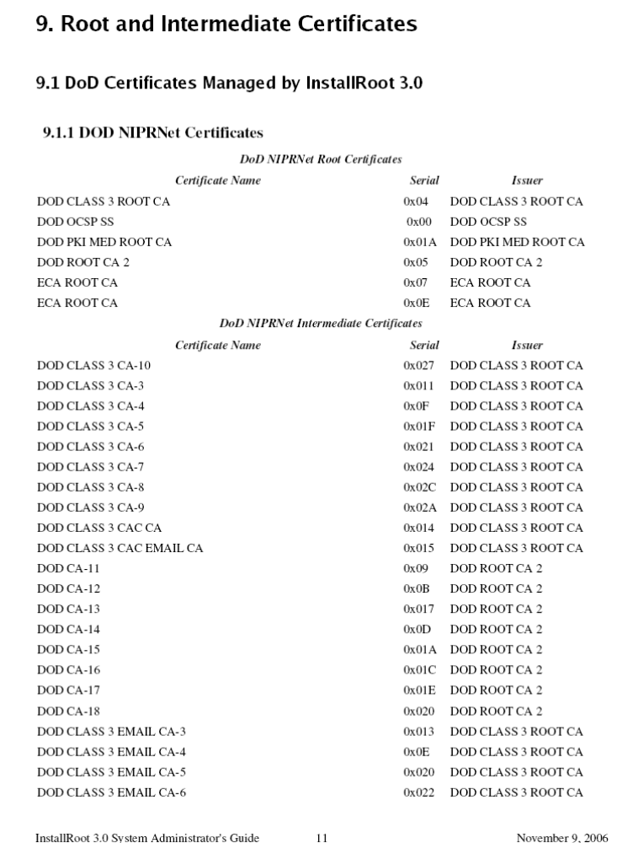

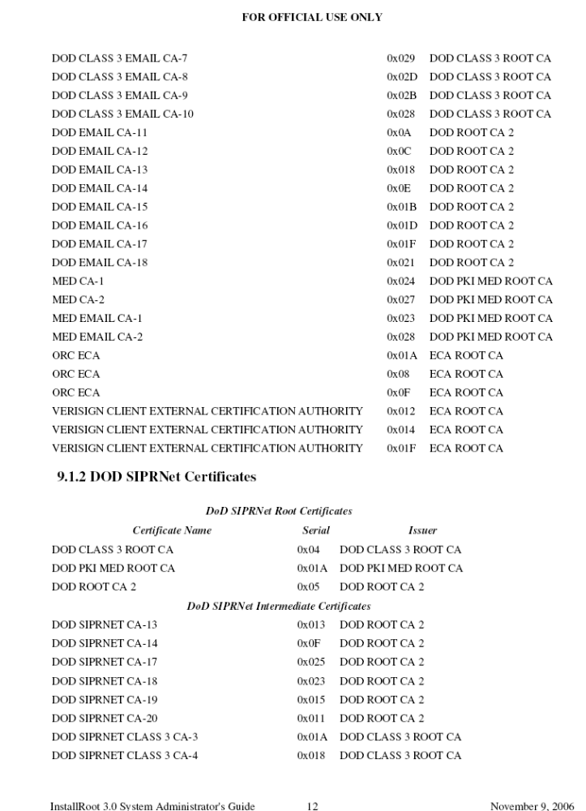

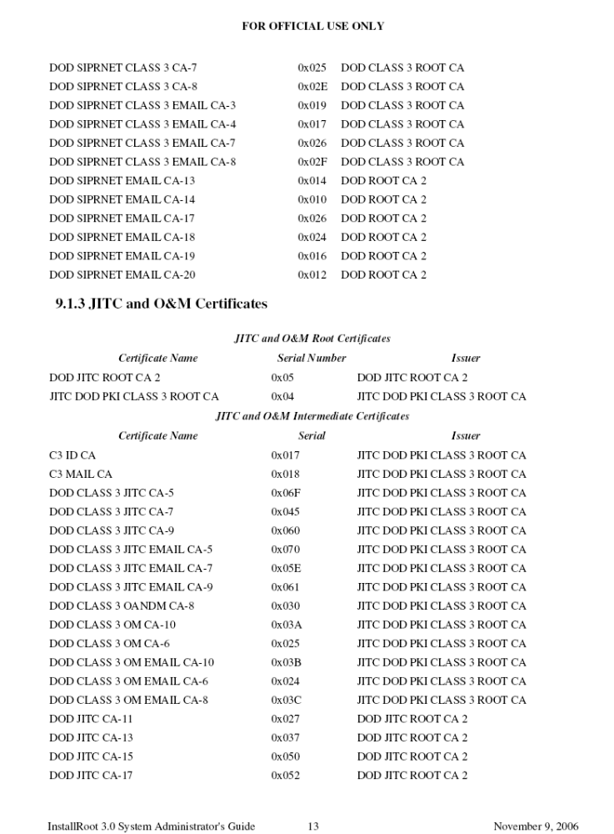

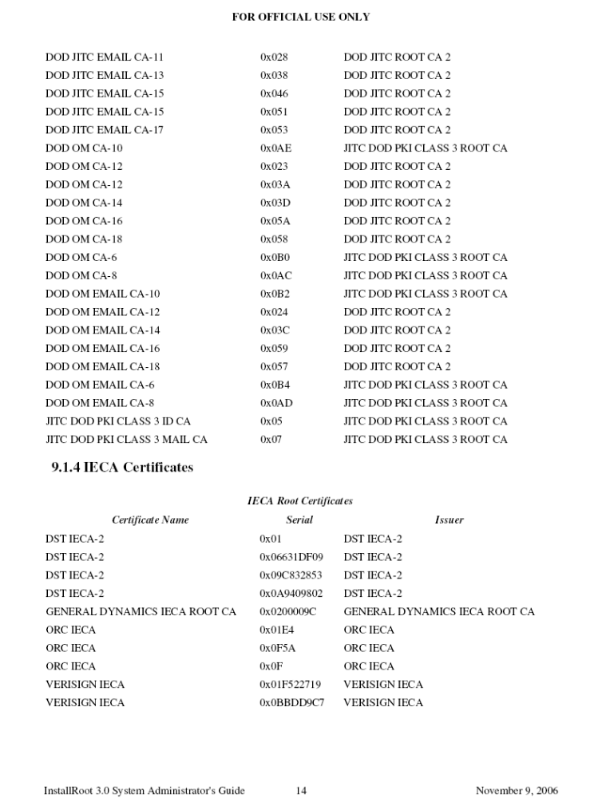

APPENDIX C. ACRONYM LIST

CD Compact Disc

DISA Defense Information Systems Agency
DKO Defense Knowledge Online
DMZ Demilitarized Zone
DoD Department of Defense
DoDD Department of Defense Directive
DVD Digital Versatile Disc or Digital Video Disc

FSO Field Security Operations

HTML Hypertext Markup Language
HTTP Hypertext Transfer Protocol
HTTPS Hypertext Transfer Protocol Secure

IAO Information Assurance Officer
IASE Information Assurance Support Environment
IAVM Information Assurance Vulnerability Management
ICA Independent Computing Architecture
ID Identification
IE Internet Explorer
IIS Internet Information Service
IMA Independent Management Architecture
IP Internet Protocol

LHC Local Host Cache

MS Microsoft

NR Not Reviewed

OS Operating System

PC Personal Computer

SA System Administrator
SRR Security Readiness Review
SSL Secure Socket Layer
STIG Security Technical Implementation Guide

TCP Transmission Control Protocol
TLS Transport Layer Security

USB Universal Serial Bus

VMS Vulnerability Management System

XenApp Citrix Presentation Server
XML Extensible Markup Language

