1. Run the program, and the interface is as follows:

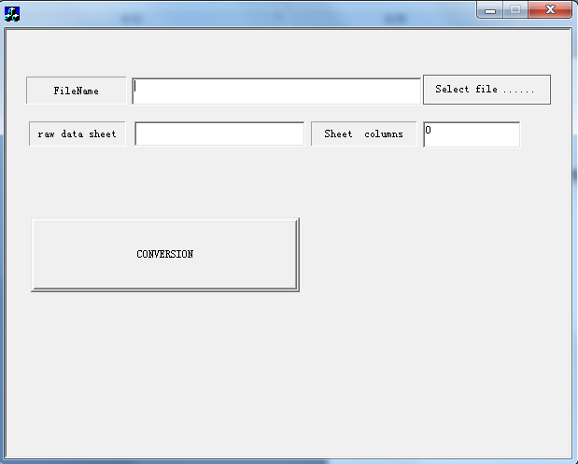

1. Click the button [Select file …], choose the Excel file to be converted (only .xls file format), and then click the button 【Open】, that is 【打开】in the picture below.

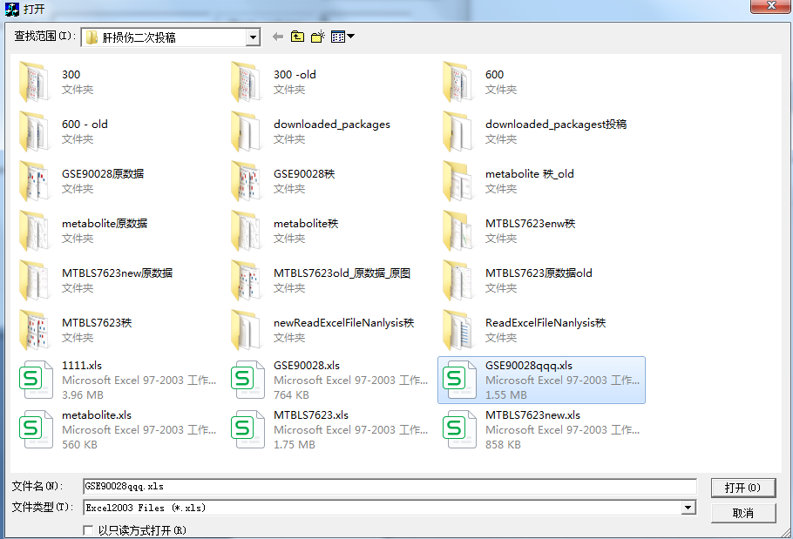

1. In the [raw data sheet] text box, enter the name of the data sheet to be converted, such as [Sheet1];
2. In the [Sheet num] text box, enter the total number of fields in the data sheet [Sheet1], including one marker field and all samples.

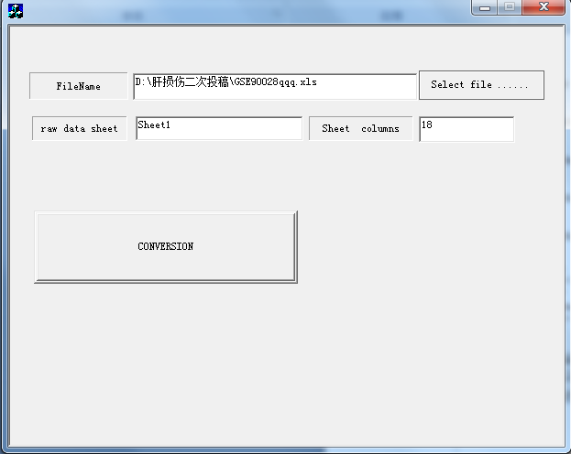

5. Click [CONVERSION], and a new data sheet will be automatically created in the Excel file, named as the [raw data sheet] name + “rank”. In this example, the sheet “Sheet1Rank” will be created, and the converted rank data will be stored in this sheet.  
Note: If the Excel file already contains a data sheet with the same name as the one to be created, such as “Sheet1Rank” in this example, the data will be directly stored in this sheet.