Deploy the trained model and .py program to the server

**1.First ssh to login to the server.**

**2. copy the model folder to the server:**

**~/Documents/tensorflow/models/research/object_detection/**

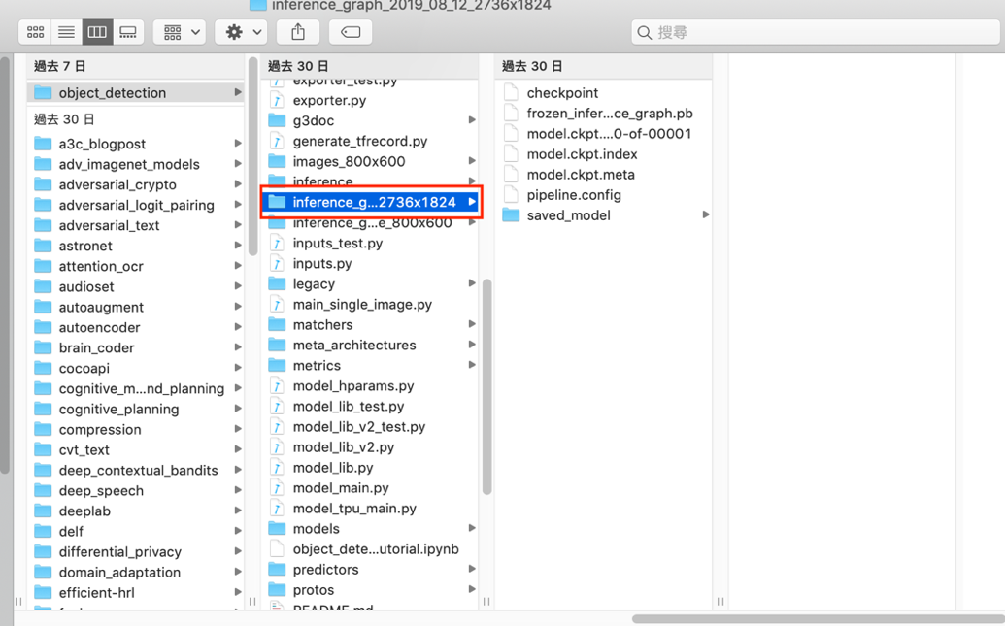

**2.1 copy the local faster_rcnn_inception_v2_pets.config, labelmap.pbtxt in training folder to server: ~/Documents/tensorflow/models/research/object_detection/training**

**2.2 copy the local detect_my_images.py to server: ~/Documents/tensorflow/models/research/object_detection/**

**3. Test the model and .py**

**Given the test images folder to test.**

**Type in cmd:**

|  |
| --- |
| python [detect_my_images.py](http://detect_my_images.py/) -i test_img -o test_img |