Titanic Data Analysis

Determine if the survival rate is associated to the class of passenger

Total passengers in this data: 890

Total in each class("Pclass") - 1:First Class, 2:second Class, 3: Third Class / Survived: 0: Dead 1:A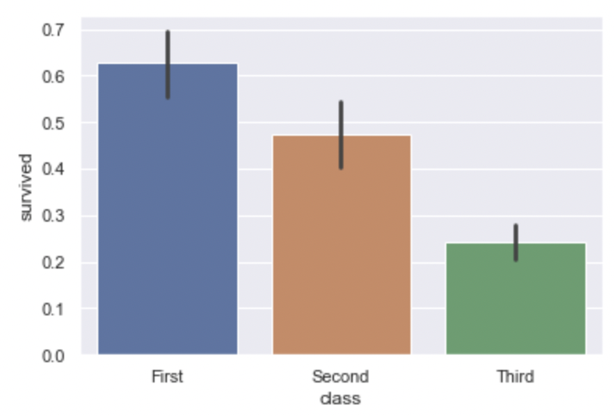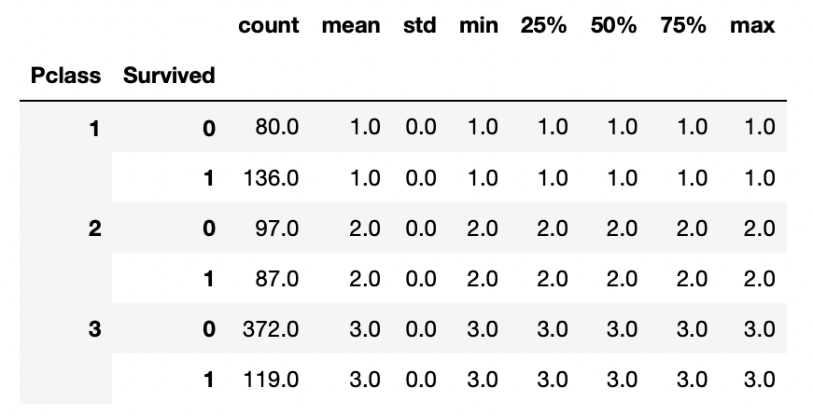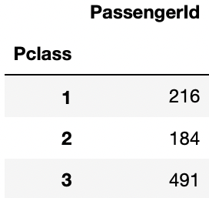live

|  |  |  |  |
| --- | --- | --- | --- |
|  | First Class | Second Class | Third Class |
| Survived | 136 ( ~62%) | 87(~47%) | 119(~24%) |
| Not survived | 80(~38%) | 97(~53%) | 372(~76%) |

In the table above we can see that 136 passengers of 216 survived from the first class , a total of 62%. From the second class 87 of 184 survived , a total of 47% and from the third class just 119 of 491 , a total of 24%.

The graph above show to us the percentage of survivors in each class. The percentage in the first, second and third class is approximately : 62%,47% and 24% respectively.

The Titanic was designed to accommodate different classes of passengers: 1st, 2nd and 3rd class (commonly referred to as "steerage"). It seems obvious that 1st class passengers would have had the greatest chance of reaching the lifeboats since their accommodations were directly below the boat deck. Even if steerage passengers did have equal oppor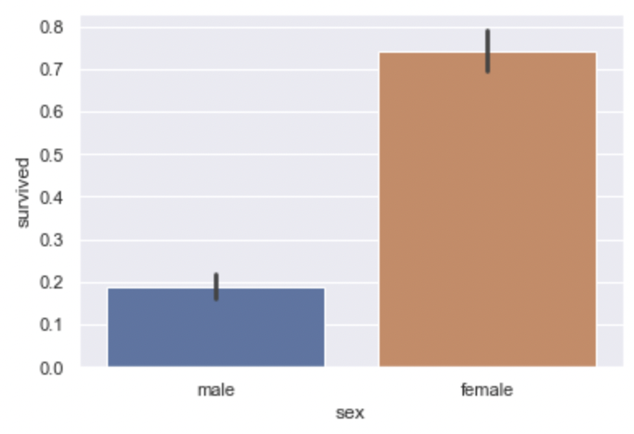tunity to reach the boat deck, they probably would have had a difficult time finding their way around unfamiliar parts of the ship. Language was also a barrier since many of the emigrants spoke very little English.

Determine if the survival rate is associated to the gender

Total passengers : female: 314, male:577

|  |  |  |
| --- | --- | --- |
|  | Male | Female |
| Survived | 109(~18%) | 233(~74%) |
| Not survived | 468(~82%) | 81(~26%) |

In the graph above we can see the percentage of male and females that survived.The percentage of male and females that survived is approximately approximately : 18% and 74% respectively

Looking the graph above we can conclude that the gender mattered between who survived or not in the case of the Titanic disaster.

Determine the survival rate is associated to the age

In the graph above you can see the quantity of people that survived based on their age.

Regarding this graph we can see that most of the people that survived was children and passengers from 0 to 3 years old and 18 to 36 years old approximately.

One interesting point is that most of people that don't survived was approximately from 18 to 36 years old as well. Probably most of the people that don't survived was young men passengers giving the preference to older, women and children ones.

In this case we can conclude that the age mattered in the case of Titanic disaster.