# Lab: Unit Testing

Problems for exercises and homework for the ["C# OOP" course @ SoftUni"](https://softuni.bg/trainings/4377/csharp-oop-february-2024).

You can check your solutions here: <https://judge.softuni.org/Contests/1844/Unit-Testing-Lab>

## Part I: Unit Testing Basics

### Test Axe

Load provided solution in Visual Studio. Add new project **Tests**

An AxeTests is given

Create the following tests:

* Test if weapon loses durability after each attack
* Test attacking with a broken weapon

#### Solution

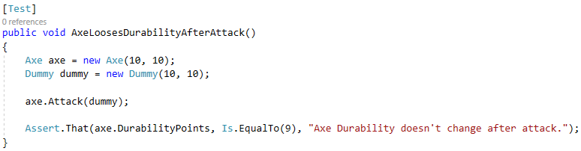

## Test Dummy

A DummyTests is given

Create the following tests:

* Dummy loses health if attacked
* Dead Dummy throws an exception if attacked
* Dead Dummy can give XP
* Alive Dummy can't give XP

### Hints

Follow the logic of the previous problem

## Refactor Tests

Refactor the tests for Axe and Dummy classes

Make sure that:

* **Names** of test methods are **descriptive**
* You use **appropriate** **assertions** (assert equals vs assert true)
* You use **assertion** **messages**
* There are **no magic numbers**
* There is **no code duplication** (Don’t Repeat Yourself)

### Hints

Extract constants and private fields for Axe class

Create a method that executes **before each test**

Make use of constants and private fields, as well as add assertion messages

Follow the same logic for other test methods and TestDummy class