$$ϵ\sim N\left(0,1\right)$$

$$w_{t}=W\left(d\right)+ε_{t}∙\sqrt{\frac{D}{δt}}$$

$$W\left(d\right)=\left\{\begin{matrix}-v∙(1-\exp\left(-\frac{d_{min}-d}{λ}\right)) \\ 0 \\ v∙(1-\exp\left(-\frac{d-d_{max}}{λ}\right))\end{matrix}\right.\begin{matrix}if d<d_{min} \\ if d_{min}≤d≤d_{max} \\ d_{max}≤d\end{matrix}$$

In the above, $ϵ$ is a normal random variate, *wt* is the total vertical velocity at time *t*, *W*(*d*) is the deterministic (directed) swimming speed at depth *d*, *D* is the diffusion constant, and $δt$ is the integration time step. If *W*(*d*) = 0 for all *d*, (i.e., no directed swimming occurs), then the *variance* of the vertical displacement of a particle from its initial depth increases like $D∙t$ over time (i.e., like a white noise process). The effect of the terms in parentheses in *W*(*d*) is to make the directed swimming speed smoothly go to zero as an individual approaches its preferred depth range (e.g., Fig.1).

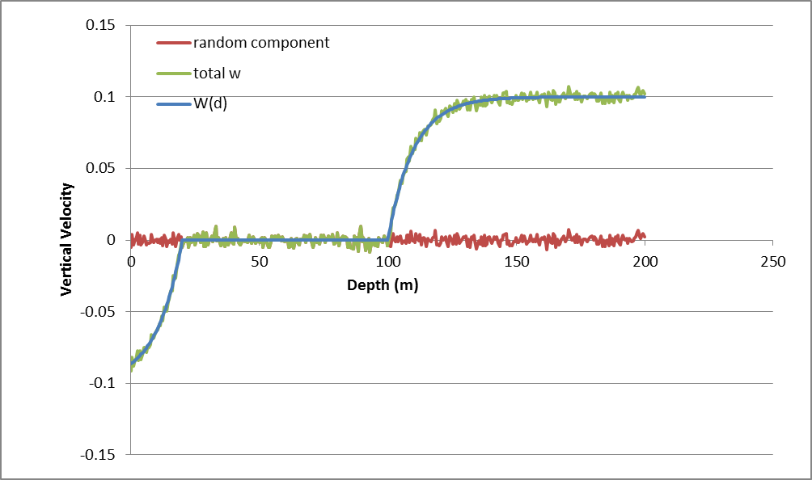

Figure . Example profile of vertical velocity. $d_{min}=10$ m. $d_{max}=100$ m. *v* = 0.1 m/s, *D* = 0.01 m2/s, s.