# Simulation Record

## des_key_check && des_key

the simulation result of des_key_check module and des_key module.

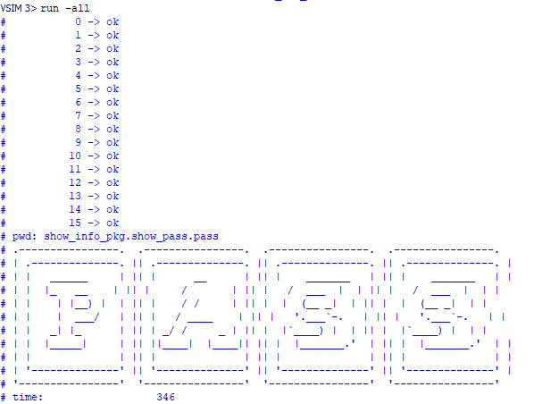

Figure 1 des_key module’s simulation result

## des_ip

the simulation result of des_ip module. (initial permutation)

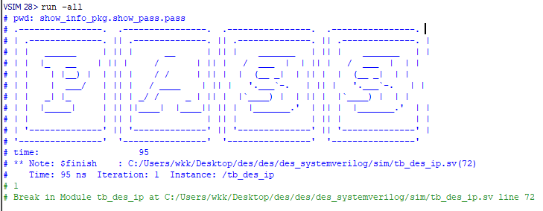

Figure 2 des_ip module’s simulation result

## des_ext

the simulation result of des_ext module.

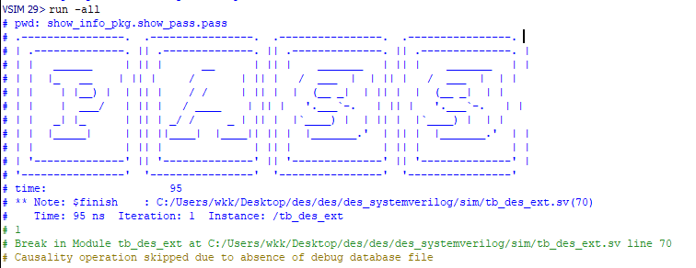

Figure 3 des_ext module’s simulation result

## des_scomp

the simulation result of des_scomp module.

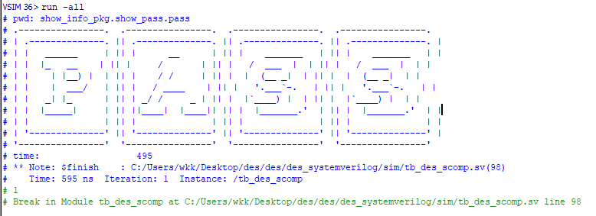

Figure 4 des_scomp module’s simulation result