
COMSATS University Islamabad
Waleed Ahmad
FA23-BBD-151
Lab Assignment 9, 10
Section: 7B

Instructions
This submission contains the complete work for Lab 9 (Sequence-to-Sequence Models in Python) and Lab 10 (Seq2Seq with Attention vs without Attention) of the deep learning lab manual on attention mechanisms for sequence modelling in Business Data Analytics. Each lab includes the step-by-step walkthrough, all lab tasks and the lab assignment, with every code cell followed by its output.

Contents
- Lab 9: walkthrough Steps 1 to 7 (dataset, input preparation, encoder-decoder LSTM, training, greedy decoding and evaluation, context-vector bottleneck), Lab Tasks 1 to 4, and Lab Assignment 3 (Tasks 1 to 6).
- Lab 10: walkthrough Steps 1 to 7 (attention by hand, data, models with and without attention, training, comparison, attention heatmaps, own dates), Lab Tasks 1 to 4, and Lab Assignment 4 (Tasks 1 to 6).

Tools and dataset
- Software: Python 3 with TensorFlow/Keras, NumPy, pandas and Matplotlib, run in Google Colab.
- Labs 9 and 10 dataset: 20,000 synthetic invoice dates (1990 to 2029, written in 8 supplier formats) paired with the standard ISO date; 16,000 pairs for training and 4,000 for testing, generated in the notebook with a fixed random seed.
- Assignment 3 dataset: 12,000 amounts written in words paired with their digits (for example "two thousand five hundred" to 2500); 10,000 for training and 2,000 for testing.
- Assignment 4 dataset: the invoice dates with a supplier name and invoice number placed before the date, so the model must find the date inside a longer string.

How to read this document
- Grey boxes contain the code exactly as it was run. The boxes below them, with a blue border, contain the output of that code: printed results, tables, model summaries, training logs and charts.
- Written answers for tasks that ask for an explanation, recommendation or conclusion appear after the related code and output.
- Accuracy values and training times depend on the run, so the figures shown are the ones produced in this run of the notebook.

Lab 9: Sequence-to-Sequence Models in Python

Step 1: Import libraries
CODE
import random
import datetime
import numpy as np
import pandas as pd
import matplotlib.pyplot as plt
import tensorflow as tf
from tensorflow.keras.models import Model
from tensorflow.keras.layers import Input, Embedding, LSTM, Dense
from tensorflow.keras.preprocessing.sequence import pad_sequences

random.seed(42)
np.random.seed(42)
tf.random.set_seed(42)
OUTPUT
WARNING: All log messages before absl::InitializeLog() is called are written to STDERR
I0000 00:00:1791622976.538262 11695 port.cc:153] oneDNN custom operations are on. You may see slightly different
numerical results due to floating-point round-off errors from different computation orders. To turn them off,
set the environment variable `TF_ENABLE_ONEDNN_OPTS=0`.
I0000 00:00:1791622976.539099 11695 cudart_stub.cc:31] Could not find cuda drivers on your machine, GPU will not
be used.
WARNING: All log messages before absl::InitializeLog() is called are written to STDERR
I0000 00:00:1791622978.902035 11695 port.cc:153] oneDNN custom operations are on. You may see slightly different
numerical results due to floating-point round-off errors from different computation orders. To turn them off,
set the environment variable `TF_ENABLE_ONEDNN_OPTS=0`.
I0000 00:00:1791622978.902698 11695 cudart_stub.cc:31] Could not find cuda drivers on your machine, GPU will not
be used.

Step 2: Create the dataset
CODE
formats = ['%d %B %Y', '%d %b %Y', '%B %d, %Y', '%d/%m/%Y', '%d.%m.%y', '%A, %d %B %Y', '%b %d %Y', '%d-%b-%
y']

def random_date():
d = datetime.date(1990, 1, 1) + datetime.timedelta(days=random.randint(0, 14600))
return d.strftime(random.choice(formats)).lower(), d.isoformat()

data = [random_date() for _ in range(20000)]
df = pd.DataFrame(data, columns=['invoice_date', 'standard_date'])
print(df.head(8))
print(df['invoice_date'].str.len().describe())
OUTPUT
invoice_date standard_date
0 07 sep 2018 2018-09-07
1 14.02.91 1991-02-14
2 26/12/2000 2000-12-26
3 05 apr 1996 1996-04-05
4 10 may 2020 2020-05-10
5 jun 27 2016 2016-06-27
6 05 june 1991 1991-06-05
7 16/03/1994 1994-03-16
count 20000.000000
mean 12.657900
std 4.692182
min 8.000000
25% 10.000000
50% 11.000000
75% 15.000000
max 28.000000
Name: invoice_date, dtype: float64

Step 3: Prepare the inputs
CODE
in_chars = sorted(set(''.join(df['invoice_date'])))
out_chars = sorted(set(''.join(df['standard_date'])))
in_index = {c: i + 1 for i, c in enumerate(in_chars)}
out_index = {c: i + 1 for i, c in enumerate(out_chars)}
inv_out = {i: c for c, i in out_index.items()}
start_id = len(out_chars) + 1
in_vocab = len(in_chars) + 1
out_vocab = len(out_chars) + 2
print('Input vocabulary :', in_vocab)
print('Output vocabulary:', out_vocab)

max_in = 30
X = pad_sequences([[in_index[c] for c in s] for s in df['invoice_date']], maxlen=max_in, padding='post')
y = np.array([[out_index[c] for c in s] for s in df['standard_date']])
y_in = np.concatenate([np.full((len(y), 1), start_id), y[:, :-1]], axis=1)

X_train, X_test = X[:16000], X[16000:]
y_train, y_test = y[:16000], y[16000:]
y_in_train, y_in_test = y_in[:16000], y_in[16000:]
print(X_train.shape, y_in_train.shape, y_train.shape)
print(y[0])
print(y_in[0])
OUTPUT
Input vocabulary : 38
Output vocabulary: 13
(16000, 30) (16000, 10) (16000, 10)
[ 4 2 3 10 1 2 11 1 2 9]
[12 4 2 3 10 1 2 11 1 2]

Step 4: Build the encoder and decoder
CODE
def build_seq2seq(units):
enc_input = Input(shape=(max_in,), name='encoder_input')
enc_emb = Embedding(in_vocab, 32, mask_zero=True)(enc_input)
_, state_h, state_c = LSTM(units, return_state=True, name='encoder_lstm')(enc_emb)
dec_input = Input(shape=(None,), name='decoder_input')
dec_emb = Embedding(out_vocab, 32)(dec_input)
dec_seq, _, _ = LSTM(units, return_sequences=True, return_state=True, name='decoder_lstm')(dec_emb, init
ial_state=[state_h, state_c])
output = Dense(out_vocab, activation='softmax', name='output')(dec_seq)
model = Model([enc_input, dec_input], output)
model.compile(optimizer='adam', loss='sparse_categorical_crossentropy', metrics=['accuracy'])
return model

seq2seq = build_seq2seq(64)
seq2seq.summary()
OUTPUT
Model: "functional"
+---------------------+-------------------+------------+-------------------+
| Layer (type) | Output Shape | Param # | Connected to |
+---------------------+-------------------+------------+-------------------+
| encoder_input | (None, 30) | 0 | - |
| (InputLayer) | | | |
+---------------------+-------------------+------------+-------------------+
| decoder_input | (None, None) | 0 | - |
| (InputLayer) | | | |
+---------------------+-------------------+------------+-------------------+
| embedding | (None, 30, 32) | 1,216 | encoder_input[0]? |
| (Embedding) | | | |
+---------------------+-------------------+------------+-------------------+
| not_equal | (None, 30) | 0 | encoder_input[0]? |
| (NotEqual) | | | |
+---------------------+-------------------+------------+-------------------+
| embedding_1 | (None, None, 32) | 416 | decoder_input[0]? |
| (Embedding) | | | |
+---------------------+-------------------+------------+-------------------+
| encoder_lstm (LSTM) | [(None, 64), | 24,832 | embedding[0][0], |
| | (None, 64), | | not_equal[0][0] |
| | (None, 64)] | | |
+---------------------+-------------------+------------+-------------------+
| decoder_lstm (LSTM) | [(None, None, | 24,832 | embedding_1[0][0? |
| | 64), (None, 64), | | encoder_lstm[0][? |
| | (None, 64)] | | encoder_lstm[0][? |
+---------------------+-------------------+------------+-------------------+
| output (Dense) | (None, None, 13) | 845 | decoder_lstm[0][? |
+---------------------+-------------------+------------+-------------------+
Total params: 52,141 (203.68 KB)
Trainable params: 52,141 (203.68 KB)
Non-trainable params: 0 (0.00 B)

Step 5: Train the model
CODE
history = seq2seq.fit(
[X_train, y_in_train], y_train,
epochs=15, batch_size=128,
validation_split=0.1, verbose=2
)

plt.plot(history.history['loss'], label='Training loss')
plt.plot(history.history['val_loss'], label='Validation loss')
plt.xlabel('Epoch')
plt.ylabel('Loss')
plt.legend()
plt.show()
OUTPUT
Epoch 1/15
113/113 - 11s - 94ms/step - accuracy: 0.4866 - loss: 1.5771 - val_accuracy: 0.6212 - val_loss: 1.0270
Epoch 2/15
113/113 - 5s - 46ms/step - accuracy: 0.6586 - loss: 0.9067 - val_accuracy: 0.7176 - val_loss: 0.7862
Epoch 3/15
113/113 - 5s - 47ms/step - accuracy: 0.7691 - loss: 0.6818 - val_accuracy: 0.8051 - val_loss: 0.5847
Epoch 4/15
113/113 - 5s - 45ms/step - accuracy: 0.8279 - loss: 0.5119 - val_accuracy: 0.8554 - val_loss: 0.4432
Epoch 5/15
113/113 - 5s - 46ms/step - accuracy: 0.8775 - loss: 0.3817 - val_accuracy: 0.9034 - val_loss: 0.3171
Epoch 6/15
113/113 - 5s - 44ms/step - accuracy: 0.9128 - loss: 0.2765 - val_accuracy: 0.9299 - val_loss: 0.2325
Epoch 7/15
113/113 - 5s - 45ms/step - accuracy: 0.9399 - loss: 0.1990 - val_accuracy: 0.9540 - val_loss: 0.1659
Epoch 8/15
113/113 - 5s - 46ms/step - accuracy: 0.9593 - loss: 0.1450 - val_accuracy: 0.9683 - val_loss: 0.1217
Epoch 9/15
113/113 - 5s - 43ms/step - accuracy: 0.9728 - loss: 0.1070 - val_accuracy: 0.9787 - val_loss: 0.0909
Epoch 10/15
113/113 - 5s - 44ms/step - accuracy: 0.9812 - loss: 0.0805 - val_accuracy: 0.9858 - val_loss: 0.0684
Epoch 11/15
113/113 - 5s - 46ms/step - accuracy: 0.9877 - loss: 0.0602 - val_accuracy: 0.9906 - val_loss: 0.0504
Epoch 12/15
113/113 - 5s - 44ms/step - accuracy: 0.9920 - loss: 0.0455 - val_accuracy: 0.9931 - val_loss: 0.0384
Epoch 13/15
113/113 - 5s - 45ms/step - accuracy: 0.9949 - loss: 0.0345 - val_accuracy: 0.9953 - val_loss: 0.0304
Epoch 14/15
113/113 - 5s - 43ms/step - accuracy: 0.9967 - loss: 0.0267 - val_accuracy: 0.9957 - val_loss: 0.0268
Epoch 15/15
113/113 - 5s - 46ms/step - accuracy: 0.9979 - loss: 0.0214 - val_accuracy: 0.9967 - val_loss: 0.0238
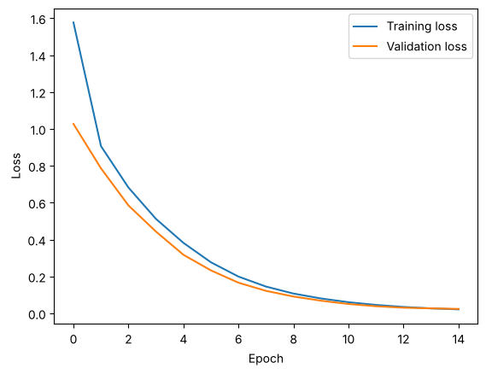

Step 6: Generate and evaluate the output
CODE
def translate(model, X):
dec = np.full((len(X), 1), start_id)
for _ in range(10):
probs = model([X, dec], training=False).numpy()
next_id = probs[:, -1, :].argmax(axis=-1)
dec = np.concatenate([dec, next_id[:, None]], axis=1)
return dec[:, 1:]

def to_text(ids):
return ''.join(inv_out.get(i, '?') for i in ids)

pred = translate(seq2seq, X_test)
print('Exact-match accuracy:', round(np.mean(np.all(pred == y_test, axis=1)), 4))
print('Character accuracy :', round(np.mean(pred == y_test), 4))

test_df = df.iloc[16000:].copy()
test_df['predicted'] = [to_text(p) for p in pred]
test_df['correct'] = test_df['predicted'] == test_df['standard_date']
print(test_df.sample(8, random_state=1))
print(test_df[~test_df['correct']].head(10))
OUTPUT
Exact-match accuracy: 0.963
Character accuracy : 0.9926
invoice_date standard_date predicted correct
16200 23-sep-14 2014-09-23 2014-09-23 True
17078 april 06, 1992 1992-04-06 1992-04-06 True
16610 08.07.04 2004-07-08 2004-07-08 True
18159 march 21, 2022 2022-03-21 2022-03-21 True
17169 21 september 2005 2005-09-21 2005-09-21 True
18448 16 jul 2012 2012-07-16 2012-07-16 True
18938 15-oct-02 2002-10-15 2002-10-15 True
16813 14 july 2026 2026-07-14 2026-07-14 True
invoice_date standard_date predicted correct
16017 11.11.00 2000-11-11 2001-10-11 False
16071 09/07/2020 2020-07-09 2020-09-07 False
16098 sep 06 1993 1993-09-06 1993-06-09 False
16111 01/09/2005 2005-09-01 2005-01-09 False
16153 10 january 2000 2000-01-10 2000-01-11 False
16225 02.01.28 2028-01-02 2028-10-02 False
16263 21.03.22 2022-03-21 2022-03-12 False
16270 01/10/1995 1995-10-01 1995-10-10 False
16281 oct 12 2028 2028-10-12 2028-11-20 False
16328 jan 12 2002 2002-01-12 2002-10-12 False

Step 7: See the bottleneck
CODE
print('Context vector shape:', seq2seq.get_layer('encoder_lstm').output[1].shape)

small = build_seq2seq(16)
small.fit([X_train, y_in_train], y_train, epochs=15, batch_size=128, validation_split=0.1, verbose=0)
small_pred = translate(small, X_test)
print('Exact-match accuracy with 16 units:', round(np.mean(np.all(small_pred == y_test, axis=1)), 4))
OUTPUT
Context vector shape: (None, 64)
Exact-match accuracy with 16 units: 0.2648

Lab 9 Task 1: Own invoice dates
CODE
my_dates = ['15 august 2021', 'mar 03 2015', '25/12/1999', '2018/09/07', '7th sep 2018']
my_true = ['2021-08-15', '2015-03-03', '1999-12-25', '2018-09-07', '2018-09-07']
my_X = pad_sequences([[in_index.get(c, 0) for c in s] for s in my_dates], maxlen=max_in, padding='post')
my_pred = [to_text(p) for p in translate(seq2seq, my_X)]
task1_df = pd.DataFrame({'Invoice date': my_dates, 'Expected': my_true, 'Predicted': my_pred})
task1_df['Correct'] = task1_df['Expected'] == task1_df['Predicted']
task1_df['Format seen in training'] = [True, True, True, False, False]
print(task1_df)
OUTPUT
Invoice date Expected Predicted Correct Format seen in training
0 15 august 2021 2021-08-15 2021-08-15 True True
1 mar 03 2015 2015-03-03 2015-03-03 True True
2 25/12/1999 1999-12-25 1999-12-25 True True
3 2018/09/07 2018-09-07 2007-06-08 False False
4 7th sep 2018 2018-09-07 2018-07-19 False False

The model got the three dates in trained formats right and both dates in unseen formats wrong: '2018/09/07' became 2007-06-08 and '7th sep 2018' became 2018-07-19. In '2018/09/07' the year comes first and is separated by '/', which in training always meant day/month/year, so the model reads the digits in the wrong positions. In '7th sep 2018' the day has one digit and is followed by 'th', which never appeared in training. The model has no rule for these positions, so it places digits in the wrong part of the output. A seq2seq model only generalises to patterns similar to its training data.

Lab 9 Task 2: Effect of the number of units
CODE
unit_results = []
for u in [8, 16, 32, 64, 128]:
m = build_seq2seq(u)
m.fit([X_train, y_in_train], y_train, epochs=15, batch_size=128, validation_split=0.1, verbose=0)
p = translate(m, X_test)
unit_results.append({
'Units': u,
'Context vector size': 2 * u,
'Parameters': m.count_params(),
'Exact-match accuracy': round(float(np.mean(np.all(p == y_test, axis=1))), 4),
'Character accuracy': round(float(np.mean(p == y_test)), 4)
})
units_df = pd.DataFrame(unit_results)
print(units_df)

plt.figure(figsize=(8, 4))
plt.plot(units_df['Units'], units_df['Exact-match accuracy'], marker='o')
plt.xscale('log', base=2)
plt.xticks(units_df['Units'], units_df['Units'])
plt.title('Exact-match Accuracy vs Number of Units')
plt.xlabel('Units')
plt.ylabel('Exact-match accuracy')
plt.grid(True)
plt.show()
OUTPUT
Units Context vector size Parameters Exact-match accuracy \
0 8 16 4373 0.0095
1 16 32 8125 0.3068
2 32 64 18701 0.8265
3 64 128 52141 0.9795
4 128 256 168173 1.0000

Character accuracy
0 0.6647
1 0.8452
2 0.9613
3 0.9958
4 1.0000
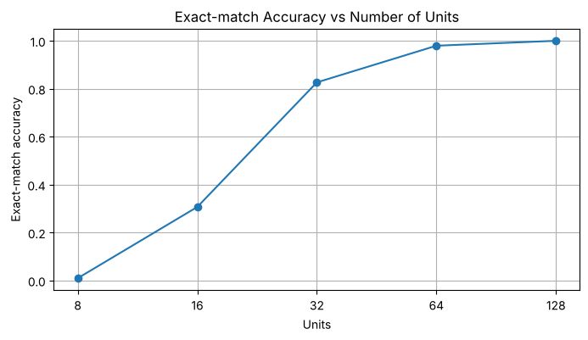

The encoder passes the whole input to the decoder only through state_h and state_c, so the context vector has 2 x units numbers. With 8 units (16 numbers) the vector is far too small and exact-match accuracy is only 0.0095; with 16 units it is 0.3068. Accuracy rises sharply to 0.8265 at 32 units and 0.9795 at 64 units, and then levels off, reaching 1.0 at 128 units, while the parameter count keeps growing roughly with the square of the units (52,141 at 64 units and 168,173 at 128). Beyond 64 units extra capacity gives little gain, which shows that the size of the fixed context vector is the main limit of the plain seq2seq model.

Lab 9 Task 3: Accuracy by input length and format
CODE
def find_format(s):
for f in formats:
try:
datetime.datetime.strptime(s, f)
return f
except ValueError:
pass
return 'unknown'

def error_type(row):
p, t = row['predicted'], row['standard_date']
if p == t:
return 'correct'
if p[:4] == t[:4] and p[5:7] == t[8:10] and p[8:10] == t[5:7]:
return 'day-month swap'
parts = [name for name, a, b in [('year', p[:4], t[:4]), ('month', p[5:7], t[5:7]), ('day', p[8:10], t[8
:10])] if a != b]
return ' + '.join(parts) + ' wrong' if parts else 'separator wrong'

test_df['length'] = test_df['invoice_date'].str.len()
test_df['length_group'] = pd.cut(test_df['length'], bins=[0, 9, 12, 16, 20, 30], labels=['8-9', '10-12', '13
-16', '17-20', '21-28'])
test_df['format'] = test_df['invoice_date'].apply(find_format)
test_df['error_type'] = test_df.apply(error_type, axis=1)

by_length = test_df.groupby('length_group', observed=True)['correct'].agg(['count', 'mean']).rename(columns=
{'count': 'Samples', 'mean': 'Exact-match accuracy'})
print(by_length.round(4))

by_format = test_df.groupby('format')['correct'].agg(['count', 'mean']).rename(columns={'count': 'Samples',
'mean': 'Exact-match accuracy'}).sort_values('Exact-match accuracy')
print(by_format.round(4))

errors = test_df[~test_df['correct']]
print(errors['error_type'].value_counts())
print(errors.groupby('format')['error_type'].agg(lambda s: s.value_counts().index[0]))
OUTPUT
Samples Exact-match accuracy
length_group
8-9 1007 0.9563
10-12 1688 0.9585
13-16 599 0.9649
17-20 261 0.9808
21-28 445 0.9820
Samples Exact-match accuracy
format
%d/%m/%Y 512 0.9258
%d.%m.%y 503 0.9364
%b %d %Y 518 0.9556
%B %d, %Y 466 0.9571
%d-%b-%y 504 0.9762
%A, %d %B %Y 511 0.9824
%d %B %Y 556 0.9838
%d %b %Y 430 0.9884
error_type
day wrong 57
month + day wrong 52
month wrong 29
day-month swap 8
year + month wrong 1
year + day wrong 1
Name: count, dtype: int64
format
%A, %d %B %Y day wrong
%B %d, %Y day wrong
%b %d %Y month + day wrong
%d %B %Y day wrong
%d %b %Y day wrong
%d-%b-%y day wrong
%d.%m.%y month wrong
%d/%m/%Y month + day wrong
Name: error_type, dtype: str

The numeric formats cause the most errors: '%d/%m/%Y' (0.9258) and '%d.%m.%y' (0.9364) are the two least accurate, because the day and the month are both two digits and only their position separates them. The most common error type is a wrong day (57 errors), followed by month and day both wrong (52) and month wrong (29); clean day-month swaps are rare (8). So the model usually knows which digits appear but puts some of them in the wrong place. Formats with a month name are easier, because the month is identified by letters that cannot be confused with the day. Longer inputs are not harder here: the 21-28 character group (long month and weekday names) is the most accurate (0.982) and the short 8-9 character group, which is mostly numeric dates, is the least accurate (0.9563).

Lab 9 Task 4: Business estimate
CODE
best_acc = max(units_df['Exact-match accuracy'].max(), float(np.mean(np.all(pred == y_test, axis=1))))
monthly_invoices = 10000
wrong_per_month = round(monthly_invoices * (1 - best_acc))
print('Best exact-match accuracy :', round(best_acc, 4))
print('Expected wrong dates/month:', wrong_per_month, 'out of', monthly_invoices)
OUTPUT
Best exact-match accuracy : 1.0
Expected wrong dates/month: 0 out of 10000

The best model (128 units) got all 4,000 test dates right, so the estimate is 0 wrong dates per month out of 10,000. This figure is too optimistic for real use: the test data contains only the same 8 formats used in training, and Task 1 showed that the model fails on formats it has not seen, such as '2018/09/07' and '7th sep 2018'. A wrong date can cause late payments, wrong due dates and errors in period-end reporting, so full automation is still not safe. The recommended approach is to use the model with human review: dates that fail a validity check, are numeric with a day value of 12 or less (where day and month could be swapped), or come in a new supplier format should go to an accounts-payable clerk. This removes most of the manual work while keeping control over the risky cases.

Lab Assignment 3: Amounts in words to digits

Task 1: Task description and example pairs
CODE
random.seed(3)
np.random.seed(3)
tf.random.set_seed(3)

ones = ['zero', 'one', 'two', 'three', 'four', 'five', 'six', 'seven', 'eight', 'nine', 'ten',
'eleven', 'twelve', 'thirteen', 'fourteen', 'fifteen', 'sixteen', 'seventeen', 'eighteen', 'nineteen
']
tens = ['', '', 'twenty', 'thirty', 'forty', 'fifty', 'sixty', 'seventy', 'eighty', 'ninety']

def below_thousand(n, use_and):
parts = []
if n >= 100:
parts += [ones[n // 100], 'hundred']
n %= 100
if n and use_and:
parts.append('and')
if n >= 20:
parts.append(tens[n // 10])
n %= 10
if n:
parts.append(ones[n])
elif n > 0:
parts.append(ones[n])
return parts

def number_to_words(n):
use_and = random.random() < 0.3
parts = []
if n >= 1000:
parts += below_thousand(n // 1000, use_and) + ['thousand']
n %= 1000
if n:
parts += below_thousand(n, use_and)
return ' '.join(parts)

numbers = random.sample(range(1, 10000), 3000) + random.sample(range(10000, 1000000), 9000)
random.shuffle(numbers)
amount_df = pd.DataFrame({'amount_words': [number_to_words(n) for n in numbers], 'amount_digits': [str(n) fo
r n in numbers]})
print(amount_df.head(10).to_string())
print(len(amount_df), 'pairs')
print(amount_df['amount_words'].str.len().describe())
OUTPUT
amount_words amount_digits
0 twenty six thousand seven hundred four 26704
1 nine hundred sixty one thousand two hundred fifty five 961255
2 three hundred fifty seven thousand two hundred seventy six 357276
3 nine hundred thirty five thousand five hundred seventy eight 935578
4 five hundred and eighty four thousand eight hundred and ninety three 584893
5 nine hundred fifty three thousand forty one 953041
6 one thousand twenty four 1024
7 four thousand six hundred and seventy six 4676
8 two hundred and twelve thousand eight hundred and four 212804
9 five hundred twenty six thousand eight hundred seventy nine 526879
12000 pairs
count 12000.000000
mean 49.318250
std 11.410185
min 3.000000
25% 40.000000
50% 52.000000
75% 58.000000
max 71.000000
Name: amount_words, dtype: float64

Cheques, invoices and contracts often write amounts in words ("two thousand five hundred"), and finance teams must convert them into digits before they can be checked against the amount written in figures or entered into the accounting system. A rule-based converter must handle every word for units, teens, tens, hundreds and thousands, optional words such as "and", different spellings and spacing, and the place value that each word implies. Every new variation needs new rules and new exceptions, so the code becomes long and fragile. A seq2seq model learns these place-value rules directly from examples and can be retrained when new patterns appear.

Task 2: Encoder input, decoder input and decoder target
CODE
a_out_len = 7
a_in_chars = sorted(set(''.join(amount_df['amount_words'])))
a_out_chars = sorted(set('0123456789$'))
a_in_index = {c: i + 1 for i, c in enumerate(a_in_chars)}
a_out_index = {c: i + 1 for i, c in enumerate(a_out_chars)}
a_inv_out = {i: c for c, i in a_out_index.items()}
a_start = len(a_out_chars) + 1
a_in_vocab = len(a_in_chars) + 1
a_out_vocab = len(a_out_chars) + 2
a_max_in = int(amount_df['amount_words'].str.len().max()) + 2

a_X = pad_sequences([[a_in_index[c] for c in s] for s in amount_df['amount_words']], maxlen=a_max_in, paddin
g='post')
a_targets = [s + '$' * (a_out_len - len(s)) for s in amount_df['amount_digits']]
a_y = np.array([[a_out_index[c] for c in s] for s in a_targets])
a_y_in = np.concatenate([np.full((len(a_y), 1), a_start), a_y[:, :-1]], axis=1)

a_X_train, a_X_test = a_X[:10000], a_X[10000:]
a_y_train, a_y_test = a_y[:10000], a_y[10000:]
a_y_in_train, a_y_in_test = a_y_in[:10000], a_y_in[10000:]

print('Input vocabulary :', a_in_vocab)
print('Output vocabulary:', a_out_vocab)
print('Encoder input :', a_X_train.shape)
print('Decoder input :', a_y_in_train.shape)
print('Decoder target :', a_y_train.shape)
print(amount_df['amount_digits'].iloc[0], a_targets[0])
print(a_y[0])
print(a_y_in[0])
OUTPUT
Input vocabulary : 20
Output vocabulary: 13
Encoder input : (10000, 73)
Decoder input : (10000, 7)
Decoder target : (10000, 7)
26704 26704$$
[4 8 9 2 6 1 1]
[12 4 8 9 2 6 1]

Task 3: Build and train the encoder-decoder LSTM
CODE
def build_amount_model(units):
enc_input = Input(shape=(a_max_in,), name='encoder_input')
enc_emb = Embedding(a_in_vocab, 32, mask_zero=True, name='encoder_embedding')(enc_input)
_, state_h, state_c = LSTM(units, return_state=True, name='encoder_lstm')(enc_emb)
dec_input = Input(shape=(None,), name='decoder_input')
dec_emb = Embedding(a_out_vocab, 32, name='decoder_embedding')(dec_input)
dec_seq, _, _ = LSTM(units, return_sequences=True, return_state=True, name='decoder_lstm')(dec_emb, init
ial_state=[state_h, state_c])
output = Dense(a_out_vocab, activation='softmax', name='output')(dec_seq)
model = Model([enc_input, dec_input], output)
model.compile(optimizer='adam', loss='sparse_categorical_crossentropy', metrics=['accuracy'])
return model

def translate_amount(model, X):
dec = np.full((len(X), 1), a_start)
for _ in range(a_out_len):
probs = model([X, dec], training=False).numpy()
dec = np.concatenate([dec, probs[:, -1, :].argmax(axis=-1)[:, None]], axis=1)
return dec[:, 1:]

def amount_text(ids):
return ''.join(a_inv_out.get(i, '?') for i in ids).replace('$', '')

amount_model = build_amount_model(128)
amount_model.summary()
amount_history = amount_model.fit([a_X_train, a_y_in_train], a_y_train, epochs=30, batch_size=128, validatio
n_split=0.1, verbose=2)

plt.figure(figsize=(10, 4))
plt.subplot(1, 2, 1)
plt.plot(amount_history.history['loss'], label='Training loss')
plt.plot(amount_history.history['val_loss'], label='Validation loss')
plt.xlabel('Epoch')
plt.ylabel('Loss')
plt.legend()
plt.subplot(1, 2, 2)
plt.plot(amount_history.history['accuracy'], label='Training accuracy')
plt.plot(amount_history.history['val_accuracy'], label='Validation accuracy')
plt.xlabel('Epoch')
plt.ylabel('Accuracy')
plt.legend()
plt.tight_layout()
plt.show()
OUTPUT
Model: "functional_7"
+---------------------+-------------------+------------+-------------------+
| Layer (type) | Output Shape | Param # | Connected to |
+---------------------+-------------------+------------+-------------------+
| encoder_input | (None, 73) | 0 | - |
| (InputLayer) | | | |
+---------------------+-------------------+------------+-------------------+
| decoder_input | (None, None) | 0 | - |
| (InputLayer) | | | |
+---------------------+-------------------+------------+-------------------+
| encoder_embedding | (None, 73, 32) | 640 | encoder_input[0]? |
| (Embedding) | | | |
+---------------------+-------------------+------------+-------------------+
| not_equal_7 | (None, 73) | 0 | encoder_input[0]? |
| (NotEqual) | | | |
+---------------------+-------------------+------------+-------------------+
| decoder_embedding | (None, None, 32) | 416 | decoder_input[0]? |
| (Embedding) | | | |
+---------------------+-------------------+------------+-------------------+
| encoder_lstm (LSTM) | [(None, 128), | 82,432 | encoder_embeddin? |
| | (None, 128), | | not_equal_7[0][0] |
| | (None, 128)] | | |
+---------------------+-------------------+------------+-------------------+
| decoder_lstm (LSTM) | [(None, None, | 82,432 | decoder_embeddin? |
| | 128), (None, | | encoder_lstm[0][? |
| | 128), (None, | | encoder_lstm[0][? |
| | 128)] | | |
+---------------------+-------------------+------------+-------------------+
| output (Dense) | (None, None, 13) | 1,677 | decoder_lstm[0][? |
+---------------------+-------------------+------------+-------------------+
Total params: 167,597 (654.68 KB)
Trainable params: 167,597 (654.68 KB)
Non-trainable params: 0 (0.00 B)
Epoch 1/30
71/71 - 17s - 233ms/step - accuracy: 0.2738 - loss: 2.0536 - val_accuracy: 0.2916 - val_loss: 1.9109
Epoch 2/30
71/71 - 10s - 145ms/step - accuracy: 0.3136 - loss: 1.8207 - val_accuracy: 0.3231 - val_loss: 1.7663
Epoch 3/30
71/71 - 11s - 151ms/step - accuracy: 0.3506 - loss: 1.7136 - val_accuracy: 0.3770 - val_loss: 1.6441
Epoch 4/30
71/71 - 10s - 146ms/step - accuracy: 0.4198 - loss: 1.5616 - val_accuracy: 0.4719 - val_loss: 1.4519
Epoch 5/30
71/71 - 11s - 149ms/step - accuracy: 0.5051 - loss: 1.3532 - val_accuracy: 0.5571 - val_loss: 1.2225
Epoch 6/30
71/71 - 11s - 154ms/step - accuracy: 0.5977 - loss: 1.1049 - val_accuracy: 0.6440 - val_loss: 0.9949
Epoch 7/30
71/71 - 11s - 149ms/step - accuracy: 0.6969 - loss: 0.8643 - val_accuracy: 0.7444 - val_loss: 0.7610
Epoch 8/30
71/71 - 11s - 156ms/step - accuracy: 0.7843 - loss: 0.6575 - val_accuracy: 0.8226 - val_loss: 0.5659
Epoch 9/30
71/71 - 10s - 148ms/step - accuracy: 0.8402 - loss: 0.5113 - val_accuracy: 0.8721 - val_loss: 0.4398
Epoch 10/30
71/71 - 11s - 150ms/step - accuracy: 0.8934 - loss: 0.3798 - val_accuracy: 0.9047 - val_loss: 0.3353
Epoch 11/30
71/71 - 10s - 145ms/step - accuracy: 0.9230 - loss: 0.2940 - val_accuracy: 0.9253 - val_loss: 0.2729
Epoch 12/30
71/71 - 10s - 139ms/step - accuracy: 0.9430 - loss: 0.2342 - val_accuracy: 0.9543 - val_loss: 0.2047
Epoch 13/30
71/71 - 10s - 143ms/step - accuracy: 0.9615 - loss: 0.1809 - val_accuracy: 0.9563 - val_loss: 0.1843
Epoch 14/30
71/71 - 11s - 149ms/step - accuracy: 0.9721 - loss: 0.1445 - val_accuracy: 0.9660 - val_loss: 0.1527
Epoch 15/30
71/71 - 10s - 146ms/step - accuracy: 0.9781 - loss: 0.1208 - val_accuracy: 0.9776 - val_loss: 0.1201
Epoch 16/30
71/71 - 11s - 149ms/step - accuracy: 0.9817 - loss: 0.1035 - val_accuracy: 0.9866 - val_loss: 0.0880
Epoch 17/30
71/71 - 11s - 158ms/step - accuracy: 0.9896 - loss: 0.0792 - val_accuracy: 0.9904 - val_loss: 0.0754
Epoch 18/30
71/71 - 11s - 149ms/step - accuracy: 0.9921 - loss: 0.0662 - val_accuracy: 0.9914 - val_loss: 0.0652
Epoch 19/30
71/71 - 10s - 147ms/step - accuracy: 0.9943 - loss: 0.0565 - val_accuracy: 0.9914 - val_loss: 0.0568
Epoch 20/30
71/71 - 10s - 145ms/step - accuracy: 0.9968 - loss: 0.0456 - val_accuracy: 0.9937 - val_loss: 0.0466
Epoch 21/30
71/71 - 10s - 144ms/step - accuracy: 0.9976 - loss: 0.0390 - val_accuracy: 0.9956 - val_loss: 0.0388
Epoch 22/30
71/71 - 10s - 144ms/step - accuracy: 0.9979 - loss: 0.0340 - val_accuracy: 0.9966 - val_loss: 0.0340
Epoch 23/30
71/71 - 10s - 142ms/step - accuracy: 0.9985 - loss: 0.0294 - val_accuracy: 0.9967 - val_loss: 0.0305
Epoch 24/30
71/71 - 10s - 141ms/step - accuracy: 0.9989 - loss: 0.0257 - val_accuracy: 0.9939 - val_loss: 0.0360
Epoch 25/30
71/71 - 10s - 144ms/step - accuracy: 0.9989 - loss: 0.0239 - val_accuracy: 0.9911 - val_loss: 0.0422
Epoch 26/30
71/71 - 10s - 145ms/step - accuracy: 0.9985 - loss: 0.0243 - val_accuracy: 0.9936 - val_loss: 0.0360
Epoch 27/30
71/71 - 10s - 144ms/step - accuracy: 0.9993 - loss: 0.0192 - val_accuracy: 0.9990 - val_loss: 0.0196
Epoch 28/30
71/71 - 10s - 138ms/step - accuracy: 0.9997 - loss: 0.0147 - val_accuracy: 0.9983 - val_loss: 0.0185
Epoch 29/30
71/71 - 10s - 140ms/step - accuracy: 0.9999 - loss: 0.0125 - val_accuracy: 0.9989 - val_loss: 0.0164
Epoch 30/30
71/71 - 10s - 140ms/step - accuracy: 0.9999 - loss: 0.0113 - val_accuracy: 0.9991 - val_loss: 0.0147
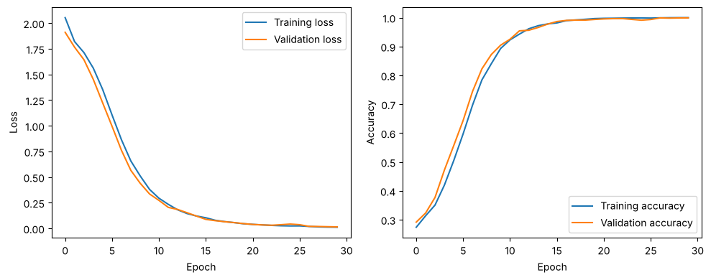

- encoder_input: receives the amount in words as a padded sequence of character ids.
- encoder_embedding: turns every character id into a 32-number vector; mask_zero=True makes the LSTM skip the padding.
- encoder_lstm: reads the characters one by one and keeps only its final hidden state and cell state, which together form the context vector that summarises the whole amount.
- decoder_input: receives the start token followed by the correct previous digits (teacher forcing).
- decoder_embedding: turns every output id into a 32-number vector.
- decoder_lstm: starts from the context vector and produces one hidden state for each of the 7 output positions.
- output (Dense + softmax): gives a probability for each of the 13 output symbols (digits, the end/padding symbol '$', padding id and start token) at every position.

Task 4: Exact-match and character accuracy
CODE
a_pred = translate_amount(amount_model, a_X_test)
print('Exact-match accuracy:', round(float(np.mean(np.all(a_pred == a_y_test, axis=1))), 4))
print('Character accuracy :', round(float(np.mean(a_pred == a_y_test)), 4))

amount_test = amount_df.iloc[10000:].copy()
amount_test['predicted'] = [amount_text(p) for p in a_pred]
amount_test['correct'] = amount_test['predicted'] == amount_test['amount_digits']
print(amount_test.sample(10, random_state=1).to_string())
print(amount_test[~amount_test['correct']].head(10).to_string())
OUTPUT
Exact-match accuracy: 0.995
Character accuracy : 0.9986
amount_words amount_digits predicted correct
10674 nine hundred twenty thousand three hundred twenty one 920321 920321 True
11699 nine hundred thirty four thousand seven hundred thirty eight 934738 934738 True
11282 six hundred and sixty five 665 665 True
11315 six hundred and sixty six thousand seven hundred and fifty three 666753 666753 True
11210 two hundred sixty one thousand six hundred three 261603 261603 True
11636 seventy seven thousand nine hundred sixty eight 77968 77968 True
10613 one thousand two hundred twenty one 1221 1221 True
10447 two hundred seventy thousand one hundred forty three 270143 270143 True
11131 seven hundred sixty one thousand four hundred twenty 761420 761420 True
10808 nine thousand three hundred twenty five 9325 9325 True
amount_words amount_digits predicted correct
10128 three hundred and ninety thousand two hundred and seven 390207 390217 False
10466 eight hundred and thirty eight thousand forty nine 838049 883049 False
10486 sixty eight thousand nineteen 68019 68091 False
11077 four hundred twenty thousand four 420004 4200004 False
11138 nine hundred and fifty two thousand sixteen 952016 952007 False
11412 thirty two 32 302 False
11439 five hundred and six thousand nine hundred and thirty two 506932 506923 False
11562 one hundred thirty three thousand three hundred sixty 133360 133306 False
11798 three thousand seventeen 3017 3071 False
11803 one hundred thousand twenty two 100022 100202 False

Task 5: Size of the context vector
CODE
amount_units = []
for u in [32, 64, 128, 256]:
if u == 128:
p = a_pred
params = amount_model.count_params()
else:
m = build_amount_model(u)
m.fit([a_X_train, a_y_in_train], a_y_train, epochs=30, batch_size=128, validation_split=0.1, verbose
=0)
p = translate_amount(m, a_X_test)
params = m.count_params()
amount_units.append({
'Units': u,
'Context vector size': 2 * u,
'Parameters': params,
'Exact-match accuracy': round(float(np.mean(np.all(p == a_y_test, axis=1))), 4),
'Character accuracy': round(float(np.mean(p == a_y_test)), 4)
})
amount_units_df = pd.DataFrame(amount_units)
print(amount_units_df)

plt.figure(figsize=(8, 4))
plt.plot(amount_units_df['Units'], amount_units_df['Exact-match accuracy'], marker='o', label='Exact-match')
plt.plot(amount_units_df['Units'], amount_units_df['Character accuracy'], marker='s', label='Character')
plt.xscale('log', base=2)
plt.xticks(amount_units_df['Units'], amount_units_df['Units'])
plt.xlabel('Units')
plt.ylabel('Accuracy')
plt.title('Amount Conversion: Effect of Context Vector Size')
plt.legend()
plt.grid(True)
plt.show()
OUTPUT
Units Context vector size Parameters Exact-match accuracy \
0 32 64 18125 0.4000
1 64 128 51565 0.7630
2 128 256 167597 0.9950
3 256 512 596269 0.9965

Character accuracy
0 0.7215
1 0.9176
2 0.9986
3 0.9991
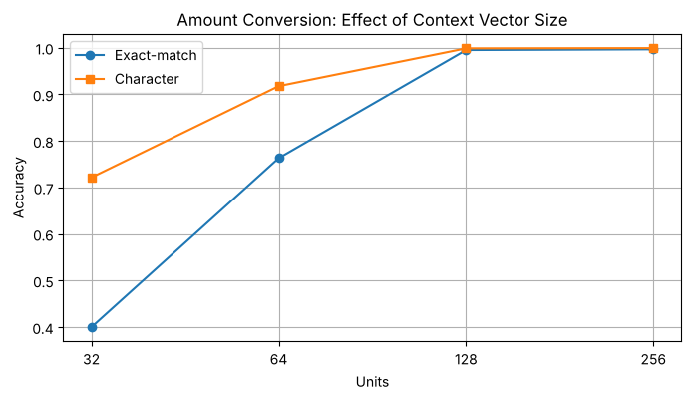

Task 6: Conclusion
A finance department can use this model to read the amount in words on cheques, invoices, purchase orders and contracts and convert it into digits automatically. The converted value can then be compared with the amount written in figures, so that any mismatch is flagged before payment, which is a standard control against fraud and data-entry mistakes. The model removes repetitive manual typing and can be retrained when new wording appears, without rewriting rules.
The risk of a wrong output is high, because an amount with one wrong, swapped or extra digit can be far from the true value; for example the model turned 420004 into 4200004 and 32 into 302. The experiments show that a larger context vector strongly improves exact-match accuracy, from 0.40 at 32 units and 0.763 at 64 units to 0.995 at 128 units, after which it levels off (0.9965 at 256 units) while the parameters grow from about 168,000 to 596,000. Even the best model still makes a few errors, mostly swapped or misplaced digits. For this reason the model should not post payments by itself: every converted amount should be checked against the figure written in digits, and any mismatch or unusual amount should be sent to a person for approval. Used this way, the model saves time while the business keeps control over financial risk.

Lab 10: Seq2Seq with Attention vs without Attention

Step 1: Compute attention by hand
CODE
import numpy as np

words = ['the', 'delivery', 'was', 'very', 'late']
encoder_states = np.array([
[0.1, 0.0, 0.2],
[0.9, 0.1, 0.3],
[0.0, 0.1, 0.1],
[0.2, 0.6, 0.1],
[0.8, 0.9, 0.2]
])
decoder_state = np.array([1.0, 1.0, 0.0])

scores = encoder_states @ decoder_state
weights = np.exp(scores) / np.exp(scores).sum()
context = weights @ encoder_states
for w, s, a in zip(words, scores, weights):
print(f'{w:10s} score={s:.2f} weight={a:.2f}')
print('Context vector:', context.round(3))
OUTPUT
the score=0.10 weight=0.09
delivery score=1.00 weight=0.22
was score=0.10 weight=0.09
very score=0.80 weight=0.18
late score=1.70 weight=0.43
Context vector: [0.585 0.526 0.195]

Step 2: Import libraries and recreate the data
CODE
import time
import random
import datetime
import pandas as pd
import matplotlib.pyplot as plt
import tensorflow as tf
from tensorflow.keras.models import Model
from tensorflow.keras.layers import Input, Embedding, LSTM, Dense, Attention, Concatenate
from tensorflow.keras.preprocessing.sequence import pad_sequences

random.seed(42)
np.random.seed(42)
tf.random.set_seed(42)

formats = ['%d %B %Y', '%d %b %Y', '%B %d, %Y', '%d/%m/%Y', '%d.%m.%y', '%A, %d %B %Y', '%b %d %Y', '%d-%b-%
y']

def random_date():
d = datetime.date(1990, 1, 1) + datetime.timedelta(days=random.randint(0, 14600))
return d.strftime(random.choice(formats)).lower(), d.isoformat()

df = pd.DataFrame([random_date() for _ in range(20000)], columns=['invoice_date', 'standard_date'])

in_chars = sorted(set(''.join(df['invoice_date'])))
out_chars = sorted(set(''.join(df['standard_date'])))
in_index = {c: i + 1 for i, c in enumerate(in_chars)}
out_index = {c: i + 1 for i, c in enumerate(out_chars)}
inv_out = {i: c for c, i in out_index.items()}
start_id = len(out_chars) + 1
in_vocab = len(in_chars) + 1
out_vocab = len(out_chars) + 2

max_in = 30
X = pad_sequences([[in_index[c] for c in s] for s in df['invoice_date']], maxlen=max_in, padding='post')
y = np.array([[out_index[c] for c in s] for s in df['standard_date']])
y_in = np.concatenate([np.full((len(y), 1), start_id), y[:, :-1]], axis=1)

X_train, X_test = X[:16000], X[16000:]
y_train, y_test = y[:16000], y[16000:]
y_in_train, y_in_test = y_in[:16000], y_in[16000:]

def translate(model, X):
dec = np.full((len(X), 1), start_id)
for _ in range(10):
probs = model([X, dec], training=False).numpy()
next_id = probs[:, -1, :].argmax(axis=-1)
dec = np.concatenate([dec, next_id[:, None]], axis=1)
return dec[:, 1:]

def to_text(ids):
return ''.join(inv_out.get(i, '?') for i in ids)

Step 3: Define one function for both models
CODE
units = 32

def build_model(use_attention):
enc_input = Input(shape=(max_in,), name='encoder_input')
enc_emb = Embedding(in_vocab, 32, mask_zero=True)(enc_input)
enc_seq, state_h, state_c = LSTM(units, return_sequences=True, return_state=True, name='encoder_lstm')(e
nc_emb)
dec_input = Input(shape=(None,), name='decoder_input')
dec_emb = Embedding(out_vocab, 32)(dec_input)
dec_seq, _, _ = LSTM(units, return_sequences=True, return_state=True, name='decoder_lstm')(dec_emb, init
ial_state=[state_h, state_c])
score_model = None
if use_attention:
context, scores = Attention(name='attention')([dec_seq, enc_seq], return_attention_scores=True)
dec_seq = Concatenate(name='concat')([dec_seq, context])
score_model = Model([enc_input, dec_input], scores)
output = Dense(out_vocab, activation='softmax', name='output')(dec_seq)
model = Model([enc_input, dec_input], output)
model.compile(optimizer='adam', loss='sparse_categorical_crossentropy', metrics=['accuracy'])
return model, score_model

base_model, _ = build_model(use_attention=False)
attn_model, score_model = build_model(use_attention=True)
base_model.summary()
attn_model.summary()
OUTPUT
Model: "functional_11"
+---------------------+-------------------+------------+-------------------+
| Layer (type) | Output Shape | Param # | Connected to |
+---------------------+-------------------+------------+-------------------+
| encoder_input | (None, 30) | 0 | - |
| (InputLayer) | | | |
+---------------------+-------------------+------------+-------------------+
| decoder_input | (None, None) | 0 | - |
| (InputLayer) | | | |
+---------------------+-------------------+------------+-------------------+
| embedding_14 | (None, 30, 32) | 1,216 | encoder_input[0]? |
| (Embedding) | | | |
+---------------------+-------------------+------------+-------------------+
| not_equal_11 | (None, 30) | 0 | encoder_input[0]? |
| (NotEqual) | | | |
+---------------------+-------------------+------------+-------------------+
| embedding_15 | (None, None, 32) | 416 | decoder_input[0]? |
| (Embedding) | | | |
+---------------------+-------------------+------------+-------------------+
| encoder_lstm (LSTM) | [(None, 30, 32), | 8,320 | embedding_14[0][? |
| | (None, 32), | | not_equal_11[0][? |
| | (None, 32)] | | |
+---------------------+-------------------+------------+-------------------+
| decoder_lstm (LSTM) | [(None, None, | 8,320 | embedding_15[0][? |
| | 32), (None, 32), | | encoder_lstm[0][? |
| | (None, 32)] | | encoder_lstm[0][? |
+---------------------+-------------------+------------+-------------------+
| output (Dense) | (None, None, 13) | 429 | decoder_lstm[0][? |
+---------------------+-------------------+------------+-------------------+
Total params: 18,701 (73.05 KB)
Trainable params: 18,701 (73.05 KB)
Non-trainable params: 0 (0.00 B)
Model: "functional_13"
+---------------------+-------------------+------------+-------------------+
| Layer (type) | Output Shape | Param # | Connected to |
+---------------------+-------------------+------------+-------------------+
| encoder_input | (None, 30) | 0 | - |
| (InputLayer) | | | |
+---------------------+-------------------+------------+-------------------+
| decoder_input | (None, None) | 0 | - |
| (InputLayer) | | | |
+---------------------+-------------------+------------+-------------------+
| embedding_16 | (None, 30, 32) | 1,216 | encoder_input[0]? |
| (Embedding) | | | |
+---------------------+-------------------+------------+-------------------+
| not_equal_12 | (None, 30) | 0 | encoder_input[0]? |
| (NotEqual) | | | |
+---------------------+-------------------+------------+-------------------+
| embedding_17 | (None, None, 32) | 416 | decoder_input[0]? |
| (Embedding) | | | |
+---------------------+-------------------+------------+-------------------+
| encoder_lstm (LSTM) | [(None, 30, 32), | 8,320 | embedding_16[0][? |
| | (None, 32), | | not_equal_12[0][? |
| | (None, 32)] | | |
+---------------------+-------------------+------------+-------------------+
| decoder_lstm (LSTM) | [(None, None, | 8,320 | embedding_17[0][? |
| | 32), (None, 32), | | encoder_lstm[0][? |
| | (None, 32)] | | encoder_lstm[0][? |
+---------------------+-------------------+------------+-------------------+
| attention | [(None, None, | 0 | decoder_lstm[0][? |
| (Attention) | 32), (None, None, | | encoder_lstm[0][? |
| | 30)] | | |
+---------------------+-------------------+------------+-------------------+
| concat | (None, None, 64) | 0 | decoder_lstm[0][? |
| (Concatenate) | | | attention[0][0] |
+---------------------+-------------------+------------+-------------------+
| output (Dense) | (None, None, 13) | 845 | concat[0][0] |
+---------------------+-------------------+------------+-------------------+
Total params: 19,117 (74.68 KB)
Trainable params: 19,117 (74.68 KB)
Non-trainable params: 0 (0.00 B)

Step 4: Train both models
CODE
def train(model):
start = time.time()
history = model.fit(
[X_train, y_in_train], y_train,
epochs=20, batch_size=128,
validation_split=0.1, verbose=2
)
return history, time.time() - start

base_history, base_time = train(base_model)
attn_history, attn_time = train(attn_model)
OUTPUT
Epoch 1/20
113/113 - 10s - 86ms/step - accuracy: 0.4889 - loss: 1.7262 - val_accuracy: 0.5984 - val_loss: 1.1915
Epoch 2/20
113/113 - 4s - 33ms/step - accuracy: 0.6576 - loss: 0.9999 - val_accuracy: 0.7094 - val_loss: 0.8444
Epoch 3/20
113/113 - 4s - 32ms/step - accuracy: 0.7557 - loss: 0.7372 - val_accuracy: 0.7936 - val_loss: 0.6416
Epoch 4/20
113/113 - 4s - 36ms/step - accuracy: 0.8168 - loss: 0.5794 - val_accuracy: 0.8350 - val_loss: 0.5231
Epoch 5/20
113/113 - 4s - 33ms/step - accuracy: 0.8525 - loss: 0.4788 - val_accuracy: 0.8660 - val_loss: 0.4374
Epoch 6/20
113/113 - 3s - 30ms/step - accuracy: 0.8777 - loss: 0.4055 - val_accuracy: 0.8913 - val_loss: 0.3711
Epoch 7/20
113/113 - 4s - 32ms/step - accuracy: 0.8991 - loss: 0.3436 - val_accuracy: 0.9059 - val_loss: 0.3181
Epoch 8/20
113/113 - 4s - 33ms/step - accuracy: 0.9130 - loss: 0.2972 - val_accuracy: 0.9176 - val_loss: 0.2771
Epoch 9/20
113/113 - 4s - 34ms/step - accuracy: 0.9262 - loss: 0.2564 - val_accuracy: 0.9304 - val_loss: 0.2366
Epoch 10/20
113/113 - 4s - 37ms/step - accuracy: 0.9376 - loss: 0.2204 - val_accuracy: 0.9432 - val_loss: 0.2011
Epoch 11/20
113/113 - 4s - 34ms/step - accuracy: 0.9475 - loss: 0.1878 - val_accuracy: 0.9546 - val_loss: 0.1711
Epoch 12/20
113/113 - 4s - 34ms/step - accuracy: 0.9567 - loss: 0.1601 - val_accuracy: 0.9631 - val_loss: 0.1451
Epoch 13/20
113/113 - 4s - 35ms/step - accuracy: 0.9646 - loss: 0.1363 - val_accuracy: 0.9693 - val_loss: 0.1235
Epoch 14/20
113/113 - 4s - 35ms/step - accuracy: 0.9717 - loss: 0.1161 - val_accuracy: 0.9745 - val_loss: 0.1055
Epoch 15/20
113/113 - 4s - 36ms/step - accuracy: 0.9771 - loss: 0.0992 - val_accuracy: 0.9785 - val_loss: 0.0913
Epoch 16/20
113/113 - 4s - 36ms/step - accuracy: 0.9813 - loss: 0.0853 - val_accuracy: 0.9811 - val_loss: 0.0798
Epoch 17/20
113/113 - 4s - 39ms/step - accuracy: 0.9849 - loss: 0.0733 - val_accuracy: 0.9840 - val_loss: 0.0722
Epoch 18/20
113/113 - 4s - 33ms/step - accuracy: 0.9878 - loss: 0.0637 - val_accuracy: 0.9789 - val_loss: 0.0770
Epoch 19/20
113/113 - 4s - 31ms/step - accuracy: 0.9898 - loss: 0.0560 - val_accuracy: 0.9872 - val_loss: 0.0595
Epoch 20/20
113/113 - 4s - 34ms/step - accuracy: 0.9895 - loss: 0.0535 - val_accuracy: 0.9916 - val_loss: 0.0452
Epoch 1/20
113/113 - 9s - 84ms/step - accuracy: 0.4423 - loss: 1.7647 - val_accuracy: 0.5983 - val_loss: 1.1762
Epoch 2/20
113/113 - 4s - 38ms/step - accuracy: 0.6752 - loss: 0.9499 - val_accuracy: 0.7420 - val_loss: 0.7754
Epoch 3/20
113/113 - 5s - 40ms/step - accuracy: 0.8093 - loss: 0.6437 - val_accuracy: 0.8599 - val_loss: 0.5237
Epoch 4/20
113/113 - 4s - 40ms/step - accuracy: 0.8961 - loss: 0.4119 - val_accuracy: 0.9305 - val_loss: 0.3068
Epoch 5/20
113/113 - 4s - 35ms/step - accuracy: 0.9552 - loss: 0.2249 - val_accuracy: 0.9755 - val_loss: 0.1550
Epoch 6/20
113/113 - 4s - 37ms/step - accuracy: 0.9842 - loss: 0.1109 - val_accuracy: 0.9906 - val_loss: 0.0799
Epoch 7/20
113/113 - 4s - 35ms/step - accuracy: 0.9941 - loss: 0.0608 - val_accuracy: 0.9962 - val_loss: 0.0472
Epoch 8/20
113/113 - 4s - 35ms/step - accuracy: 0.9978 - loss: 0.0374 - val_accuracy: 0.9984 - val_loss: 0.0304
Epoch 9/20
113/113 - 4s - 35ms/step - accuracy: 0.9991 - loss: 0.0250 - val_accuracy: 0.9993 - val_loss: 0.0212
Epoch 10/20
113/113 - 4s - 36ms/step - accuracy: 0.9996 - loss: 0.0178 - val_accuracy: 0.9998 - val_loss: 0.0154
Epoch 11/20
113/113 - 4s - 38ms/step - accuracy: 0.9998 - loss: 0.0133 - val_accuracy: 1.0000 - val_loss: 0.0117
Epoch 12/20
113/113 - 4s - 33ms/step - accuracy: 0.9998 - loss: 0.0103 - val_accuracy: 1.0000 - val_loss: 0.0092
Epoch 13/20
113/113 - 4s - 35ms/step - accuracy: 0.9999 - loss: 0.0082 - val_accuracy: 1.0000 - val_loss: 0.0074
Epoch 14/20
113/113 - 4s - 38ms/step - accuracy: 1.0000 - loss: 0.0066 - val_accuracy: 1.0000 - val_loss: 0.0060
Epoch 15/20
113/113 - 4s - 38ms/step - accuracy: 1.0000 - loss: 0.0054 - val_accuracy: 1.0000 - val_loss: 0.0050
Epoch 16/20
113/113 - 4s - 37ms/step - accuracy: 1.0000 - loss: 0.0045 - val_accuracy: 1.0000 - val_loss: 0.0042
Epoch 17/20
113/113 - 5s - 42ms/step - accuracy: 1.0000 - loss: 0.0038 - val_accuracy: 1.0000 - val_loss: 0.0036
Epoch 18/20
113/113 - 4s - 38ms/step - accuracy: 1.0000 - loss: 0.0033 - val_accuracy: 1.0000 - val_loss: 0.0031
Epoch 19/20
113/113 - 4s - 35ms/step - accuracy: 1.0000 - loss: 0.0028 - val_accuracy: 1.0000 - val_loss: 0.0027
Epoch 20/20
113/113 - 4s - 39ms/step - accuracy: 1.0000 - loss: 0.0025 - val_accuracy: 1.0000 - val_loss: 0.0023

Step 5: Compare the results
CODE
base_pred = translate(base_model, X_test)
attn_pred = translate(attn_model, X_test)

results = pd.DataFrame({
'Model': ['Seq2Seq', 'Seq2Seq + Attention'],
'Parameters': [base_model.count_params(), attn_model.count_params()],
'Exact-match accuracy': [np.mean(np.all(base_pred == y_test, axis=1)).round(4), np.mean(np.all(attn_pred
== y_test, axis=1)).round(4)],
'Character accuracy': [np.mean(base_pred == y_test).round(4), np.mean(attn_pred == y_test).round(4)],
'Training time (s)': [round(base_time, 1), round(attn_time, 1)]
})
print(results)

plt.figure(figsize=(10, 4))
plt.plot(base_history.history['val_accuracy'], marker='o', label='Seq2Seq')
plt.plot(attn_history.history['val_accuracy'], marker='o', label='Seq2Seq + Attention')
plt.title('Validation Accuracy: With and Without Attention')
plt.xlabel('Epoch')
plt.ylabel('Accuracy')
plt.legend()
plt.show()
OUTPUT
Model Parameters Exact-match accuracy Character accuracy \
0 Seq2Seq 18701 0.9192 0.9795
1 Seq2Seq + Attention 19117 1.0000 1.0000

Training time (s)
0 82.8
1 89.2
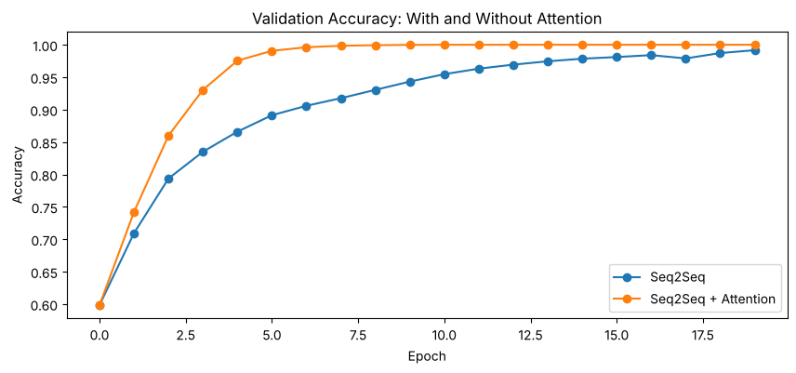

Step 6: See where the model looks
CODE
def show_attention(i):
text = df['invoice_date'].iloc[16000 + i]
out_ids = translate(attn_model, X_test[i:i + 1])[0]
dec = np.concatenate([[start_id], out_ids[:-1]])[None, :]
weights = score_model([X_test[i:i + 1], dec], training=False).numpy()[0][:, :len(text)]
plt.figure(figsize=(8, 5))
plt.imshow(weights, cmap='Blues')
plt.xticks(range(len(text)), list(text))
plt.yticks(range(10), list(to_text(out_ids)))
plt.xlabel('Input: invoice date')
plt.ylabel('Output: standard date')
plt.colorbar()
plt.show()

show_attention(0)
show_attention(5)
OUTPUT
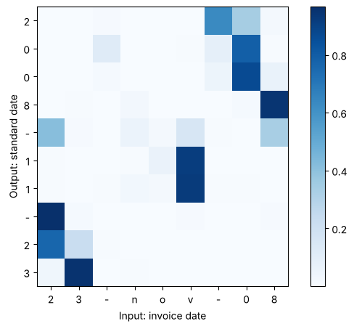
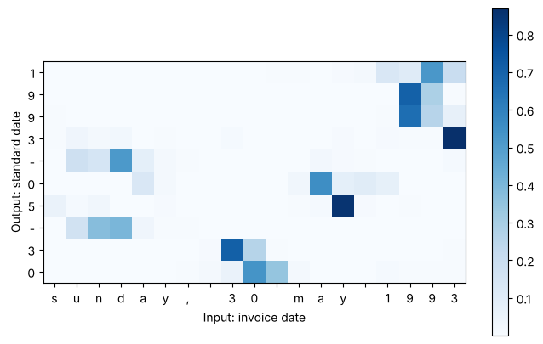

Step 7: Test on your own invoice dates
CODE
def standardise(texts, model):
ids = pad_sequences([[in_index.get(c, 0) for c in t.lower()] for t in texts], maxlen=max_in, padding='po
st')
return [to_text(p) for p in translate(model, ids)]

samples = ['3 march 2021', 'dec 25 2019', '01/07/2024', 'friday, 14 june 2002']
print(pd.DataFrame({
'Input': samples,
'Seq2Seq': standardise(samples, base_model),
'Seq2Seq + Attention': standardise(samples, attn_model)
}))
OUTPUT
Input Seq2Seq Seq2Seq + Attention
0 3 march 2021 2023-03-31 2021-03-31
1 dec 25 2019 2019-12-25 2019-12-25
2 01/07/2024 2024-07-01 2024-07-01
3 friday, 14 june 2002 2002-06-14 2002-06-14

Lab 10 Task 1: Attention heatmaps for three formats
CODE
from tensorflow.keras.layers import AdditiveAttention

def find_format(s):
for f in formats:
try:
datetime.datetime.strptime(s, f)
return f
except ValueError:
pass
return 'unknown'

def translate_gen(model, X, start, steps):
dec = np.full((len(X), 1), start)
for _ in range(steps):
probs = model([X, dec], training=False).numpy()
dec = np.concatenate([dec, probs[:, -1, :].argmax(axis=-1)[:, None]], axis=1)
return dec[:, 1:]

def plot_attention(model, smodel, x_row, text, start, steps, idx_to_char, title=''):
out_ids = translate_gen(model, x_row[None, :], start, steps)[0]
dec = np.concatenate([[start], out_ids[:-1]])[None, :]
w = smodel([x_row[None, :], dec], training=False).numpy()[0][:, :len(text)]
out_text = ''.join(idx_to_char.get(i, '?') for i in out_ids)
plt.figure(figsize=(max(8, len(text) * 0.32), 5))
plt.imshow(w, cmap='Blues', aspect='auto')
plt.xticks(range(len(text)), list(text))
plt.yticks(range(steps), list(out_text))
plt.title(title)
plt.xlabel('Input')
plt.ylabel('Output')
plt.colorbar()
plt.show()

lab10_test = df.iloc[16000:].copy().reset_index(drop=True)
lab10_test['format'] = lab10_test['invoice_date'].apply(find_format)

for f in ['%d/%m/%Y', '%B %d, %Y', '%A, %d %B %Y']:
i = int(np.where(lab10_test['format'].values == f)[0][0])
plot_attention(attn_model, score_model, X_test[i], lab10_test['invoice_date'].iloc[i], start_id, 10, inv
_out,
title=f"{lab10_test['invoice_date'].iloc[i]} -> {lab10_test['standard_date'].iloc[i]}")

wk_idx = np.where(lab10_test['format'].values == '%A, %d %B %Y')[0][:300]
wk_w = score_model([X_test[wk_idx], y_in_test[wk_idx]], training=False).numpy()
wk_mass = [wk_w[k][:, :lab10_test['invoice_date'].iloc[j].index(',')].sum(axis=1).mean() for k, j in enumera
te(wk_idx)]
print('Average share of attention on the weekday name:', round(float(np.mean(wk_mass)), 3))
OUTPUT
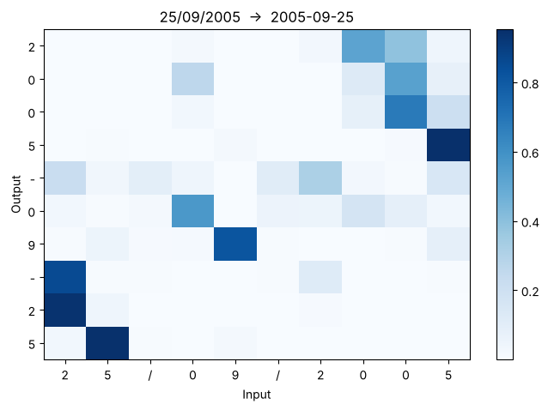
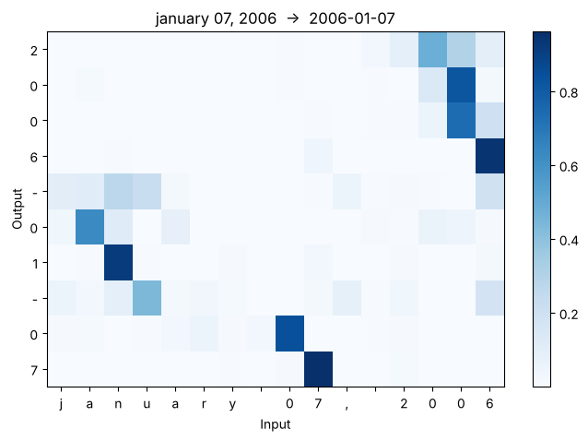
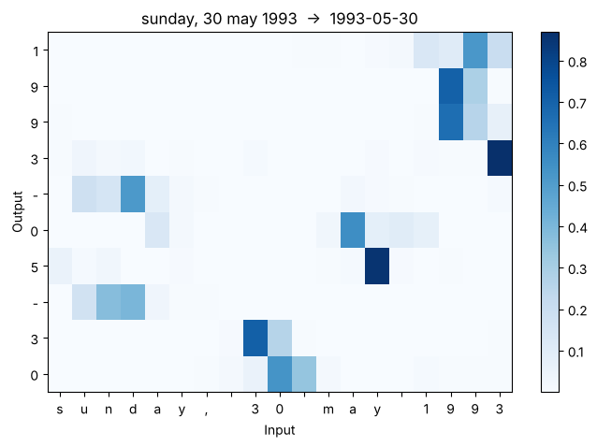
Average share of attention on the weekday name: 0.181

- dd/mm/yyyy (25/09/2005): when writing the year the model looks at the last four digits, when writing the month it looks at the '0' and '9' after the first '/', and when writing the day it looks at the first two digits.
- Month name first (january 07, 2006): the year comes from the four digits after the comma, the month from the letters of the month name (mainly 'a' and 'n'), and the day from the two digits before the comma.
- Weekday format (sunday, 30 may 1993): the digits of the output look at the day digits, the end of the month word and the year digits. The weekday name is not ignored completely: it receives 0.181 of the attention on average, but almost all of that comes from the two '-' separators in the output, which have no clear source in the input. The day, month and year digits put almost no weight on the weekday name, because it adds no information that is not already in the date.

Lab 10 Task 2: Additive (Bahdanau) attention
CODE
def build_any(kind, n_units, max_len, in_v, out_v):
enc_input = Input(shape=(max_len,), name='encoder_input')
enc_emb = Embedding(in_v, 32, mask_zero=True)(enc_input)
enc_seq, state_h, state_c = LSTM(n_units, return_sequences=True, return_state=True, name='encoder_lstm')
(enc_emb)
dec_input = Input(shape=(None,), name='decoder_input')
dec_emb = Embedding(out_v, 32)(dec_input)
dec_seq, _, _ = LSTM(n_units, return_sequences=True, return_state=True, name='decoder_lstm')(dec_emb, in
itial_state=[state_h, state_c])
score_model = None
if kind != 'none':
layer = Attention(name='attention') if kind == 'dot' else AdditiveAttention(name='attention')
context, scores = layer([dec_seq, enc_seq], return_attention_scores=True)
dec_seq = Concatenate(name='concat')([dec_seq, context])
score_model = Model([enc_input, dec_input], scores)
output = Dense(out_v, activation='softmax', name='output')(dec_seq)
model = Model([enc_input, dec_input], output)
model.compile(optimizer='adam', loss='sparse_categorical_crossentropy', metrics=['accuracy'])
return model, score_model

add_model, add_score = build_any('additive', units, max_in, in_vocab, out_vocab)
add_model.summary()
add_history, add_time = train(add_model)
add_pred = translate(add_model, X_test)

results.loc[len(results)] = ['Seq2Seq + Additive Attention', add_model.count_params(),
np.mean(np.all(add_pred == y_test, axis=1)).round(4),
np.mean(add_pred == y_test).round(4), round(add_time, 1)]

def sharpness(smodel, n=500):
w = smodel([X_test[:n], y_in_test[:n]], training=False).numpy()
return round(float(w.max(axis=-1).mean()), 3)

results['Mean max attention weight'] = [np.nan, sharpness(score_model), sharpness(add_score)]
print(results)

for i in [0, 5]:
plot_attention(attn_model, score_model, X_test[i], lab10_test['invoice_date'].iloc[i], start_id, 10, inv
_out, title='Dot-product attention')
plot_attention(add_model, add_score, X_test[i], lab10_test['invoice_date'].iloc[i], start_id, 10, inv_ou
t, title='Additive attention')
OUTPUT
Model: "functional_15"
+---------------------+-------------------+------------+-------------------+
| Layer (type) | Output Shape | Param # | Connected to |
+---------------------+-------------------+------------+-------------------+
| encoder_input | (None, 30) | 0 | - |
| (InputLayer) | | | |
+---------------------+-------------------+------------+-------------------+
| decoder_input | (None, None) | 0 | - |
| (InputLayer) | | | |
+---------------------+-------------------+------------+-------------------+
| embedding_18 | (None, 30, 32) | 1,216 | encoder_input[0]? |
| (Embedding) | | | |
+---------------------+-------------------+------------+-------------------+
| not_equal_13 | (None, 30) | 0 | encoder_input[0]? |
| (NotEqual) | | | |
+---------------------+-------------------+------------+-------------------+
| embedding_19 | (None, None, 32) | 416 | decoder_input[0]? |
| (Embedding) | | | |
+---------------------+-------------------+------------+-------------------+
| encoder_lstm (LSTM) | [(None, 30, 32), | 8,320 | embedding_18[0][? |
| | (None, 32), | | not_equal_13[0][? |
| | (None, 32)] | | |
+---------------------+-------------------+------------+-------------------+
| decoder_lstm (LSTM) | [(None, None, | 8,320 | embedding_19[0][? |
| | 32), (None, 32), | | encoder_lstm[0][? |
| | (None, 32)] | | encoder_lstm[0][? |
+---------------------+-------------------+------------+-------------------+
| attention | [(None, None, | 32 | decoder_lstm[0][? |
| (AdditiveAttention) | 32), (None, None, | | encoder_lstm[0][? |
| | 30)] | | |
+---------------------+-------------------+------------+-------------------+
| concat | (None, None, 64) | 0 | decoder_lstm[0][? |
| (Concatenate) | | | attention[0][0] |
+---------------------+-------------------+------------+-------------------+
| output (Dense) | (None, None, 13) | 845 | concat[0][0] |
+---------------------+-------------------+------------+-------------------+
Total params: 19,149 (74.80 KB)
Trainable params: 19,149 (74.80 KB)
Non-trainable params: 0 (0.00 B)
Epoch 1/20
113/113 - 10s - 90ms/step - accuracy: 0.4463 - loss: 1.8005 - val_accuracy: 0.5893 - val_loss: 1.2339
Epoch 2/20
113/113 - 5s - 42ms/step - accuracy: 0.6597 - loss: 1.0334 - val_accuracy: 0.7211 - val_loss: 0.8717
Epoch 3/20
113/113 - 5s - 44ms/step - accuracy: 0.7654 - loss: 0.7436 - val_accuracy: 0.8059 - val_loss: 0.6320
Epoch 4/20
113/113 - 5s - 43ms/step - accuracy: 0.8383 - loss: 0.5512 - val_accuracy: 0.8632 - val_loss: 0.4749
Epoch 5/20
113/113 - 5s - 45ms/step - accuracy: 0.8856 - loss: 0.4142 - val_accuracy: 0.8991 - val_loss: 0.3576
Epoch 6/20
113/113 - 5s - 44ms/step - accuracy: 0.9128 - loss: 0.3177 - val_accuracy: 0.9227 - val_loss: 0.2781
Epoch 7/20
113/113 - 5s - 42ms/step - accuracy: 0.9338 - loss: 0.2481 - val_accuracy: 0.9421 - val_loss: 0.2177
Epoch 8/20
113/113 - 5s - 43ms/step - accuracy: 0.9510 - loss: 0.1943 - val_accuracy: 0.9583 - val_loss: 0.1710
Epoch 9/20
113/113 - 5s - 47ms/step - accuracy: 0.9626 - loss: 0.1556 - val_accuracy: 0.9676 - val_loss: 0.1383
Epoch 10/20
113/113 - 5s - 46ms/step - accuracy: 0.9712 - loss: 0.1273 - val_accuracy: 0.9737 - val_loss: 0.1140
Epoch 11/20
113/113 - 5s - 43ms/step - accuracy: 0.9776 - loss: 0.1050 - val_accuracy: 0.9801 - val_loss: 0.0951
Epoch 12/20
113/113 - 5s - 45ms/step - accuracy: 0.9825 - loss: 0.0876 - val_accuracy: 0.9836 - val_loss: 0.0801
Epoch 13/20
113/113 - 5s - 46ms/step - accuracy: 0.9864 - loss: 0.0737 - val_accuracy: 0.9868 - val_loss: 0.0680
Epoch 14/20
113/113 - 5s - 45ms/step - accuracy: 0.9893 - loss: 0.0624 - val_accuracy: 0.9891 - val_loss: 0.0586
Epoch 15/20
113/113 - 5s - 42ms/step - accuracy: 0.9915 - loss: 0.0531 - val_accuracy: 0.9907 - val_loss: 0.0507
Epoch 16/20
113/113 - 5s - 42ms/step - accuracy: 0.9931 - loss: 0.0454 - val_accuracy: 0.9924 - val_loss: 0.0435
Epoch 17/20
113/113 - 5s - 43ms/step - accuracy: 0.9946 - loss: 0.0390 - val_accuracy: 0.9939 - val_loss: 0.0369
Epoch 18/20
113/113 - 5s - 41ms/step - accuracy: 0.9957 - loss: 0.0334 - val_accuracy: 0.9946 - val_loss: 0.0321
Epoch 19/20
113/113 - 5s - 43ms/step - accuracy: 0.9966 - loss: 0.0287 - val_accuracy: 0.9952 - val_loss: 0.0282
Epoch 20/20
113/113 - 5s - 43ms/step - accuracy: 0.9972 - loss: 0.0247 - val_accuracy: 0.9959 - val_loss: 0.0249
Model Parameters Exact-match accuracy \
0 Seq2Seq 18701 0.9192
1 Seq2Seq + Attention 19117 1.0000
2 Seq2Seq + Additive Attention 19149 0.9625

Character accuracy Training time (s) Mean max attention weight
0 0.9795 82.8 NaN
1 1.0000 89.2 0.674
2 0.9913 104.0 0.346
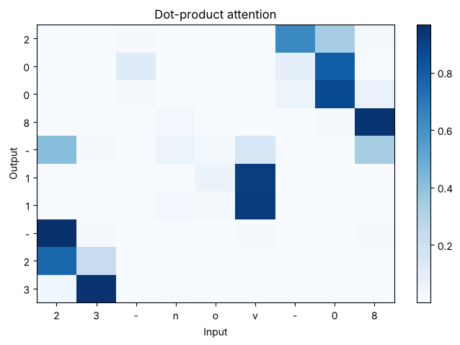
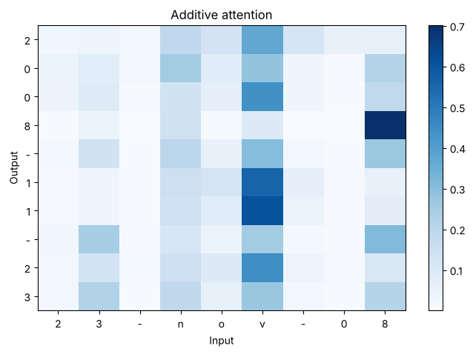
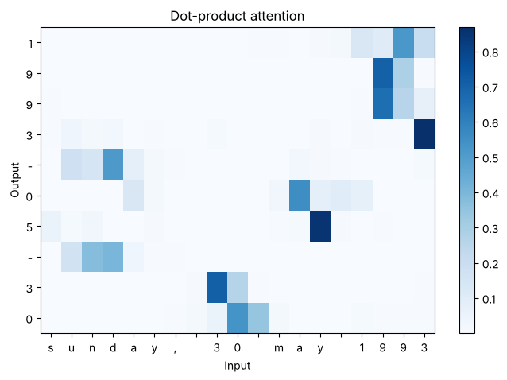
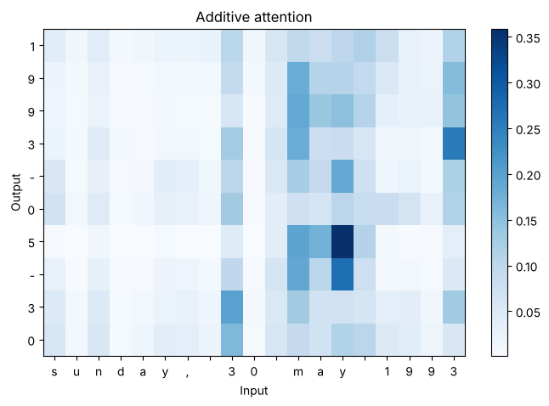

Additive attention scores each pair of decoder and encoder states with a small learned network, so it adds a few parameters (19,149 against 19,117), while dot-product attention has none. Both beat the model without attention (0.9192), but dot-product attention is clearly better here: it reaches 1.0 exact-match accuracy against 0.9625 for additive attention, and it also trains faster. The mean max attention weight measures how sharp the heatmaps are: a value near 1 means the model puts almost all of its attention on one input character. Dot-product attention is much sharper (0.674 against 0.346), and its heatmaps show clean, focused blocks on the right characters. Additive attention spreads its weight over several characters, for example the month letters, but still gets most dates right.

Lab 10 Task 3: 16, 32 and 64 units
CODE
size_rows = []
for u in [16, 32, 64]:
row = {'Units': u}
for kind, label in [('none', 'Seq2Seq'), ('dot', 'Seq2Seq + Attention')]:
if u == 32:
p = base_pred if kind == 'none' else attn_pred
else:
m, _ = build_any(kind, u, max_in, in_vocab, out_vocab)
m.fit([X_train, y_in_train], y_train, epochs=20, batch_size=128, validation_split=0.1, verbose=0
)
p = translate(m, X_test)
row[label] = round(float(np.mean(np.all(p == y_test, axis=1))), 4)
size_rows.append(row)
size_df = pd.DataFrame(size_rows)
size_df['Gap'] = (size_df['Seq2Seq + Attention'] - size_df['Seq2Seq']).round(4)
print(size_df)

plt.figure(figsize=(8, 4))
plt.plot(size_df['Units'], size_df['Seq2Seq'], marker='o', label='Seq2Seq')
plt.plot(size_df['Units'], size_df['Seq2Seq + Attention'], marker='o', label='Seq2Seq + Attention')
plt.xticks(size_df['Units'])
plt.title('Exact-match Accuracy vs Units')
plt.xlabel('Units')
plt.ylabel('Exact-match accuracy')
plt.legend()
plt.grid(True)
plt.show()
OUTPUT
Units Seq2Seq Seq2Seq + Attention Gap
0 16 0.1928 0.961 0.7682
1 32 0.9193 1.000 0.0807
2 64 0.9940 1.000 0.0060
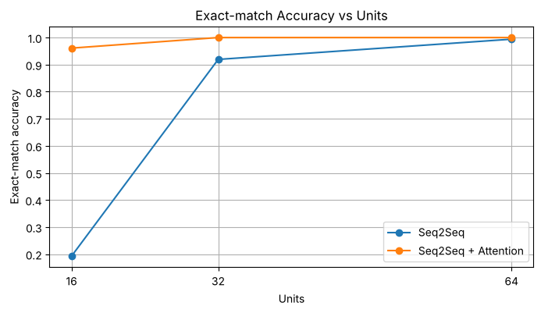

Without attention the decoder sees only the final encoder state, so everything about the input must fit into 2 x units numbers. With 16 units this context vector is far too small and exact-match accuracy drops to 0.1928; it recovers to 0.9193 at 32 units and 0.994 at 64 units. With attention the decoder can read all 30 encoder states again at every output step, so it does not depend on one fixed summary. Its accuracy stays high even at 16 units (0.961) and is 1.0 at 32 and 64 units. The gap between the two models is largest for the smallest model (0.7682 at 16 units) and narrows as the context vector grows (0.0807 at 32 and 0.006 at 64). This shows that attention removes the context-vector bottleneck from Lab 9.

Lab 10 Task 4: Recommendation
CODE
monthly = 50000
rec = results[['Model', 'Exact-match accuracy', 'Training time (s)']].copy()
rec['Wrong dates per month'] = ((1 - rec['Exact-match accuracy'].astype(float)) * monthly).round().astype(in
t)
print(rec)
OUTPUT
Model Exact-match accuracy Training time (s) \
0 Seq2Seq 0.9192 82.8
1 Seq2Seq + Attention 1.0000 89.2
2 Seq2Seq + Additive Attention 0.9625 104.0

Wrong dates per month
0 4040
1 0
2 1875

The recommended model is seq2seq with dot-product attention. At 50,000 invoices a month it is expected to produce 0 wrong dates on this test data, against 4,040 for the model without attention and 1,875 for additive attention, which directly reduces payment errors and manual correction work. It adds only 416 parameters and about 6 seconds of training time (89.2 s against 82.8 s), which is negligible because the model is trained once and then used many times. Additive attention is less accurate, has more parameters and is the slowest to train. Most importantly, the attention heatmaps show which characters were used for the day, month and year, so auditors can check why a particular date was produced. Outputs that fail a date validity check should still be sent for human review.

Lab Assignment 4: Attention-based sequence model comparison study

Task 1: Three models under the same settings (standard invoice dates)
CODE
short_rows = []
for name, m, p, t in [('Seq2Seq', base_model, base_pred, base_time),
('Seq2Seq + Dot Attention', attn_model, attn_pred, attn_time),
('Seq2Seq + Additive Attention', add_model, add_pred, add_time)]:
short_rows.append({
'Input': 'Date only',
'Model': name,
'Parameters': m.count_params(),
'Exact-match accuracy': round(float(np.mean(np.all(p == y_test, axis=1))), 4),
'Character accuracy': round(float(np.mean(p == y_test)), 4),
'Training time (s)': round(t, 1)
})
print(pd.DataFrame(short_rows))
OUTPUT
Input Model Parameters Exact-match accuracy \
0 Date only Seq2Seq 18701 0.9193
1 Date only Seq2Seq + Dot Attention 19117 1.0000
2 Date only Seq2Seq + Additive Attention 19149 0.9625

Character accuracy Training time (s)
0 0.9795 82.8
1 1.0000 89.2
2 0.9913 104.0

Task 2: Longer inputs (supplier name and invoice number before the date)
CODE
random.seed(7)
np.random.seed(7)
tf.random.set_seed(7)

suppliers = ['al-falah traders', 'karachi steel works', 'nishat textiles', 'zamzam foods', 'quetta marble co
',
'packages ltd', 'lucky cement', 'engro fertilizers', 'habib oil mills', 'sapphire fibres',
'hashoo logistics', 'kohinoor mills']
templates = ['{s} inv-{n} {d}', '{s} | invoice #{n} | {d}', 'invoice {n} from {s} dated {d}', '{s}, bill no
{n}, {d}']

long_df = pd.DataFrame({
'invoice_text': [random.choice(templates).format(s=random.choice(suppliers), n=random.randint(1000, 9999
9), d=d) for d in df['invoice_date']],
'standard_date': df['standard_date']
})
print(long_df.head(8).to_string())
print(long_df['invoice_text'].str.len().describe())

l_chars = sorted(set(''.join(long_df['invoice_text'])))
l_index = {c: i + 1 for i, c in enumerate(l_chars)}
l_vocab = len(l_chars) + 1
max_long = int(long_df['invoice_text'].str.len().max()) + 2

XL = pad_sequences([[l_index[c] for c in s] for s in long_df['invoice_text']], maxlen=max_long, padding='pos
t')
XL_train, XL_test = XL[:16000], XL[16000:]
print('Input vocabulary:', l_vocab, ' max length:', max_long, ' shapes:', XL_train.shape, XL_test.shape)

def train_long(model):
start = time.time()
history = model.fit([XL_train, y_in_train], y_train, epochs=20, batch_size=128, validation_split=0.1, ve
rbose=2)
return history, time.time() - start

long_models = {}
for kind, name in [('none', 'Seq2Seq'), ('dot', 'Seq2Seq + Dot Attention'), ('additive', 'Seq2Seq + Additive
Attention')]:
m, sm = build_any(kind, units, max_long, l_vocab, out_vocab)
h, t = train_long(m)
p = translate_gen(m, XL_test, start_id, 10)
long_models[name] = {'model': m, 'score_model': sm, 'history': h, 'time': t, 'pred': p}

plt.figure(figsize=(10, 4))
for name, r in long_models.items():
plt.plot(r['history'].history['val_accuracy'], marker='o', label=name)
plt.title('Validation Accuracy on Long Inputs')
plt.xlabel('Epoch')
plt.ylabel('Accuracy')
plt.legend()
plt.show()
OUTPUT
invoice_text standard_date
0 invoice 52750 from nishat textiles dated 07 sep 2018 2018-09-07
1 karachi steel works inv-71239 14.02.91 1991-02-14
2 packages ltd inv-77387 26/12/2000 2000-12-26
3 habib oil mills inv-29140 05 apr 1996 1996-04-05
4 karachi steel works inv-57838 10 may 2020 2020-05-10
5 karachi steel works, bill no 32544, jun 27 2016 2016-06-27
6 habib oil mills inv-56642 05 june 1991 1991-06-05
7 sapphire fibres inv-17226 16/03/1994 1994-03-16
count 20000.000000
mean 45.932750
std 7.503002
min 30.000000
25% 41.000000
50% 45.500000
75% 51.000000
max 73.000000
Name: invoice_text, dtype: float64
Input vocabulary: 44 max length: 75 shapes: (16000, 75) (4000, 75)
Epoch 1/20
113/113 - 13s - 116ms/step - accuracy: 0.4460 - loss: 1.7538 - val_accuracy: 0.5838 - val_loss: 1.2409
Epoch 2/20
113/113 - 8s - 69ms/step - accuracy: 0.6317 - loss: 1.0494 - val_accuracy: 0.6819 - val_loss: 0.8963
Epoch 3/20
113/113 - 8s - 67ms/step - accuracy: 0.7208 - loss: 0.8101 - val_accuracy: 0.7626 - val_loss: 0.7323
Epoch 4/20
113/113 - 8s - 67ms/step - accuracy: 0.7837 - loss: 0.6734 - val_accuracy: 0.8013 - val_loss: 0.6280
Epoch 5/20
113/113 - 8s - 68ms/step - accuracy: 0.8104 - loss: 0.5868 - val_accuracy: 0.8201 - val_loss: 0.5577
Epoch 6/20
113/113 - 7s - 66ms/step - accuracy: 0.8264 - loss: 0.5263 - val_accuracy: 0.8345 - val_loss: 0.5021
Epoch 7/20
113/113 - 8s - 69ms/step - accuracy: 0.8448 - loss: 0.4729 - val_accuracy: 0.8562 - val_loss: 0.4434
Epoch 8/20
113/113 - 8s - 69ms/step - accuracy: 0.8632 - loss: 0.4217 - val_accuracy: 0.8752 - val_loss: 0.3925
Epoch 9/20
113/113 - 8s - 68ms/step - accuracy: 0.8798 - loss: 0.3739 - val_accuracy: 0.8904 - val_loss: 0.3486
Epoch 10/20
113/113 - 8s - 69ms/step - accuracy: 0.8944 - loss: 0.3307 - val_accuracy: 0.9037 - val_loss: 0.3072
Epoch 11/20
113/113 - 8s - 72ms/step - accuracy: 0.9078 - loss: 0.2902 - val_accuracy: 0.9149 - val_loss: 0.2702
Epoch 12/20
113/113 - 8s - 67ms/step - accuracy: 0.9188 - loss: 0.2564 - val_accuracy: 0.9211 - val_loss: 0.2419
Epoch 13/20
113/113 - 8s - 67ms/step - accuracy: 0.9273 - loss: 0.2288 - val_accuracy: 0.9291 - val_loss: 0.2173
Epoch 14/20
113/113 - 8s - 68ms/step - accuracy: 0.9344 - loss: 0.2049 - val_accuracy: 0.9356 - val_loss: 0.1956
Epoch 15/20
113/113 - 8s - 68ms/step - accuracy: 0.9410 - loss: 0.1846 - val_accuracy: 0.9404 - val_loss: 0.1815
Epoch 16/20
113/113 - 8s - 69ms/step - accuracy: 0.9466 - loss: 0.1666 - val_accuracy: 0.9439 - val_loss: 0.1716
Epoch 17/20
113/113 - 8s - 71ms/step - accuracy: 0.9524 - loss: 0.1510 - val_accuracy: 0.9487 - val_loss: 0.1563
Epoch 18/20
113/113 - 7s - 66ms/step - accuracy: 0.9567 - loss: 0.1375 - val_accuracy: 0.9534 - val_loss: 0.1422
Epoch 19/20
113/113 - 8s - 70ms/step - accuracy: 0.9604 - loss: 0.1258 - val_accuracy: 0.9580 - val_loss: 0.1311
Epoch 20/20
113/113 - 8s - 69ms/step - accuracy: 0.9637 - loss: 0.1157 - val_accuracy: 0.9623 - val_loss: 0.1192
Epoch 1/20
113/113 - 13s - 116ms/step - accuracy: 0.4383 - loss: 1.7698 - val_accuracy: 0.6069 - val_loss: 1.1948
Epoch 2/20
113/113 - 9s - 80ms/step - accuracy: 0.6614 - loss: 0.9826 - val_accuracy: 0.7017 - val_loss: 0.8516
Epoch 3/20
113/113 - 9s - 76ms/step - accuracy: 0.7471 - loss: 0.7519 - val_accuracy: 0.7861 - val_loss: 0.6568
Epoch 4/20
113/113 - 8s - 70ms/step - accuracy: 0.8176 - loss: 0.5794 - val_accuracy: 0.8460 - val_loss: 0.5043
Epoch 5/20
113/113 - 8s - 71ms/step - accuracy: 0.8748 - loss: 0.4374 - val_accuracy: 0.9060 - val_loss: 0.3690
Epoch 6/20
113/113 - 8s - 71ms/step - accuracy: 0.9250 - loss: 0.3118 - val_accuracy: 0.9476 - val_loss: 0.2546
Epoch 7/20
113/113 - 8s - 71ms/step - accuracy: 0.9588 - loss: 0.2033 - val_accuracy: 0.9740 - val_loss: 0.1578
Epoch 8/20
113/113 - 8s - 73ms/step - accuracy: 0.9793 - loss: 0.1253 - val_accuracy: 0.9861 - val_loss: 0.0970
Epoch 9/20
113/113 - 8s - 74ms/step - accuracy: 0.9898 - loss: 0.0788 - val_accuracy: 0.9936 - val_loss: 0.0641
Epoch 10/20
113/113 - 8s - 74ms/step - accuracy: 0.9948 - loss: 0.0524 - val_accuracy: 0.9965 - val_loss: 0.0435
Epoch 11/20
113/113 - 9s - 75ms/step - accuracy: 0.9972 - loss: 0.0361 - val_accuracy: 0.9981 - val_loss: 0.0309
Epoch 12/20
113/113 - 8s - 71ms/step - accuracy: 0.9985 - loss: 0.0258 - val_accuracy: 0.9986 - val_loss: 0.0226
Epoch 13/20
113/113 - 8s - 70ms/step - accuracy: 0.9990 - loss: 0.0193 - val_accuracy: 0.9989 - val_loss: 0.0172
Epoch 14/20
113/113 - 8s - 72ms/step - accuracy: 0.9994 - loss: 0.0149 - val_accuracy: 0.9994 - val_loss: 0.0135
Epoch 15/20
113/113 - 8s - 68ms/step - accuracy: 0.9996 - loss: 0.0118 - val_accuracy: 0.9996 - val_loss: 0.0108
Epoch 16/20
113/113 - 8s - 72ms/step - accuracy: 0.9998 - loss: 0.0095 - val_accuracy: 0.9997 - val_loss: 0.0087
Epoch 17/20
113/113 - 8s - 73ms/step - accuracy: 0.9999 - loss: 0.0078 - val_accuracy: 0.9999 - val_loss: 0.0072
Epoch 18/20
113/113 - 9s - 76ms/step - accuracy: 1.0000 - loss: 0.0065 - val_accuracy: 0.9999 - val_loss: 0.0060
Epoch 19/20
113/113 - 8s - 75ms/step - accuracy: 1.0000 - loss: 0.0055 - val_accuracy: 0.9999 - val_loss: 0.0051
Epoch 20/20
113/113 - 8s - 73ms/step - accuracy: 1.0000 - loss: 0.0047 - val_accuracy: 0.9999 - val_loss: 0.0044
Epoch 1/20
113/113 - 16s - 142ms/step - accuracy: 0.4337 - loss: 1.7712 - val_accuracy: 0.5913 - val_loss: 1.2326
Epoch 2/20
113/113 - 10s - 88ms/step - accuracy: 0.6289 - loss: 1.0459 - val_accuracy: 0.6713 - val_loss: 0.9115
Epoch 3/20
113/113 - 10s - 90ms/step - accuracy: 0.7170 - loss: 0.8101 - val_accuracy: 0.7595 - val_loss: 0.7167
Epoch 4/20
113/113 - 10s - 89ms/step - accuracy: 0.7886 - loss: 0.6484 - val_accuracy: 0.8110 - val_loss: 0.5901
Epoch 5/20
113/113 - 10s - 87ms/step - accuracy: 0.8220 - loss: 0.5496 - val_accuracy: 0.8323 - val_loss: 0.5141
Epoch 6/20
113/113 - 10s - 88ms/step - accuracy: 0.8411 - loss: 0.4856 - val_accuracy: 0.8484 - val_loss: 0.4596
Epoch 7/20
113/113 - 9s - 83ms/step - accuracy: 0.8556 - loss: 0.4369 - val_accuracy: 0.8634 - val_loss: 0.4164
Epoch 8/20
113/113 - 10s - 85ms/step - accuracy: 0.8687 - loss: 0.3953 - val_accuracy: 0.8800 - val_loss: 0.3743
Epoch 9/20
113/113 - 10s - 85ms/step - accuracy: 0.8831 - loss: 0.3527 - val_accuracy: 0.8892 - val_loss: 0.3365
Epoch 10/20
113/113 - 10s - 85ms/step - accuracy: 0.8978 - loss: 0.3099 - val_accuracy: 0.9011 - val_loss: 0.2999
Epoch 11/20
113/113 - 10s - 90ms/step - accuracy: 0.9114 - loss: 0.2705 - val_accuracy: 0.9139 - val_loss: 0.2608
Epoch 12/20
113/113 - 10s - 86ms/step - accuracy: 0.9245 - loss: 0.2344 - val_accuracy: 0.9241 - val_loss: 0.2298
Epoch 13/20
113/113 - 9s - 84ms/step - accuracy: 0.9352 - loss: 0.2037 - val_accuracy: 0.9345 - val_loss: 0.2028
Epoch 14/20
113/113 - 10s - 86ms/step - accuracy: 0.9445 - loss: 0.1781 - val_accuracy: 0.9434 - val_loss: 0.1791
Epoch 15/20
113/113 - 9s - 81ms/step - accuracy: 0.9513 - loss: 0.1569 - val_accuracy: 0.9528 - val_loss: 0.1519
Epoch 16/20
113/113 - 9s - 79ms/step - accuracy: 0.9581 - loss: 0.1381 - val_accuracy: 0.9611 - val_loss: 0.1316
Epoch 17/20
113/113 - 9s - 83ms/step - accuracy: 0.9637 - loss: 0.1226 - val_accuracy: 0.9658 - val_loss: 0.1169
Epoch 18/20
113/113 - 9s - 83ms/step - accuracy: 0.9677 - loss: 0.1097 - val_accuracy: 0.9704 - val_loss: 0.1044
Epoch 19/20
113/113 - 9s - 80ms/step - accuracy: 0.9722 - loss: 0.0976 - val_accuracy: 0.9725 - val_loss: 0.0955
Epoch 20/20
113/113 - 9s - 82ms/step - accuracy: 0.9757 - loss: 0.0871 - val_accuracy: 0.9755 - val_loss: 0.0876
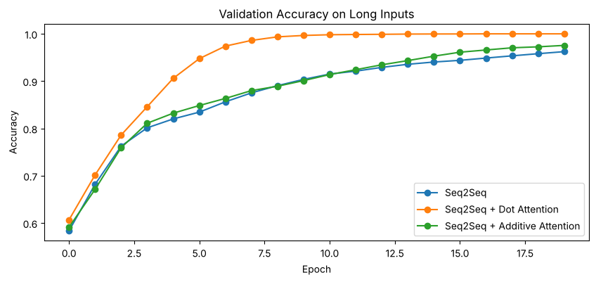

Task 3: Results table
CODE
long_rows = []
for name, r in long_models.items():
long_rows.append({
'Input': 'Supplier + invoice no + date',
'Model': name,
'Parameters': r['model'].count_params(),
'Exact-match accuracy': round(float(np.mean(np.all(r['pred'] == y_test, axis=1))), 4),
'Character accuracy': round(float(np.mean(r['pred'] == y_test)), 4),
'Training time (s)': round(r['time'], 1)
})
study = pd.DataFrame(short_rows + long_rows)
print(study.to_string(index=False))

pivot = study.pivot(index='Model', columns='Input', values='Exact-match accuracy')
pivot.plot(kind='bar', figsize=(9, 4), rot=0)
plt.title('Exact-match Accuracy: Short vs Long Inputs')
plt.ylabel('Exact-match accuracy')
plt.ylim(0, 1.05)
plt.show()
OUTPUT
Input Model Parameters Exact-match accuracy Character accuracy T
raining time (s)
Date only Seq2Seq 18701 0.9193 0.9795
82.8
Date only Seq2Seq + Dot Attention 19117 1.0000 1.0000
89.2
Date only Seq2Seq + Additive Attention 19149 0.9625 0.9913
104.0
Supplier + invoice no + date Seq2Seq 18893 0.6478 0.9270
160.3
Supplier + invoice no + date Seq2Seq + Dot Attention 19309 0.9992 0.9998
169.7
Supplier + invoice no + date Seq2Seq + Additive Attention 19341 0.7612 0.9497
198.6
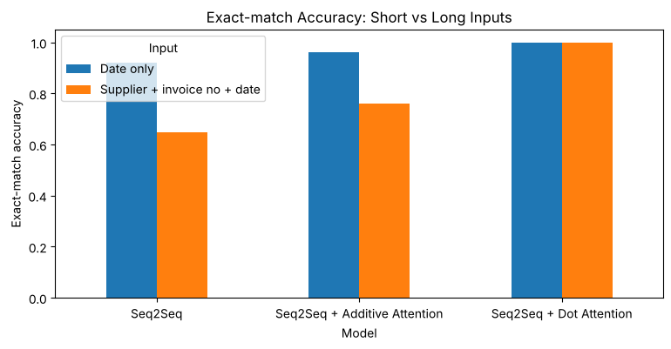

Task 4: Heatmaps for correct and wrong predictions of the best model
CODE
best_name = max(['Seq2Seq + Dot Attention', 'Seq2Seq + Additive Attention'],
key=lambda n: np.mean(np.all(long_models[n]['pred'] == y_test, axis=1)))
best = long_models[best_name]
print('Best model:', best_name)

long_test = long_df.iloc[16000:].copy().reset_index(drop=True)
long_test['predicted'] = [to_text(p) for p in best['pred']]
long_test['base_predicted'] = [to_text(p) for p in long_models['Seq2Seq']['pred']]
long_test['correct'] = long_test['predicted'] == long_test['standard_date']
long_test['base_correct'] = long_test['base_predicted'] == long_test['standard_date']

correct_idx = np.where(long_test['correct'])[0][:2]
wrong_idx = np.where(~long_test['correct'])[0][:2]
print(long_test.loc[wrong_idx, ['invoice_text', 'standard_date', 'predicted']].to_string())

for i in list(correct_idx) + list(wrong_idx):
status = 'CORRECT' if long_test['correct'].iloc[i] else 'WRONG'
plot_attention(best['model'], best['score_model'], XL_test[i], long_test['invoice_text'].iloc[i], start_
id, 10, inv_out,
title=f"{status}: true {long_test['standard_date'].iloc[i]}, predicted {long_test['predic
ted'].iloc[i]}")
OUTPUT
Best model: Seq2Seq + Dot Attention
invoice_text standard_date predicted
176 nishat textiles, bill no 9903, sep 11 1994 1994-09-11 1994-10-19
823 kohinoor mills, bill no 74268, 10.11.16 2016-11-10 1016-11-10
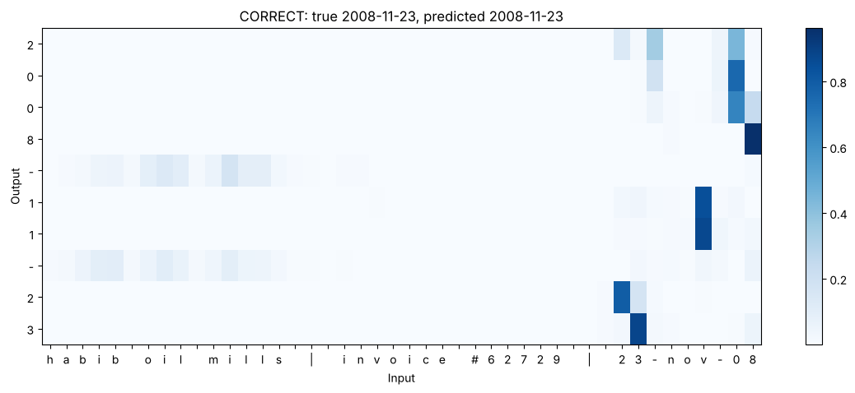
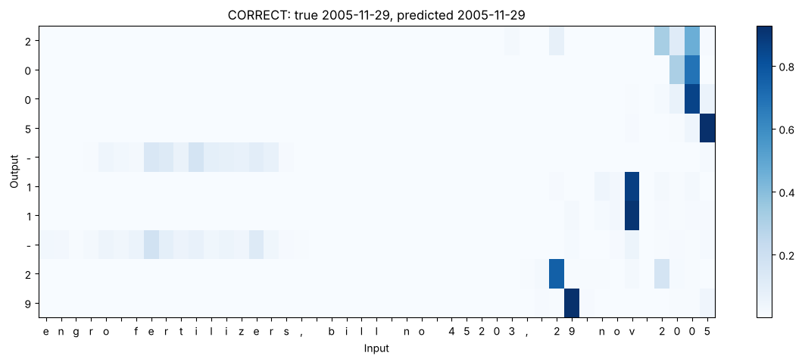
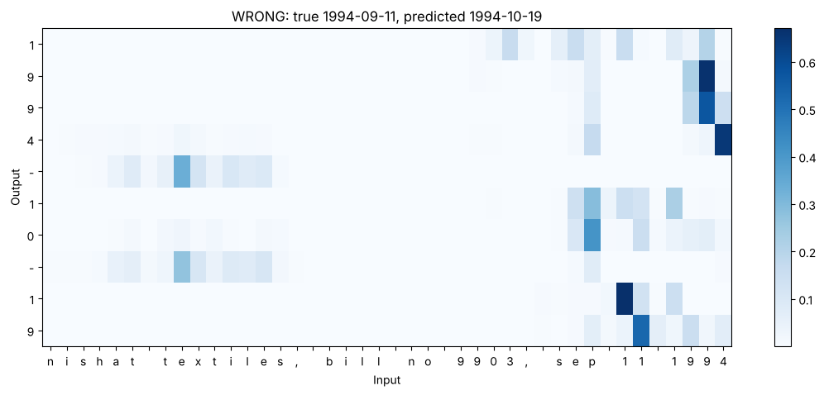
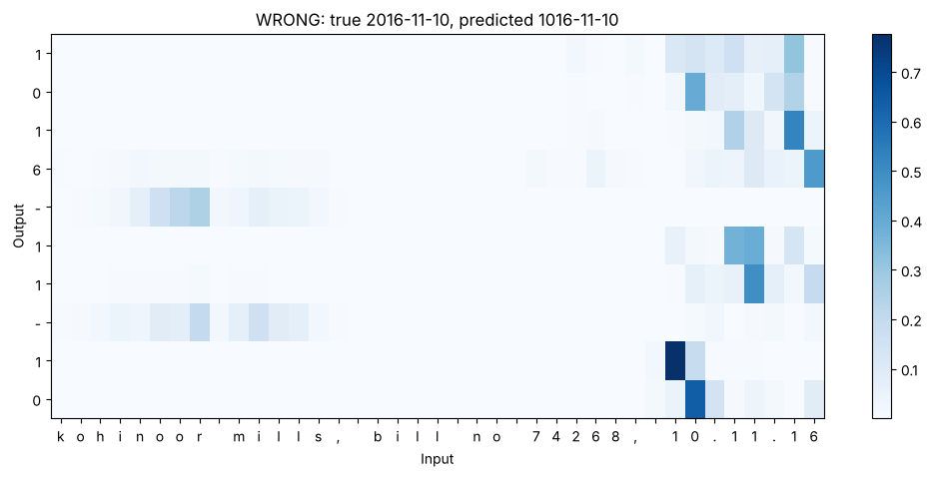

In the correct examples the day, month and year digits look only at the date at the end of the string; the supplier name and the invoice number receive almost no weight from them, so the model has learned to locate the date inside the longer text. The only attention on the supplier name comes from the '-' separators in the output. In the first wrong example ('sep 11 1994', predicted 1994-10-19) the year is read correctly, but the attention for the month is split between 'sep' and the day digits, and the second day digit looks at the wrong '1', so both the month and the day come out wrong. In the second wrong example ('10.11.16', predicted 1016-11-10) the day and month are correct, but the year has only two digits, so the century is not in the input; the attention for the first year digit is spread over '.16' and the model wrote '1' instead of '2'. The heatmap shows exactly which output character went wrong and where the model looked, which is what an analyst needs to diagnose and fix the error.

Task 5: Inputs that only the attention model got right
CODE
only_attn = long_test[(~long_test['base_correct']) & (long_test['correct'])]
print('Long inputs wrong without attention but right with attention:', len(only_attn))
print(only_attn[['invoice_text', 'standard_date', 'base_predicted', 'predicted']].head(5).to_string())

short_test = df.iloc[16000:].copy().reset_index(drop=True)
short_test['base_predicted'] = [to_text(p) for p in base_pred]
short_test['attn_predicted'] = [to_text(p) for p in attn_pred]
only_attn_short = short_test[(short_test['base_predicted'] != short_test['standard_date']) & (short_test['at
tn_predicted'] == short_test['standard_date'])]
print('Short inputs wrong without attention but right with attention:', len(only_attn_short))
print(only_attn_short.head(5).to_string())

for i in only_attn.index[:2]:
plot_attention(best['model'], best['score_model'], XL_test[i], long_test['invoice_text'].iloc[i], start_
id, 10, inv_out,
title=f"Attention right ({long_test['predicted'].iloc[i]}), no attention wrong ({long_tes
t['base_predicted'].iloc[i]})")
OUTPUT
Long inputs wrong without attention but right with attention: 1408
invoice_text standard_date base_predicted predicted
5 karachi steel works | invoice #57364 | sunday, 30 may 1993 1993-05-30 1993-05-03 1993-05-30
7 packages ltd inv-71876 20/05/2024 2024-05-20 2024-05-02 2024-05-20
10 zamzam foods, bill no 66093, 20 may 2025 2025-05-20 2025-05-02 2025-05-20
15 invoice 98048 from hashoo logistics dated sep 18 2006 2006-09-18 2006-08-19 2006-09-18
16 packages ltd, bill no 96122, january 07, 2006 2006-01-07 2006-07-01 2006-01-07
Short inputs wrong without attention but right with attention: 323
invoice_date standard_date base_predicted attn_predicted
36 nov 30 2016 2016-11-30 2016-11-03 2016-11-30
38 09 aug 1993 1993-08-09 1993-09-06 1993-08-09
40 tuesday, 18 august 2020 2020-08-18 2020-08-05 2020-08-18
46 03.10.22 2022-10-03 2022-01-30 2022-10-03
108 10.10.98 1998-10-10 1998-01-10 1998-10-10
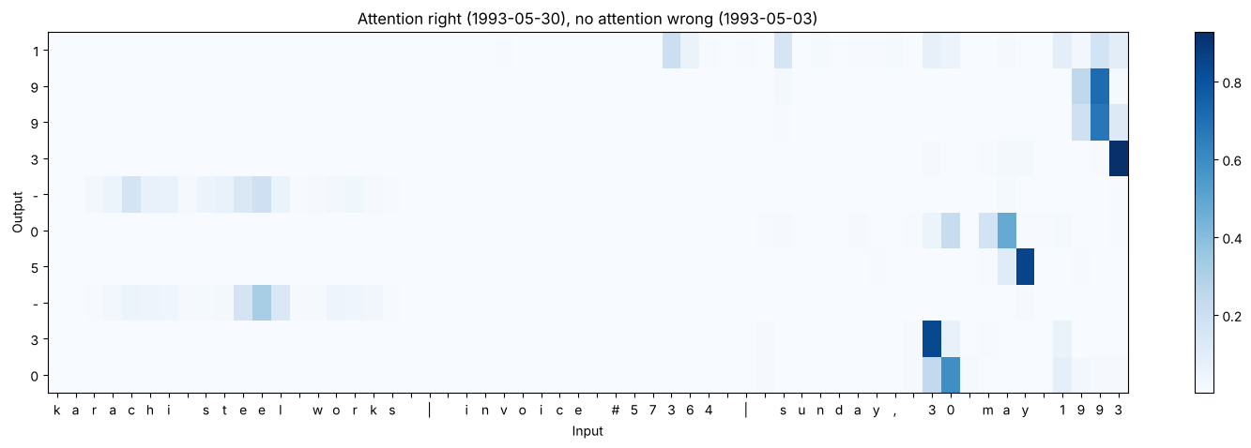
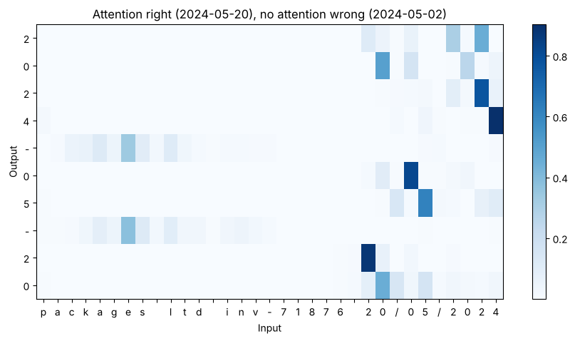

Without attention 1,408 of the 4,000 long inputs were wrong but became right with attention, against 323 for the short inputs, so the benefit of attention grows a lot with longer input. In the examples the model without attention gets the year right but mixes up the day and month digits: '30 may' became 05-03, '20/05' became 05-02, 'january 07' became 07-01 and 'sep 18' became 08-19. Without attention the encoder must keep the date digits in its final state after reading the supplier name and invoice number as well, and the invoice-number digits overwrite part of that information. With attention the decoder looks directly at the exact characters of the day, month and year when it writes each of them, as the heatmaps show, so the text in front of the date does not get in the way.

Task 6: Conclusion
The model to deploy is the seq2seq model with dot-product attention. On the plain invoice dates it reaches 1.0 exact-match accuracy, against 0.9193 without attention and 0.9625 with additive attention. When the date is hidden inside a longer string with a supplier name and an invoice number, the model without attention falls to 0.6478, because the whole string must pass through one fixed context vector of 64 numbers. The dot-product attention model keeps 0.9992 because it rebuilds the context at every output step from all encoder states and ignores the irrelevant parts of the text. Additive attention also drops, to 0.7612, so in this setting with 32 units and 20 epochs it did not learn to locate the date as well as dot-product attention.
Attention also helps beyond accuracy. The heatmaps show which characters were used for each output digit, so wrong predictions can be diagnosed and auditors can see why the system produced a particular date. The cost is small: only about 400 extra parameters and a modest increase in training time (169.7 s against 160.3 s on long inputs). Its limits are that it still fails on formats that never appeared in training, cannot recover a century that is missing from a two-digit year, and occasionally attends to the wrong digits, so outputs should be validated and uncertain cases reviewed by a person.
The same idea is the core of Transformer models such as BERT and GPT. A Transformer removes the LSTM completely and uses scaled dot-product attention between every pair of tokens (self-attention), with many attention heads working in parallel and stacked in layers. Each token builds its representation as a weighted average of all other tokens, exactly like the context vector in this lab. Because there is no step-by-step recurrence, Transformers can be trained in parallel on very large datasets, which is why they power modern translation systems, document-processing tools and chatbots.

