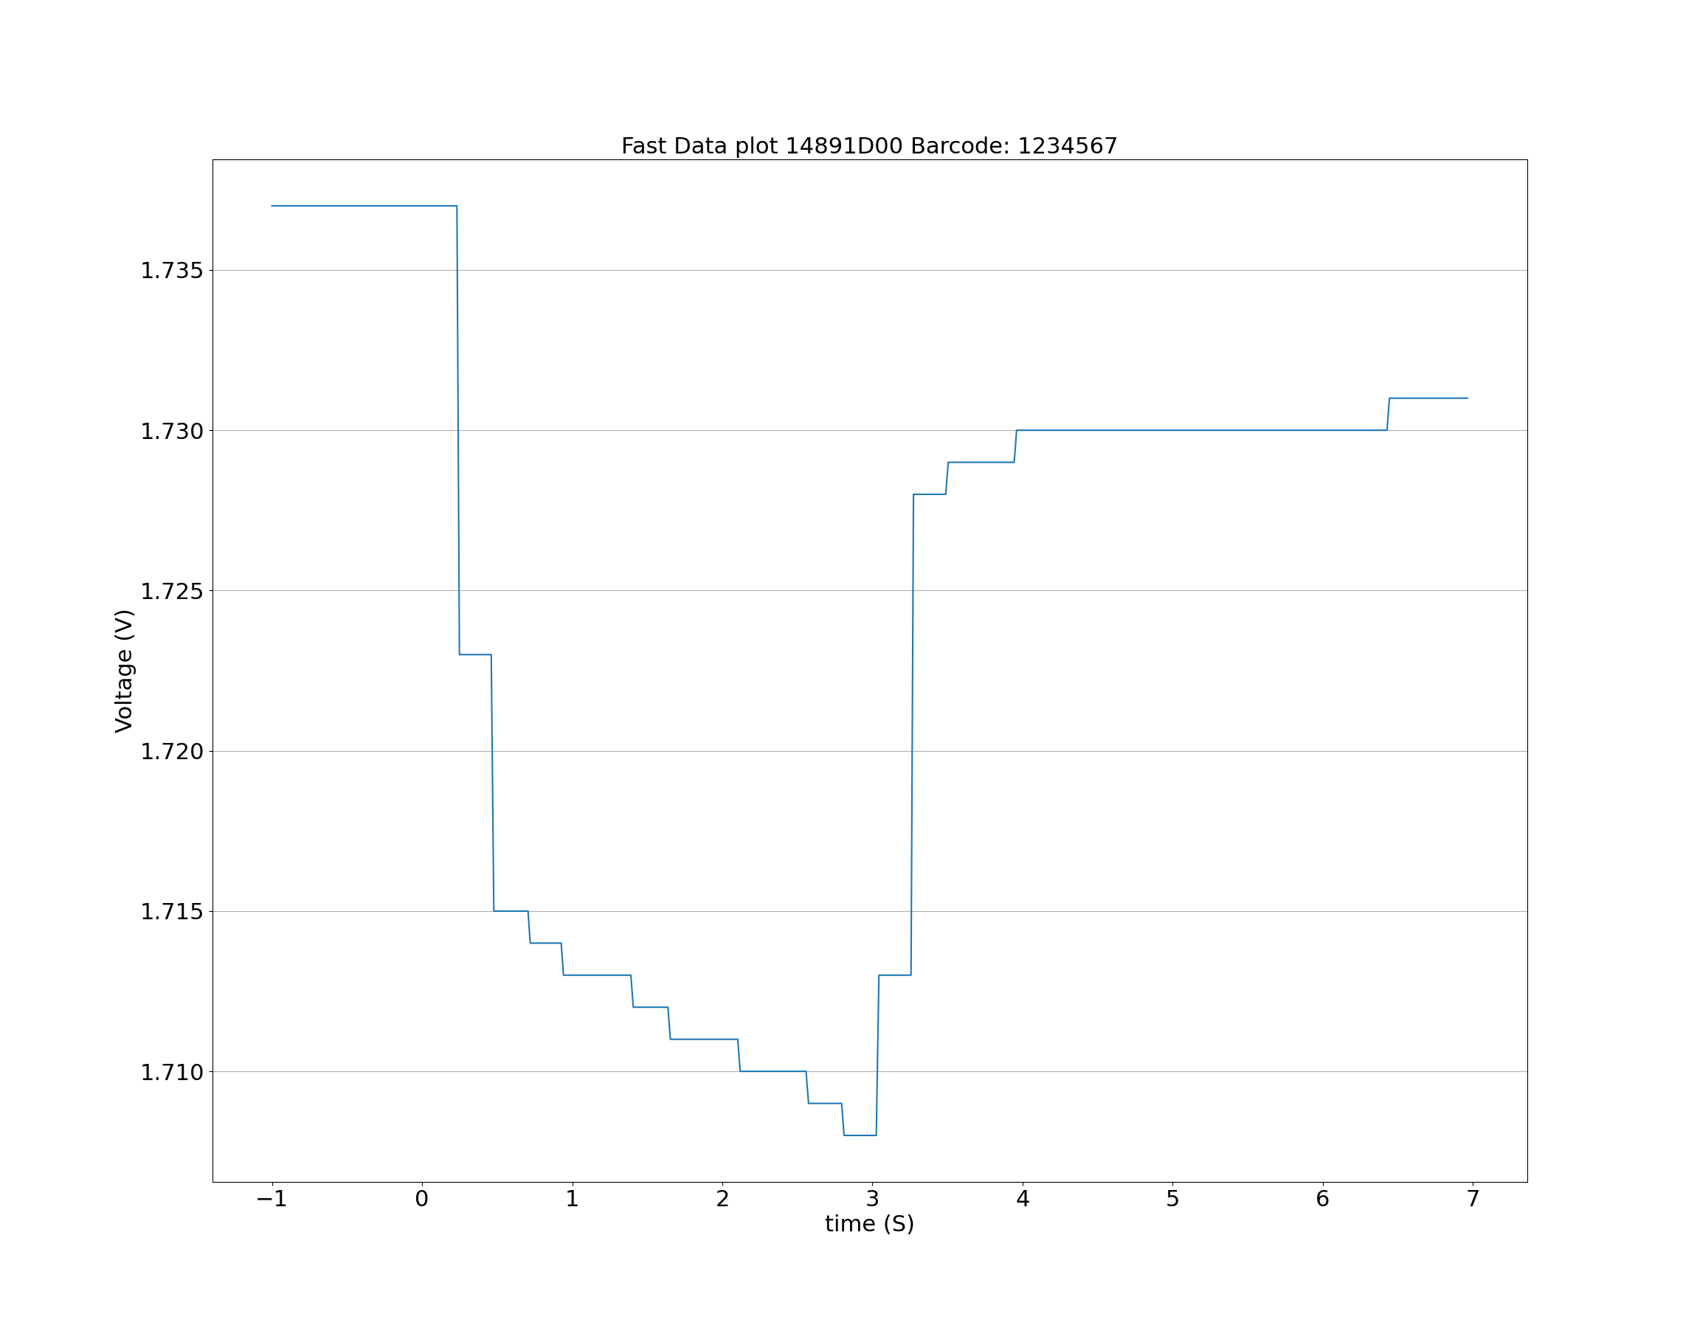

[(1.737, -1), (1.737, -0.1), (1.737, 0.0), (1.737, 0.0163), (1.737, 0.0322), (1.737, 0.0483), (1.737, 0.0654), (1.737, 0.0814), (1.737, 0.1018), (1.737, 0.1179), (1.737, 0.1346), (1.737, 0.1507), (1.737, 0.1665), (1.737, 0.182), (1.737, 0.2), (1.737, 0.2163), (1.737, 0.2324), (1.723, 0.2489), (1.723, 0.2652), (1.723, 0.2813), (1.723, 0.2978), (1.723, 0.3136), (1.723, 0.3291), (1.723, 0.3455), (1.723, 0.3614), (1.723, 0.3775), (1.723, 0.3956), (1.723, 0.4118), (1.723, 0.4276), (1.723, 0.4449), (1.723, 0.4609), (1.715, 0.478), (1.715, 0.4951), (1.715, 0.5117), (1.715, 0.5288), (1.715, 0.5449), (1.715, 0.5608), (1.715, 0.5779), (1.715, 0.5955), (1.715, 0.6116), (1.715, 0.6279), (1.715, 0.6438), (1.715, 0.6597), (1.715, 0.6749), (1.715, 0.6903), (1.715, 0.7058), (1.714, 0.7204), (1.714, 0.7366), (1.714, 0.7518), (1.714, 0.7671), (1.714, 0.7828), (1.714, 0.7981), (1.714, 0.8139), (1.714, 0.8293), (1.714, 0.8463), (1.714, 0.8622), (1.714, 0.8805), (1.714, 0.8956), (1.714, 0.9116), (1.714, 0.9268), (1.713, 0.9419), (1.713, 0.9574), (1.713, 0.9747), (1.713, 0.9911), (1.713, 1.0076), (1.713, 1.0246), (1.713, 1.0405), (1.713, 1.0572), (1.713, 1.0747), (1.713, 1.0908), (1.713, 1.1076), (1.713, 1.124), (1.713, 1.1403), (1.713, 1.1566), (1.713, 1.1741), (1.713, 1.1908), (1.713, 1.2075), (1.713, 1.2238), (1.713, 1.2399), (1.713, 1.2561), (1.713, 1.274), (1.713, 1.2904), (1.713, 1.3067), (1.713, 1.3231), (1.713, 1.3398), (1.713, 1.3569), (1.713, 1.3746), (1.713, 1.3907), (1.712, 1.407), (1.712, 1.4233), (1.712, 1.4396), (1.712, 1.4561), (1.712, 1.4736), (1.712, 1.4898), (1.712, 1.5061), (1.712, 1.5223), (1.712, 1.5385), (1.712, 1.555), (1.712, 1.5726), (1.712, 1.589), (1.712, 1.605), (1.712, 1.6215), (1.712, 1.6376), (1.711, 1.654), (1.711, 1.6717), (1.711, 1.6876), (1.711, 1.704), (1.711, 1.7201), (1.711, 1.7372), (1.711, 1.7535), (1.711, 1.7706), (1.711, 1.7876), (1.711, 1.8039), (1.711, 1.8201), (1.711, 1.8363), (1.711, 1.8526), (1.711, 1.8702), (1.711, 1.887), (1.711, 1.9034), (1.711, 1.9196), (1.711, 1.9359), (1.711, 1.9519), (1.711, 1.969), (1.711, 1.9862), (1.711, 2.0022), (1.711, 2.0192), (1.711, 2.036), (1.711, 2.0521), (1.711, 2.0692), (1.711, 2.0863), (1.711, 2.1026), (1.71, 2.1187), (1.71, 2.135), (1.71, 2.151), (1.71, 2.1691), (1.71, 2.1856), (1.71, 2.2006), (1.71, 2.2164), (1.71, 2.2313), (1.71, 2.2468), (1.71, 2.2618), (1.71, 2.277), (1.71, 2.2931), (1.71, 2.3087), (1.71, 2.3254), (1.71, 2.3413), (1.71, 2.3591), (1.71, 2.3756), (1.71, 2.3913), (1.71, 2.4078), (1.71, 2.4242), (1.71, 2.4408), (1.71, 2.458), (1.71, 2.4749), (1.71, 2.4913), (1.71, 2.5076), (1.71, 2.524), (1.71, 2.5404), (1.71, 2.5574), (1.709, 2.5743), (1.709, 2.5905), (1.709, 2.6066), (1.709, 2.6228), (1.709, 2.6388), (1.709, 2.6542), (1.709, 2.6695), (1.709, 2.6846), (1.709, 2.6999), (1.709, 2.7152), (1.709, 2.7304), (1.709, 2.7469), (1.709, 2.7628), (1.709, 2.7786), (1.709, 2.7947), (1.708, 2.8108), (1.708, 2.8262), (1.708, 2.8414), (1.708, 2.858), (1.708, 2.8746), (1.708, 2.8904), (1.708, 2.9065), (1.708, 2.9231), (1.708, 2.9405), (1.708, 2.9561), (1.708, 2.9706), (1.708, 2.993), (1.708, 3.0091), (1.708, 3.0254), (1.713, 3.0429), (1.713, 3.0592), (1.713, 3.0753), (1.713, 3.0914), (1.713, 3.1073), (1.713, 3.1241), (1.713, 3.1411), (1.713, 3.158), (1.713, 3.1743), (1.713, 3.1897), (1.713, 3.2067), (1.713, 3.2229), (1.713, 3.2405), (1.713, 3.2569), (1.728, 3.2732), (1.728, 3.2895), (1.728, 3.3052), (1.728, 3.321), (1.728, 3.3366), (1.728, 3.3516), (1.728, 3.3668), (1.728, 3.3821), (1.728, 3.3974), (1.728, 3.4126), (1.728, 3.4281), (1.728, 3.4433), (1.728, 3.4577), (1.728, 3.4738), (1.728, 3.4881), (1.729, 3.5045), (1.729, 3.5221), (1.729, 3.5383), (1.729, 3.5549), (1.729, 3.5707), (1.729, 3.5872), (1.729, 3.6033), (1.729, 3.6208), (1.729, 3.637), (1.729, 3.6532), (1.729, 3.6693), (1.729, 3.6855), (1.729, 3.7012), (1.729, 3.7191), (1.729, 3.735), (1.729, 3.7509), (1.729, 3.766), (1.729, 3.7811), (1.729, 3.7961), (1.729, 3.8123), (1.729, 3.8284), (1.729, 3.8453), (1.729, 3.8612), (1.729, 3.8774), (1.729, 3.894), (1.729, 3.9113), (1.729, 3.9276), (1.729, 3.9439), (1.73, 3.9601), (1.73, 3.9762), (1.73, 3.9924), (1.73, 4.0099), (1.73, 4.0261), (1.73, 4.0422), (1.73, 4.0581), (1.73, 4.0745), (1.73, 4.0908), (1.73, 4.1079), (1.73, 4.1243), (1.73, 4.1406), (1.73, 4.1565), (1.73, 4.1717), (1.73, 4.188), (1.73, 4.2056), (1.73, 4.221), (1.73, 4.2371), (1.73, 4.2531), (1.73, 4.269), (1.73, 4.2854), (1.73, 4.3021), (1.73, 4.3187), (1.73, 4.3353), (1.73, 4.3513), (1.73, 4.3677), (1.73, 4.384), (1.73, 4.4012), (1.73, 4.4173), (1.73, 4.4338), (1.73, 4.4501), (1.73, 4.4663), (1.73, 4.4826), (1.73, 4.4997), (1.73, 4.5154), (1.73, 4.5314), (1.73, 4.5474), (1.73, 4.5634), (1.73, 4.5799), (1.73, 4.5979), (1.73, 4.6134), (1.73, 4.6297), (1.73, 4.646), (1.73, 4.6628), (1.73, 4.6782), (1.73, 4.6965), (1.73, 4.7124), (1.73, 4.7286), (1.73, 4.7449), (1.73, 4.7604), (1.73, 4.7775), (1.73, 4.795), (1.73, 4.8112), (1.73, 4.8273), (1.73, 4.8436), (1.73, 4.8595), (1.73, 4.8758), (1.73, 4.8917), (1.73, 4.9096), (1.73, 4.9257), (1.73, 4.9418), (1.73, 4.958), (1.73, 4.9743), (1.73, 4.9905), (1.73, 5.006), (1.73, 5.021), (1.73, 5.0374), (1.73, 5.0525), (1.73, 5.0685), (1.73, 5.0838), (1.73, 5.0986), (1.73, 5.1146), (1.73, 5.1299), (1.73, 5.1451), (1.73, 5.1608), (1.73, 5.1769), (1.73, 5.1942), (1.73, 5.21), (1.73, 5.2261), (1.73, 5.2424), (1.73, 5.2586), (1.73, 5.2746), (1.73, 5.292), (1.73, 5.3072), (1.73, 5.3223), (1.73, 5.3376), (1.73, 5.3527), (1.73, 5.3675), (1.73, 5.3836), (1.73, 5.398), (1.73, 5.4139), (1.73, 5.4282), (1.73, 5.4442), (1.73, 5.4594), (1.73, 5.475), (1.73, 5.4902), (1.73, 5.5059), (1.73, 5.5214), (1.73, 5.5374), (1.73, 5.5534), (1.73, 5.5689), (1.73, 5.584), (1.73, 5.599), (1.73, 5.6142), (1.73, 5.6296), (1.73, 5.6446), (1.73, 5.6609), (1.73, 5.6775), (1.73, 5.6936), (1.73, 5.7099), (1.73, 5.7258), (1.73, 5.742), (1.73, 5.76), (1.73, 5.7762), (1.73, 5.7923), (1.73, 5.8085), (1.73, 5.8247), (1.73, 5.8409), (1.73, 5.8586), (1.73, 5.8749), (1.73, 5.891), (1.73, 5.9073), (1.73, 5.9236), (1.73, 5.9397), (1.73, 5.9573), (1.73, 5.9735), (1.73, 5.9896), (1.73, 6.0059), (1.73, 6.0212), (1.73, 6.038), (1.73, 6.0551), (1.73, 6.0713), (1.73, 6.0878), (1.73, 6.1045), (1.73, 6.1207), (1.73, 6.137), (1.73, 6.1545), (1.73, 6.1706), (1.73, 6.1868), (1.73, 6.202), (1.73, 6.2175), (1.73, 6.2322), (1.73, 6.2504), (1.73, 6.2664), (1.73, 6.283), (1.73, 6.2988), (1.73, 6.3158), (1.73, 6.3318), (1.73, 6.3497), (1.73, 6.3657), (1.73, 6.3807), (1.73, 6.3959), (1.73, 6.412), (1.73, 6.4272), (1.731, 6.4432), (1.731, 6.4597), (1.731, 6.4758), (1.731, 6.4913), (1.731, 6.5076), (1.731, 6.5236), (1.731, 6.5407), (1.731, 6.5568), (1.731, 6.5711), (1.731, 6.5872), (1.731, 6.6025), (1.731, 6.6178), (1.731, 6.6332), (1.731, 6.65), (1.731, 6.666), (1.731, 6.6819), (1.731, 6.6981), (1.731, 6.7154), (1.731, 6.7327), (1.731, 6.7489), (1.731, 6.7649), (1.731, 6.7812), (1.731, 6.7979), (1.731, 6.8146), (1.731, 6.8317), (1.731, 6.848), (1.731, 6.8646), (1.731, 6.8806), (1.731, 6.8969), (1.731, 6.9132), (1.731, 6.9309), (1.731, 6.947), (1.731, 6.9632)]