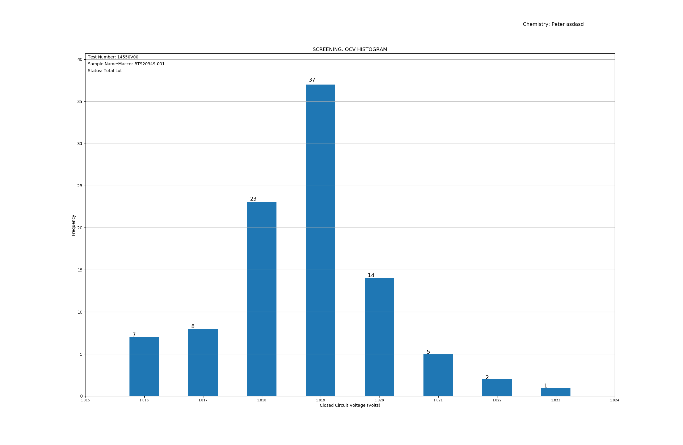

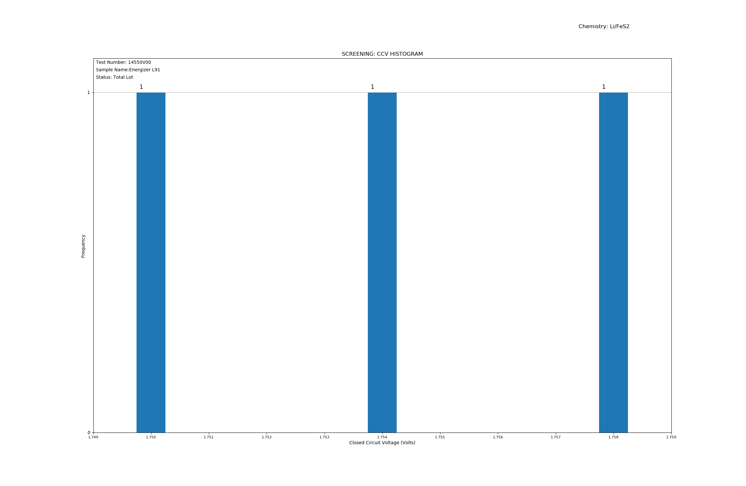

**SCREEING REPORT** Page: 1

**Test Number:** FunTesting2  **Report Date:** 2019-12-03

**Battery Name:** Energizer L91

**Chemistry:** Li/FeS2

_________________________________________________________________________________________________________

**Request Number:** p

**Task Number:** e

**Lot Number:** 9613

**Form Factor:** Cylindrical AA

**Purpose:** e

**Project Engineer:** t

Criteria: Section One Min. Section TwoMin.

**OCV (Volt):** 1.51.5

**CCV (Volt):** 1.41.4

**Drain Time (Sec):** 22

**Resistor (Ω): :** 2525

_________________________________________________________________________________________________________

**Battery Size (cm):** 50.5(H) X 14.0(D)

**Discharge Temperature (°C):** 24

_________________________________________________________________________________________________________

**Number of Batteries Tested :** 3

**Number of Batteries Failled(*):** 0

_________________________________________________________________________________________________________

**Date of Manufacture:** 2/15/2016

**Date of Receipt:** 6/23/2016

**Date Started:** 10/21/2019

**Date Completed:** 10/21/2019

_________________________________________________________________________________________________________

Prepared By: ____________ Date: ___________ Reviewed By: ________________ Date: ____________

Reviewed By: ________________ Date: ____________

**Test Number:** FunTesting2

Note(s):  
  
1. Report Date:  
  
2. Test Responsibility:  
   
 a. Data file preparation:  
 b. Technical review:  
 c. Final review: