**Part 1: Capturing HTTP Traffic.**

Task 1: Start Wireshark and capture packets.

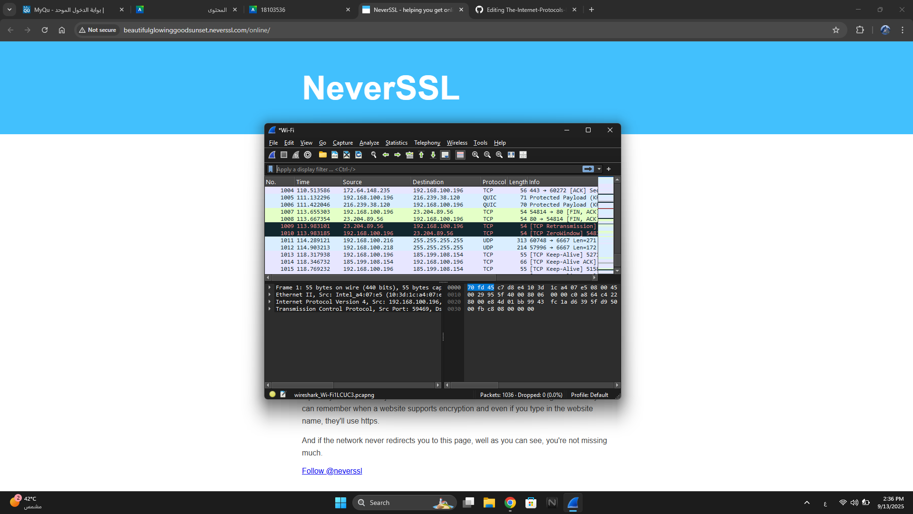

Task 2: Filter HTTP packets and analyze them.

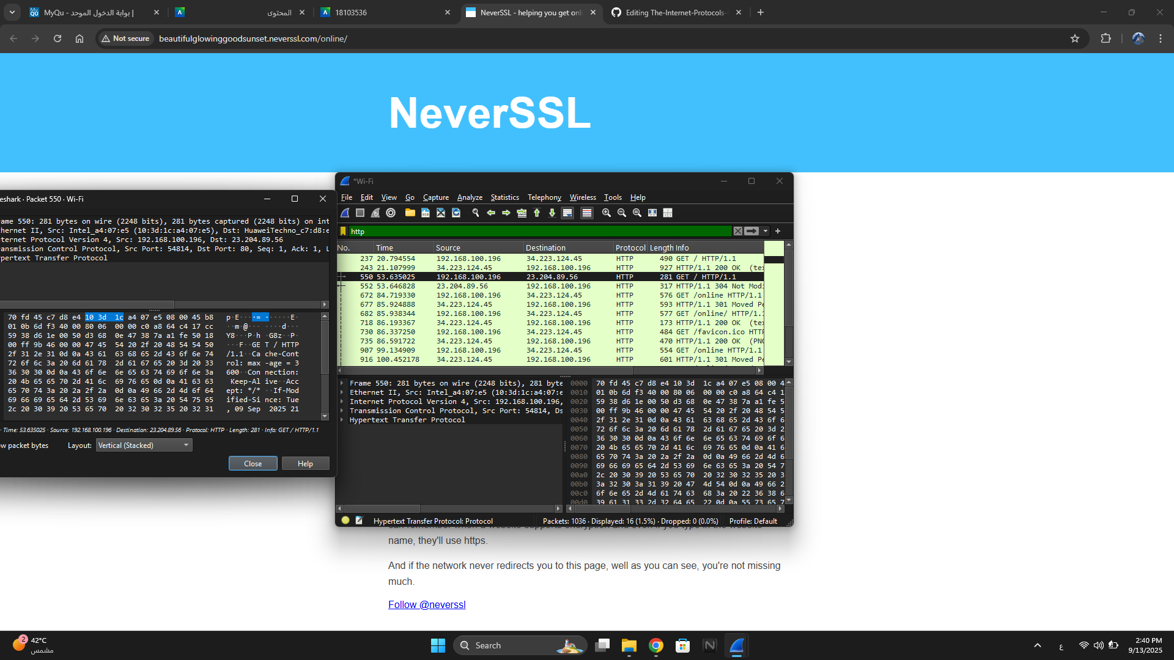

**Part 2: Analyzing TCP/IP Traffic.**

Task 1: Filter TCP packets.

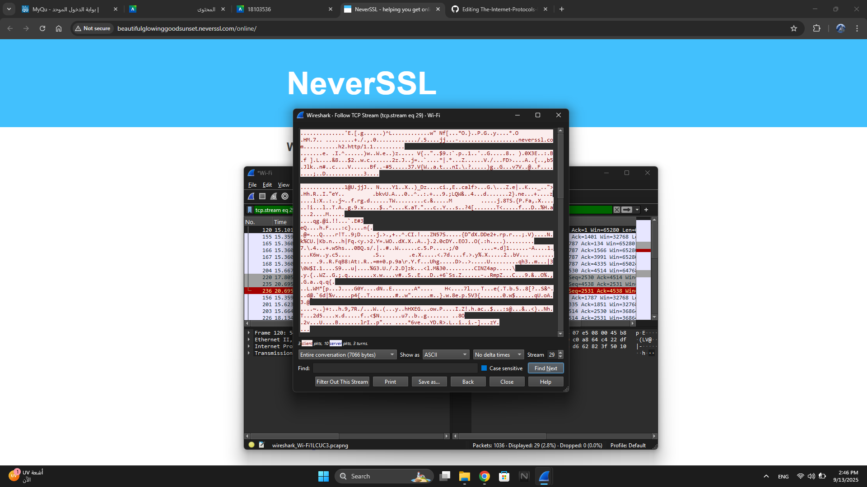

Task 2: Analyze TCP handshake and investigate Data Transfer and Termination

1.

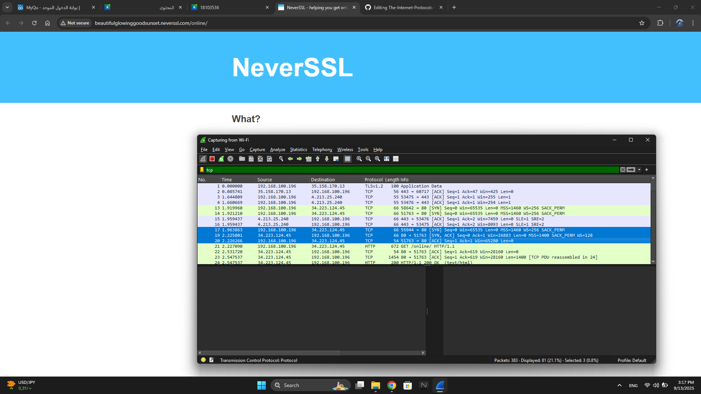

2.

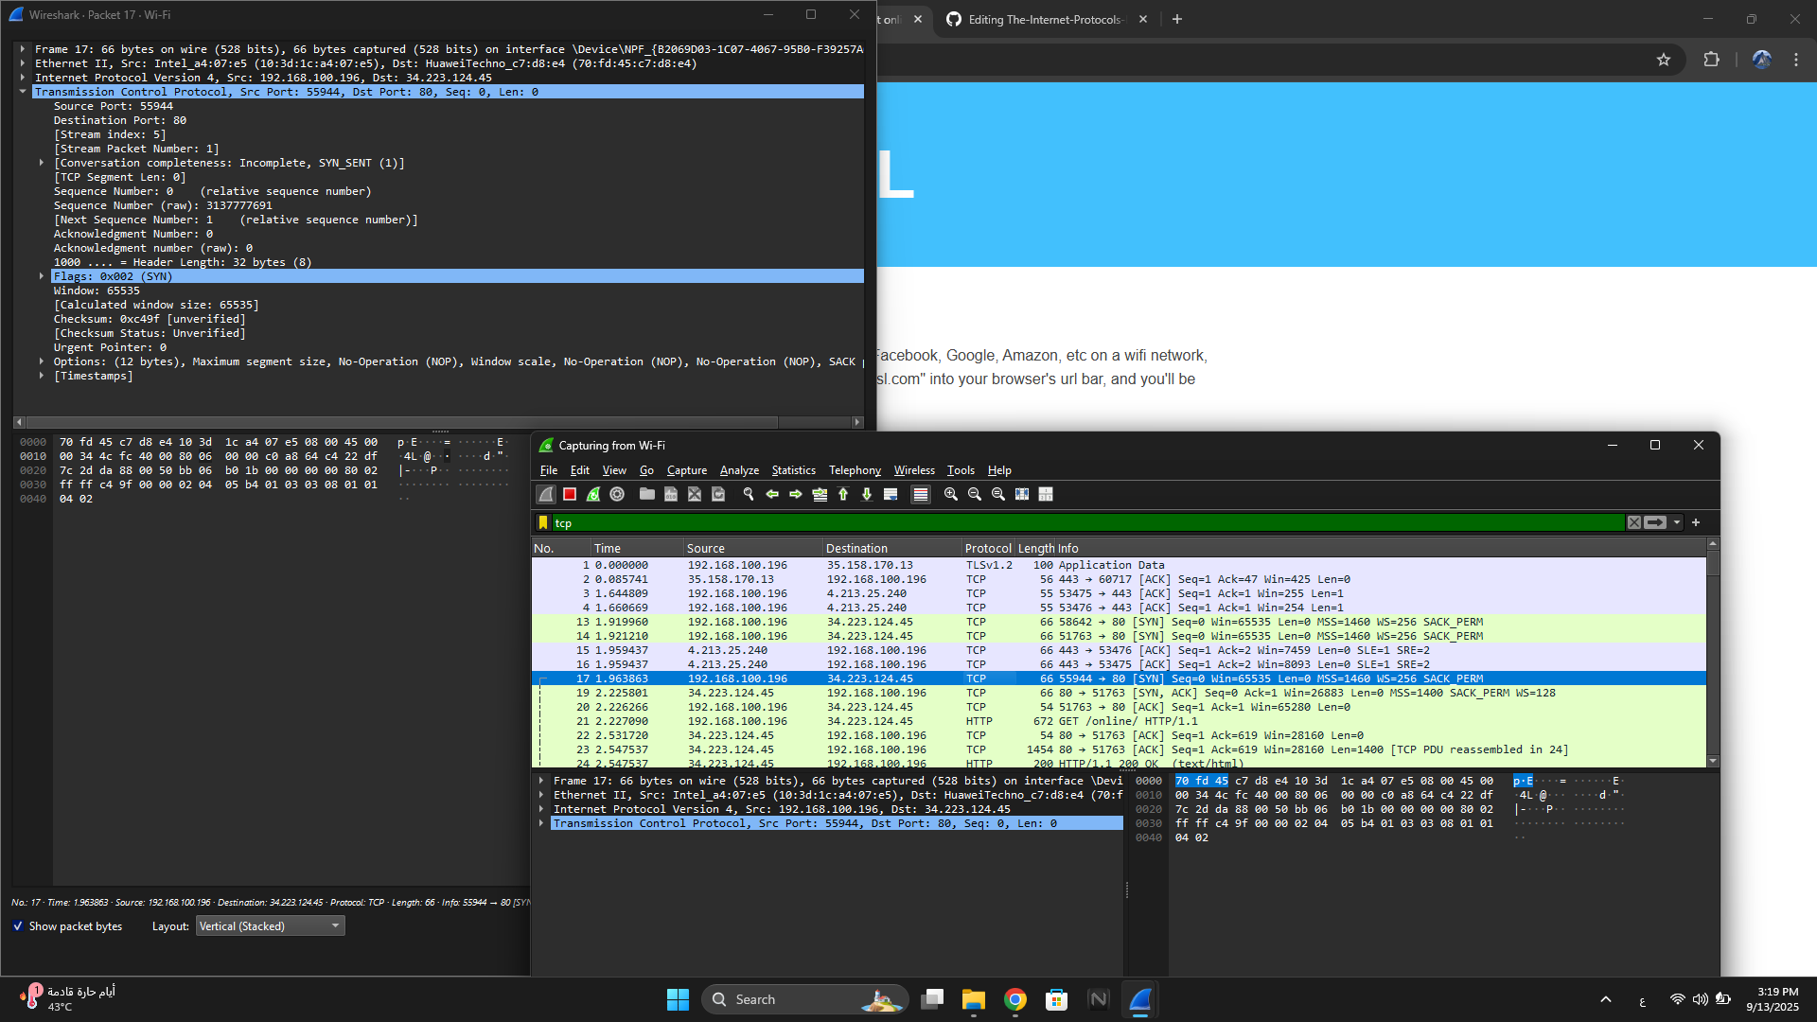

**Part 3: Capturing and Analyzing UDP Traffic**

Task 1: Generate UDP traffic and capture packets

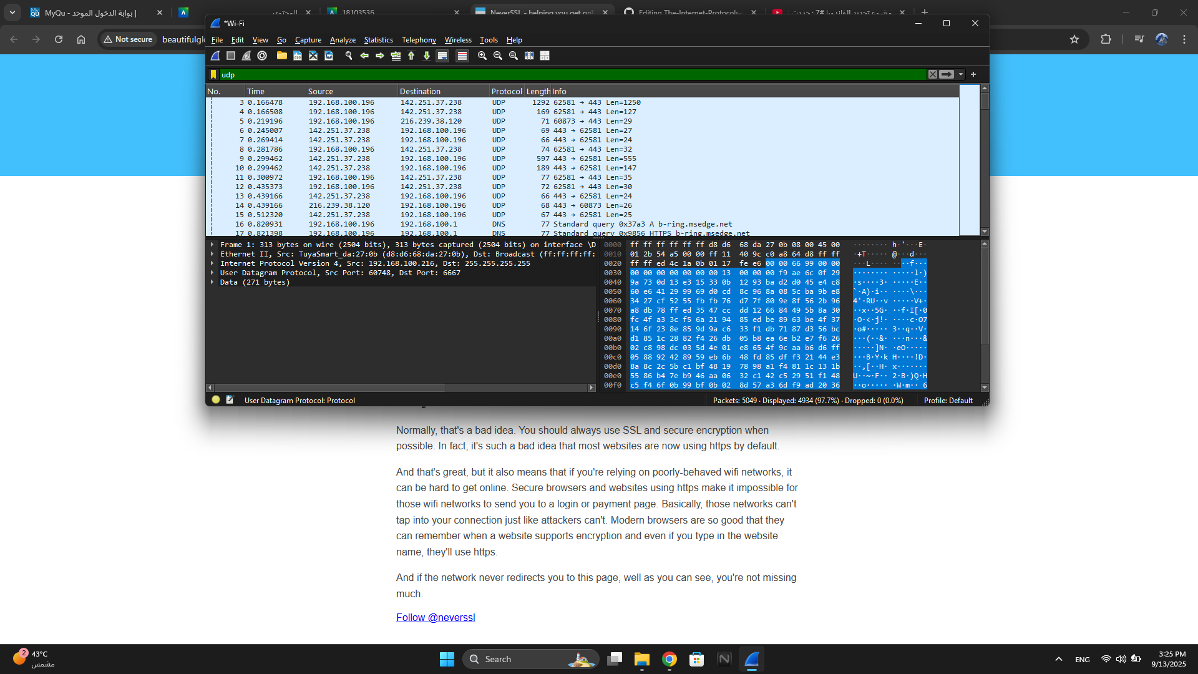

Task 2: Filter and analysis UDP Packets

1.

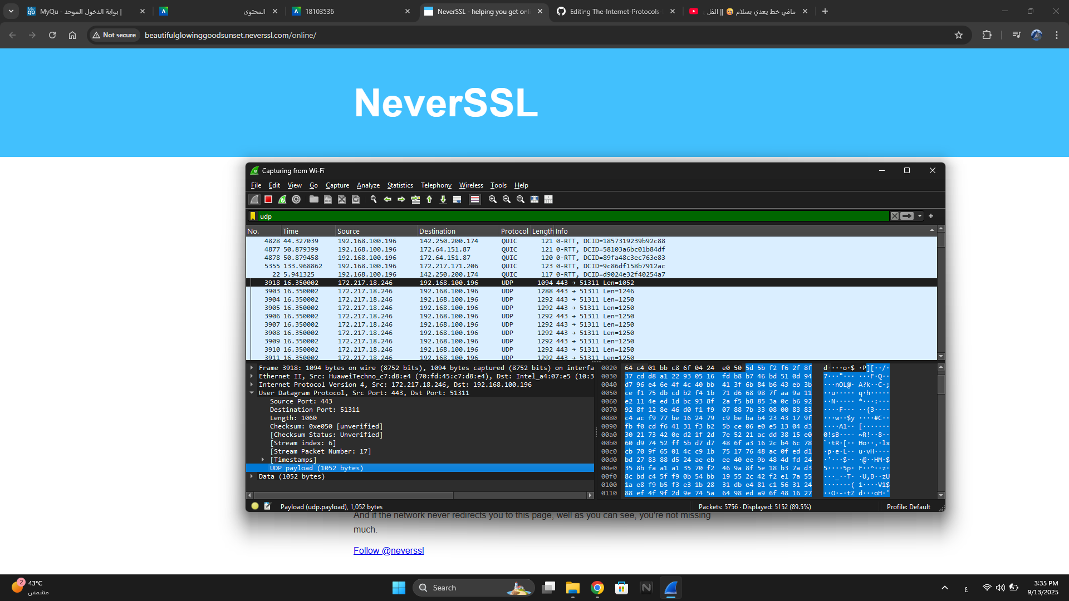

2.

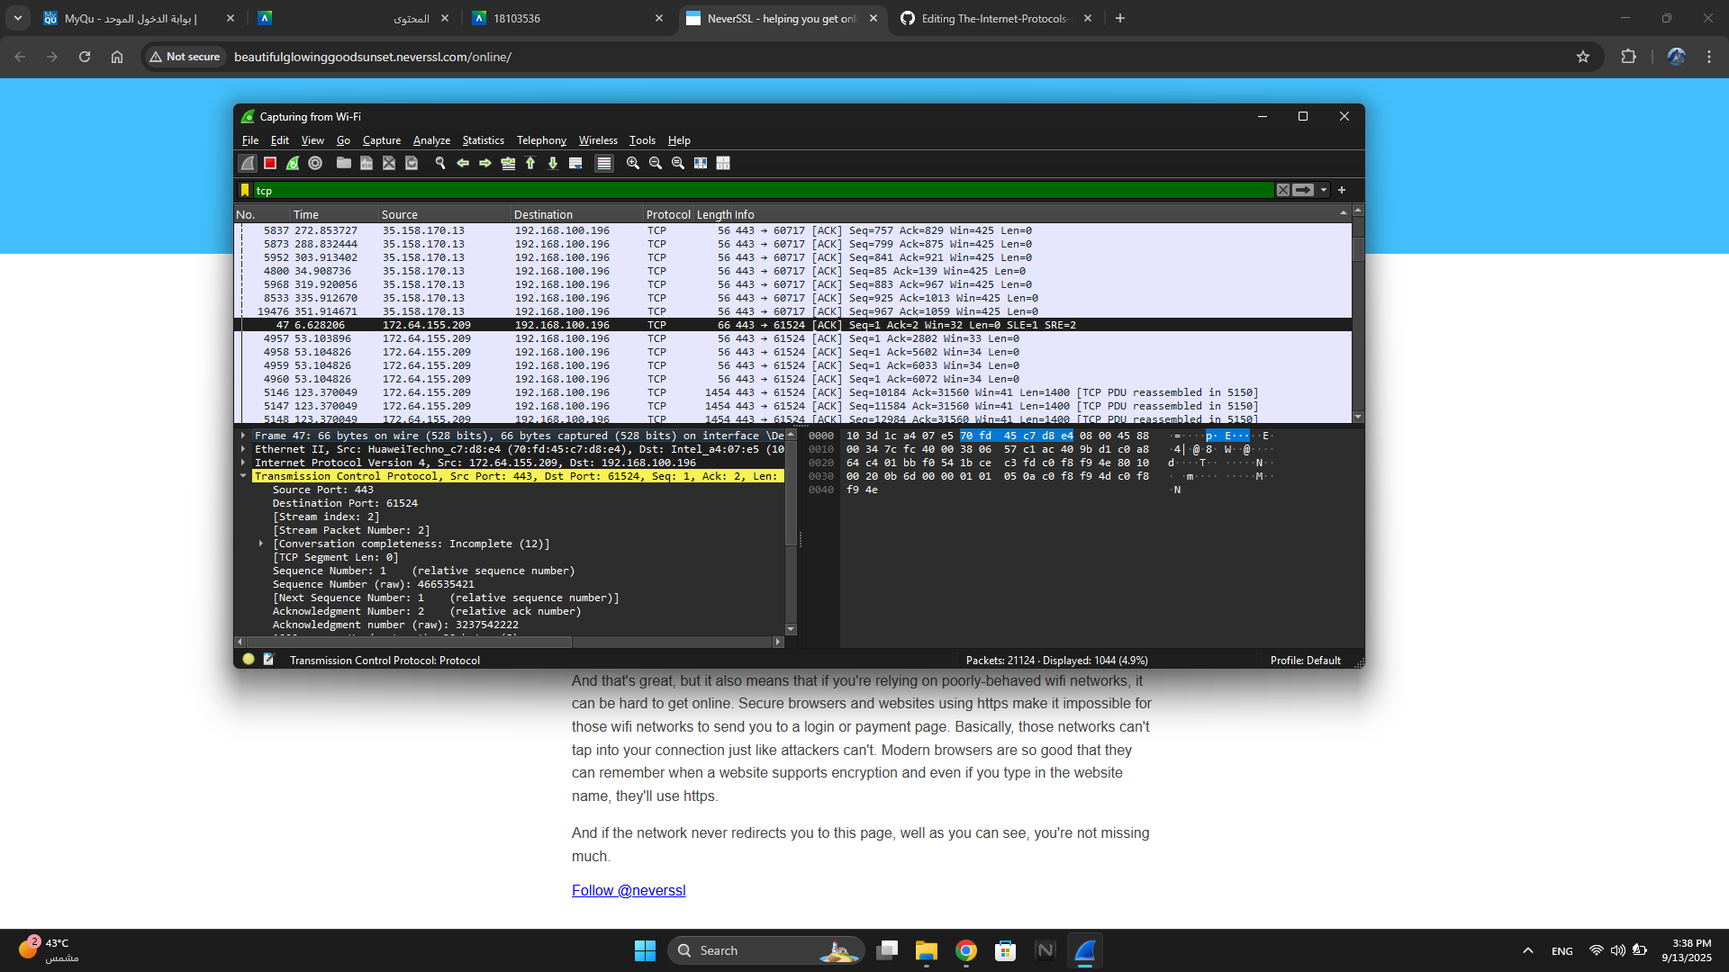

**Part 4: Comparing TCP and UDP by filling in the following tables. Save your work (e.g., in an MS Word document), and upload it to your online git repo**

Task 1: Fill in the following table and provide reasons.

|  | **TCP or UDP** | **Reasons** |
| --- | --- | --- |
| Reliability and Connection Establishment | TCP | Reliable and connection-oriented. Establishes connection with three-way handshake (SYN, SYN-ACK, ACK). Ensures data delivery and order. |
| Data Integrity and Ordering | UDP | Connectionless and unreliable. Sends packets without handshake; no guarantee of delivery or order. |

Task 2: Identify the use Cases and Performance of TCP and UDP.

|  | TCP | UDP |
| --- | --- | --- |
| Use cases | - Web browsing (HTTP/HTTPS)  - Email  - File Transfer (FTP)  - Secure communication | - Video/Audio streaming  - VoIP  - Online gaming  - DNS queries |
| Performance | Slower due to connection setup and reliability overhead (handshake, acknowledgments, retransmissions) | - Faster, lightweight, minimal overhead, no retransmissions |