Hiii

First, I think that I did what was required of me in the task.

the idea was create and determine prefix and middleware of routes from RouteServiceProvider

* api -> auth -> guard ->api for api’s I use Passport token
* web -> auth -> guard -> web for web session
* admin -> this create new for solve problem update and create products elc by use routes api but in web guard prevent that because make api auth expect login and register

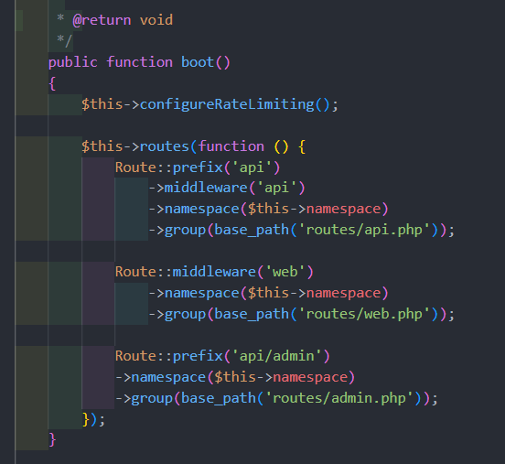

and in config->auth.php make guardes for api passport

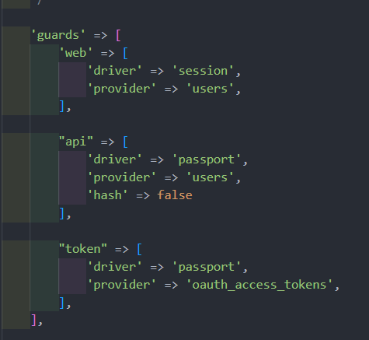

in databse I create users,types,roles,role_user,products

idea in price display for user by his type so make price attribute json.

products:

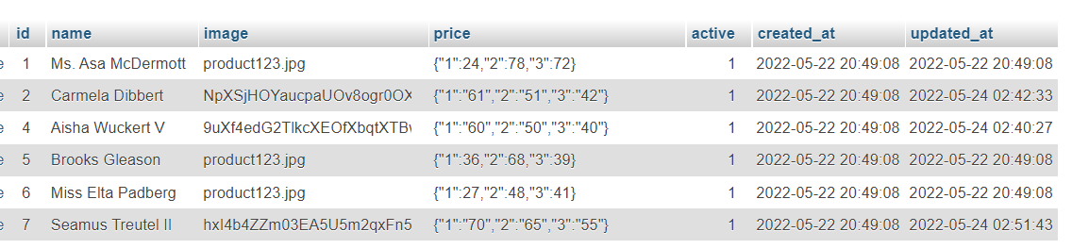

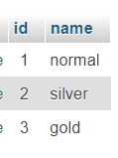

<<- types

type_id in users table

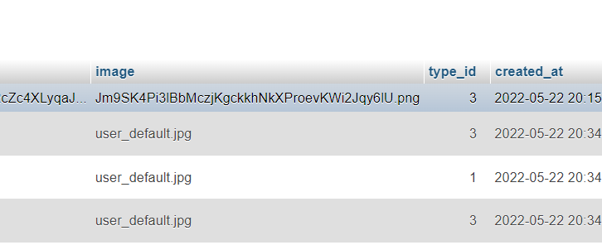

type has many user relationship

api routes

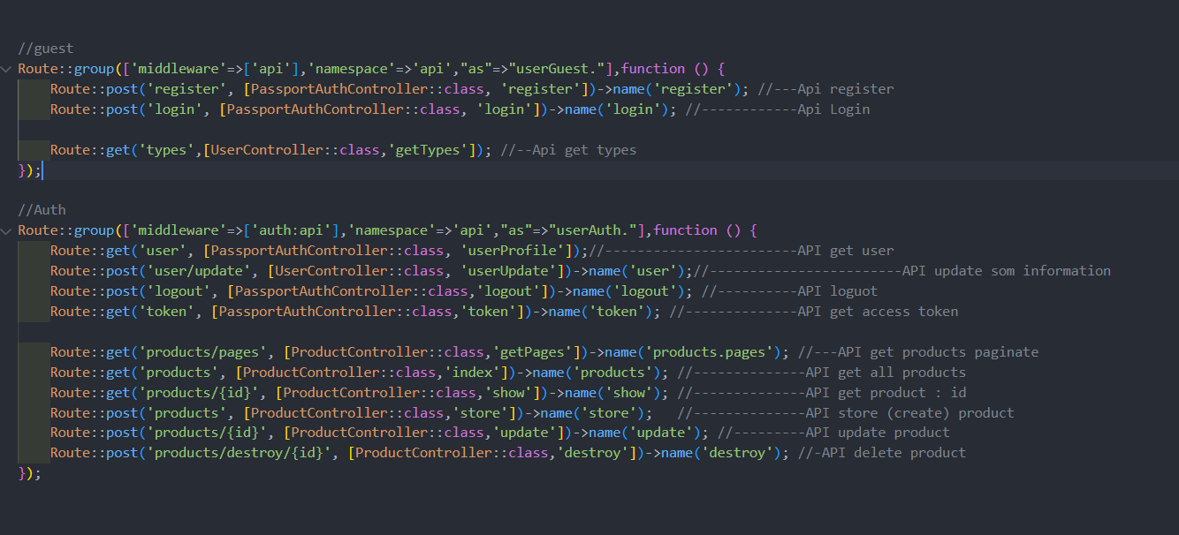

web route just to display pages to use vue.js

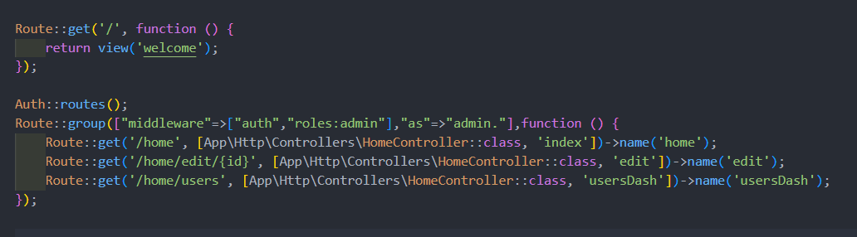

admin routs

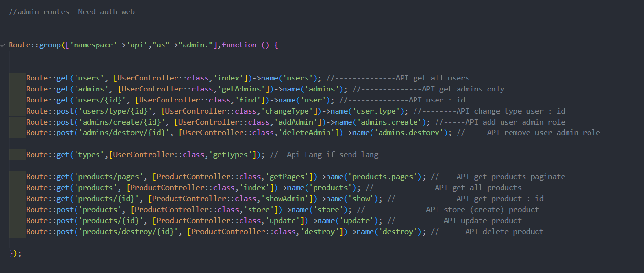

same api route but it use jus web auth and has admin role to open dashboard

by roles middleware

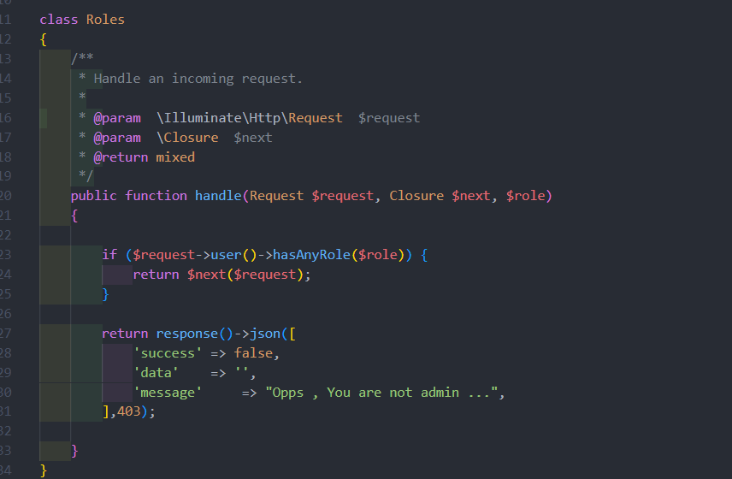

user many to many roles relationship

ues repository

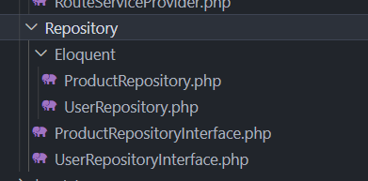

userRepositoryInterface

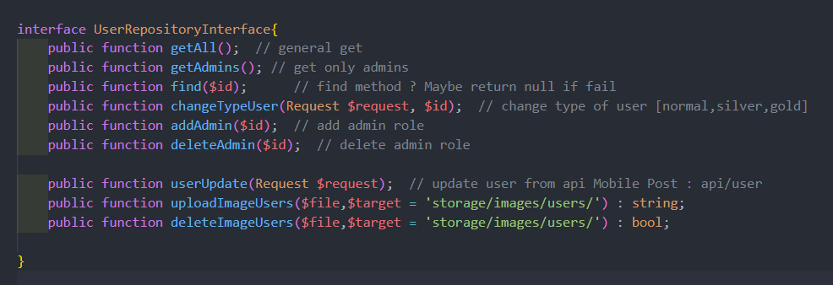

productRepositoryInterface

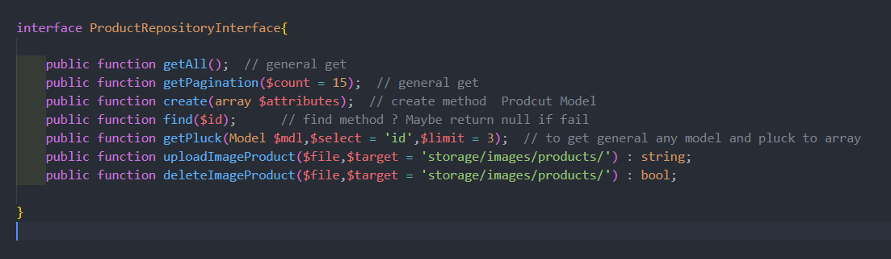

use BaseController for return unique json

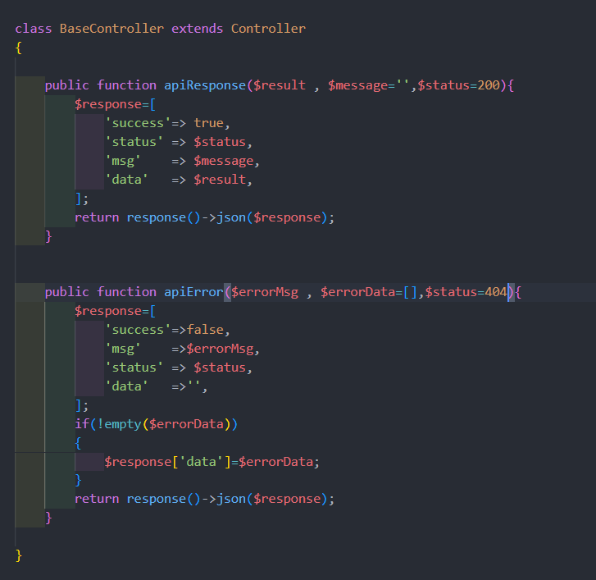

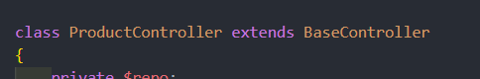

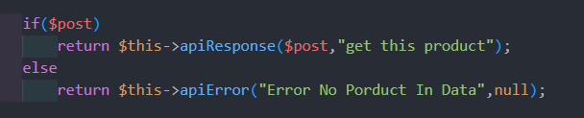

see : https://github.com/waadmawlood/taskDishNetwork