Task1: Install Ros and Ubuntu

First to you need to install Virtual Box:

To install it go to <https://www.virtualbox.org/>

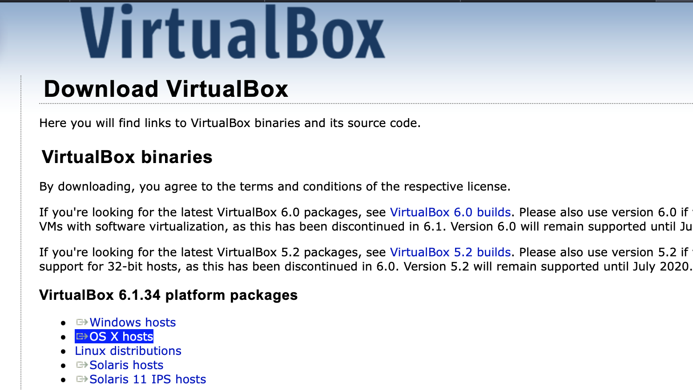

Second to install ubuntu go to <https://ubuntu.com/download/desktop>

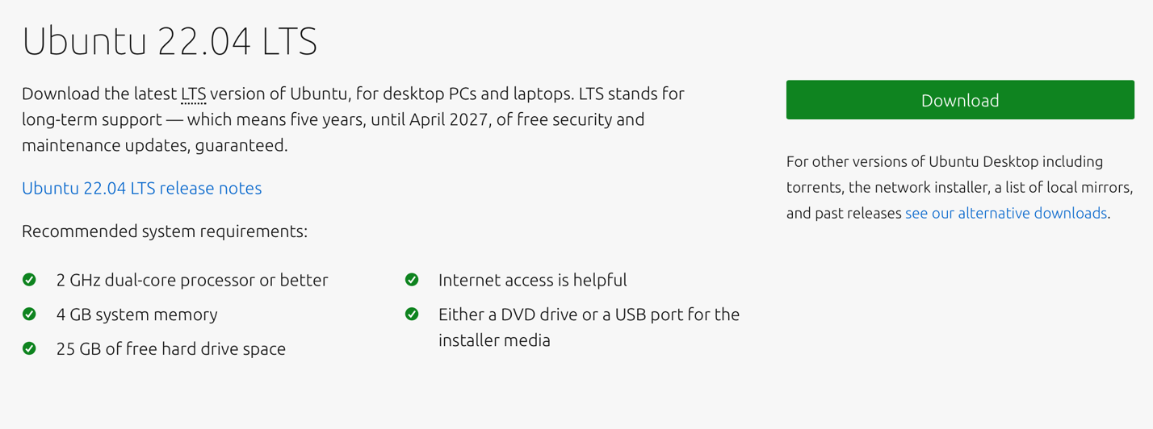

Third to install ROS on virtual box using ubuntu commands on this website <http://wiki.ros.org/noetic/Installation/Ubuntu>

Task 2: installing ROS2

First install ROS2-foxy from this website <https://docs.ros.org/en/foxy/Installation/Ubuntu-Install-Debians.html#id8>

Enter the commands in ubuntu

Finally download Balena for jetson nano

<https://www.balena.io/etcher/>