E-Project: online Vaccination Booking System

FLOWCHART:

ABOUT US

SERVICES

REGISTER/LOGIN

HOME

CHILD REGISTRATION

APPOINTMENT

ADD HOSPITAL

USER PROFILE

FOOTER

APPROVED APPOINMENTST

REGISTRATION:

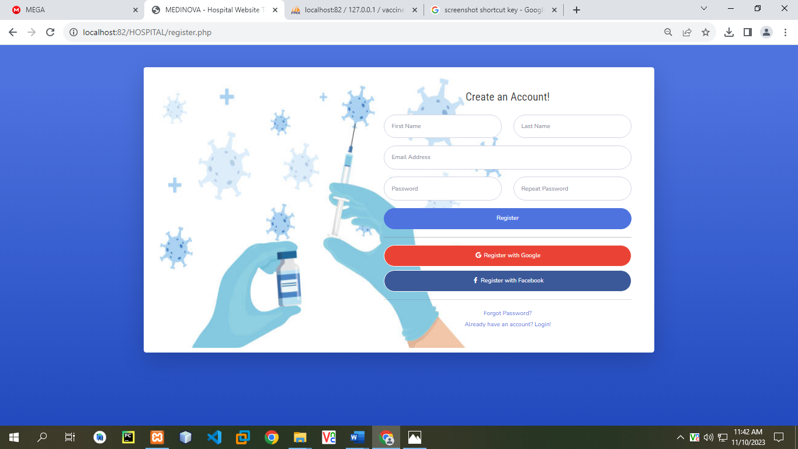

LOGIN:

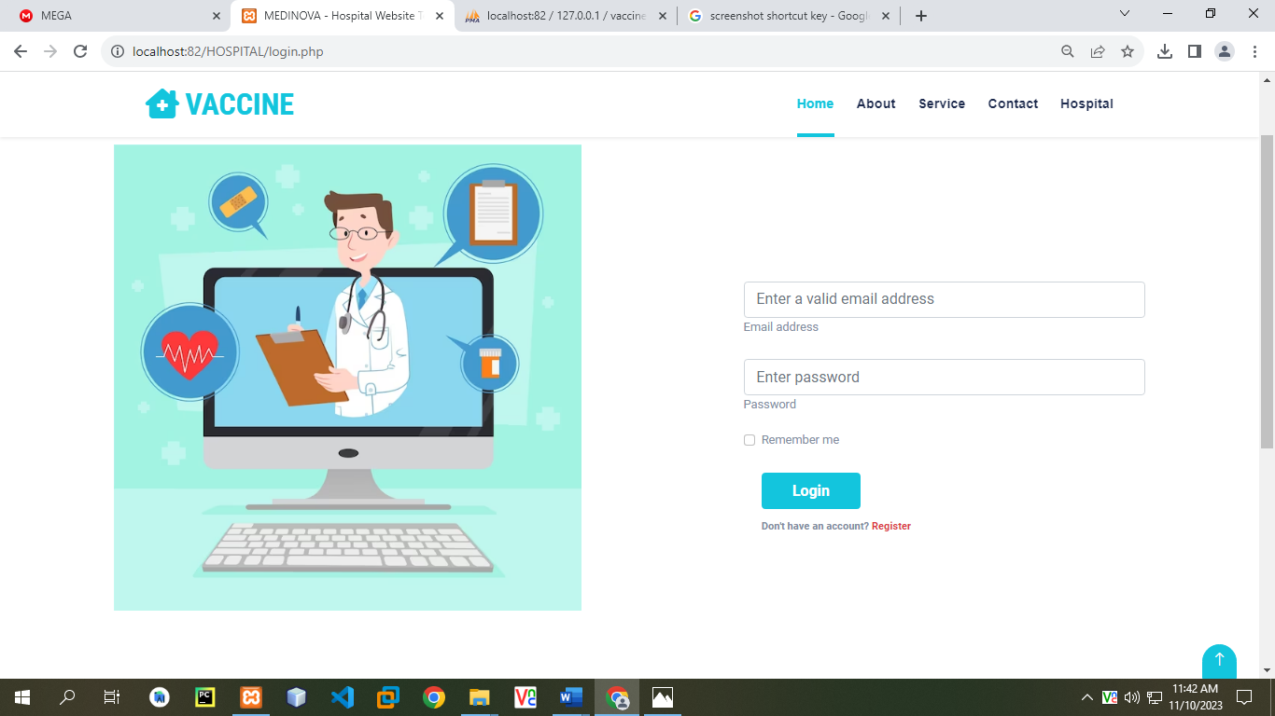

HOME:

****

ABOUT US:



SERVICES: 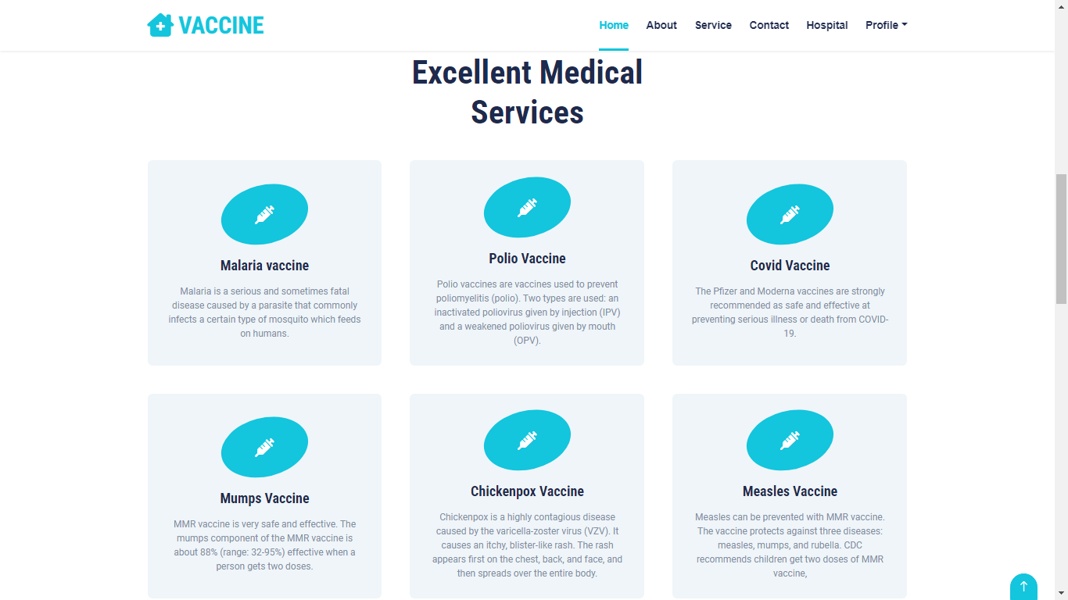

ADD HOSPITAL:

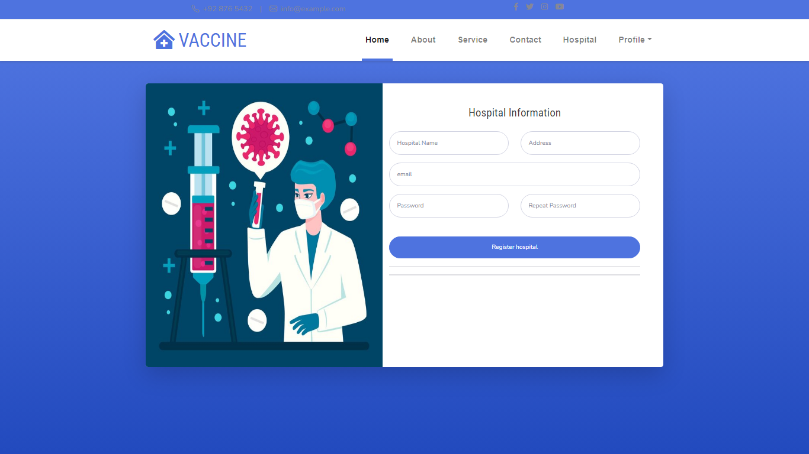

USER PROFILE:

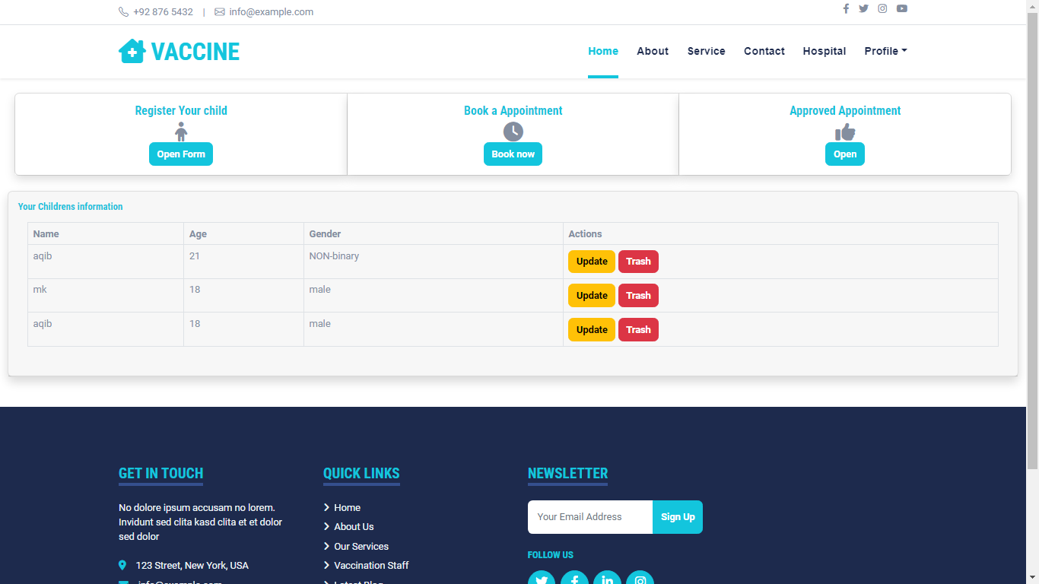

CHILD REGISTRATION:

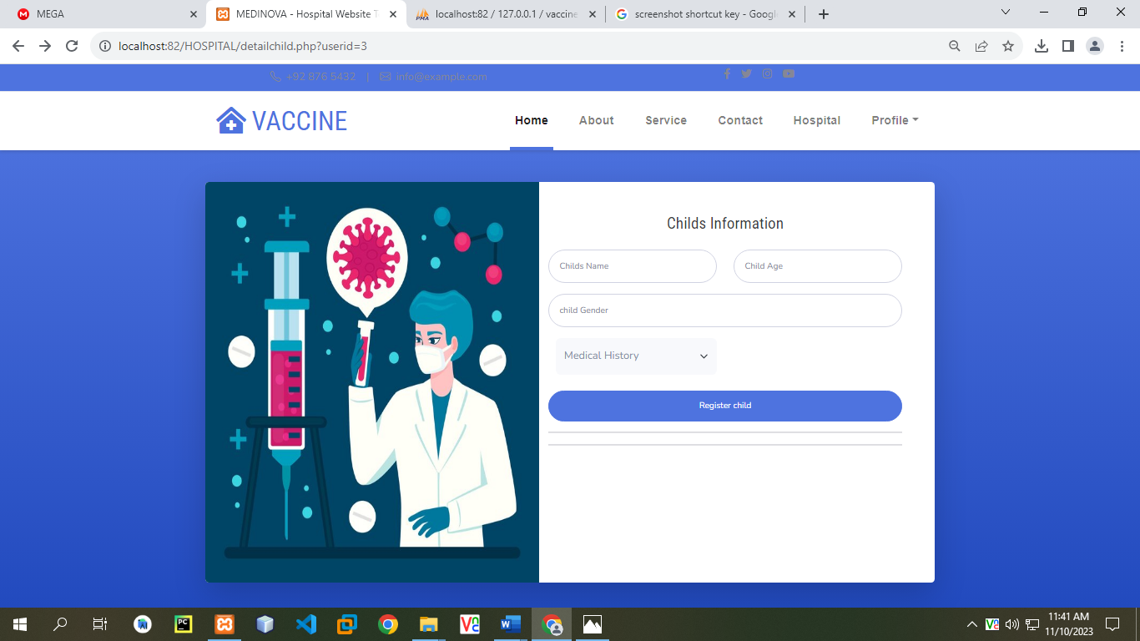

APPOINTMENT:

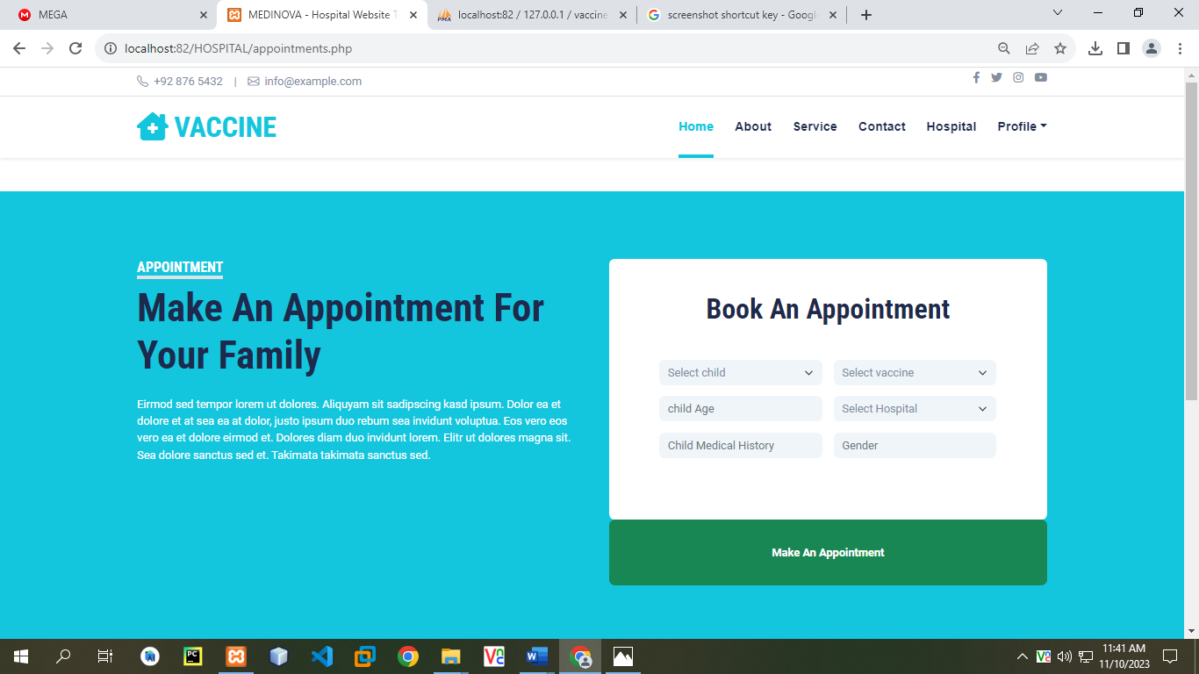

APPROVED APPOINTMENTS:

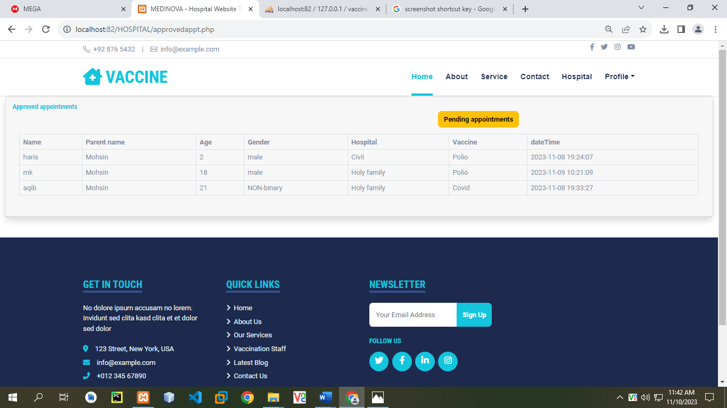

FOOTER:

