Environment Control for Grow Facilities
A Product of Triton Technologies, Inc.
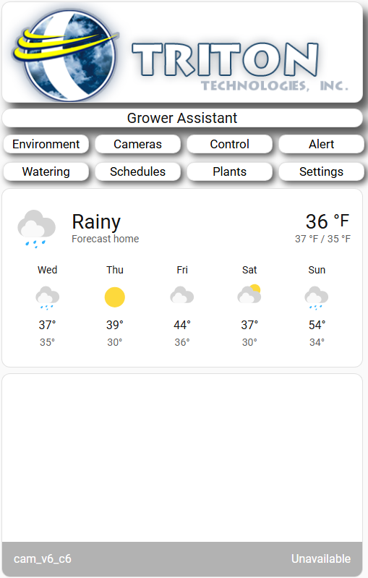 | Main menu – overview  The TTI-GA Grower Assistant is an automation solution designed to eliminate the variables in indoor cultivation.  By leveraging an AI integrated computer appliance the TTI-GA moves your facility beyond simple timers and into the era of localized, data-driven intelligence.  All controls are accessable locally or remote. You can access the system through any web browser as well as your smartphone ¹  ¹ Internet access with WIFI at the facility is required for this feature.

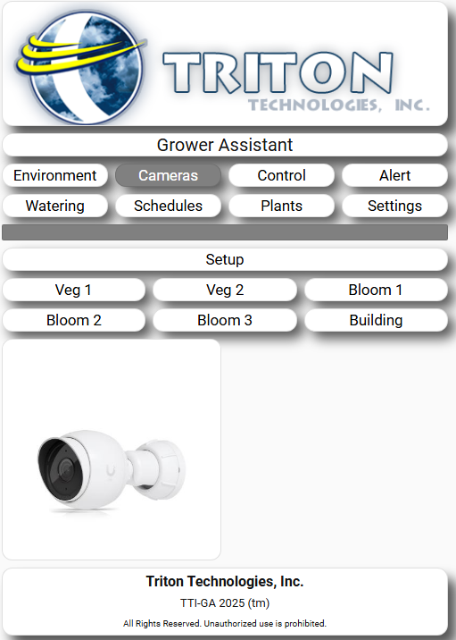 | Cameras  Cameras see what is happening at your grow facility.  It is layed out a six pages of six cameras. 36 total cameras. You define the name of the area and enter the camera information.  This setup uses rtsp (real time streaming protocol)

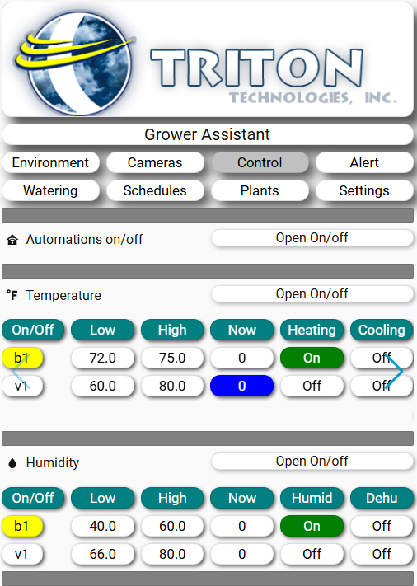 |  | Control  The system provides real-time adjustments and deep historical logging for the six pillars of plant health:  - Temperature & Humidity: Maintain perfect atmospheric conditions using standard Honeywell and Nest controls.  - VPD (Vapor Pressure Deficit): The system calculates VPD in real-time, allowing you to optimize transpiration and nutrient uptake.  - CO2 Enrichment: Automated CO2 injection based on sensor thresholds to maximize photosynthetic rates.  - Lighting: Full schedule and intensity control with dimming capabilities.  - Watering: Precise irrigation cycles managed through Open Sprinkler integration and inexpensive sensors.
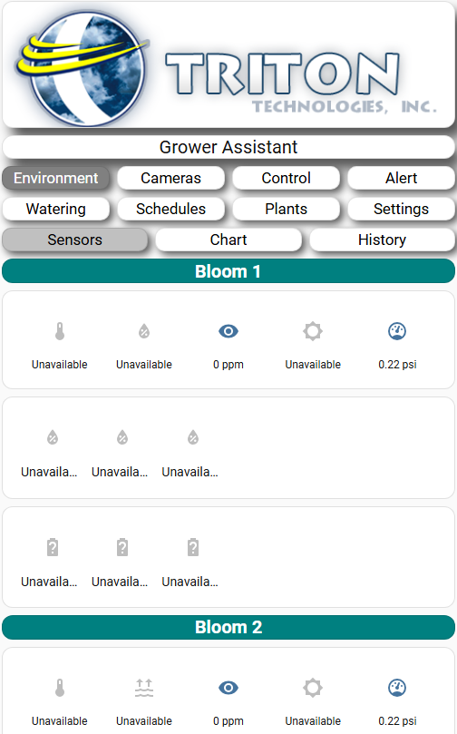 | Environment  This is a quick glance at the conditions in all rooms.  An ICON with values beneath for Temperature, Humidity, CO2, Light and VPI make up the first row. Soil moisture and temperature make up the second row and sensor battery levels make up the third row.  Each ICON may be clicked to show historical data from the past 24 hours to the past 120+ days.Control  The system provides real-time adjustments and deep historical logging for the six pillars of plant health:  - Temperature & Humidity: Maintain perfect atmospheric conditions using standard Honeywell and Nest controls.  - VPD (Vapor Pressure Deficit): The system calculates VPD in real-time, allowing you to optimize transpiration and nutrient uptake.  - CO2 Enrichment: Automated CO2 injection based on sensor thresholds to maximize photosynthetic rates.  - Lighting: Full schedule and intensity control with dimming capabilities.  Watering: Precise irrigation cycles managed through Open Sprinkler integration and inexpensive sensors

Technical Specifications
Component | Specification
Brain | TTI-GA computer, Intel based.
Platform | Home Assistant (Private, Local Processing)
Connectivity | WIFI, Zigbee 3.0, Z-Wave Plus
Hardware Partners | Honeywell, Sonoff, Shelly, Grier
Access | Smartphone (iOS/Android) &  Desktop Local and Remote Access
Storage | Local database for multi-year historical tracking

[IMAGE 3: Mobile Interface - Showing the smartphone app view]

Why TTI-GA?

1. Local Reliability, Global Access
Unlike cloud-dependent systems, the TTI-GA lives on your local network. If your internet goes down, your plants are still safe. When you are away, secure remote access keeps you in control from your smartphone.

2. History is Your Teacher
Every event—from a temperature spike to a watering cycle—is recorded. Compare current crop performance against previous harvests to dial in the perfect "recipe" for your specific strains.

3. Universal Compatibility
By utilizing Wi-Fi, Zigbee, and Z-Wave simultaneously, the TTI-GA is not locked into one brand. We use the best hardware from Honeywell and Shelly to ensure your hardware is as professional as your product.

Contact Us
Triton Technologies, Inc. Precision Solutions for Professional Growers

Next Step: Once you upload the screenshots, I can describe them specifically in the text or even suggest captions for each one. Would you like me to add a "System Requirements" section or a "Sample Automation" list (e.g., "If Temp > 85°F, then Turn on Exhaust")?

