[LOGO]

Internal Audit Procedure

Document Code. | [DOCUMENT CODE]
Revision No. | [REVISION]
Effective Date | [EFFECTIVE DATE]
Review Date | [NEXT REVIEW DATE]
Classification | [CLASSIFICATION]

REVIEW AND APPROVAL
Prepared By:
Name | [PREPARED BY] | Date | [PREPARED DATE]
Reviewed By:
Name | [REVIEWED BY] | Date | [REVIEWED DATE]
Approved By:
Name | [APPROVED BY] | Date | [APPROVED DATE]

REVISION HISTORY
Effective Date | Rev. No. | Page No. | Description of Amendments
 | 0 | – | Final version for release

Reference: ISO/IEC 27001:2022 Requirement
Clause/Control | Requirement
9.2 | Internal audit

Index
Index 3
1. Objective 4
2. Scope 4
3. Role and Responsibility 4
4. Definition 5
5. Entry Criteria 5
6. Procedure 6
6.1 Internal Audit Procedure 6
6.1.1 Workflow Diagram 6
6.1.2 Details of the internal audit 7
7. Exit Criteria 9
8. Schedule 10
9. Supporting Documents 10

Objective
This procedure is established to describe the internal audit process of the company for monitoring and ensuring the proper and appropriate implementation of the Management System.

Scope
The procedure for conducting internal audits of the management system is applicable to [MANAGEMENT SYSTEM STANDARDS]. It covers [IN-SCOPE DEPARTMENTS] at [ORGANISATION NAME] (hereinafter referred to as “the Company”).

Role and Responsibility
Role | Responsibility
[STEERING COMMITTEE] | Selection of internal auditors
[AUDIT PROGRAMME OWNER] | - Announce the appointment of individuals responsible for the internal audit.  - Plan and create the Annual Audit Schedule.  - Notify the audit schedule to the auditors and Lead Auditor.  - Obtain approval to conduct the audit.  - Provide the annual audit schedule to the selected internal auditors, Lead Auditor, and auditees.
Lead Auditor | - Prepare the internal audit plan and distribute copies of the plan to the internal audit team.  - Conduct the opening meeting with management or the representative of the audited department.  - Hold a closing meeting at the end of the audit on the last day of the audit in that department.  - Prepare the Internal Audit Report and issue a Corrective Action Request (CAR).
Internal auditor | - Prepare the internal audit checklist to be used during the audit.  - Conduct the internal audit to assess the alignment of documents with actual practices and record the audit results in the internal audit checklist.  - Perform follow-up audits and document the results in order to close the CAR if corrective actions are completed, or to open a new CAR if corrective actions are still pending.  - Retain internal audit records in accordance with the Record Control Procedure.

Definition
Term | Definition
Internal auditor | Refers to individuals who are qualified to conduct audits within the Management System. They must have [INTERNAL AUDITOR QUALIFICATION].
Auditee | Refers to departments within the company that fall within the scope of the audit, as well as relevant external parties, such as external service providers.
Audit | Systematic, independent and documented process for obtaining audit evidence and evaluating it objectively to determine the extent to which the audit criteria are fulfilled
Conformity | Fulfilment of a requirement
Corrective action | Action to eliminate the cause or reduce the likelihood of recurrence of a detected nonconformity or other undesirable situation
Nonconformity | Non-fulfilment of a requirement
The Company | Means [ORGANISATION NAME]

Entry Criteria
The commencement of the annual audit or audit as per the scheduled timeframe.

Procedure

Internal Audit Procedure

[AUDIT WORKFLOW DIAGRAM]
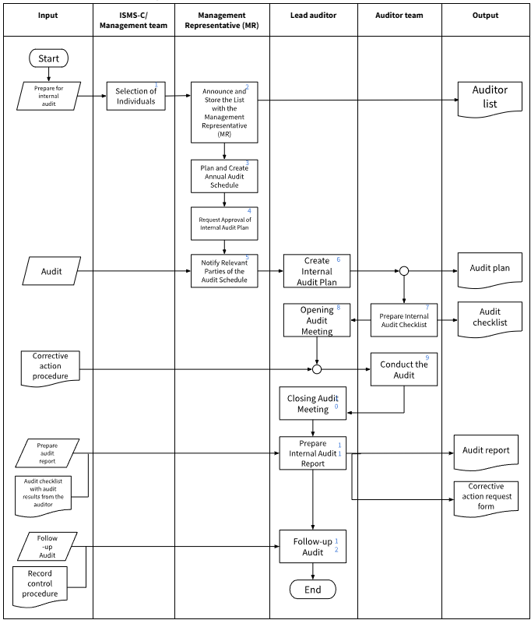

Details of the internal audit
Event | - Internal audit  - Corrective Action Procedure  - Internal audit report  - Internal Audit Checklist  - Follow-up Audit  - Record Control Procedure
No. | Activity | Description
1 | Selection of Individuals | [STEERING COMMITTEE] - The process of selecting individuals to perform audits. The selected individuals must have [INTERNAL AUDITOR QUALIFICATION]. When selecting the internal audit team, it must be ensured that the auditors are independent of the department being audited, meaning they do not perform any operational duties in that department.
2 | Announce and Store the List with the Management Representative (MR) | The Management Representative (MR) announces the appointment of individuals responsible for audits and stores the list of appointed auditors with the Management Representative (MR) for record-keeping.
3 | Plan and Create Annual Audit Schedule | The Management Representative (MR) plans and creates the Annual Audit Schedule [AUDIT FREQUENCY], referring to the audit cycle as defined by each standard's policies. The frequency of audits may be more frequent than the scheduled period, depending on the Management Representative's (MR) consideration, such as:  - Importance of activities and departments to be audited, along with audit results.  - Management requesting an internal audit.  - Changes that affect the company.
4 | Request Approval of Internal Audit Plan | The Management Representative (MR) presents the internal audit plan to the management team for approval before proceeding with the audit.
5 | Notify Relevant Parties of the Audit Schedule | The Management Representative (MR) notifies the annual audit schedule to the auditors, Lead Auditor, and auditees [SCHEDULE NOTICE PERIOD] in advance (except for urgent audits, where MR can send the plan [URGENT AUDIT NOTICE PERIOD] before the audit).
6 | Create Internal Audit Plan | Upon receiving the annual audit schedule from the Management Representative (MR), the Lead Auditor prepares the Internal Audit Plan, detailing the objectives, scope, dates, times, and list of auditors, and sends it to the auditee's head of department immediately (must be sent at least [AUDIT PLAN NOTICE PERIOD] before the actual internal audit). Before submitting the Internal Audit Plan, the Lead Auditor distributes copies of the plan to the internal audit team.  Note: In the case where the auditor is from outside the organization, the auditor may use the audit plan (Audit Schedule) document from the external party, provided that ISMR/MR grants permission.
7 | Prepare Internal Audit Checklist | The internal audit team prepares the Internal Audit Checklist for conducting the audit, ensuring that it aligns with the applicable standards and relevant laws that need to be complied with.
8 | Opening Audit Meeting | The Lead Auditor conducts an opening meeting with the management or representatives of the auditee to explain the objectives, scope, and documents used in the audit.  Note: In the case of any doubts or if the scheduled audit time is inconvenient, the auditor may propose an alternative date for the audit, provided it remains within the specified timeframe. However, in the event of unforeseen circumstances, the auditor may reschedule the audit outside the original audit period.
9 | Conduct the Audit | The internal audit team conducts the audit to assess the alignment of documents with actual practices and records the results in the Internal Audit Checklist. The audit considers non-conformance based on the criteria table for evaluating non-compliance levels and timelines for corrective actions in the Corrective Action Procedure.
10 | Closing Audit Meeting | The Lead Auditor conducts a closing meeting at the end of the audit, on the last day of the audit, to summarize the audit results to the auditee's management.
11 | Prepare Internal Audit Report | After the audit, the internal audit team sends the Internal Audit Checklist, which records the audit results, to the Lead Auditor to prepare the Internal Audit Report and generate a Corrective Action Request (CAR) according to the Corrective Action Procedure within [AUDIT REPORT TIMELINE] after the audit.
12 | Follow-up Audit | When the corrective actions are expected to be completed or when the responsible person has completed the corrective actions, the internal auditor conducts a follow-up audit. The audit results are recorded to propose the closure of the Corrective Action Request (CAR) if corrections are made, or to open a new Corrective Action Request (CAR) if corrections are still pending. All records related to the internal audit process are maintained for [AUDIT RECORD RETENTION] in accordance with the Record Control Procedure.
Result | - Internal audit plan  - Internal audit checklist  - Internal audit report  - Corrective Action Request (CAR)

Exit Criteria
Corrective Action Request (CAR) has been successfully addressed and closed.

Schedule
This document shall be reviewed [SCHEDULED REVIEW FREQUENCY] and whenever significant changes occur in the organization.

Supporting Documents
- PC-ISMS-04 Corrective Action Procedure
- FM-ISMS-05 Annual Audit Schedule
- FM-ISMS-30 Corrective Action
- FM-ISMS-32 ISMS Audit Plan
- FM-ISMS-33 ISMS Audit Checklist
- SD-ISMS-08 ISMS Internal audit report

