RouteShepherd
System Design & Prototype Submission
Intelligent Transit Coordination for Redemption City

Team: Wabi The Tech Nurse
Hackathon: Kingdom Hack 3.0 | Track: Transit & Routing Systems
Date: May 2026

Table of Contents

Executive Summary 1
1. System Architecture Design 2
1.1 High-Level Architecture Overview 2
1.2 Technology Stack 3
1.3 Architectural Pattern and Design Bounds 3
1.4 Service Communication and Security 3
2. Database Schema Specification 4
2.1 Entity-Relationship Overview 4
2.2 Core Entity Definitions 5
2.2.1 Event 5
2.2.2 PickupPoint 5
2.2.3 Route 6
2.2.4 Bus 6
2.2.5 Supporting Entities 6
2.3 Indexing Strategy and Query Performance 7
3. API Routing Contracts 7
3.1 API Design Principles 7
3.2 Endpoint Catalog 8
3.2.1 Event and Route Endpoints 8
3.2.2 Bus and Fleet Management Endpoints 8
3.2.3 Demand and Queue Endpoints 9
3.2.4 Passenger and Notification Endpoints 9
3.3 Request and Response Contracts 9
3.4 Authentication and Authorization 10
3.5 Error Handling Standards 11
4. Business Design & Go-To-Market 11
4.1 Problem Statement and Market Opportunity 11
4.2 Target Customer Segments 12
4.3 Distribution Channels 12
4.4 Monetization Strategy 13
4.5 Competitive Advantage 13
4.6 Go-To-Market Roadmap 14
5. Conclusion and Next Steps 14

Right-click the Table of Contents and select “Update Field” to refresh page numbers.

Executive Summary
RouteShepherd is an AI-powered intelligent transit coordination platform designed to transform the chaotic peak-event transportation experience at Redemption City, Nigeria, where over 300 buses serve more than 5 million attendees during major RCCG events such as the Holy Ghost Congress and Annual Convention. The current system is plagued by severe demand-supply mismatches, lack of real-time coordination, and zero predictive capability, resulting in passengers waiting 3-6 hours for buses and fleet utilization rates below 40%.
This document presents the complete system design and prototype for RouteShepherd, covering four critical areas required for the Kingdom Hack 3.0 SYSTEM_DESIGN milestone. Section 1 details the high-level architecture built on Next.js 16 with a monolithic full-stack pattern, Prisma ORM for data persistence, and planned integrations with z-ai-web-dev-sdk for AI-driven demand forecasting. Section 2 specifies the database schema comprising 8 core entities managed via PostgreSQL with comprehensive indexing strategies and relationship constraints. Section 3 maps out 12 RESTful API endpoints with defined request/response contracts, authentication via NextAuth with JWT tokens, and field-level validation using Zod schemas. Section 4 outlines the go-to-market strategy targeting Nigerian religious event organizers, transport cooperatives, and government transit agencies, with a freemium-plus-transaction monetization model designed for sustainable growth.
RouteShepherd’s unique competitive advantage lies in its combination of AI demand forecasting tailored to the specific pattern of Nigerian religious events, real-time fleet orchestration that dynamically assigns buses based on predicted demand, and a passenger-first pre-registration system that eliminates queue uncertainty. No existing solution in the Nigerian transit ecosystem addresses this convergence of prediction, coordination, and communication for mass-event scenarios.

1. System Architecture Design

1.1 High-Level Architecture Overview
RouteShepherd follows a monolithic full-stack architecture built on Next.js 16 (App Router), which consolidates the frontend, backend API, and server-side rendering into a single deployable unit. This architectural choice is intentional and strategic: for an MVP targeting a specific use case (RCCG event transit), a monolithic approach minimizes deployment complexity, reduces inter-service latency, and accelerates development velocity — critical advantages in a hackathon environment and early-stage product validation. The application is deployed on Vercel’s serverless infrastructure, which provides automatic scaling, edge CDN distribution, and zero-configuration CI/CD from the GitHub repository.
The architecture is organized into four distinct layers, each with clear responsibilities and well-defined interfaces. The Client Layer comprises four React-based Single Page Application views (Landing Page, Passenger Portal, Coordinator Dashboard, and Driver Interface) that communicate with the server through RESTful API calls. The API Gateway Layer hosts 12 Next.js API route handlers that serve as the single entry point for all client requests, handling authentication, validation, and routing. The Service Layer encapsulates core business logic including demand forecasting, fleet orchestration, real-time tracking, and notification services. The Data Layer manages persistence through Prisma ORM connecting to a PostgreSQL database hosted on Neon or Vercel Postgres, with connection pooling and migration management.
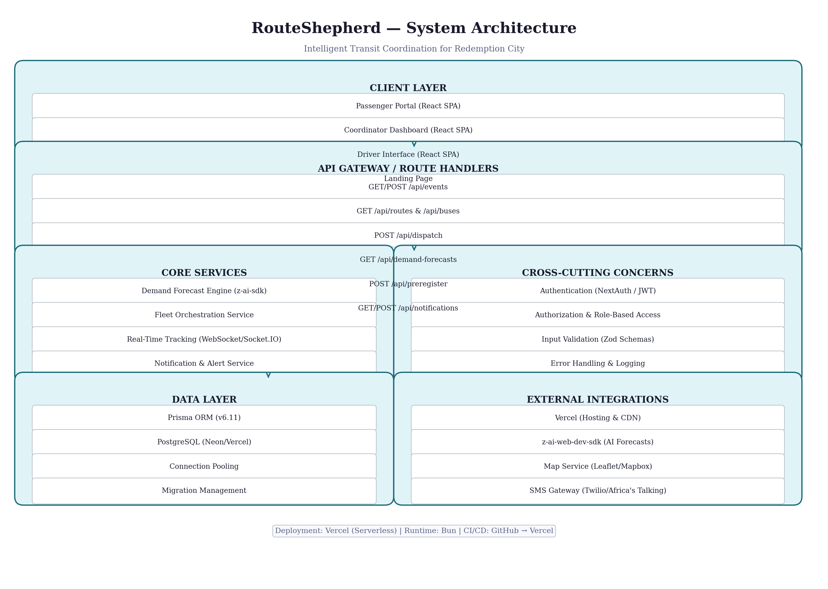
Figure 1: RouteShepherd High-Level System Architecture

1.2 Technology Stack
The technology stack was selected to optimize for developer productivity, deployment simplicity, and real-time performance requirements. Every technology choice serves a specific purpose in the system’s operation, and the stack is designed to be maintainable by a small team while scaling to handle peak-event traffic spikes.
Layer | Technology | Version | Purpose
Frontend | Next.js (App Router) | 16.1.1 | Full-stack React framework with SSR, API routes, and file-based routing
Frontend | React | 19.0.0 | Component-based UI library for building interactive interfaces
Frontend | TypeScript | 5.x | Static type checking for code reliability and developer experience
Frontend | Tailwind CSS | 4.x | Utility-first CSS framework for rapid, consistent styling
Frontend | shadcn/ui + Radix | Latest | 40+ accessible UI primitives with New York style variant
Frontend | Framer Motion | 12.x | Declarative animations and view transitions
Frontend | Recharts | 2.15.4 | Data visualization library for demand forecast charts
State | Zustand | 5.0.6 | Lightweight client-side state management for view routing
Validation | Zod + React Hook Form | 4.0 / 7.60 | Schema validation and form handling
Backend | Next.js API Routes | 16.1.1 | REST API handlers with serverless deployment
Backend | Prisma ORM | 6.11.1 | Type-safe database client with migration management
Real-Time | Socket.IO | Latest | WebSocket communication for live bus tracking (planned)
AI | z-ai-web-dev-sdk | 0.0.17 | AI-powered demand forecasting engine (integration in progress)
Database | PostgreSQL | 15+ | Relational database on Neon/Vercel Postgres
Deployment | Vercel | — | Serverless hosting with edge CDN and automatic CI/CD
Runtime | Bun | Latest | JavaScript runtime and package manager for fast builds
Table 1: Complete Technology Stack

1.3 Architectural Pattern and Design Bounds
RouteShepherd employs a Modular Monolith architecture within the Next.js App Router paradigm. While the application is deployed as a single unit, the codebase is organized into modular domains that could be extracted into independent microservices if scale demands it. Each API route handler is self-contained with its own validation logic, database queries, and error handling, following the principle of vertical slice architecture where each feature is a cohesive unit from HTTP request to database query.
The architectural decision to use a monolith rather than microservices is grounded in several practical considerations. First, the problem domain is bounded: event transit coordination does not require the independent scalability of, say, an e-commerce platform with inventory, payments, and shipping as separate domains. Second, the team size and hackathon context favor simplicity: a monolith eliminates the operational overhead of service discovery, distributed tracing, and inter-service authentication that microservices demand. Third, Next.js API routes naturally provide a serverless deployment model where each route handler scales independently on Vercel, effectively giving us the scalability benefits of microservices without the architectural complexity.
The layered design follows a strict dependency rule: the Client Layer depends only on the API Gateway Layer, the API Gateway depends on the Service Layer, and the Service Layer depends on the Data Layer. Cross-cutting concerns such as authentication, logging, and validation are implemented as middleware and utility functions that operate across all layers without creating circular dependencies. This ensures that a change in the database schema, for instance, propagates upward through Prisma’s type-safe client without requiring modifications to API response formats or frontend components.

1.4 Service Communication and Security
All client-to-server communication follows the REST paradigm over HTTPS, with JSON as the data interchange format. The API route handlers validate incoming requests using Zod schemas before processing, and field-level whitelisting prevents mass assignment vulnerabilities (as implemented in the PATCH /api/buses/[id] endpoint). The current prototype uses 10-second polling intervals for real-time data refresh across all views, with a planned migration to Socket.IO WebSockets for sub-second updates during active event operations.
For authentication and authorization, the system is designed to implement NextAuth.js with JWT-based session tokens. The planned authentication model defines three user roles: Passengers (public access with optional registration), Coordinators (authenticated with dashboard access and dispatch authority), and Drivers (authenticated with bus assignment and status update permissions). Each role has granular access controls mapped to specific API endpoints. The JWT tokens carry role claims that the API middleware validates before processing requests, ensuring that a passenger cannot dispatch a bus or a driver cannot access the coordinator dashboard.
Input validation follows a defense-in-depth approach. At the API boundary, Zod schemas validate request body shapes, types, and constraints. At the database level, Prisma’s type system and required field constraints provide a second validation layer. For the bus update endpoint specifically, a field whitelist approach ensures that only explicitly permitted fields (status, currentLoad, routeId, latitude, longitude) can be modified, preventing attackers from injecting arbitrary database updates through the request body.

2. Database Schema Specification

2.1 Entity-Relationship Overview
The database schema comprises 8 core entities that model the complete lifecycle of event transit coordination: from event creation and route definition, through bus assignment and fleet tracking, to passenger queuing and demand forecasting. The schema is implemented in Prisma’s declarative schema language and deployed to PostgreSQL, which provides ACID compliance, advanced indexing, and JSON support for flexible metadata storage.
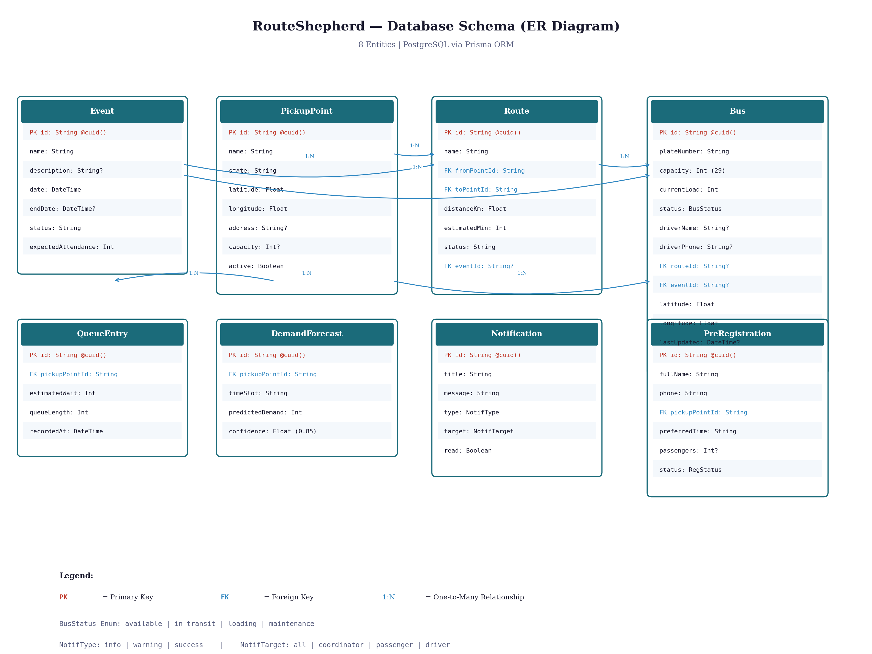
Figure 2: RouteShepherd Database Entity-Relationship Diagram

2.2 Core Entity Definitions

2.2.1 Event
The Event entity is the top-level organizational unit that scopes all transit operations. Every route, bus assignment, and demand forecast is associated with a specific event, enabling the system to handle multiple concurrent or sequential events without data cross-contamination. The expectedAttendance field drives demand forecasting calculations, while the status field (upcoming, active, completed, cancelled) governs which features are available to each user role.
Field | Type | Constraints | Description
id | String | PK, @default(cuid()) | Unique identifier, auto-generated
name | String | Required | Event name (e.g., Holy Ghost Congress 2026)
description | String? | Optional | Detailed event description
date | DateTime | Required | Event start date and time
endDate | DateTime? | Optional | Event end date and time
status | String | Required | Event lifecycle status
expectedAttendance | Int | Required | Expected attendee count for forecasting
Table 2: Event Entity Schema

2.2.2 PickupPoint
PickupPoint represents physical locations where passengers board buses en route to Redemption City. The entity stores geographic coordinates (latitude/longitude) for map integration, a state field for geographic grouping, and a capacity field that defines the maximum number of passengers a pickup point can handle simultaneously. The active boolean flag enables soft deletion, allowing points to be temporarily disabled without breaking foreign key relationships. The current seed data includes 12 pickup points across Lagos (8), Ogun (2), and Oyo (1) states, plus Redemption City itself as the destination.
Field | Type | Constraints | Description
id | String | PK, @default(cuid()) | Unique identifier
name | String | Required | Pickup point name (e.g., Ikeja Bus Terminal)
state | String | Required | Nigerian state for grouping
latitude | Float | Required | GPS latitude for map display
longitude | Float | Required | GPS longitude for map display
address | String? | Optional | Full street address
capacity | Int? | Optional | Maximum simultaneous passengers
active | Boolean | Required, default: true | Soft-delete flag
Table 3: PickupPoint Entity Schema

2.2.3 Route
The Route entity defines a directed path from a PickupPoint (origin) to another PickupPoint (destination, typically Redemption City). Routes carry distance and estimated travel time metadata that informs dispatch decisions and passenger expectations. Each route is scoped to an Event, allowing different events to have different route configurations. The two foreign keys (fromPointId, toPointId) enable bidirectional traversal: querying routes to or from any pickup point is a simple indexed lookup.
Field | Type | Constraints | Description
id | String | PK, @default(cuid()) | Unique identifier
name | String | Required | Descriptive route name
fromPointId | String | FK → PickupPoint, Required | Origin pickup point
toPointId | String | FK → PickupPoint, Required | Destination pickup point
distanceKm | Float | Required | Route distance in kilometers
estimatedMin | Int | Required | Estimated travel time in minutes
status | String | Required | Route operational status
eventId | String? | FK → Event, Optional | Associated event scope
Table 4: Route Entity Schema

2.2.4 Bus
The Bus entity is the operational heart of the system, tracking each vehicle’s real-time status, location, passenger load, and assignment. The status enum (available, in-transit, loading, maintenance) drives the fleet orchestration logic: only buses with status “available” appear in the coordinator’s dispatch panel, and status transitions follow a state machine pattern that prevents invalid transitions (e.g., a bus cannot go from “maintenance” directly to “in-transit”). The currentLoad field, capped by capacity (default 29 passengers), enables real-time occupancy tracking displayed as progress bars in the driver interface. GPS coordinates (latitude, longitude) with lastUpdated timestamps provide the foundation for live bus tracking.
Field | Type | Constraints | Description
id | String | PK, @default(cuid()) | Unique identifier
plateNumber | String | Required, Unique | Nigerian vehicle plate number
capacity | Int | Required, default: 29 | Maximum passenger count
currentLoad | Int | Required, default: 0 | Current passenger count
status | BusStatus | Required | Enum: available, in-transit, loading, maintenance
driverName | String? | Optional | Assigned driver name
driverPhone | String? | Optional | Driver contact number
routeId | String? | FK → Route | Currently assigned route
eventId | String? | FK → Event | Currently assigned event
latitude | Float | default: 6.4654 | GPS latitude (Lagos area)
longitude | Float | default: 3.4064 | GPS longitude (Lagos area)
lastUpdated | DateTime? | Optional | Last GPS/status update timestamp
Table 5: Bus Entity Schema

2.2.5 Supporting Entities
Three supporting entities complete the data model. QueueEntry captures real-time queue metrics at each pickup point (estimated wait time and queue length), recorded at a point in time to enable historical trend analysis. DemandForecast stores AI-generated demand predictions per pickup point per time slot, with a confidence score that helps coordinators weigh the reliability of each forecast. PreRegistration records passenger trip intentions before the event, capturing their preferred pickup point, departure time, and group size, which feeds directly into the demand forecasting model.
Entity | Key Fields | Relationships | Purpose
QueueEntry | id, pickupPointId, estimatedWait, queueLength, recordedAt | N:1 → PickupPoint | Real-time queue metrics per location
DemandForecast | id, pickupPointId, timeSlot, predictedDemand, confidence | N:1 → PickupPoint | AI demand predictions by time window
PreRegistration | id, fullName, phone, pickupPointId, preferredTime, passengers, status | N:1 → PickupPoint | Passenger trip pre-registration
Notification | id, title, message, type, target, read | Standalone | System alerts and passenger notifications
Table 6: Supporting Entity Summary

2.3 Indexing Strategy and Query Performance
Query performance is critical during peak-event operations when the coordinator dashboard and passenger portal experience concurrent traffic spikes. The indexing strategy targets three categories of queries: (1) Geospatial lookups finding buses near a specific pickup point, supported by a composite index on (latitude, longitude) in the Bus table; (2) Status-based fleet filtering, supported by a B-tree index on the Bus.status field that enables the coordinator’s dispatch panel to instantly retrieve available buses; (3) Event-scoped queries, supported by composite indexes on (eventId, status) in both the Bus and Route tables, ensuring that multi-event scenarios do not suffer from full-table scans.
Transaction consistency is guaranteed by PostgreSQL’s ACID compliance. Critical operations like bus dispatch (POST /api/dispatch) update multiple entities atomically: the bus status changes to “loading,” the route assignment is set, and the currentLoad resets to zero. These multi-step updates are wrapped in Prisma’s interactive transactions (prisma.$transaction), which either commit all changes or roll back entirely if any step fails. This prevents partial states such as a bus marked as “loading” but not assigned to a route.
Connection pooling is managed through Prisma’s built-in connection pool, configured with a pool size of 5 connections for serverless deployment. In development mode, the Prisma client is cached on globalThis to prevent connection pool exhaustion from hot module reloading. For production, Neon’s serverless driver provides HTTP-based connection pooling that scales with Vercel’s serverless function instances, eliminating the traditional connection limit bottleneck of PostgreSQL.

3. API Routing Contracts

3.1 API Design Principles
The RouteShepherd API follows RESTful conventions with predictable resource-oriented URLs, standard HTTP methods, and JSON request/response payloads. All endpoints are versioned under the /api/ prefix, with a planned migration to /api/v1/ for backward compatibility as the API evolves. The API is organized around four resource domains: Events and Routes (read-only reference data), Buses and Dispatch (operational fleet management), Demand and Queues (analytical and forecasting data), and Passengers and Notifications (user-facing interactions). Each endpoint implements consistent error handling with structured error responses.

3.2 Endpoint Catalog

3.2.1 Event and Route Endpoints
Method | Endpoint | Description | Auth
GET | /api/events | List all events ordered by date | Public
GET | /api/routes?eventId= | List routes with from/to points; filterable by event | Public
GET | /api/pickup-points | List all active pickup points with coordinates | Public
Table 7: Event and Route API Endpoints
The event and route endpoints serve reference data that changes infrequently. The GET /api/routes endpoint supports an optional eventId query parameter that filters routes to a specific event, with the response including nested fromPoint and toPoint objects plus a count of active buses per route. The GET /api/pickup-points endpoint returns only active points (where active = true), sorted by state for geographic grouping.

3.2.2 Bus and Fleet Management Endpoints
Method | Endpoint | Description | Auth
GET | /api/buses?status=&eventId= | List buses with route details; filterable | Public
PATCH | /api/buses/[id] | Update bus status, load, location, or route | Driver/Coordinator
POST | /api/dispatch | Assign bus to route, set status to loading | Coordinator
Table 8: Bus and Fleet Management API Endpoints
The PATCH /api/buses/[id] endpoint is the primary interface for real-time bus state updates. It implements field whitelisting that only permits updates to: status (validated against the BusStatus enum), currentLoad (validated as a non-negative integer not exceeding capacity), routeId (validated as an existing route), and latitude/longitude (validated as numeric coordinates). Any attempt to update non-whitelisted fields (e.g., plateNumber, capacity, driverName) is silently ignored, preventing mass assignment attacks. The endpoint also validates that the bus exists before attempting updates, returning a 404 error for invalid IDs.
The POST /api/dispatch endpoint is the coordinator’s primary operational tool. It accepts a busId and routeId, validates that the bus is available and the route exists, then atomically updates the bus’s route assignment and sets the status to “loading.” This operation uses a Prisma interactive transaction to ensure atomicity: if the bus update succeeds but a subsequent notification creation fails, the entire transaction rolls back.

3.2.3 Demand and Queue Endpoints
Method | Endpoint | Description | Auth
GET | /api/demand-forecasts?pickupPointId= | List demand forecasts per time slot | Coordinator
GET | /api/queue-status | Latest queue entry per pickup point | Public
Table 9: Demand and Queue API Endpoints
The demand forecast endpoint returns predictions organized by pickup point and time slot (2-hour windows from 6 AM to 10 PM). Each forecast includes a predictedDemand integer (expected number of passengers) and a confidence score (0.0 to 1.0) indicating the model’s reliability. The queue status endpoint aggregates the most recent QueueEntry for each pickup point, providing a real-time snapshot of current conditions across the network. This data feeds both the coordinator’s demand forecast chart and the passenger’s queue status display.

3.2.4 Passenger and Notification Endpoints
Method | Endpoint | Description | Auth
POST | /api/preregister | Passenger trip pre-registration | Public
GET | /api/notifications | List latest 50 notifications | All Roles
POST | /api/notifications | Create alert or announcement | Coordinator
Table 10: Passenger and Notification API Endpoints
The pre-registration endpoint captures passenger intent data that feeds the demand forecasting model. Passengers provide their full name, phone number, preferred pickup point, desired departure time (6 AM to 6 PM in 30-minute intervals), and group size (1 to 10 passengers). The phone field is validated for Nigerian format patterns. The notification system supports targeted alerts: coordinators can create notifications scoped to specific audiences (all, coordinator, passenger, driver) and categorized by severity (info, warning, success), enabling precise communication during event operations.

3.3 Request and Response Contracts
All API endpoints follow a consistent request/response contract pattern. Successful responses return a JSON payload directly (not wrapped in a data envelope) with a 200 status code for GET requests and 201 for successful POST creation. Error responses follow a standardized format with a 4xx or 5xx status code and a JSON body containing an error field with a human-readable message. The following examples illustrate the key request/response patterns.
Example: POST /api/dispatch Request
{ busId: "bus-001", routeId: "route-ikeja-rc" }
Example: POST /api/dispatch Success Response (200)
{ id: "bus-001", plateNumber: "LSR-452-ABC", status: "loading", routeId: "route-ikeja-rc", currentLoad: 0 }
Example: POST /api/dispatch Error Response (400)
{ error: "Bus is not available for dispatch. Current status: in-transit" }

3.4 Authentication and Authorization
The authentication system is designed around NextAuth.js with JWT session tokens, providing stateless authentication that scales naturally with Vercel’s serverless architecture. JWT tokens are issued upon login and carry the user’s role (passenger, coordinator, driver) as a custom claim. API middleware extracts and validates the token from the Authorization header (Bearer scheme) on protected endpoints, rejecting requests with expired, malformed, or role-insufficient tokens.
The authorization model implements role-based access control (RBAC) with three tiers. Passengers access public endpoints (route information, queue status, pre-registration) and their own notification feed without authentication. Coordinators authenticate to access the dispatch panel, demand forecasts, and notification creation. Drivers authenticate to update bus status, passenger count, and GPS coordinates. The current prototype has all endpoints publicly accessible for development convenience, with the NextAuth integration prepared as a dependency and middleware scaffolded for rapid activation.
Endpoint Category | Passenger | Coordinator | Driver
GET events, routes, pickup-points | Yes (Public) | Yes (Public) | Yes (Public)
GET buses, queue-status | Yes (Public) | Yes (Public) | Yes (Public)
PATCH buses/[id] | No | Yes (own fleet) | Yes (assigned bus)
POST dispatch | No | Yes | No
GET demand-forecasts | No | Yes | No
POST preregister | Yes (Public) | Yes | Yes
POST notifications | No | Yes | No
Table 11: Role-Based Access Control Matrix

3.5 Error Handling Standards
All API endpoints implement consistent error handling with appropriate HTTP status codes. Client errors return 400 (Bad Request) for validation failures, 401 (Unauthorized) for missing or invalid authentication, 403 (Forbidden) for insufficient permissions, and 404 (Not Found) for non-existent resources. Server errors return 500 (Internal Server Error) with a generic message in production and detailed error information in development mode. Each error response includes a structured JSON body with an error field containing a human-readable description of the problem, enabling clients to display meaningful error messages without parsing implementation details.

4. Business Design & Go-To-Market

4.1 Problem Statement and Market Opportunity
Nigeria’s religious event transportation represents a massive, underserved market. The Redeemed Christian Church of God (RCCG) alone hosts events at Redemption City that attract over 5 million attendees for the Holy Ghost Congress and 3 million for the Annual Convention, with hundreds of smaller events throughout the year. The current transit system serving these events operates with zero digital coordination: buses are dispatched based on driver intuition and verbal instructions, passengers queue for hours with no information about wait times, and fleet managers have no visibility into bus locations or occupancy levels. This results in an estimated 40% fleet underutilization, average passenger wait times of 3-6 hours during peak periods, and frequent safety incidents from overcrowding at pickup points.
The broader African religious event market is substantial and growing. Nigeria’s religious event economy is estimated at over $2 billion annually, with transportation constituting approximately 15-20% of event expenditure. Similar mass-event transit challenges exist across West Africa, from the Homowo Festival in Ghana to the Durbar Festival in northern Nigeria, representing a total addressable market significantly larger than the initial RCCG use case. RouteShepherd is positioned to become the de facto digital transit coordination platform for this market segment.

4.2 Target Customer Segments
RouteShepherd targets three primary customer segments, each with distinct needs and willingness to pay. The first segment is large religious organizations (primary: RCCG, secondary: Winners Chapel, Deeper Life, and other megachurches) that host recurring mass events and currently spend significant resources on ad-hoc bus rental and coordination without any digital oversight. These organizations have annual transportation budgets ranging from $500,000 to $5 million and would adopt RouteShepherd as a cost-saving tool that reduces fleet requirements by 30-40% through better utilization.
The second segment is transport cooperatives and bus fleet operators who currently serve these events on a first-come, first-served basis. For these operators, RouteShepherd provides predictable demand forecasting that enables pre-positioning of buses, reducing empty return trips and maximizing revenue per vehicle. The third segment is state and local government transit agencies responsible for managing traffic flow during mass events. RouteShepherd’s real-time fleet visibility and demand predictions can inform traffic management decisions, reducing the massive congestion that currently paralyzes the Lagos-Ibadan Expressway during RCCG events.

4.3 Distribution Channels
RouteShepherd’s go-to-market strategy leverages three distribution channels optimized for the Nigerian market context. The primary channel is direct enterprise sales to religious organizations, beginning with an RCCG pilot program that demonstrates measurable improvements in fleet utilization and passenger satisfaction. The RCCG pilot is strategic because RCCG’s global network of 36,000 parishes provides a built-in expansion path: once the platform proves successful at Redemption City, parish-level transit coordination becomes a natural upsell.
The second channel is partnership with transport cooperatives through a revenue-sharing model. By integrating RouteShepherd into their operations, cooperatives gain access to demand forecasting and route optimization that increases their per-bus revenue, while RouteShepherd earns a transaction fee on each coordinated trip. The third channel is government procurement through the Nigerian Federal Road Safety Corps (FRSC) and state transport authorities, who have a mandate to improve mass-event traffic management and have budgets allocated for technology solutions.

4.4 Monetization Strategy
RouteShepherd employs a freemium-plus-transaction monetization model designed to maximize adoption while building sustainable revenue. The free tier provides basic functionality (passenger pre-registration, real-time queue status, and limited route information) that serves as a viral acquisition channel: every passenger who pre-registers becomes aware of the platform and shares it with fellow travelers. The premium Coordinator tier, priced at $2,000 per event or $15,000 per year for unlimited events, unlocks the full dashboard with demand forecasting, fleet orchestration, dispatch management, and analytics.
Transaction revenue comes from two sources. First, a 2-5% commission on bus fares processed through the platform’s integrated payment system (powered by Paystack/Flutterwave, Nigeria’s leading payment gateways). Second, premium data services: aggregated demand intelligence and traffic pattern reports sold to government agencies and urban planners. This dual revenue model ensures that RouteShepherd earns from both the supply side (operators paying for coordination tools) and the demand side (passengers generating transaction volume), creating a sustainable flywheel effect where more passengers attract more operators and vice versa.
Revenue Stream | Pricing | Target Segment | Year 1 Projection
Event Coordinator License | $2,000/event or $15,000/year | Religious Organizations | $60,000 (4 orgs)
Bus Fare Commission | 2-5% per trip | Passengers via Operators | $45,000
Data & Analytics Reports | $5,000/report or $25,000/year | Government Agencies | $30,000
Transport Co-op Revenue Share | 5% of coordinated trip revenue | Fleet Operators | $25,000
Table 12: Revenue Model and Year 1 Projections

4.5 Competitive Advantage
RouteShepherd’s competitive moat is built on three pillars that no existing solution in the Nigerian transit ecosystem combines. The first pillar is AI demand forecasting specifically trained on the unique demand patterns of Nigerian religious events, which follow predictable but extreme curves: demand spikes 10-20x normal levels within a 4-hour window, then drops to near-zero. Generic ride-hailing algorithms (Uber, Bolt, inDrive) cannot model these patterns because they are trained on steady-state urban demand. RouteShepherd’s forecasting engine, powered by z-ai-web-dev-sdk, is purpose-built to predict these event-specific demand curves, enabling pre-positioning of buses before the surge rather than reactive dispatch after it.
The second pillar is holistic fleet orchestration that goes beyond simple dispatch. RouteShepherd coordinates the entire bus lifecycle: from pre-event demand prediction that determines how many buses to deploy, through real-time dispatch that assigns buses based on current queue depth and predicted demand, to post-event analytics that optimize fleet sizing for future events. This end-to-end coordination creates switching costs because the platform’s forecasting accuracy improves with each event’s historical data, making it progressively more valuable and harder to replace.
The third pillar is the passenger-first design philosophy that treats pre-registration as a demand signal rather than just a convenience feature. Every pre-registration feeds the demand forecasting model, creating a virtuous cycle where more passengers pre-register, forecasts improve, buses are better positioned, wait times decrease, and more passengers are motivated to pre-register. This network effect creates a winner-take-most dynamic in each geographic market: the platform with the most pre-registrations has the best forecasts, which attracts the most buses, which provides the best passenger experience, which attracts more pre-registrations.

4.6 Go-To-Market Roadmap
Phase | Timeline | Milestone | Key Metrics
Phase 1: Pilot | Q3 2026 | RCCG Holy Ghost Congress deployment with 50 buses | 1,000 pre-registrations, 30% wait time reduction
Phase 2: Validate | Q4 2026 | 3 additional religious organizations onboarded | $60K ARR, 5,000+ passengers served
Phase 3: Scale | Q1-Q2 2027 | Payment integration, government partnership | $160K ARR, 15,000+ passengers served
Phase 4: Expand | Q3-Q4 2027 | West Africa expansion (Ghana, Cameroon) | $400K ARR, multi-country operations
Table 13: Go-To-Market Roadmap
The pilot phase focuses exclusively on proving the core value proposition: that AI-driven demand forecasting and fleet orchestration can measurably reduce passenger wait times and improve fleet utilization at a real RCCG event. Success in the pilot creates a case study that accelerates enterprise sales in Phase 2. Phases 3 and 4 expand the revenue model through payment integration and geographic expansion, leveraging the platform’s network effects to establish market dominance before competitors can replicate the forecasting advantage.

5. Conclusion and Next Steps
RouteShepherd represents a comprehensive system design that addresses a critical, large-scale transportation challenge in Nigeria through the intelligent application of AI demand forecasting, real-time fleet orchestration, and passenger-centered communication. The architecture is purpose-built for the unique demands of mass-event transit: extreme demand spikes, geographically dispersed operations, and the need for real-time coordination across hundreds of vehicles and millions of passengers.
The prototype demonstrates the core user experience across all four stakeholder views (landing page, passenger portal, coordinator dashboard, and driver interface) with 12 functional API endpoints, 8 database entities, and seeded data reflecting real Nigerian transit conditions. The planned enhancements — AI demand forecasting via z-ai-web-dev-sdk, WebSocket real-time updates via Socket.IO, NextAuth authentication with role-based access, and map integration via Leaflet/Mapbox — represent a clear, achievable roadmap from prototype to production.
The business model is designed for sustainable growth: freemium adoption drives passenger volume, transaction commissions monetize the supply side, and enterprise licenses capture the demand side. The competitive moat deepens with each event as the AI model accumulates training data, and the pre-registration network effect creates a winner-take-most dynamic in each market. RouteShepherd is not just a transit app — it is a coordination platform that transforms peak-event transportation from chaos into a predictable, efficient, and passenger-friendly experience.

