Set environment variables:
RAID_PATH – set this to the directory below which the fitacf files are located.

The directory structure assumed by the code is $RAID_PATH/yyyy/mo.dy/

for example all files for the files for June 2, 2014 are found at: $RAID_PATH/2014/06.02/…

TZ – time zone. The code will set the timezone to “” (might effect settings in your shell)

SD_RADAR – set by the RST. Gives location of “radar.dat”

SD_HDWPATH – set by the RST. Gives path to “hdw.dat.xxx” files

BINPATH – path to rst executables

The software also assumes that you have a directory “bin” where your executables reside

Untar the file into its own directory. In that directory type “make”

To run the software, first use the RST potential mapping. The included Perl scripts “map_potential” and “grid” will make the appropriate map file. To use these scripts you make sure they are in your path, and type “map_potential” followed by whatever flags you want to use, then the date. For example to calculate the maps for the full day of June 2, 2014 type:

> map_potential -clean 20140602

The “-clean” flag makes the script remove intermediate files from the calculation when done. If you want the maps for the southern hemisphere add the “-south” flag.

After you have the map file you are ready to run the local mapping. First you need to edit the “instructions” file, which contains the parameters of the fit.

In the example instructions file, the first block of lines defines the area where the fit will be carried out. You can choose any set of latitude and longitudes you want for this. The points define the vertices of a polygon on the surface of the earth. The example file results in the area shown below:

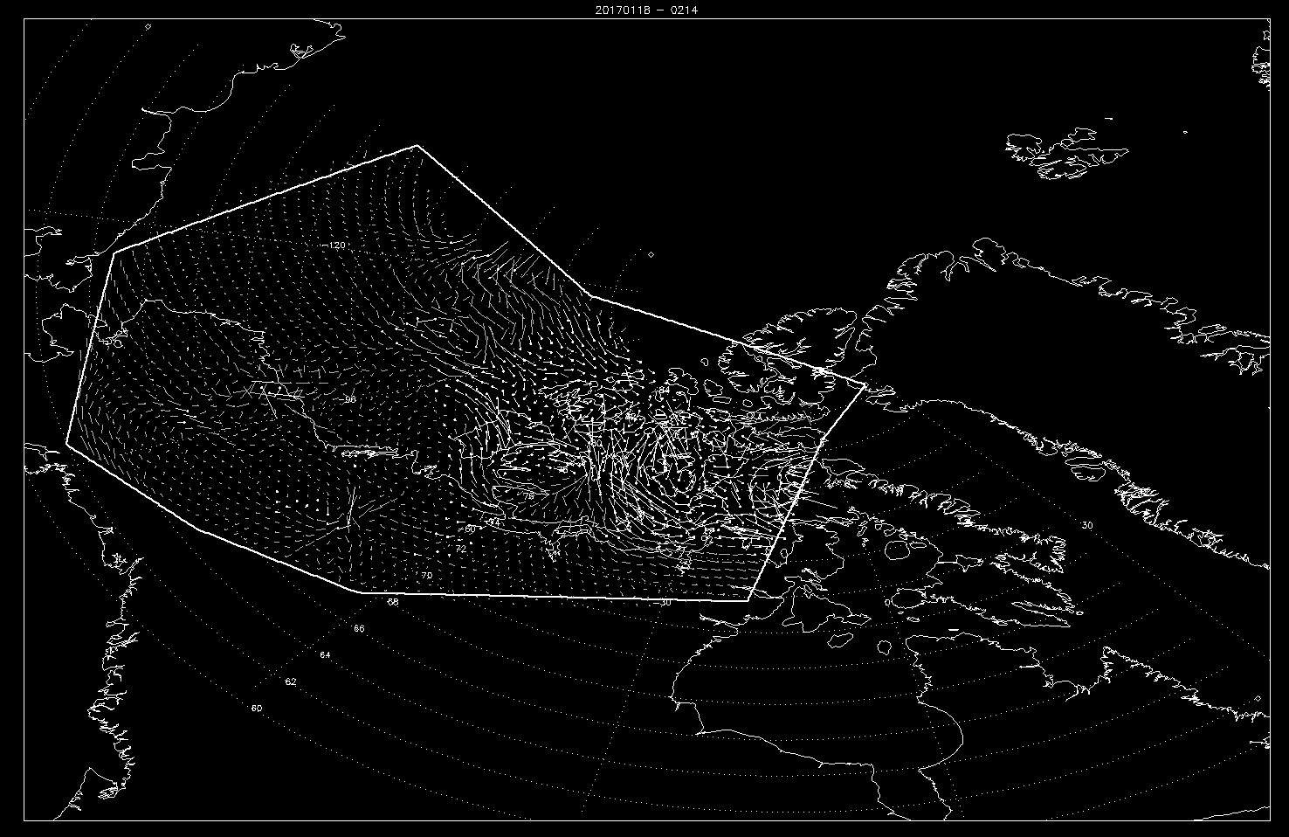

The next two lines of the file give the grid spacing: “lat_dl” and “lon_dl”, given in degrees.

Next is the “smooth” parameter. Probably best to always leave it as “0”, unless the results are very noisy.

“model_scale” controls the weighting of the RST potential mapping error. A smaller number means that you assume the potential mapping is close to correct and it is weighted more heavily in the fit. About 1000 seems to be a good value for most things I have tried.

“start_time:, “end_time” and “avg_interval” should be pretty self explanatory. Time is “yyyymmddhhmm”. “avg_interval” is in seconds (120 seconds, two minutes)

“shf_file” is the name of the map file from the RST potential mapping.

“radar_list” is a list of the radar identifiers for the radars you want to use. Note that you have to leave a space after the last identifier in the list.

