**ONLINE JOB RECRUITMENT PORTAL**

**A CASE STUDY OF KAKAMEA COUNTY**

**WANGILA W KENNEDY**

**BSIT/034J/2014**

**SUPERVISOR**

**DR. MGALLA**

**Research Project Submitted in Partial Fulfillment for the Degree in Bachelor of Science in Information Technology of Technical University of Mombasa**

**July 2018**

# DECLARATRION

This project is my original work and has not been presented for a degree in any other University or for any other award

Students Name: ______________

Sign ____________________ Date _____________

I confirm that the work reported in this project was carried out by the candidate under my supervision.

Name: Sign ____________________ Date _____________

# DEDICATION

# I dedicate this proposal to my parent’s who gave me financial support and moral to finish this project.

# ACKNOWLEDGEMENT

# ABSTRACT

In this current world, the technology among the people is so increasing that the jobs for them are now decreasing. The companies even want the people who are best in their fields. At that time, it becomes difficult to find the people who are intelligent enough to be hired. The work for the companies also increases to find the people who can fulfill their requirements. This job portal will help both the job seekers and recruiters finding the right organization for the employees. In the case of job seekers, according to their educational qualification and their preferences, the job portal shows the list of companies to them. So that fresher’s who are looking for the job can spend more time on preparation and less time on information collection.

**List of Figures**

Figure 2.1 University of the East …………………………………………………………………5

Figure 2.2 Job Portals……………………………………………………………………………..7

Figure 3.1 RAD………………………………………………………………………………….10

Figure 3.2 Activity Diagram……………………………………………………………………..15

Figure 3.3 Use case diagram…………………………………………………………………..…16

List of Tables

Table 3.1 Hardware specifications. 17

Table 3.2 Software specification 18

Table 3.3 Budget. 19

**ACRONYMS**

**CSS Cascading Style Sheet**

**E-HRM Electronic Human Resource Manager.**

**HTML Hypertext Markup Language**

**MYSQL Structured Query Language**

**RAM Random Access Memory**

**PHP Preprocessor hypertext**

**XML Extensible Markup Language**

# CHAPTER ONE.

# INTRODUCTION.

# Background information.

Job application in Kakamega County has always been a real trouble among applicants who are interested in applying for the vacancy available due to challenges to do with the human resource management and offices of respective officials and managers. It involves a lot of challenges including terrain of the County and therefore making the process tedious.

This issues prompted me to come up with a system that will help in solving this problem. In this system, an applicant is able to apply for available jobs at the comfort of their home regardless of the region of the county he/she is. After the application, the applicant should be able to get a notification, telling him/her if she has got the job or not.

# 1.2 Problem Statement.

Job Application in Kakamega has been a difficult task over the years, it usually involves a strenuous activity getting the hardcopy form and therefore making the process long and tedious. The process is usually not transparent and sometimes the job are given based on tribes or corruptions , this is very late bad and thus applicants who are not rom the tribe of the interviewer or the managers get discouraged and are denied the job.

In this system, I am trying to bring all the processes to be transparent so that the

There will be no tribalism or corruption when giving out the jobs. It will be less tiresome and the process simple and easy and to improve transparency.

# 1.3 Objectives.

# 1.3.1 Main objective

To develop a system that will reduce the cost of hiring workers by bringing all the parameters for applying job in one place.

# Specific objectives

To ensure job seekers apply for jobs available in a very simple procedure.

To design a system a system that will ensure transparency and equality. And to help improve transparency in the constituency in terms of job seeking.

To test the system.

# 1.4 Justification.

The project will be of great help to Kakamega County, the applicants and other stakeholders Involved in job application. The completion of this project will help restore faith in the county about job placement and interview in terms of service delivery and transparency. Judging from my observation over the years, the company is in high need of this project if they want to reduce the problems encountered in job application and interview. I therefore urge the companies’ stakeholders to embrace this project and support it.

# 1.5 Scope.

# 1.5.1 Target users.

The users of this system are job seekers who have completed either Diploma, degree or Masters and are seeking jobs.

Also the Administrators in the County who verify the applicant’s details and approving the vacancy a pass or a fail under the guidance of the recruitment panel and the Human Resource Manager.

# CHAPTER TWO

# LITERATURE REVIEW

# 2.1 Introduction

In today’s world technology has moved fast and we have to maintain it moving forward, so there is a need to develop new strategies to stay relevant in a changing global business environment.

A usual recruitment process seen from the organization’s viewpoint can be divided into four phases:

Requirements analysis

Publishing the job posting.

Receiving and preselecting applications

Final recruitment decision.

This online is going to integrate all this steps into one module which will greatly enhance job seeking by graduate’s job seekers.

# 2.2 Theoretical review

Employee Recruitment can be defined as a practice and an activity carried on by individuals for the purpose of identifying, attracting competitive and efficient employees

(Bizer et al., 2005) Using semantic web technologies in the domain of online recruitment could increase market transparency in job seeking. In this paper it’s describe how online recruitment processes can be streamlined using information technology.(Dias, 2001)Little is known about applicant reactions to web based and selections procedures. It was found that the features of the site perceived efficiency and friendliness to the users.(Greiner, 2004) Introduces online recruitment as a convenient and efficient way of recruiting people to companies and organizations.

(De Meo, Quattrone, Terracina, & Ursino, 2007) In this paper we propose an XML-based multiage recommender system for supporting online recruitment services. The paper discusses the basic features of the proposed system, presents the results of an experimental study we have carried out for evaluating its performance, and makes a comparison between the proposed system and other e-recruitment systems already presented in the past.(Mareschal & Rudin, 2011)in this study the author puts out that it’s easy to apply for a job online compared to manually.(Strohmeier, 2007) in this article the author finds out that electronic human resource has a lot of implication in the current advancing technological world. The review further reveals that employees diverse empirical methods and refers to diverse topics in e-hrm.

(Bock, Baetge, & Nicklisch, 2014)the author discuss the use of an online software for economic developments.(P & Nagi, 2017) In this study the author focuses on electronic recruitment usage of e-recruitment forms in organizations. The internet has improved the desire for online recruitment in organizations.(Greiner, 2015) Here its discussed that online recruitment can help in economic developments. The software package provides a free and efficient and very strong tool to organize recruitments. (Moghaddam, Rezaei, & Amin, 2015) Electronic commerce have become the key thing among competitive business organizations, therefore placing recruitment on the digital platform will be of great importance to the organization

# 2.3 System review

**University of the East.**



**Figure 2. 1 University of the East**

The system automatically shortlisted the application forms according to years of experience, skills, and educational attainment relevant to the job vacancy. The system was able to provide sending of automated responses to qualified applicants. On the other hand, applicants could view further particulars of the post, which included background information concerning the University, faculty, department, the job description, and person specifications. They could fill out the application form online, and easily update their profiles. Sample screenshot is shown in



**Figure 2. 2 Job Portals**

Jobs portal is an E-recruitment portal for enrolling people, the organization has over two hundred workers and has been operating for over two years. The developers of this systems understands how difficult it is to look for jobs manually and that’s why they developed this system.

# 2.4 Critique of the existing systems.

**University of East.**

However, the system was not capable of doing such task as detecting errors on entered data of applicants. The system could not determine whether the data provided by the applicants were correct. Typographical errors were not detected by the system. The system could not also verify if all skills, knowledge, experience, and education specified by the users were true. Software evaluation was conducted to find out the acceptability of the software. Software evaluation was based on FURPS (Functionality, Usability, Reliability, Performance, and Security) Quality Factors. Only three quality indicators (Performance, Reliability, and Security) were selected from FURPS because only these three criteria were deemed applicable in this study. Moreover, Performance and Functionality were treated as one criterion since both referred to the effective processes of the software. Lastly, Cost-effectiveness was included since it was asserted that the software could save costs to the University.

**Job portals.**

This system has a good user interface and good choice for colors to be persuasive to its users.

However as I interacted with this system I found out that the system consumes a lot of RAM, and also requires machine with high hardware specifications to function effectively. The system also only shortlists the applicants without numbering them and placing them in any order, therefore it’s difficult to find out who applied for the job earlier than the other one.

# 2.5 Summary

In examining the findings, the key message for recruiters is to acknowledge that the adoption of e-recruitment is about more than just technology. It is about the recruitment system being able to attract the right candidate, the selection process being based on sound and credible criteria, and the tracking process being able to integrate with existing systems. Perhaps most significantly, e-recruitment is about cultural and behavioral change.

# 

# CHAPTER THREE

# ANALYSIS AND DESIGN

# 3.1 Introduction

This section elaborates the techniques that I used in the fact finding, analysis design, the design used and requirements analysis.

# 3.2 Development Approach

# 3.2.1 System design

The section describes how the new system will function and how it is going to satisfy the user requirements of the new system. The system encompasses the design of data flow and physical design.

**3.2.1.1 RAD**

I decided to use this method for rapid development of this system. Rapid Application

Development integrates project management techniques to build a quality applications

System. RAD software methodology has a better risk management techniques when

designing systems.

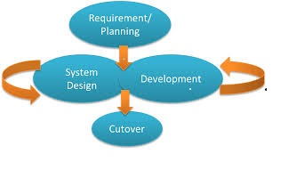

**Figure 3. 1 RAD**

# 3.2.1.2 Justification of the Design

The design has various advantages and this prompted me to choose it. They include:

Reduced cycle time and improved productivity with fewer people means lower cost.

Time box approach mitigates cost and also schedule risk.

The fact that customers are involved throughout the cycle helps to minimize the risk of not achieving customer’s satisfaction.

Focus move from documentation to code.

It also uses modelling concepts to capture information about data and processes.

The methodology can also be used when:

The requirements are reasonably known.

There is need for user’s involvement.

High performance is not required.

There is low technical risk.

The system can be modularized.

**Disadvantages of RAD.**

Depends on strong team and individual performances for identifying business requirements.

High dependency on modelling skills.

Required highly skilled designers.

Lack of scalability. Logically RAD focuses on typically small software projects, hence when need for expansions of the software arises there is a challenge.

# 3.3 Fact Finding Approach

This refers to all the processes used to collect information from applicants of the manual way of job application.

# 3.3.1 Research design

This refers to all the processes used to collect information from applicants of the manual way of job application

# 3.3.2 Population

The targeted users for this online recruitment system are job applicants who are facing difficulties in moving from one location to another looking for vacant jobs.

# 3.3.3 Sampling Design.

This will involve an appropriate satisfied and efficient random sampling technique. In

addition this method is cost saving, flexible and dependable. In this sampling method the participants provide information through

**Interviews**

Target respondents were interview questioning them about the hardship they

faced when conducting manual job seeking. Interview allow the researcher

direct contact with the respondent by this giving him an additional advantage to gain more information from the respondents.

# 3.3.4 Data collection Tools

The data for this proposal and the system to be generated was mainly through my own experience having to go through harsh and tough job seeking procedures, I experienced the difficulties of getting employed. Other data collected for the proposal was also through observation and with this I learnt a lot. Other data collected for the proposal was also through observation and with this I learnt a lot

# 3.4 Requirement Analysis

Comprises of the user, functional and non-functional requirements

**3.4.1 Use requirements**

The users require a system that has the following features.

A user friendly graphical user interface.

An informative and intuitive website.

**3.4.1.1 Functional requirements**

This is how the system shall look like and do when successfully completed. The system shall meet the following functional requirements:

The system shall allow job seekers to apply for jobs online. The system shall also accept only valid data to be entered into a database it shall allow registered or authorized administrators who are logged in to perform operations on the system. It will allow job seekers who have applied for the jobs to track their information (getting feedback whether granted or denied) by viewing there profiles. Only authorized administrator shall be able to add and/or delete fake profiles and a particular jobs. Shall also be able to grant/deny job vacancy to applicants. The system will also allow the applicants to register their problems and the administrator shall be able to view them and act accordingly. The system shall be able to clearly outline the requirements for a particular job.

**3.4.1.2 Non-functional Requirements**

The non-functional requirements of the system include.

The system shall display an alert reminding the user to enter valid data if he/she enters invalid data (verification). It shall also be able to run on a networked environment efficiently and effectively. The system shall also display an error massage when a user attempts to enter wrong data at logging window. It shall store data in the most efficient manner possible to keep the database from growing too big with unnecessary data.

# 3.5 Logical design

**Activity diagram.**

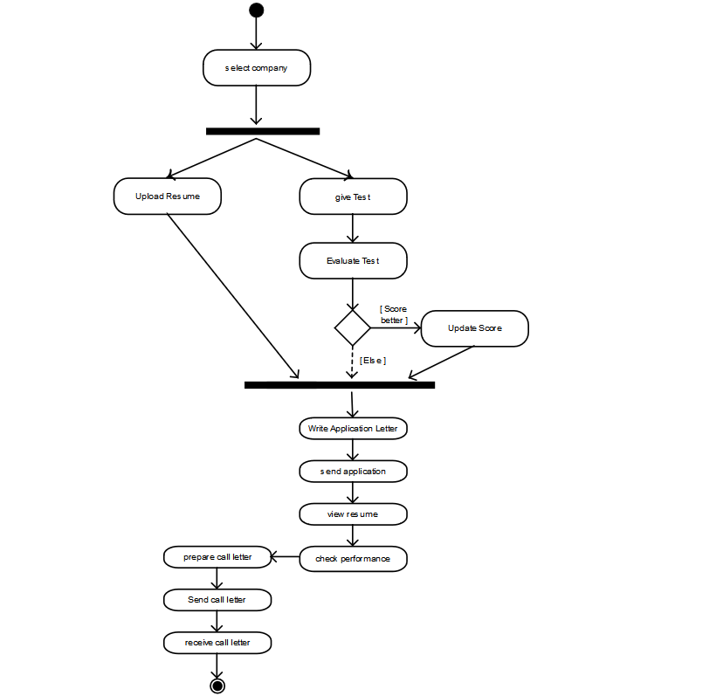

Figure 3.

**Use case diagram.**

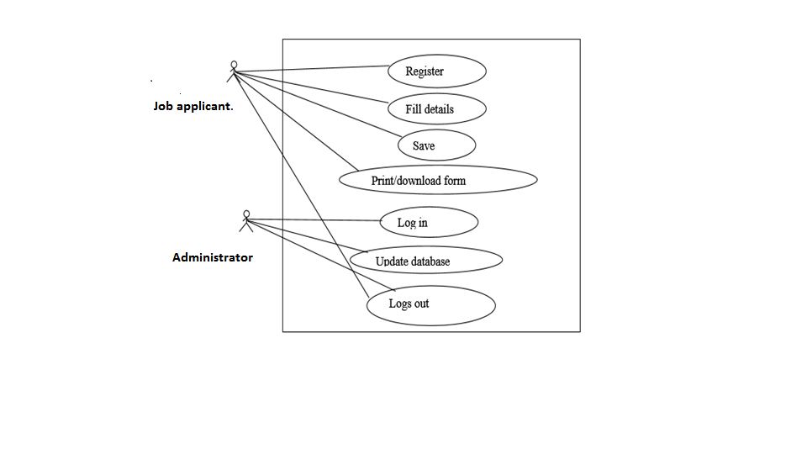

**Figure 3. 3 Use case diagram**

When the users visit the job application tab in the website, this are the steps followed from the use case diagram:

He/she registers and given an account.

He/she proceeds to the application tab and fills in the required details.

After filling all the details, the applicant will be required to save details after every step.

The applicant then has the option to print or download the already filled form for stamping

by the school principal or dean of students.

He/she then logs out.

According to the use case diagram above:

The administrator only logs in and updates the database. He then verifies the applicant’s details

# 3.6 Specific platforms

# 3.6.1 Hardware specification

|  |  |
| --- | --- |
| **Hardware** | **Minimum requirements** |
| Processor | Intel Pentium 4 , Intel Celeron |
| Hard disk siz**e** | Minimum of 320GB |
| Memory | 2GB |

***Table 3.1 hardware specification***

# 3.6.1 Software specification

|  |  |
| --- | --- |
| Software | **Minimum system requirements** |
| Client operating systems | Windows 7 and higher |
| Web server. | Apache |
| Server operating system | Windows 8 |
| Database management system | MYSQL server version |
| Web browser | Mozilla Firefox, Google chrome and Microsoft edge |
| Text editor | Sublime text. |
| Programming language | Php,html, css, and bootstrap |

***Table 3.2 software specification***

### **3.7 BUDGET**

This table contains detail on the approximated amount of funds that I will require to carry out the proposed research successfully. The details below are the actual figures that cost me on my project.

|  |  |
| --- | --- |
| ITEMS | COST |
| Laptop | Ksh 45,000 |
| Printing and binding | Ksh 600 |
| Transport | Ksh 900 |
| Internet | Ksh 1,200 |
| Research Cost | Ksh 2,000 |
| Other expenses | Ksh 1,000 |
| Total | Ksh 50,700 |

***Table 3.3 Budget***

# REFERENCES

Bizer, C., Heese, R., Mochol, M., Oldakowski, R., Tolksdorf, R., & Eckstein, R. (2005). The Impact of Semantic Web Technologies on Job Recruitment Processes. In *Wirtschaftsinformatik 2005* (pp. 1367–1381). Physica, Heidelberg. https://doi.org/10.1007/3-7908-1624-8_72

Bock, O., Baetge, I., & Nicklisch, A. (2014). hroot: Hamburg Registration and Organization Online Tool. *European Economic Review*, *71*, 117–120. https://doi.org/10.1016/j.euroecorev.2014.07.003

De Meo, P., Quattrone, G., Terracina, G., & Ursino, D. (2007). An XML-based multiagent system for supporting online recruitment services. *IEEE Transactions on Systems, Man, and Cybernetics-Part A: Systems and Humans*, *37*(4), 464–480.

Dias, C. (2001). Corporate portals: a literature review of a new concept in Information Management. *International Journal of Information Management*, *21*(4), 269–287.

Greiner, B. (2004). An online recruitment system for economic experiments.

Greiner, B. (2015). Subject pool recruitment procedures: organizing experiments with ORSEE. *Journal of the Economic Science Association*, *1*(1), 114–125.

Mareschal, P. M., & Rudin, J. P. (2011). E-Government Versus E-Business: A Comparison of Online Recruitment in the Public and Private Sectors. *The American Review of Public Administration*, *41*(4), 453–467. https://doi.org/10.1177/0275074010375573

P, N. M., & Nagi, D. M. S. (2017). A Conceptual Study on E- Recruitment System and Its Efficiency in Indian MNC Companies. *Imperial Journal of Interdisciplinary Research*, *3*(8). Retrieved from http://www.imperialjournals.com/index.php/IJIR/article/view/5551

Strohmeier, S. (2007). Research in e-HRM: Review and implications. *Human Resource Management Review*, *17*(1), 19–37.