**Identify top trending categories by country? Is what’s popular in the US, the same in other countries?**

**United states graph And Analysis**

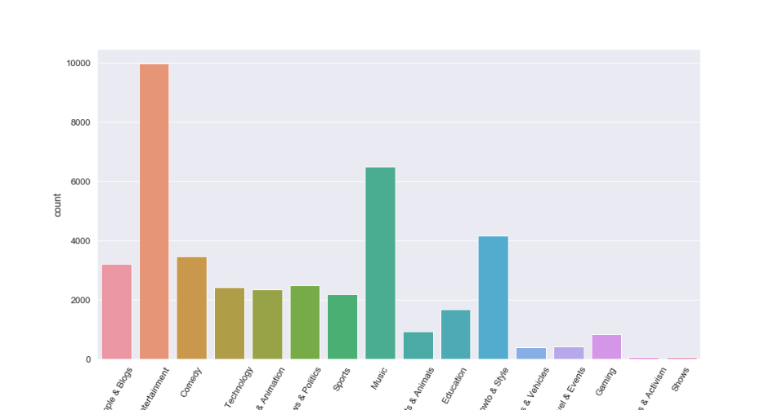

**Observation**

* Entertainment category leads in the United States as the most trending category followed by music ,while the least trending categories are Nonprofits and activism and Shows.

**Canada Graph And Analysis**

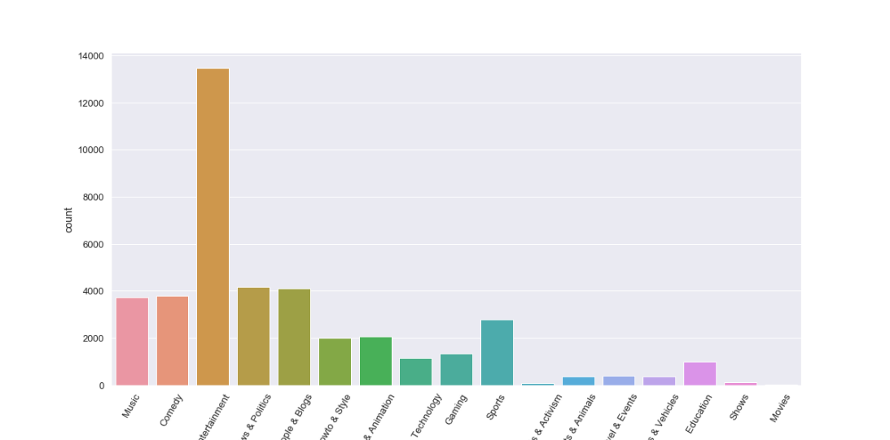

**Observation**

* In both Canada and United States the most trending videos are Entertainment.
* In Canada the least trending category happens to be the movies Category.
* News &Politics together with People & Blogs categories happen to be in the second place in the most trending categories.

**Mexico Graph And Analysis**

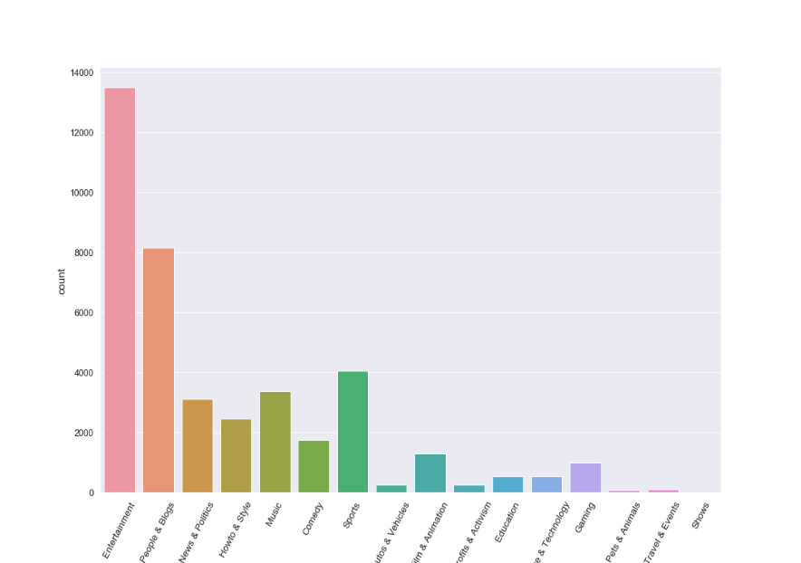

**Observation**

* In Mexico the top three trending categories happen to be Entertainment,People&Blogs,and Sports .
* The least trending categories happen to be Shows,Pets&Animals ,and Travel and Events.

**North America Observation**

* In the North American countries Entertainment categories happens to be the most trending while the least trending happens to vary from country to country.

**Japan Graph And Analysis**

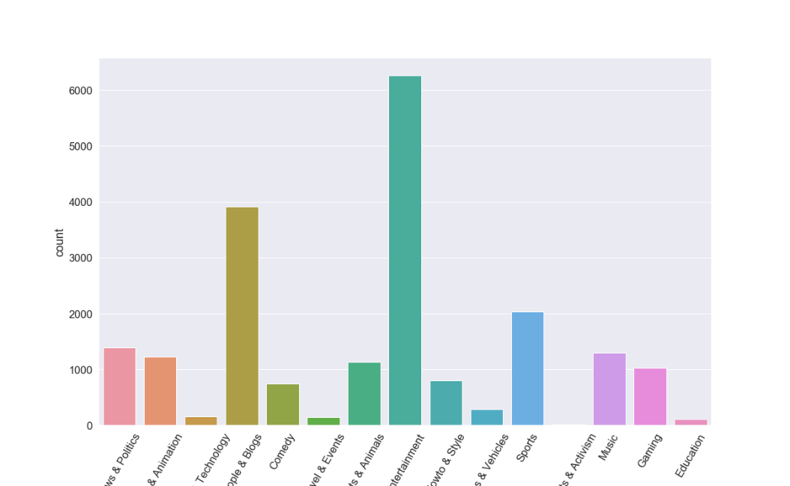

**Observation**

* Japan has the Entertainment category as the top category followed by people and blogs.
* The least trending category happen to be Education.

**South Korea Graph And Analysis**

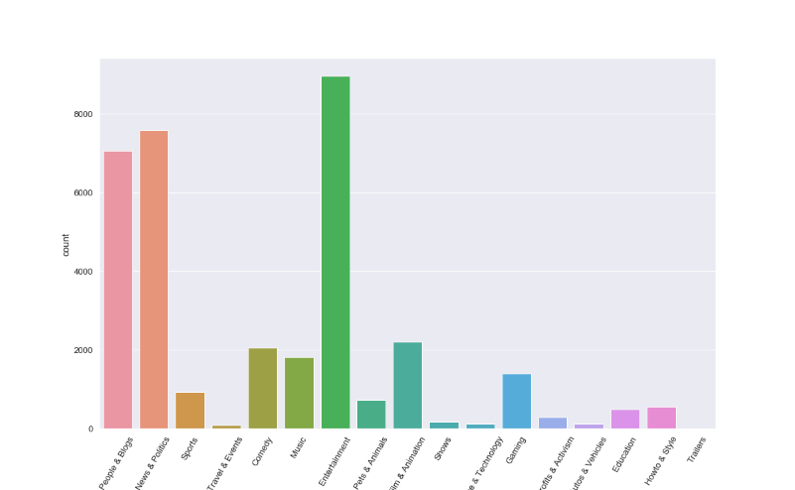

**Observation**

* In Korea, Entertainment , News & Politics , and People & Blogs happen to be the top three trending categories .
* Travel & Events happen to be the least trending category in Korea.

**India Graph and Analysis**

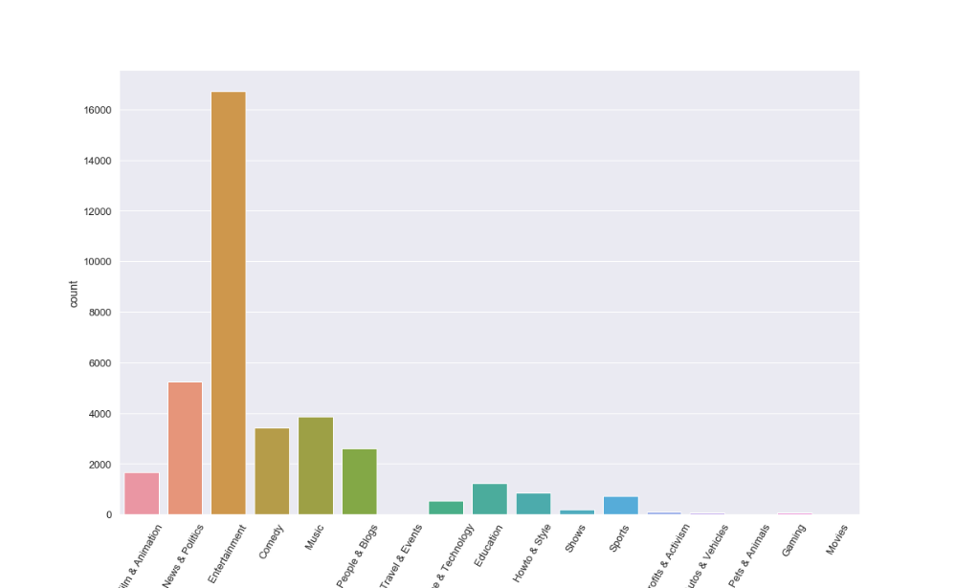

**Observation**

* In India the top trending category is Entertainment followed by News & Politics which happens to be the second most trending.

**Asia Analysis**

* The top trending categories happens to be entertainment in all the three countries.

**All analysis**

In all the six countries it is evident that the entertainment category is the top trending category, while the least trending category does vary from country to country for example in Japan the least trending category does differ from that in Mexico and the one in the United States.