Masterarbeit - Sicherheitsanalysebericht

Generiert am: 23.01.2025 12:13:53

# Gesamtstatistik

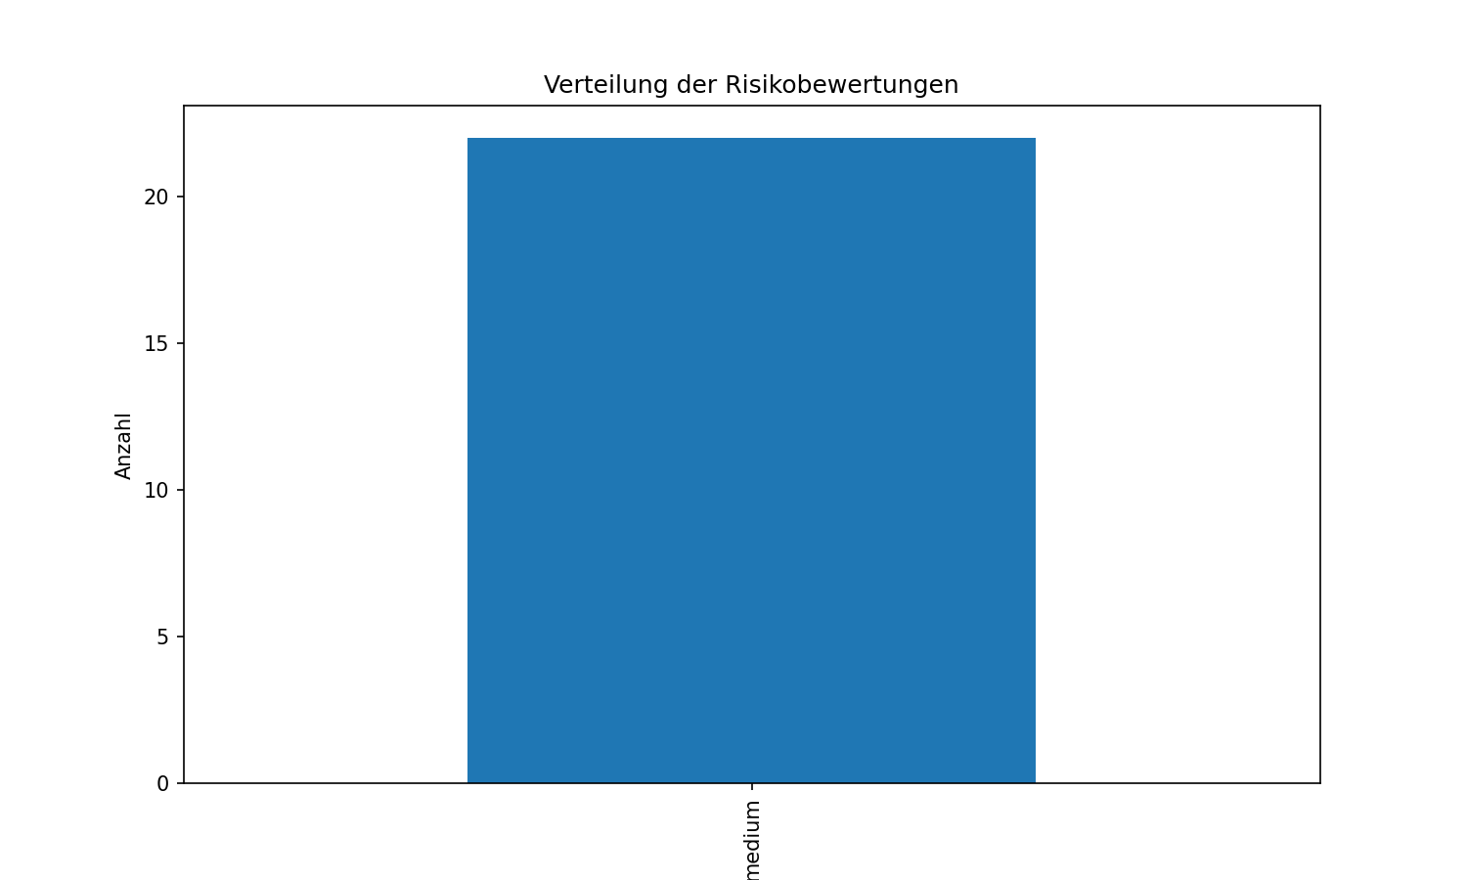

# Einzelergebnisse

|  |  |  |  |
| --- | --- | --- | --- |
| Dateiname | Risikostufe | Empfehlungen | Schlüsselwörter |
| 20000913_A320_C-GTDC.pdf | MEDIUM |  | 3 |
| 20151016_A320_9V-TRH.pdf | MEDIUM |  | 4 |
| Accepted Final Investigation Report VT-ITG.pdf | MEDIUM |  | 3 |
| Accepted Final Investigation Report VT-ITP.pdf | MEDIUM |  | 3 |
| Accepted Final Investigation Report VT-ITQ.pdf | MEDIUM |  | 3 |
| Accepted Final Investigation Report VT-ITW.pdf | MEDIUM |  | 3 |
| Accepted Final Investigation Report VT-IVB.pdf | MEDIUM |  | 3 |
| Accepted Final Investigation Report VT-WGT.pdf | MEDIUM |  | 4 |
| Accepted Report to VT-WGJ.pdf | MEDIUM |  | 3 |
| Accident Airbus A300B2-101 VT-EDV, Monday 15 November 1993.pdf | MEDIUM |  | 0 |
| Accident Airbus A300B4-203 F-BVGK, Wednesday 17 March 1982.pdf | MEDIUM |  | 1 |
| Accident Airbus A320-232 N413UA, Friday 21 November 1997.pdf | MEDIUM |  | 0 |
| Accident Airbus A321-211 VQ-BOZ, Thursday 15 August 2019.pdf | MEDIUM |  | 0 |
| Airbus_A320-214_OE-LOA_09-20.pdf | MEDIUM |  | 3 |
| Airbus_A320-232_9H-LOZ_06-22.pdf | MEDIUM |  | 3 |
| Serious incident Airbus A320-231 YR-SEA, Thursday 26 August 2021.pdf | MEDIUM |  | 1 |
| Serious incident Airbus A320-232 (WL) HS-TXH, Thursday 11 January 2018.pdf | MEDIUM |  | 1 |
| Serious incident Airbus A320-232 (WL) HS-TXN, Monday 25 January 2016.pdf | MEDIUM |  | 1 |
| Serious incident Airbus A320-232 (WL) XA-VAP, Friday 17 September 2021.pdf | MEDIUM |  | 1 |
| Serious incident Airbus A320-232 HA-LWK, Wednesday 8 November 2017.pdf | MEDIUM |  | 1 |
| Serious incident Airbus A320-233 N505VL, Friday 26 January 2018.pdf | MEDIUM |  | 1 |
| Serious incident Airbus A320-251N HS-BBX, Sunday 29 November 2020.pdf | MEDIUM |  | 1 |