Washington Cooperative Fish & Wildlife Research Unit FY2019 Financial Report

October 23, 2019

## here() starts at C:/Users/conve/Dropbox/Administrative/Coop Unit/financial_report

## Total Project Funds

The WACFWRU Cooperative Agreement facilitated $5,608,241 in total project funds across the University of Washington and Washington State University in state fiscal year 2019 (7/1/2018 to 6/30/2019), with $997,463 in new project funds. WDFW was the largest single funder, followed by WDNR and USFWS.

Table 1. Total funds and new funds by sponsor and university in FY2019

|  |  |  |  |  |
| --- | --- | --- | --- | --- |
|  | Sponsor | University | Total Funds | New Funds |
| 1 | BR | UW | $122,774 | $0 |
| 2 | DOD | UW | $175,834 | $175,835 |
| 3 | NOAA | UW | $354,884 | $354,884 |
| 4 | USFWS | UW | $857,970 | $83,298 |
| 5 | USGS | UW | $428,777 | $20,000 |
| 6 | WDFW-Fisheries | UW | $452,886 | $190,470 |
| 7 | WDFW-Habitat | UW | $180,000 | $0 |
| 8 | WDFW-Wildlife | UW | $1,242,571 | $0 |
| 9 | WDNR | UW | $1,145,406 | $105,026 |
| 10 | WDOE | UW | $207,935 | $0 |
| 16 | WDFW-Fisheries | WSU | $0 | $0 |
| 17 | WDFW-Habitat | WSU | $25,000 | $0 |
| 18 | WDFW-Wildlife | WSU | $213,961 | $48,871 |
| 19 | WDNR | WSU | $0 | $0 |
| 20 | WDOE | WSU | $200,243 | $19,079 |

## Waiver Usage

At UW, $0 of the $400,000 waiver was unused by the end of FY2019. As of the date of this report, $78,610 is still available for FY2020. At WSU, $180,921 was unused by the end of FY2019, while $374,129 is still available for FY2020.

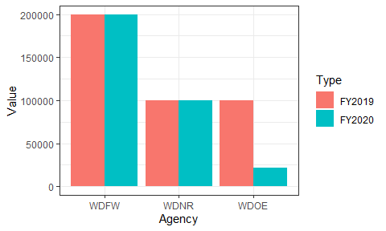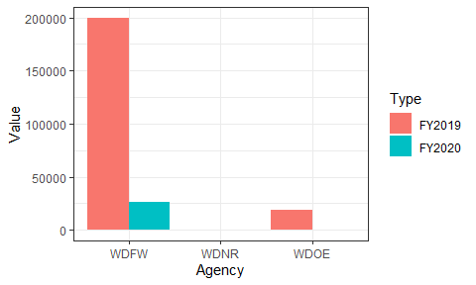

## Base Spending

The WACFWRU base account balance was $140,950 at the end of state fiscal year 2019. Total spending on base funds was $57,415 in FY2019, against total income of $71,250.

Table 2. Spending on base funds by category in FY2019

|  |  |
| --- | --- |
| Category | Total |
| Salaries | $26,725 |
| Benefits | $5,288 |
| Personal_Services | $550 |
| Services | $10,666 |
| Travel | $5,724 |
| Supplies | $4,718 |
| Equipment | $0 |
| Tuition | $2,572 |
| Adjustments | $1,172 |
| Total | $57,415 |