Washington Cooperative Fish & Wildlife Research Unit FY2020 Financial Report

August 23, 2020

## Total Project Funds

The WACFWRU Cooperative Agreement facilitated $9,984,167 in total project funds across the University of Washington and Washington State University in state fiscal year 2020 (7/1/2019 to 6/30/2020), with $5,784,713 in new project funds. WDFW was the largest single funder, followed by WDOE and WDNR.

Table 1. Total funds and new funds by sponsor and university in FY2020

|  |  |  |  |  |
| --- | --- | --- | --- | --- |
|  | Sponsor | University | Total Funds | New Funds |
| 1 | BR | UW | $122,774 | $0 |
| 2 | DOD | UW | $310,702 | $134,867 |
| 3 | NOAA | UW | $354,884 | $0 |
| 4 | NPS | UW | $317,224 | $317,224 |
| 5 | USFWS | UW | $938,206 | $80,236 |
| 6 | USGS | UW | $851,631 | $432,399 |
| 7 | WDFW-F | UW | $1,046,742 | $627,856 |
| 8 | WDFW-H | UW | $635,000 | $635,000 |
| 9 | WDFW-W | UW | $1,379,373 | $303,432 |
| 10 | WDNR | UW | $990,890 | $436,919 |
| 11 | WDOE | UW | $74,715 | $74,715 |
| 20 | WDFW-W | WSU | $311,138 | $97,177 |
| 21 | WDNR | WSU | $0 | $0 |
| 22 | WDOE | WSU | $2,650,888 | $2,644,888 |

## Waiver Usage

At UW, $0 of the $400,000 waiver was unused by the end of FY2020. As of the date of this report, $129,184 is still available for FY2021. At WSU, $230,716 was unused by the end of FY2020, while $359,271 is still available for FY2021.

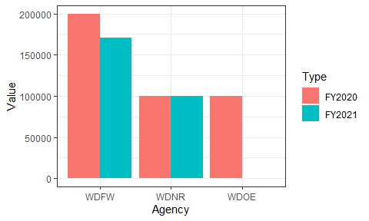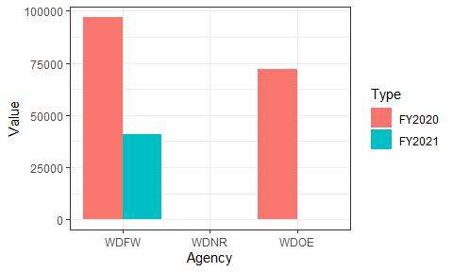

## Base Spending

The WACFWRU base account balance was $167,383 at the end of state fiscal year 2019. Total spending on base funds was $53,056 in FY2020, against total income of $71,250.

Table 2. Spending on base funds by category in FY2020

|  |  |
| --- | --- |
| Category | Total |
| Salaries | $26,167 |
| Benefits | $5,529 |
| Personal_Services | $0 |
| Services | $4,433 |
| Travel | $6,216 |
| Supplies | $3,214 |
| Equipment | $0 |
| Tuition | $6,818 |
| Adjustments | $678 |
| Total | $53,056 |