Kmid 2.4.0 Karaoke en Ubuntu Linux y derivados
http://www.lffl.org/2014/03/kmid-240-il-karaoke-in-ubuntu-linux-e.html

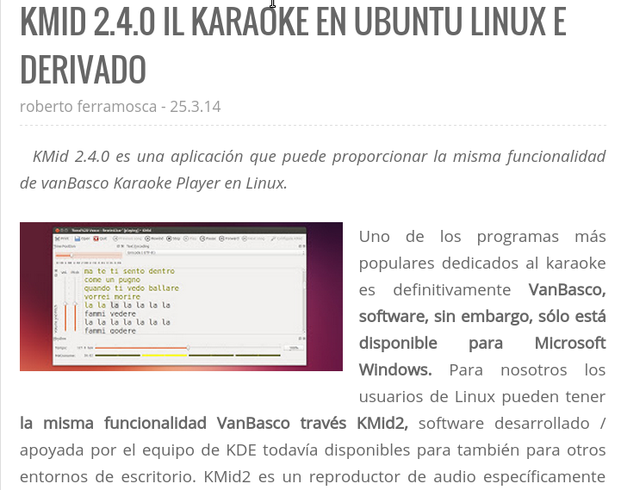
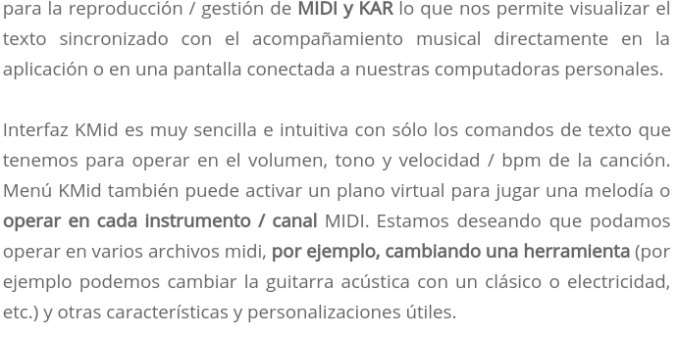

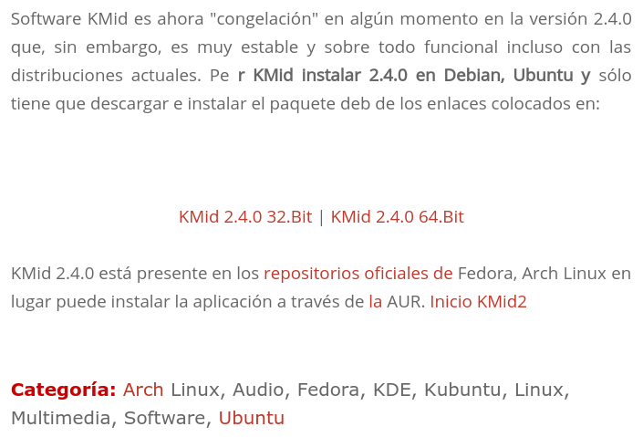

Kmid 2.4.0 32bits
http://sourceforge.net/projects/linuxfreedomfor/files/ubuntu/kmid2_2.4.0_i386.deb

Kmid 2.4.0 64bits
http://sourceforge.net/projects/linuxfreedomfor/files/ubuntu/kmid2_2.4.0_amd64.deb

HOME
https://userbase.kde.org/KMid2

En el HOME dice Features
- Playback to external hardware MIDI devices
- Allow to use software synths like Timidity++ and QSynth/FluidSynth
- Tempo, volume and pitch controls
- Configurable font and character encodings for lyrics
- Rhythm view (visual metronome)
- Player piano view (pianola)
- Channels view with mute/solo controls and instrument selector.
- Playlists (song collections)

Categories
MIDI, Players

