Move Tool: Creating multiple copies (linear arrays)
http://help.sketchup.com/en/article/94867

Creating multiple copies (linear arrays)
The Move tool can also be used to create arrays, or a series of copies of geometry. To create multiple copies of one or more entities:
- Select the Select tool (). The cursor will change to an arrow.
- Select the entities to be copied.
- Select the Move tool (). The cursor will change to a four-way arrow.
- Press and release the Ctrl (Microsoft Windows) orOption (Mac OS X) key on your keyboard. The cursor will change to an arrow with a plus sign. This action informs SketchUp that you want to duplicate the selected entities.
- Click on the selected entities to copy.
- Move your mouse to copy the entities. A copy of the selected entities will follow as you move your mouse.
- Click at the destination point to finish your copy operation. The copied entities are now selected and the original entities are deselected.
- Type a multiplier value to create additional multiple copies. For example, typing in 2x (or *2) will create one additional copy (or 2 copies total, the one you manually copied plus one you automatically copied using this step) instead of just one.
Creating Copies at an Equal Distance Apart
You can divide the distance between the copy and the original by typing in a divisor value. For example, typing 5/(or /5) will create five copies evenly distributed between the original and the first copy. You can keep typing in distances and multipliers until you perform another operation.
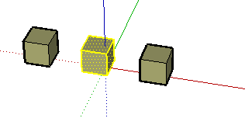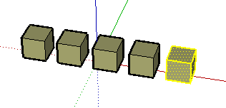

This feature is particularly useful in creating models of items such as fences, bridges, and decks, where you might want several posts or beams an equal distance apart.

