**DbGenSchemaReport**

1. Download plugin

<https://raw.githubusercontent.com/wachira90/lern-mysql/main/DbGenSchemaReport.py>

1. Install plugin **Script > Install Plugin / Module** Browse **DbGenSchemaReport.py**
2. In MySQL workbench, open model which expected to export, then click **Tools > Catalog > Database Schema Report in HTML Format.**

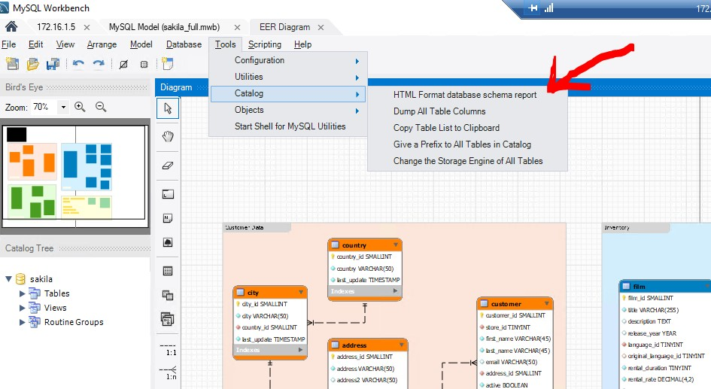

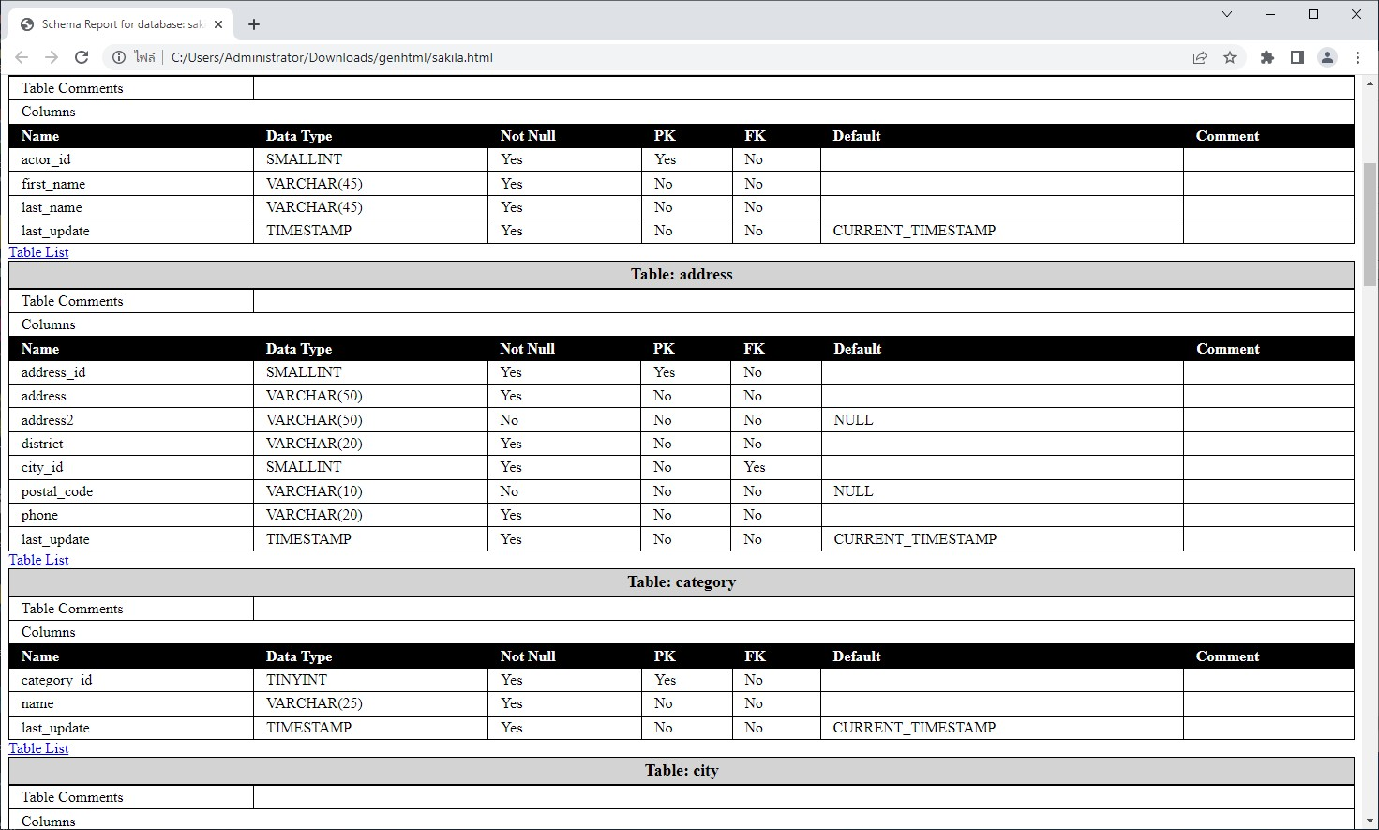

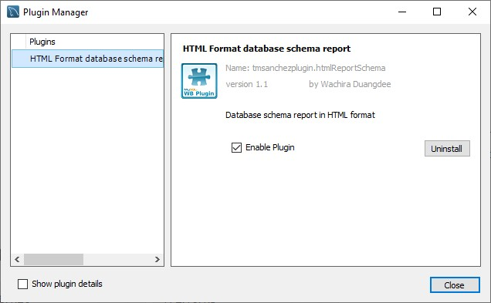

<https://www.chunho-ling.com/mysql-generate-data-dictionary/>