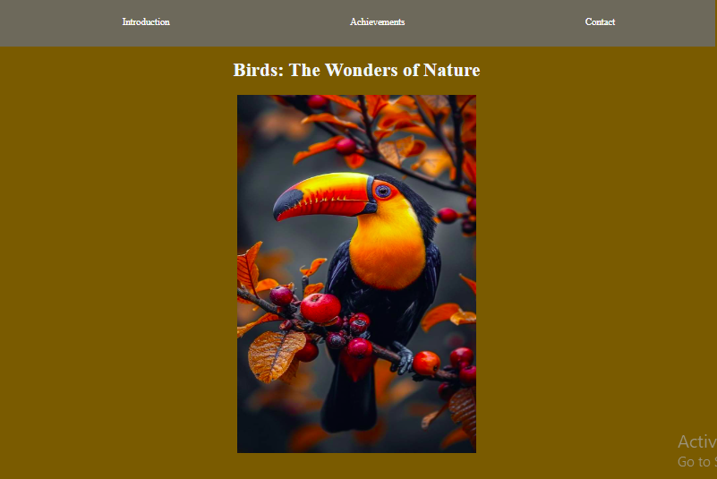
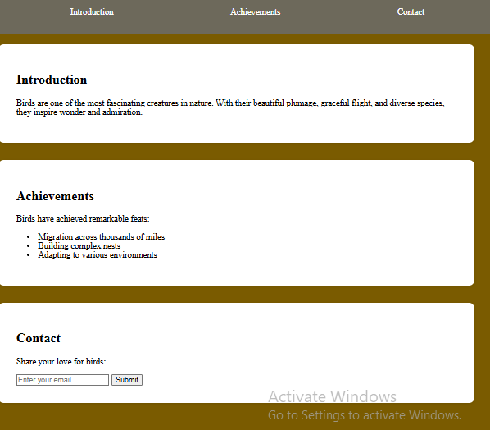
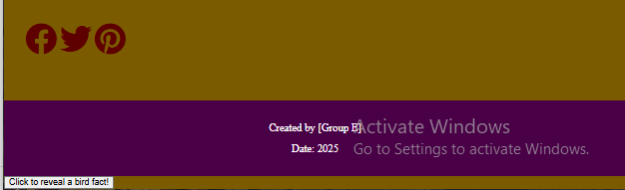
<!DOCTYPE html>
<html lang="en">
<head>
<link rel="stylesheet" href="https://cdnjs.cloudflare.com/ajax/libs/font-awesome/6.4.2/css/all.min.css">
<meta charset="UTF-8">
<title>Tribute to Birds</title>
<style>
body {
max-width: 1200px;
margin: 0 auto;
background-color: rgb(124, 86, 35);
}

.navbar {
background-color:rgb(110, 103, 93);
padding: 1rem;
position: sticky;
top: 0;
}

.navbar ul {
display: flex;
justify-content: space-around;
list-style: none;
}

.navbar a {
color: white;
text-decoration: none;
padding: 0.5rem 1rem;

}

.navbar a:hover {
border-radius: 300%;
background-color:rgb(29, 38, 41);
}

.header {
color: aliceblue;
text-align: center;
padding: 2rem 0;
}

.header img {
width: 400px;
height: 600px;

margin-bottom: 1rem;
}

.content {
padding: 2rem;
display: flex;
flex-direction: column;
gap: 2rem;
}

.section {
background-color: white;
padding: 2rem;
border-radius: 10px;
box-shadow: 0 2px 5px rgba(0,0,0,0.1);
}

.social-icons {
display: inline-block;
justify-content: center;
gap: 2rem;
margin-top: 2rem;
}

..social-icons i {
font-size: 2rem; /* Increase size */
color:rgb(146, 37, 23); /* Ensure color is set */
display: inline-block;
}

.social-icons a {
color:rgb(94, 17, 7);
font-size: 3rem;
transition: color 2s;
}

.social-icons a:hover {
color:rgb(9, 31, 94);
}

.footer {
text-align: center;
padding: 1rem;
margin-top: 2rem;
background-color:rgb(68, 12, 68);
color: white;
}

@media (max-width: 768px) {
.navbar ul {
flex-direction: column;
text-align: center;
}

.header img {
max-width: 200px;
}
}
</style>
</head>
<body>
<nav class="navbar">
<ul>
<li><a href="#introduction">Introduction</a></li>
<li><a href="#achievements">Achievements</a></li>
<li><a href="#contact">Contact</a></li>
</ul>
</nav>
<header class="header">
<h1>Birds: The Wonders of Nature</h1>
<img src="https://i.pinimg.com/736x/7a/38/f6/7a38f6f0884c46df0f53ff86b74d076a.jpg" alt="Bird">
</header>

<main class="content">
<section id="introduction" class="section">
<h2>Introduction</h2>
<p>Birds are one of the most fascinating creatures in nature. With their beautiful plumage, graceful flight, and diverse species, they inspire wonder and admiration.</p>
</section>

<section id="achievements" class="section">
<h2>Achievements</h2>
<p>Birds have achieved remarkable feats:
<ul>
<li>Migration across thousands of miles</li>
<li>Building complex nests</li>
<li>Adapting to various environments</li>
</ul>
</p>
</section>

<section id="contact" class="section">
<h2>Contact</h2>
<p>Share your love for birds:</p>
<form>
<input type="email" placeholder="Enter your email" required>
<button type="submit">Submit</button>
</form>
</section>

<div class="social-icons">
<a href="https://www.facebook.com/groups/amateurbirdphotography/" target="_blank"><i class="fab fa-facebook"></i></a>
<a href="https://x.com/CrapWildlife" target="_blank"><i class="fab fa-twitter"></i></a>
<a href="https://www.pinterest.com/missingamarble/bird-photography/" target="_blank"><i class="fab fa-pinterest"></i></a>
</div>
</main>

<footer class="footer">
<p>Created by [Group E]</p>
<p>Date: 2025</p>
</footer>

<script>
// Reveal hidden fact when button is clicked
const factButton = document.createElement('button');
factButton.textContent = 'Click to reveal a bird fact!';
document.body.appendChild(factButton);

const hiddenFact = document.createElement('div');
hiddenFact.textContent = 'Did you know that the fastest bird is the peregrine falcon, which can reach speeds of up to 242 mph during its hunting dive?';
hiddenFact.style.display = 'none';
document.body.appendChild(hiddenFact);

factButton.onclick = function() {
if (hiddenFact.style.display === 'none') {
hiddenFact.style.display = 'block';
} else {
hiddenFact.style.display = 'none';
}
};

// Smooth scroll for navigation links
document.querySelectorAll('a[href^="#"]').forEach(anchor => {
anchor.addEventListener('click', function (e) {
e.preventDefault();
document.querySelector(this.getAttribute('href')).scrollIntoView({
behavior: 'smooth'
});
});
});
</script>
</body>
</html>

